Supplementary Appendix

Supplementary Table 1. Details on the diagnostic criteria met for individual CPVT patients. The criteria proposed by the 2013 HRS/EHRA/APHRS expert consensus statement were used:
1. CPVT is diagnosed in the presence of a structurally normal heart, normal ECG, and unexplained exercise or catecholamine-induced bidirectional VT, polymorphic ventricular premature beats or VT in individuals <40 years of age.
2. CPVT is diagnosed in patients (index case or family member) who have a pathogenic mutation.
3. CPVT is diagnosed in family members of a CPVT index case with a normal heart who manifests exercise-induced PVCs or bidirectional/polymorphic VT.
4. CPVT can be diagnosed in the presence of a structurally normal heart and coronary arteries, normal ECG, and unexplained exercise or catecholamine-induced bidirectional VT, polymorphic ventricular premature beats or VT in individuals >40 years of age.
Case number | Criteria 1 | Criteria 2 | Criteria 3 | Criteria 4
1 | 1 | 1 | 0 | 0
2 | 1 | 1 | 0 | 0
3 | 1 | 1 | 0 | 0
4 | 1 | 1 | 0 | 0
5 | 0 | 1 | 1 (brother, mother, maternal granduncle) | 0
6 | 1 | 1 | 1 (brother, mother – not related to case 5) | 0
7 | 1 | 1 | 0 | 0
8 | 1 | 1 | 0 | 0
9 | 1 | 0 | 0 | 0
10 | 1 | 1 | 0 | 0
11 | 0 | 1 | 1 (father, sister) | 0
12 | 1 | 1 | 0 | 0
13 | 1 | 0 | 0 | 0
14 | 1 | 1 | 0 | 0
15 | 1 | 1 | 0 | 0
16 | 1 | 1 | 0 | 0

Supplementary Table 2. Genetic testing in individual CPVT patients. All mutations detected were in the RyR2 gene.
Case number | Genetic test performed | Abnormal genetic test | Genetic results | Coding effect | Novel compared to overseas studies | Reference
1 | 1 | 1 | c.14848G>A | E4950K | No | [1]
2 | 1 | 1 | c.12475C>A | Q4159K | No | [2]
3 | 1 | 0 | - | - | - | -
4 | 1 | 1 | c.7420A>G | R2474G | No | [3]
5 | 1 | 0 | - | -
6 | 1 | 1 | c.11836G>A | G3946S | No | [4]
7 | 1 | 0 | - | - | - | -
8 | 1 | 1 | c.14861C>G | A4954G | Yes | -
9 | 0 | - | - | - | - | -
10 | 1 | 1 | c.14159T>C | L4720P | No | RCV000182842
11 | 1 | 1 | c.10046C>T | S3349L | No | [5, 6]
12 | 1 | 0 | - | - | - | -
13 | 0 | - | - | - | - | -
14 | 1 | 0 | - | - | - | -
15 | 1 | 0 | 0 | - | - | -
16 | 1 | 1 | c.7202G>A | R2401H | No | [7]

Supplementary Figures

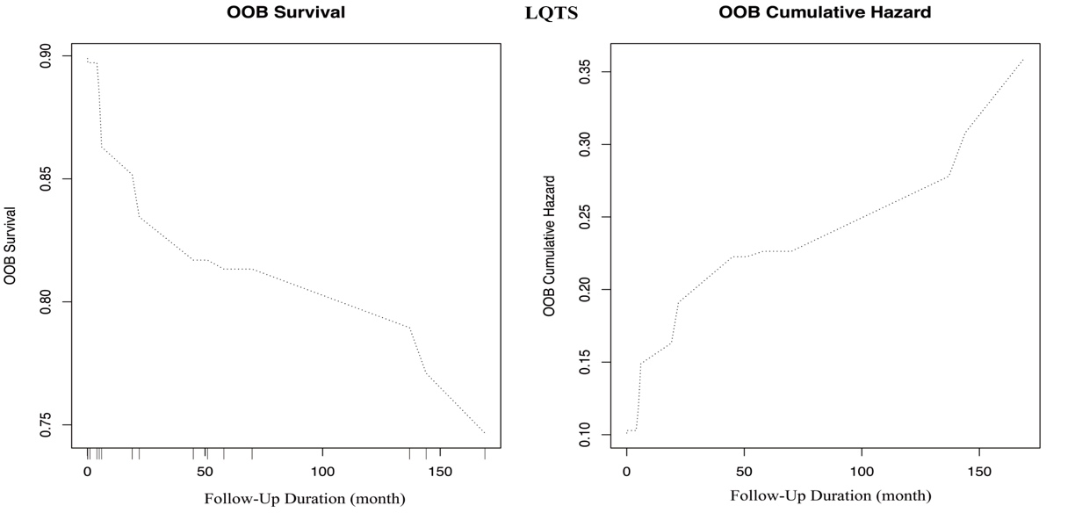
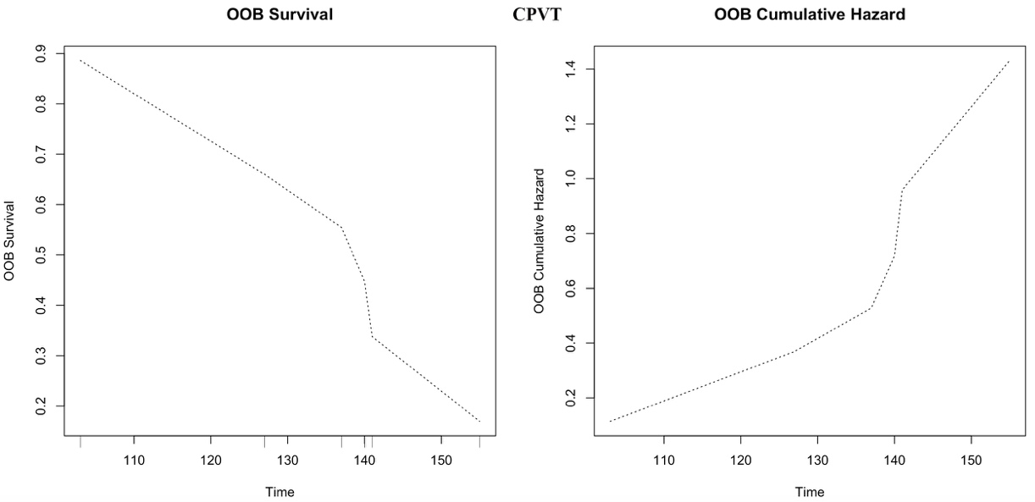
Supplementary Fig. 1. Predicted OOB survivals and cumulative hazards generated by the RSF model for predicting incident VT/VF in LQTS (a, b) and CPVT (c, d).

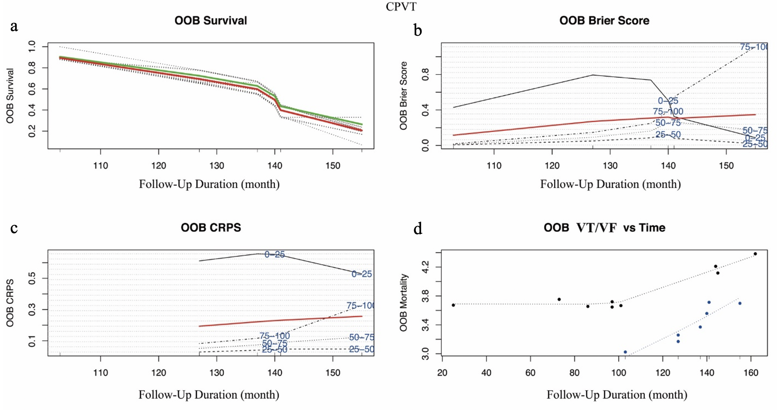
Supplementary Fig. 2. Survival estimates for the CPVT cohort generated from the random survival forest (RSF) model. The overall ensemble survival is indicated by the red line; the Nelson-Aalen estimator is given by the green line (a). Brier score (0=perfect, 1=poor, and 0.25=guessing) stratified by ensemble mortality based on the inverse probability of censoring weight (IPCW) method (b) The cohort was stratified into four groups of 0-25, 25-50, 50-75 and 75-100 percentile mortality (the overall, non-stratified, Brier score is shown by the red line). Continuous rank probability score (CRPS) given by the integrated Brier score divided by time (c). The plot of incident VT/VF of each LQTS patient versus observed time (d). Events are shown as blue points, whereas censored observations are shown as red points.

References
[1] Priori SG, Napolitano C, Memmi M, Colombi B, Drago F, Gasparini M, et al. Clinical and molecular characterization of patients with catecholaminergic polymorphic ventricular tachycardia. Circulation. 2002; 106: 69-74.
[2] Kawata H, Ohno S, Aiba T, Sakaguchi H, Miyazaki A, Sumitomo N, et al. Catecholaminergic Polymorphic Ventricular Tachycardia (CPVT) Associated With Ryanodine Receptor (RyR2) Gene Mutations- Long-Term Prognosis After Initiation of Medical Treatment. Circ J. 2016; 80: 1907-1915.
[3] Ozawa J, Ohno S, Fujii Y, Makiyama T, Suzuki H, Saitoh A, et al. Differential Diagnosis Between Catecholaminergic Polymorphic Ventricular Tachycardia and Long QT Syndrome Type 1- Modified Schwartz Score. Circ J. 2018; 82: 2269-2276.
[4] Gallegos-Cortez A, Alonso-Ortiz N, Antunez-Arguellez E, Villarreal-Molina T, Totomoch-Serra A, Iturralde-Torres P, et al. Catecholaminergic polymorphic ventricular tachycardia due to de novo RyR2 mutation: recreational cycling as a trigger of lethal arrhythmias. Arch Med Sci. 2020; 16: 466-470.
[5] Seidelmann SB, Smith E, Subrahmanyan L, Dykas D, Abou Ziki MD, Azari B, et al. Application of Whole Exome Sequencing in the Clinical Diagnosis and Management of Inherited Cardiovascular Diseases in Adults. Circ Cardiovasc Genet. 2017; 10.
[6] Christiansen SL, Hertz CL, Ferrero-Miliani L, Dahl M, Weeke PE, LuCamp, et al. Genetic investigation of 100 heart genes in sudden unexplained death victims in a forensic setting. European journal of human genetics : EJHG. 2016; 24: 1797-1802.
[7] Aizawa Y, Ueda K, Komura S, Washizuka T, Chinushi M, Inagaki N, et al. A novel mutation in FKBP12.6 binding region of the human cardiac ryanodine receptor gene (R2401H) in a Japanese patient with catecholaminergic polymorphic ventricular tachycardia. Int J Cardiol. 2005; 99: 343-345.

