Supplementary Materials
Supplementary Table 1. Assessment of evidence within the recurrent restenosis outcome.
Recurrent Restenosis for femoropopliteal in-stent restenosis
Patient or population: patients with femoropopliteal in-stent restenosis
Settings:
Intervention: Paclitaxel-coated balloon angioplasty (PCB group) or uncoated balloon angioplasty (UCB group)
Outcomes | Illustrative comparative risks* (95% CI) |  | Relative effect  (95% CI) | No of Participants  (studies) | Quality of the evidence  (GRADE) | Comments
Outcomes | Assumed risk | Corresponding risk
 | Control | Recurrent Restenosis
recurrent restenosis (6 months)  Follow-up: 6 months | Study population |  | OR 0·23  (0·13 to 0·38) | 281  (4 studies) | ⊕⊕⊕⊕  high
recurrent restenosis (6 months)  Follow-up: 6 months | 561 per 1000 | 227 per 1000  (142 to 327)
recurrent restenosis (6 months)  Follow-up: 6 months | Moderate
recurrent restenosis (6 months)  Follow-up: 6 months | 593 per 1000 | 251 per 1000  (159 to 356)
recurrent restenosis (12 months)  Follow-up: 12 months | Study population |  | OR 0·18  (0·1 to 0·34) | 224  (3 studies) | ⊕⊕⊕⊝  moderate¹
recurrent restenosis (12 months)  Follow-up: 12 months | 709 per 1000 | 305 per 1000  (196 to 453)
recurrent restenosis (12 months)  Follow-up: 12 months | Moderate
recurrent restenosis (12 months)  Follow-up: 12 months | 667 per 1000 | 265 per 1000  (167 to 405)
*The basis for the assumed risk (e.g. the median control group risk across studies) is provided in footnotes. The corresponding risk (and its 95% confidence interval) is based on the assumed risk in the comparison group and the relative effect of the intervention (and its 95% CI).
CI: Confidence interval; OR: Odds ratio;
GRADE Working Group grades of evidence
High quality: Further research is very unlikely to change our confidence in the estimate of effect.
Moderate quality: Further research is likely to have an important impact on our confidence in the estimate of effect and may change the estimate.
Low quality: Further research is very likely to have an important impact on our confidence in the estimate of effect and is likely to change the estimate.
Very low quality: We are very uncertain about the estimate.
¹ The DEBATE-ISR trial has a bias in the process, which may cause an error in the results.

Supplementary Table 2. Assessment of evidence within the primary patency outcome.
Primary Patency for femoropopliteal in-stent restenosis
Patient or population: patients with femoropopliteal in-stent restenosis
Settings:
Intervention: Paclitaxel-coated balloon angioplasty (PCB group) or uncoated balloon angioplasty (UCB group)
Outcomes | Illustrative comparative risks* (95% CI) |  | Relative effect  (95% CI) | No of Participants  (studies) | Quality of the evidence  (GRADE) | Comments
Outcomes | Assumed risk | Corresponding risk
 | Control | Primary Patency
primary patency (12 months)  Follow-up: 12 months | Study population |  | OR 3·5  (1·65 to 7·4) | 156  (3 studies) | ⊕⊕⊕⊝  moderate¹
primary patency (12 months)  Follow-up: 12 months | 459 per 1000 | 748 per 1000  (583 to 863)
primary patency (12 months)  Follow-up: 12 months | Moderate
primary patency (12 months)  Follow-up: 12 months | 478 per 1000 | 762 per 1000  (602 to 871)
*The basis for the assumed risk (e.g. the median control group risk across studies) is provided in footnotes. The corresponding risk (and its 95% confidence interval) is based on the assumed risk in the comparison group and the relative effect of the intervention (and its 95% CI).
CI: Confidence interval; OR: Odds ratio;
GRADE Working Group grades of evidence
High quality: Further research is very unlikely to change our confidence in the estimate of effect.
Moderate quality: Further research is likely to have an important impact on our confidence in the estimate of effect and may change the estimate.
Low quality: Further research is very likely to have an important impact on our confidence in the estimate of effect and is likely to change the estimate.
Very low quality: We are very uncertain about the estimate.
¹ The PACUBA study contained a few number of participants in the 12-month follow-up, which may cause a low precision ratio.

Supplementary Table 3. Assessment of evidence within the freedom from TLR outcome.
Freedom From TLR for femoropopliteal in-stent restenosis
Patient or population: patients with femoropopliteal in-stent restenosis
Settings:
Intervention: Paclitaxel-coated balloon angioplasty (PCB group) or uncoated balloon angioplasty (UCB group)
Outcomes | Illustrative comparative risks* (95% CI) |  | Relative effect  (95% CI) | No of Participants  (studies) | Quality of the evidence  (GRADE) | Comments
Outcomes | Assumed risk | Corresponding risk
 | Control | Freedom From TLR
Freedom from TLR (6 months)  Follow-up: 6 months | Study population |  | OR 2.55  (1.25 to 5.19) | 391  (5 studies) | ⊕⊕⊕⊝  moderate¹
Freedom from TLR (6 months)  Follow-up: 6 months | 839 per 1000 | 930 per 1000  (867 to 964)
Freedom from TLR (6 months)  Follow-up: 6 months | Moderate
Freedom from TLR (6 months)  Follow-up: 6 months | 839 per 1000 | 930 per 1000  (867 to 964)
Freedom From TLR (12 months)  Follow-up: 12 months | Study population |  | OR 4.02  (2.55 to 6.34) | 475  (7 studies) | ⊕⊕⊕⊝  moderate²
Freedom From TLR (12 months)  Follow-up: 12 months | 613 per 1000 | 834 per 1000  (724 to 944)
Freedom From TLR (12 months)  Follow-up: 12 months | Moderate
Freedom From TLR (12 months)  Follow-up: 12 months | 625 per 1000 | 850 per 1000  (737 to 962)
*The basis for the assumed risk (e.g. the median control group risk across studies) is provided in footnotes. The corresponding risk (and its 95% confidence interval) is based on the assumed risk in the comparison group and the relative effect of the intervention (and its 95% CI).
CI: Confidence interval; RR: Risk ratio; OR: Odds ratio;
GRADE Working Group grades of evidence
High quality: Further research is very unlikely to change our confidence in the estimate of effect.
Moderate quality: Further research is likely to have an important impact on our confidence in the estimate of effect and may change the estimate.
Low quality: Further research is very likely to have an important impact on our confidence in the estimate of effect and is likely to change the estimate.
Very low quality: We are very uncertain about the estimate.
¹ Result of FAIR trial is not consistent with others.
² The DEBATE-ISR trial has a bias in the process, which may cause an error in the results.

Supplementary Table 4. Assessment of evidence within the clinical improvement outcome.
Clinical Improvement for femoropopliteal in-stent restenosis
Patient or population: patients with femoropopliteal in-stent restenosis
Settings:
Intervention: Paclitaxel-coated balloon angioplasty (PCB group) or uncoated balloon angioplasty (UCB group)
Outcomes | Illustrative comparative risks* (95% CI) |  | Relative effect  (95% CI) | No of Participants  (studies) | Quality of the evidence  (GRADE) | Comments
Outcomes | Assumed risk | Corresponding risk
 | Control | Clinical Improvement
clinical improvement (6 months)  Follow-up: 6 months | Study population |  | OR 1·86  (1·1 to 3·16) | 276  (4 studies) | ⊕⊕⊕⊕  high
clinical improvement (6 months)  Follow-up: 6 months | 479 per 1000 | 631 per 1000  (503 to 744)
clinical improvement (6 months)  Follow-up: 6 months | Moderate
clinical improvement (6 months)  Follow-up: 6 months | 567 per 1000 | 709 per 1000  (590 to 805)
clinical improvement (12 months)  Follow-up: 12 months | Study population |  | OR 2·38  (1·49 to 3·8) | 337  (5 studies) | ⊕⊕⊝⊝  low^{1,2}
clinical improvement (12 months)  Follow-up: 12 months | 540 per 1000 | 736 per 1000  (636 to 817)
clinical improvement (12 months)  Follow-up: 12 months | Moderate
clinical improvement (12 months)  Follow-up: 12 months | 523 per 1000 | 723 per 1000  (620 to 806)
*The basis for the assumed risk (e.g. the median control group risk across studies) is provided in footnotes. The corresponding risk (and its 95% confidence interval) is based on the assumed risk in the comparison group and the relative effect of the intervention (and its 95% CI).
CI: Confidence interval; OR: Odds ratio;
GRADE Working Group grades of evidence
High quality: Further research is very unlikely to change our confidence in the estimate of effect.
Moderate quality: Further research is likely to have an important impact on our confidence in the estimate of effect and may change the estimate.
Low quality: Further research is very likely to have an important impact on our confidence in the estimate of effect and is likely to change the estimate.
Very low quality: We are very uncertain about the estimate.
¹ The DEBATE-ISR trial has a bias in the process, which may cause an error in the results.
² Results of FAIR trial and Liao trial are a little different from those of the other three trials.

Supplementary Table 5. Assessment of evidence within the ABI outcome.
ABI for femoropopliteal in-stent restenosis
Patient or population: patients with femoropopliteal in-stent restenosis
Settings:
Intervention: Paclitaxel-coated balloon angioplasty (PCB group) or uncoated balloon angioplasty (UCB group)
Outcomes | Illustrative comparative risks* (95% CI) |  | Relative effect  (95% CI) | No of Participants  (studies) | Quality of the evidence  (GRADE) | Comments
Outcomes | Assumed risk | Corresponding risk
 | Control | ABI
ABI (12 months)  Follow-up: 12 months |  | The mean ABI (12 months) in the intervention groups was  0.02 higher  (0.11 lower to 0.14 higher) |  | 216  (3 studies) | ⊕⊝⊝⊝  very low^{1,2}
*The basis for the assumed risk (e.g. the median control group risk across studies) is provided in footnotes. The corresponding risk (and its 95% confidence interval) is based on the assumed risk in the comparison group and the relative effect of the intervention (and its 95% CI).
CI: Confidence interval;
GRADE Working Group grades of evidence
High quality: Further research is very unlikely to change our confidence in the estimate of effect.
Moderate quality: Further research is likely to have an important impact on our confidence in the estimate of effect and may change the estimate.
Low quality: Further research is very likely to have an important impact on our confidence in the estimate of effect and is likely to change the estimate.
Very low quality: We are very uncertain about the estimate.
¹ The COPA CABANA trial failed to present the ABI as they designed in the Method section.
² This outcome is only published by 3 studies of 7 included studies, and the study Liao 2019 fail to keep consistent with the other two.

Supplementary Table 6. Assessment of evidence within the MAEs outcome.
Major Adverse Events for femoropopliteal in-stent restenosis
Patient or population: patients with femoropopliteal in-stent restenosis
Settings:
Intervention: Paclitaxel-coated balloon angioplasty (PCB group) or uncoated balloon angioplasty (UCB group)
Outcomes | Illustrative comparative risks* (95% CI) |  | Relative effect  (95% CI) | No of Participants  (studies) | Quality of the evidence  (GRADE) | Comments
Outcomes | Assumed risk | Corresponding risk
 | Control | Major Adverse Events
major adverse event (6 months)  Follow-up: 6 months | Study population |  | OR 0·68  (0·22 to 2·13) | 251  (3 studies) | ⊕⊕⊕⊝  moderate¹
major adverse event (6 months)  Follow-up: 6 months | 56 per 1000 | 38 per 1000  (13 to 111)
major adverse event (6 months)  Follow-up: 6 months | Moderate
major adverse event (6 months)  Follow-up: 6 months | 43 per 1000 | 30 per 1000  (10 to 87)
major adverse event (12 months)  Follow-up: 12 months | Study population |  | OR 0·51  (0·27 to 0·96) | 321  (4 studies) | ⊕⊕⊕⊝  moderate²
major adverse event (12 months)  Follow-up: 12 months | 196 per 1000 | 110 per 1000  (62 to 189)
major adverse event (12 months)  Follow-up: 12 months | Moderate
major adverse event (12 months)  Follow-up: 12 months | 209 per 1000 | 119 per 1000  (67 to 202)
*The basis for the assumed risk (e.g. the median control group risk across studies) is provided in footnotes. The corresponding risk (and its 95% confidence interval) is based on the assumed risk in the comparison group and the relative effect of the intervention (and its 95% CI).
CI: Confidence interval; OR: Odds ratio;
GRADE Working Group grades of evidence
High quality: Further research is very unlikely to change our confidence in the estimate of effect.
Moderate quality: Further research is likely to have an important impact on our confidence in the estimate of effect and may change the estimate.
Low quality: Further research is very likely to have an important impact on our confidence in the estimate of effect and is likely to change the estimate.
Very low quality: We are very uncertain about the estimate.
¹ Result of ISAR-PEBIS trial is not consistent with others.
² The DEBATE-ISR trial has a bias in the process, which may cause an error in the results.

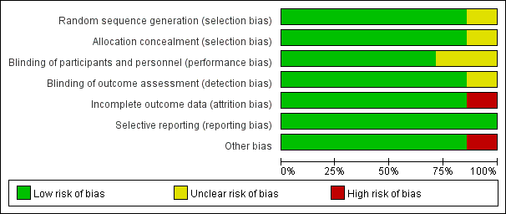
Supplementary Fig. 1. Bias risk graph. Judgements about each risk of bias item presented as percentages across all seven included studies.

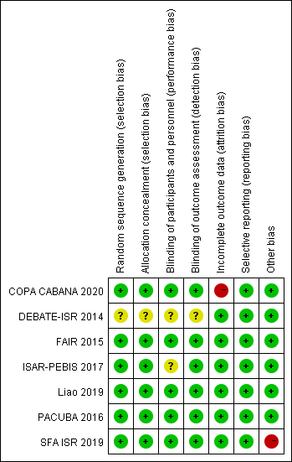
Supplementary Fig. 2. Bias risk summary. Judgements about each risk of bias item for each included study.

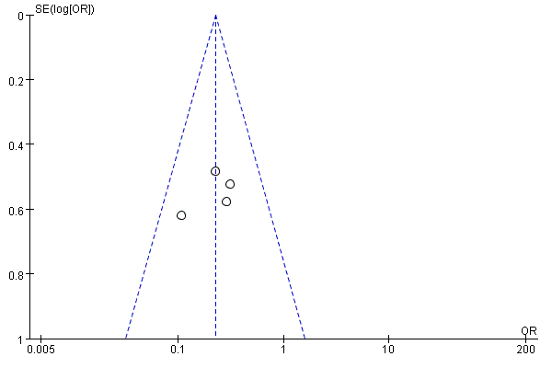
Supplementary Fig. 3. Funnel plot estimated individual and overall effect of recurrent restenosis between PCB and UCB groups at 6 months.

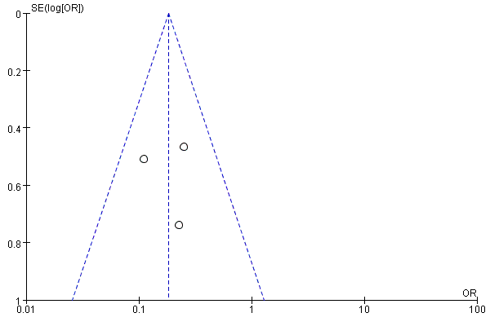
Supplementary Fig. 4. Funnel plot estimated individual and overall effect of recurrent restenosis between PCB and UCB groups at 12 months.

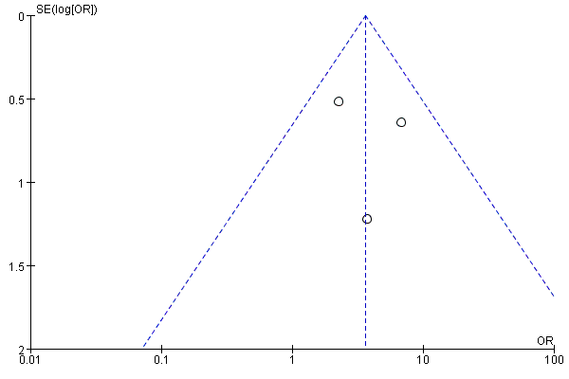
Supplementary Fig. 5. Funnel plot of estimated individual and overall effect of primary patency between PCB and UCB groups at 12 months.

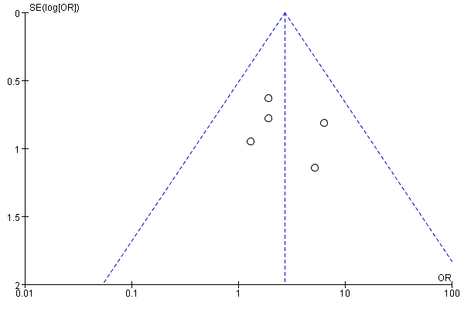
Supplementary Fig. 6. Funnel plot of estimated individual and overall effect of freedom from TLR between PCB and UCB groups at 6 months.

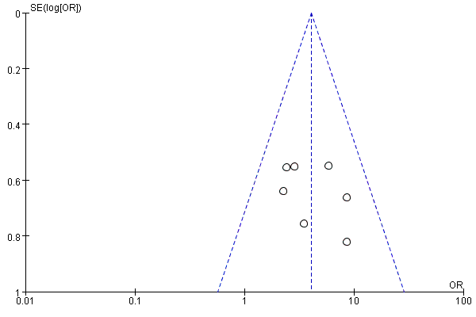
Supplementary Fig. 7. Funnel plot of estimated individual and overall effect of freedom from TLR between PCB and UCB groups at 12 months.

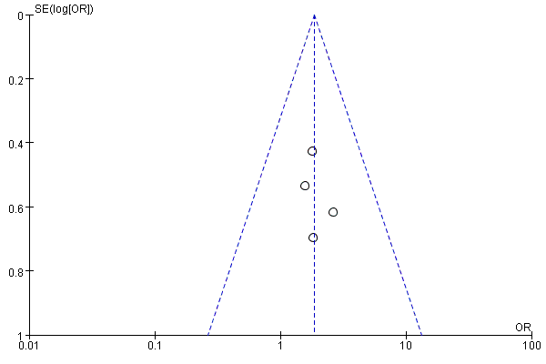
Supplementary Fig. 8. Funnel plot of estimated individual and overall effect of clinical improvement between PCB and UCB groups at 6 months.

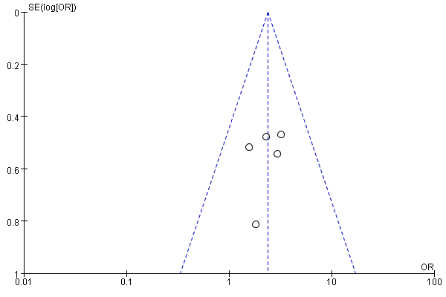
Supplementary Fig. 9. Funnel plot of estimated individual and overall effect of clinical improvement between PCB and UCB groups at 12 months.

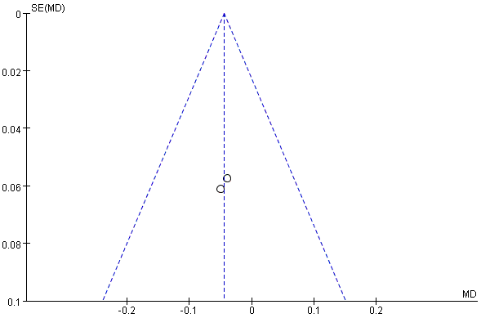
Supplementary Fig. 10. Funnel plot of revised estimated individual and overall effect of the ABI between PCB and UCB groups at 12 months.

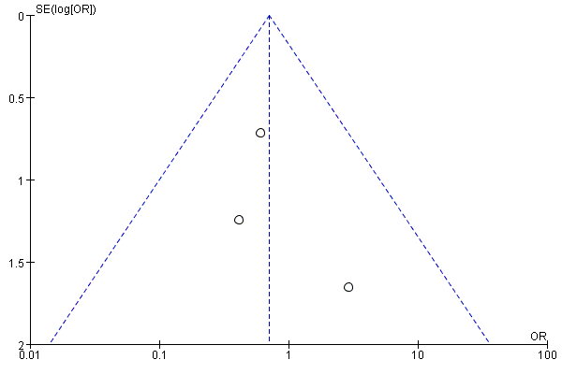
Supplementary Fig. 11. Funnel plot of estimated individual and overall effect of MAEs between PCB and UCB groups at 6 months.

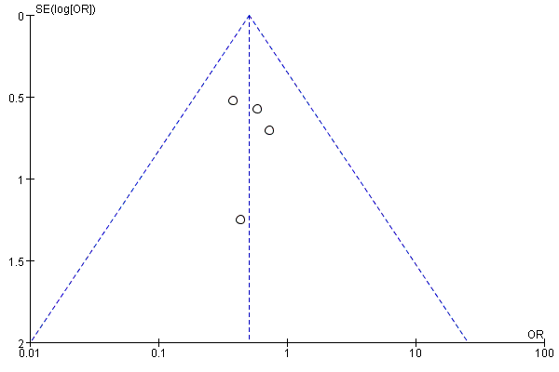
Supplementary Fig. 12. Funnel plot of estimated individual and overall effect of MAEs between PCB and UCB groups at 12 months.

(A)
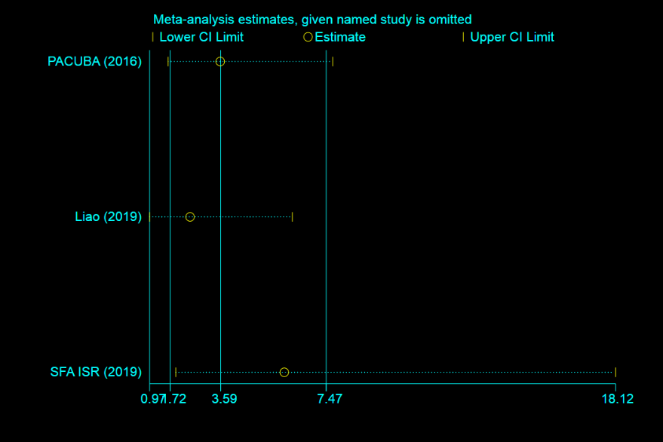
(B)
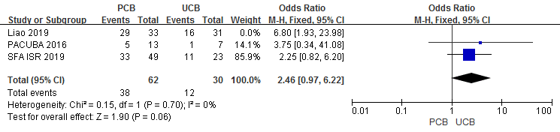
(C)
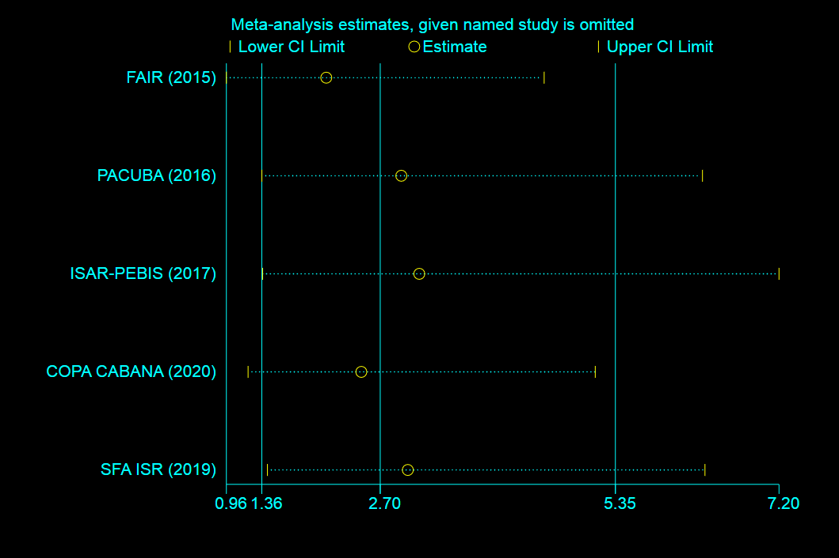
(D)
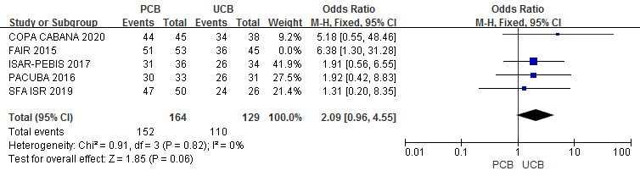
(E)
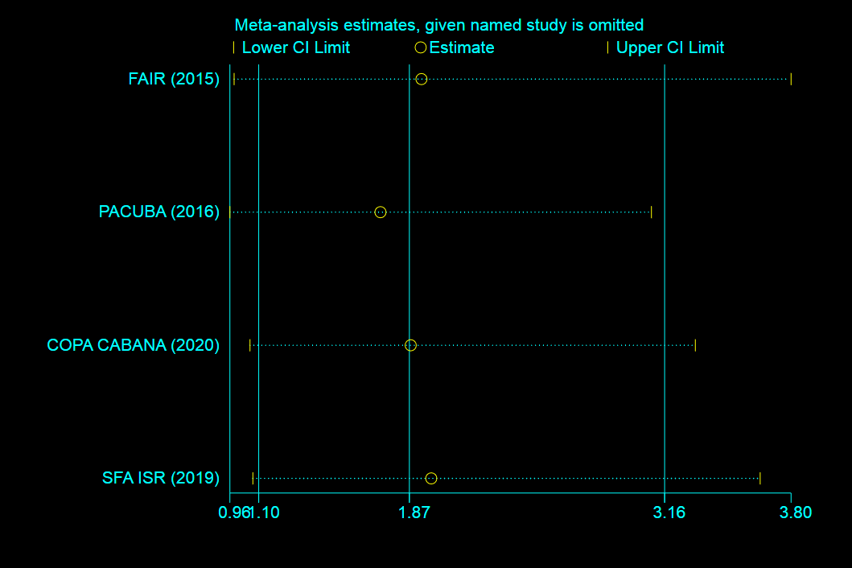
(F)
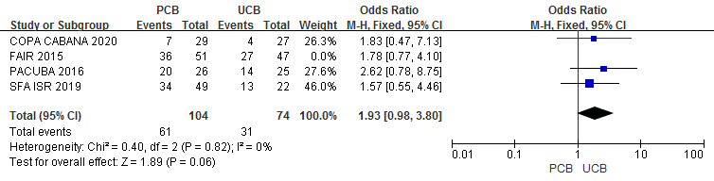
(G)
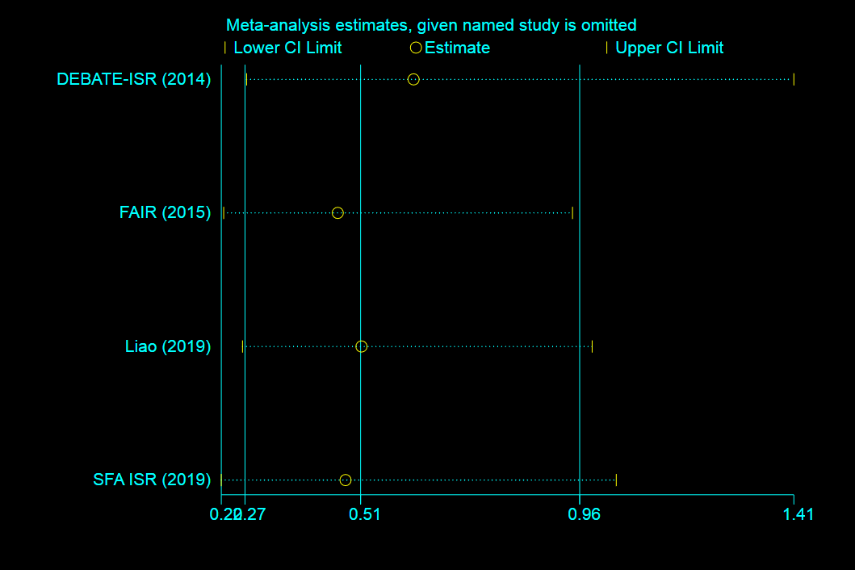
(H)
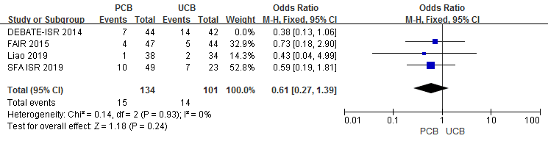
Supplementary Fig. 13. Sensitivity analysis. (A) Influence analysis of estimated individual and overall effect of the primary patency between PCB and UCB groups at 12 months. (B) Forest plot of estimated individual and overall effect of the primary patency between PCB and UCB groups at 12 months with Liao trial omitted. (C) Influence analysis of estimated individual and overall effect of the freedom from TLR at 6 months between PCB and UCB groups. (D) Forest plot of estimated individual and overall effect of the freedom from TLR at 6 months between PCB and UCB groups with FAIR trial omitted. (E) Influence analysis of estimated individual and overall effect of the clinical improvement between PCB and UCB groups at 6 months. (F) Forest plot of estimated individual and overall effect of the clinical improvement between PCB and UCB groups at 6 months with FAIR trial omitted. (G) Influence analysis of estimated individual and overall effect of the MAEs between PCB and UCB groups at 12 months. (H) Forest plot of estimated individual and overall effect of the MAEs between PCB and UCB groups at 12 months with DEBATE-ISR trial omitted.

