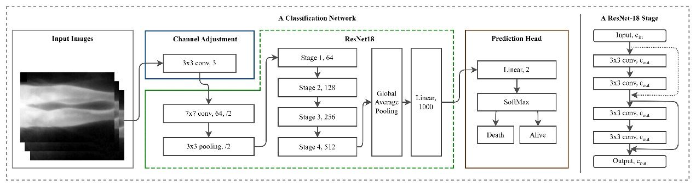
Supplementary Fig. 1. An example network architecture for the classification task.
Left: our implemented ResNet-18 model as a reference. Right: the architecture of a single stage in ResNet-18. The dotted connection serves as a shortcut connection, which is an identity operation when c_in=c_out while an 1×1 convolution to match number of channels when c_in≠c_out.
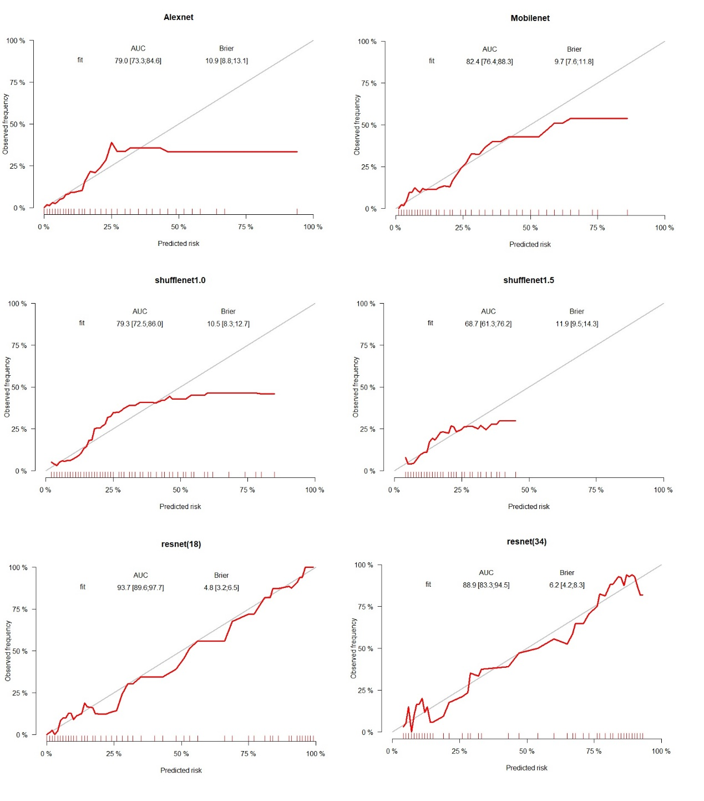
Supplementary Fig. 2. Calibration curves

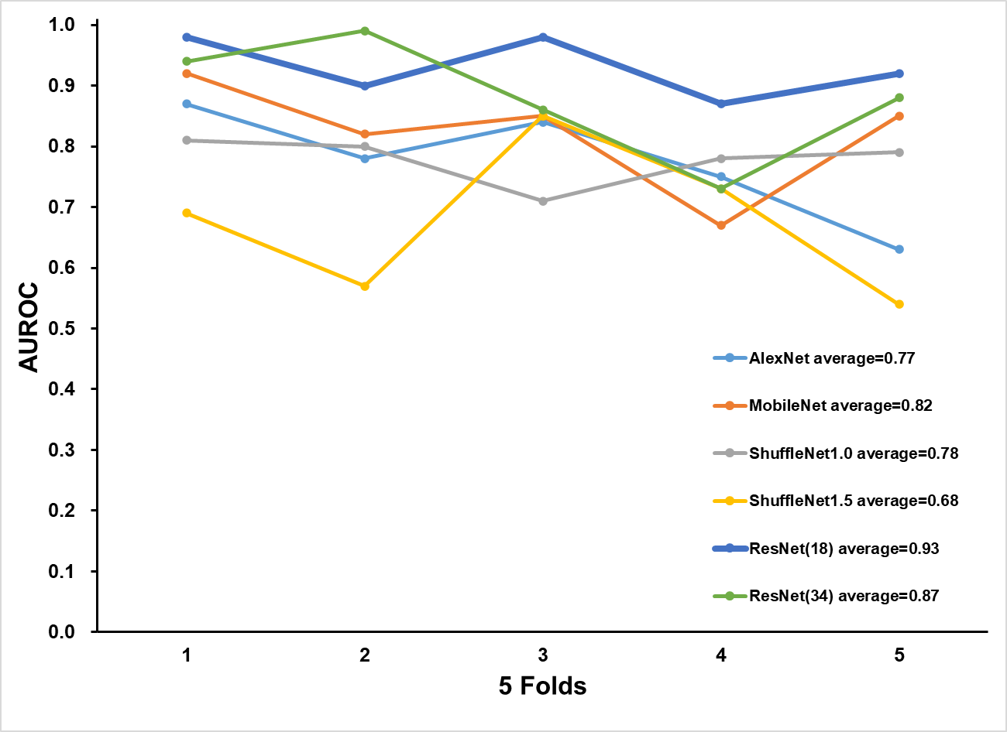
Supplementary Fig. 3. 5-fold cross validation

