Supplementary Appendix

Supplementary Figure 1. Configuration of Huami smartwatch from Anhui Huami Information Technology Co. Ltd.
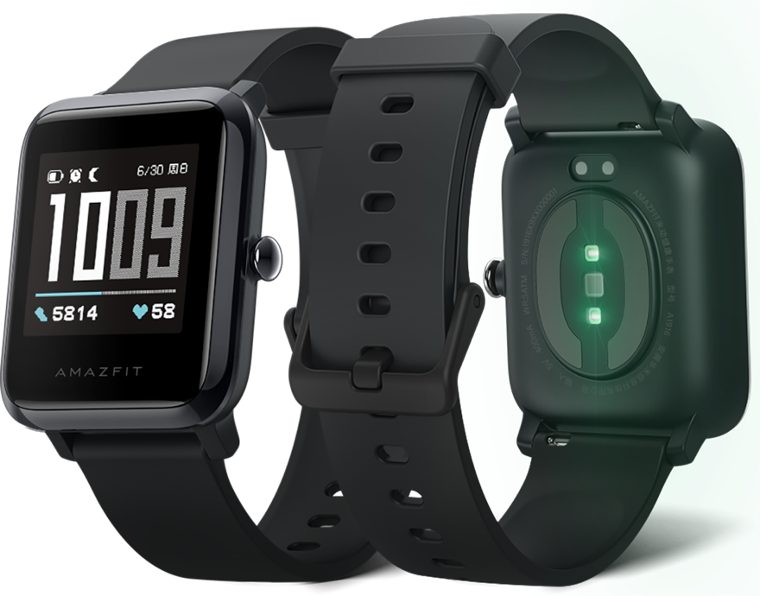

Analysis of daily sleep, step and heartbeat for 30 days after discharge
There were 67 patients with complete 24-hour heartbeat data (which meant smartwatch wearing time more than 22 hour per day) within 30 days after discharge were included in the analysis of variation of daily heartbeat, sleep and step counts from pre-operative stage to 4 weeks after discharge. The analysis of variation of 24-hour heartbeat excluded 9 patients (13.4%, 9/67) with persistent AF after discharge. After multiple pairwise comparison which corrected by false-positive rate error control, results indicated that 24-hour heartbeat, sleep duration, deep sleep duration, and step count did not differ significantly across time periods (Supplementary Figure 2). At pre-operative stage, post-operative stage, 1 week after discharge, 2 weeks after discharge, 3 weeks after discharge and 4 weeks after discharge, the mean 24-hour heartbeat were 110124.3 times, 108027.6 times, 107452.5 times, 109852.3 times, 109844.4 times and 107408.1 times, respectively; the mean 24-hour sleep duration were 410.0 minutes, 455.2 minutes, 454.0 minutes, 461.6 minutes, 426.1 minutes and 419.9 minutes, respectively; the mean 24-hour deep sleep duration were 101.8 minutes, 107.1 minutes, 103 minutes, 109.4 minutes, 101.2 minutes and 98.7 minutes, respectively; the mean 24-hour step counts were 3848.5 steps, 3736.3 steps, 3866.2 steps, 3202.1 steps, 3899.9 steps and 3840.9 steps, respectively.
Supplementary figure 2. Variation of 24-hour heartbeat (A), sleep duration (B), deep sleep duration (C) and step counts (D) from pre-operative stage to 4 weeks after discharge.
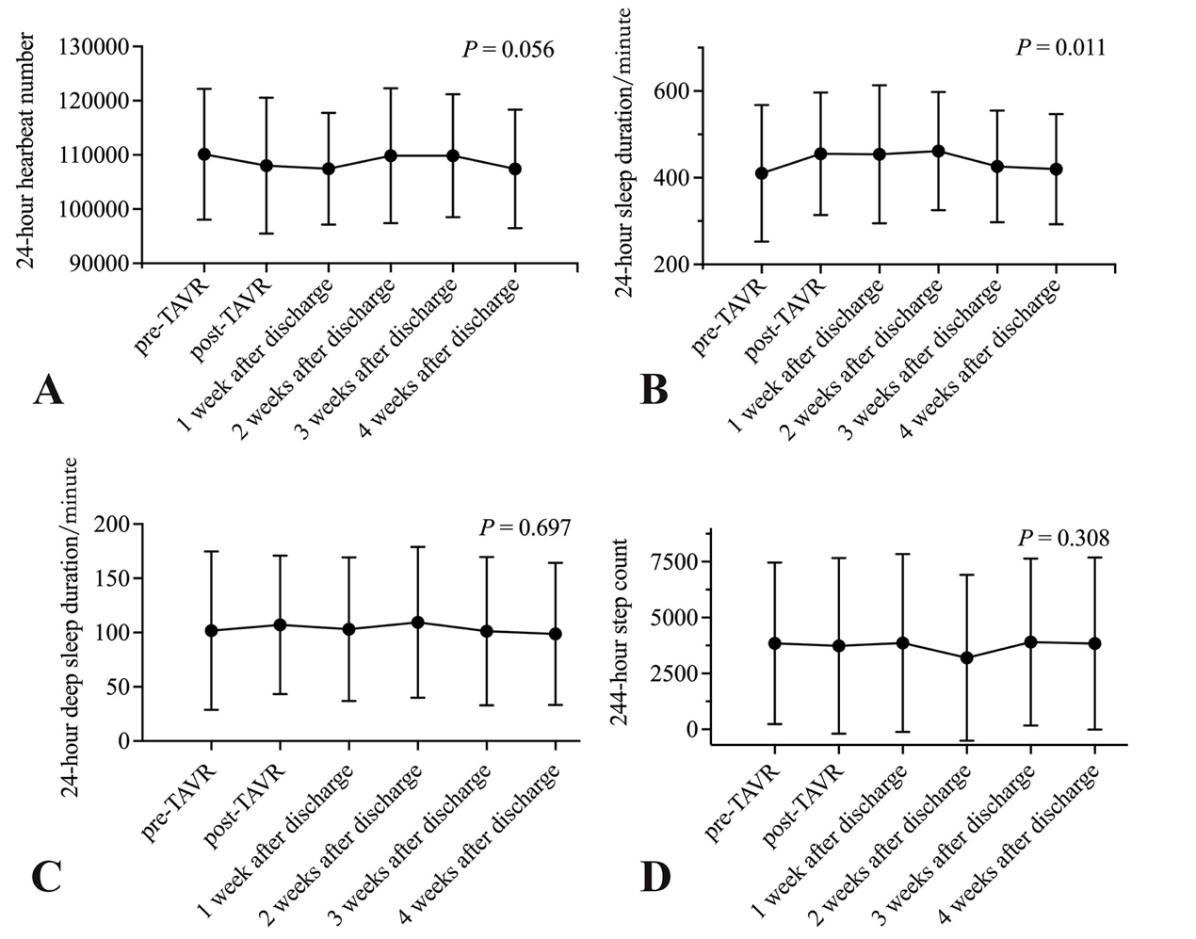
*Abbreviation: TAVR = transcatheter aortic valve replacement.

Supplementary Table 1. The diagnostic outcomes of AF, LBBB and RBBB from 24-hour Holter ECGs and smartwatch ECGs.
Smartwatch ECG (N) | 24-hour Holter ECG (N)
Smartwatch ECG (N) | Diagnosed | Undiagnosed | Total
AF | 10 | 0 | 10
Non-AF | 3 | 83 | 86
Unable diagnosis | 2 | 2 | 4
Total | 15 | 85 | 100
LBBB | 17 | 11 | 28
Non-LBBB | 8 | 60 | 68
Unable diagnosis | 1 | 3 | 4
Total | 26 | 74 | 100
RBBB | 3 | 2 | 5
Non-RBBB | 3 | 88 | 91
Unable diagnosis | 0 | 4 | 4
Total | 6 | 94 | 100
ECG: electrocardiograph; AF: atrial fibrillation; LBBB: left bundle branch block; RBBB: right bundle branch block.

Supplementary Table 2. The diagnostic outcomes of AF, LBBB and RBBB from 12-lead ECGs and smartwatch ECGs.
Smartwatch ECGs (N) | 12-lead ECGs (N)
Smartwatch ECGs (N) | Diagnosed | Undiagnosed | Total
AF | 46 | 6 | 52
Non-AF | 1 | 365 | 366
Unable diagnosis | 5 | 15 | 20
Total | 52 | 386 | 438
LBBB | 95 | 11 | 106
Non-LBBB | 11 | 301 | 312
Unable diagnosis | 8 | 12 | 20
Total | 114 | 324 | 438
RBBB | 19 | 4 | 23
Non-RBBB | 23 | 372 | 395
Unable diagnosis | 0 | 20 | 20
Total | 42 | 396 | 438
AF: atrial fibrillation; LBBB: left bundle branch block; RBBB: right bundle branch block.

Supplementary Table 3. Regression analysis of predictors for delayed new-onset AF, delay new-onset SCD, overall new-onset AF, and overall new-onset permanent LBBB.
 | Univariate regression  OR [95% CI] | P | Multivariate regression  OR [95% CI] | P
Predictors for delayed new-onset AF
Age | 0.956 [0.873, 1.047] | 0.332 | 0.955 [0.852, 1.070] | 0.428
Female | 1.813 [0.622, 5.284] | 0.275 | 3.565 [0.845, 15.044] | 0.084
STS-PROM | 0.705 [0.429, 1.159] | 0.168 | 0.700 [0.323, 1.518] | 0.367
Severe aortic stenosis | 0.343 [0.116 - 1.014] | 0.053 | 0.958 [0.192 – 4.785] | 0.958
THV implantation depth | 1.107 [1.014 - 1.209] | 0.023 | 1.151 [1.000 - 1.324] | 0.050
Predictors for delay new-onset SCD
Age | 1.001 [0.891 - 1.125] | 0.983 | 1.026 [0.884 - 1.191] | 0.736
Male† | 2.287 [0.518 - 10.089] | 0.275 | 2.084 [0.409 – 10.619] | 0.377
STS-PROM | 0.954 [0.580 - 1.570] | 0.853 | 0.917 [0.491 - 1.712] | 0.785
Prosthesis implantation depth | 0.929 [0.790, 1.091] | 0.367 | 0.938 [0.795, 1.107] | 0.448
Early new-onset RBBB | 6.467 [1.032 - 40.533] | 0.046 | 6.512 [0.893 – 47.492] | 0.065
Predictors for overall new-onset AF
Age | 1.004 [0.934, 1.080] | 0.908 | 1.019 [0.928, 1.118] | 0.694
Female | 1.389 [0.560, 3.442] | 0.478 | 2.290 [0.736, 7.129] | 0.153
STS-PROM | 0.930 [0.679, 1.275] | 0.654 | 0.857 [0.514, 1.429] | 0.555
THV implantation depth | 1.116 [1.030 - 1.210] | 0.008 | 1.110 [0.991 - 1.243] | 0.072
Severe aortic stenosis | 0.240 [0.093 - 0.621] | 0.003 | 0.630 [0.165 - 2.412] | 0.500
Predictors for overall new-onset SCD
Age | 1.008 [0.939, 1.082] | 0.822 | 1.002 [0.907, 1.106] | 0.969
Female | 1.716 [0.708, 4.160] | 0.232 | 1.618 [0.537, 4.871] | 0.392
STS-PROM | 1.065 [0.809, 1.401] | 0.654 | 1.141 [0.698, 1.865] | 0.599
THV implantation depth | 0.940 [0.854, 1.034] | 0.202 | 0.950 [0.856, 1.055] | 0.340
baseline RBBB | 14.909 [1.585 - 140.224] | 0.018 | 21.659 [1.631, 287.551] | 0.020
Pre-TAVR statins | 2.216 [0.906 - 5.418] | 0.081 | 3.793 [1.243, 11.574] | 0.019
Predictors for overall new-onset permanent LBBB
Age | 1.013 [0.930, 1.102] | 0.769 | 1.005 [0.900, 1.123] | 0.924
Female | 0.379 [0.114, 1.260] | 0.113 | 0.566 [0.133, 2.406] | 0.441
STS-PROM | 1.316 [0.982 - 1.763] | 0.066 | 1.438 [0.981 – 2.106] | 0.063
Renal dysfunction | 4.108 [0.876 - 19.259] | 0.073 | 1.979 [0.232 – 16.857] | 0.532
Pre-TAVR PG_{mean} | 0.959 [0.921 - 0.999] | 0.044 | 0.960 [0.920 - 1.003] | 0.066
AF: atrial fibrillation; STS-PROM: Society of Thoracic Surgeons predicted rate of mortality; THV: transcatheter heart valve; SCD: severe conduction disturbances; RBBB: right bundle branch block; LBBB: left bundle branch block; TAVR: transcatheter aortic valve replacement; OR: odds ratio; CI: confidence interval.

