Supplementary Material

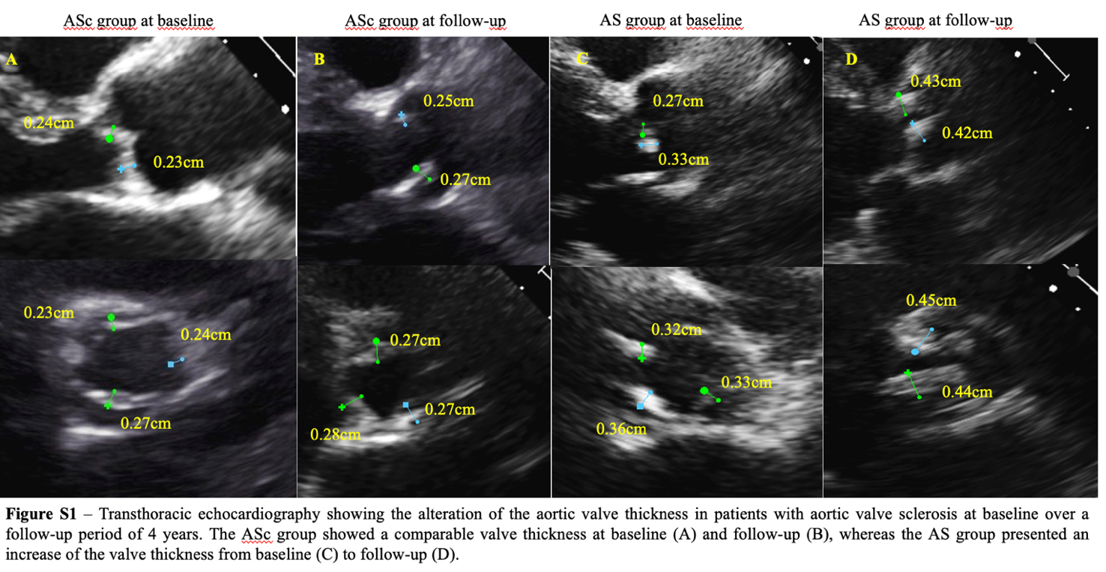
Supplementary Fig. 1. Transthoracic echocardiography showing the alteration of the aortic valve thickness in patients with aortic valve sclerosis at baseline and over a follow-up period of 4 years.

