SUPPLEMENTAL MATERIALS
1.Supplemental Methods
We performed matching using the nearest-neighbor method with a ratio of 1:1. The propensity score estimation was identified by a multivariable logistic regression. The variables included in the model estimating propensity score: age, gender, body mass index, hypertension, diabetes mellitus, eGFR<60ml/min/1.73m², peripheral artery disease, prior stroke, prior MI, prior CABG, prior PCI, prior cerebral hemorrhage, atrial fibrillation, coronary artery disease, STEMI, NSTEMI, dilated cardiomyopathy, hypertrophic cardiomyopathy, ARVD with associated LV impairment, perinatal cardiomyopathy, restrictive cardiomyopathy, alcoholic cardiomyopathy, myocarditis, NVM, LVEDD, LVEF, LVEF<=40%, global hypokinesis, hypokinesis, akinesis, apical LVT, round LVT, mobile LVT, multiple LVT, calcified LVT, LVT largest diameter, LVT area, left ventricular aneurysm. The standardized mean difference (SMD) was used to evaluate the availability of PSM in reducing the baseline discrepancy between the two groups. An SMD<20% indicated successful PSM.

2.Supplemental Tables
Supplemental Table 1 Baseline features according to the anticoagulation therapy at discharge after propensity score matching.
 | Without anticoagulation | With anticoagulation | P value | SMD
n | 257 | 257
Demographic
Age | 57.00 [46.00, 66.00] | 56.00 [46.00, 65.00] | 0.593 | 0.063
Male | 212 (82.5) | 214 (83.3) | 0.907 | 0.021
Body mass index/kg/m² | 25.05 [23.03, 27.41] | 25.06 [22.60, 27.44] | 0.874 | 0.036
Past medical history
Hypertension | 133 (51.8) | 132 (51.4) | 1 | 0.008
Diabetes mellitus | 104 (40.5) | 107 (41.6) | 0.858 | 0.024
eGFR<60 ml/min/1.73m² | 33 (12.8) | 36 (14.0) | 0.796 | 0.034
Peripheral artery disease | 17 (6.6) | 17 (6.6) | 1 | <0.001
Prior stroke | 44 (17.1) | 43 (16.7) | 1 | 0.01
Prior MI | 160 (62.3) | 154 (59.9) | 0.651 | 0.048
Prior CABG | 5 (1.9) | 5 (1.9) | 1 | <0.001
Prior PCI | 46 (17.9) | 41 (16.0) | 0.638 | 0.052
Prior cerebral hemorrhage | 0 (0.0) | 0 (0.0) | NA | <0.001
Atrial fibrillation | 18 (7.0) | 20 (7.8) | 0.866 | 0.03
Underlying disease
Coronary artery disease | 231 (89.9) | 226 (87.9) | 0.574 | 0.062
STEMI | 67 (26.1) | 71 (27.6) | 0.765 | 0.035
NSTEMI | 12 (4.7) | 15 (5.8) | 0.693 | 0.052
Dilated cardiomyopathy | 20 (7.8) | 18 (7.0) | 0.866 | 0.03
Hypertrophic cardiomyopathy | 3 (1.2) | 3 (1.2) | 1 | <0.001
ARVD with associated LV impairment | 0 (0.0) | 0 (0.0) | NA | <0.001
Perinatal cardiomyopathy | 1 (0.4) | 2 (0.8) | 1 | 0.051
Restrictive cardiomyopathy | 0 (0.0) | 0 (0.0) | NA | <0.001
Alcoholic cardiomyopathy | 0 (0.0) | 0 (0.0) | NA | <0.001
Myocarditis | 1 (0.4) | 3 (1.2) | 0.616 | 0.089
NVM | 5 (1.9) | 7 (2.7) | 0.77 | 0.052
Imaging morphology of LVT
LVEDD | 57.00 [52.00, 62.00] | 57.00 [52.00, 61.00] | 0.553 | 0.062
LVEF | 40.00 [33.00, 47.00] | 40.00 [33.00, 48.00] | 0.77 | 0.019
LVEF<=40% | 148 (57.6) | 140 (54.5) | 0.534 | 0.063
Global hypokinesis | 38 (14.8) | 40 (15.6) | 0.902 | 0.022
Hypokinesis | 130 (50.6) | 125 (48.6) | 0.724 | 0.039
Akinesis | 184 (71.6) | 183 (71.2) | 1 | 0.009
Apical LVT | 239 (93.0) | 237 (92.2) | 0.866 | 0.03
Round LVT | 149 (58.0) | 155 (60.3) | 0.654 | 0.048
Mobile LVT | 11 (4.3) | 12 (4.7) | 1 | 0.019
Multiple LVT | 18 (7.0) | 19 (7.4) | 1 | 0.015
Calcified LVT | 36 (14.0) | 38 (14.8) | 0.9 | 0.022
LVT largest diameter/mm | 24.00 [17.00, 33.00] | 22.00 [16.00, 32.00] | 0.306 | 0.045
LVT area/mm² | 3.00 [1.68, 4.94] | 2.86 [1.60, 4.80] | 0.631 | 0.034
Left ventricular aneurysm | 158 (61.5) | 161 (62.6) | 0.856 | 0.024
Data are n/N (%) or median (IQR). eGFR=estimated glomerular filtration rate. MI=myocardial infarction. CABG=coronary artery bypass grafting. PCI=percutaneous coronary intervention. STEMI=ST-segment elevation myocardial infarction. NSTEMI=non-ST-segment elevation myocardial infarction. ARVD=arrhythmogenic right ventricular dysplasia. NVM=noncompaction of the ventricular myocardium. LVT=left ventricular thrombus. LVEDD=left ventricular end diastolic dimension. LVEF=left ventricular ejection fraction. LVA=left ventricle aneurysms.

Supplemental Table 2 Baseline features in the whole population and according to the anticoagulation therapy at discharge after inverse probability of treatment weighting.
 | Without anticoagulation | With anticoagulation | P value | SMD
n | 394.62 | 510.38
Demographic
Age | 54.00 [44.00, 64.01] | 54.05 [45.00, 64.00] | 0.943 | 0.002
Male | 319.4 (80.9) | 419.0 (82.1) | 0.735 | 0.03
Body mass index/kg/m² | 25.14 [22.95, 27.43] | 24.91 [22.59, 27.52] | 0.664 | 0.007
Past medical history
Hypertension | 179.7 (45.5) | 247.8 (48.5) | 0.448 | 0.06
Diabetes mellitus | 159.1 (40.3) | 204.7 (40.1) | 0.961 | 0.004
eGFR<60 ml/min/1.73m² | 63.8 (16.2) | 76.5 (15.0) | 0.72 | 0.032
Peripheral artery disease | 25.0 (6.3) | 37.7 (7.4) | 0.55 | 0.041
Prior stroke | 69.7 (17.7) | 82.7 (16.2) | 0.634 | 0.039
Prior MI | 202.6 (51.3) | 260.4 (51.0) | 0.938 | 0.006
Prior CABG | 8.1 (2.1) | 9.7 (1.9) | 0.87 | 0.011
Prior PCI | 58.2 (14.8) | 75.6 (14.8) | 0.98 | 0.002
Prior cerebral hemorrhage | 2.8 (0.7) | 3.9 (0.8) | 0.931 | 0.007
Atrial fibrillation | 29.4 (7.5) | 38.4 (7.5) | 0.976 | 0.003
Underlying disease
Coronary artery disease | 297.7 (75.4) | 392.9 (77.0) | 0.717 | 0.037
STEMI | 95.8 (24.3) | 123.6 (24.2) | 0.984 | 0.001
NSTEMI | 16.2 (4.1) | 21.9 (4.3) | 0.903 | 0.008
Dilated cardiomyopathy | 61.8 (15.7) | 83.1 (16.3) | 0.863 | 0.017
Hypertrophic cardiomyopathy | 16.2 (4.1) | 10.8 (2.1) | 0.328 | 0.114
ARVD with associated LV impairment | 1.3 (0.3) | 2.2 (0.4) | 0.837 | 0.015
Perinatal cardiomyopathy | 3.3 (0.8) | 6.7 (1.3) | 0.664 | 0.046
Restrictive cardiomyopathy | 0.0 (0.0) | 2.2 (0.4) | 0.081 | 0.094
Alcoholic cardiomyopathy | 0.0 (0.0) | 6.2 (1.2) | 0.004 | 0.156
Myocarditis | 3.0 (0.8) | 3.8 (0.7) | 0.978 | 0.002
NVM | 16.0 (4.0) | 12.5 (2.4) | 0.356 | 0.09
Imaging morphology of LVT
LVEDD | 58.00 [52.00, 65.00] | 58.00 [52.00, 65.00] | 0.952 | 0.013
LVEF | 38.00 [30.00, 46.00] | 38.00 [29.00, 45.62] | 0.961 | 0.011
LVEF<=40% | 242.1 (61.3) | 312.2 (61.2) | 0.965 | 0.003
Global hypokinesis | 105.4 (26.7) | 129.5 (25.4) | 0.751 | 0.031
Hypokinesis | 172.5 (43.7) | 225.4 (44.2) | 0.907 | 0.009
Akinesis | 241.2 (61.1) | 315.1 (61.7) | 0.881 | 0.013
Apical LVT | 365.8 (92.7) | 470.7 (92.2) | 0.805 | 0.018
Round LVT | 244.3 (61.9) | 314.5 (61.6) | 0.938 | 0.006
Mobile LVT | 30.4 (7.7) | 43.1 (8.4) | 0.789 | 0.027
Multiple LVT | 45.5 (11.5) | 60.6 (11.9) | 0.916 | 0.011
Calcified LVT | 65.9 (16.7) | 93.7 (18.4) | 0.611 | 0.044
LVT largest diameter/mm | 23.00 [17.00, 32.00] | 22.00 [16.00, 31.00] | 0.386 | 0.012
LVT area/mm² | 3.08 [1.68, 4.61] | 2.82 [1.60, 4.60] | 0.511 | 0.002
Left ventricular aneurysm | 205.7 (52.1) | 267.6 (52.4) | 0.942 | 0.006
Data are n/N (%) or median (IQR). eGFR=estimated glomerular filtration rate. MI=myocardial infarction. CABG=coronary artery bypass grafting. PCI=percutaneous coronary intervention. STEMI=ST-segment elevation myocardial infarction. NSTEMI=non-ST-segment elevation myocardial infarction. ARVD=arrhythmogenic right ventricular dysplasia. NVM=noncompaction of the ventricular myocardium. LVT=left ventricular thrombus. LVEDD=left ventricular end diastolic dimension. LVEF=left ventricular ejection fraction. LVA=left ventricle aneurysms.

3.Supplemental Figures
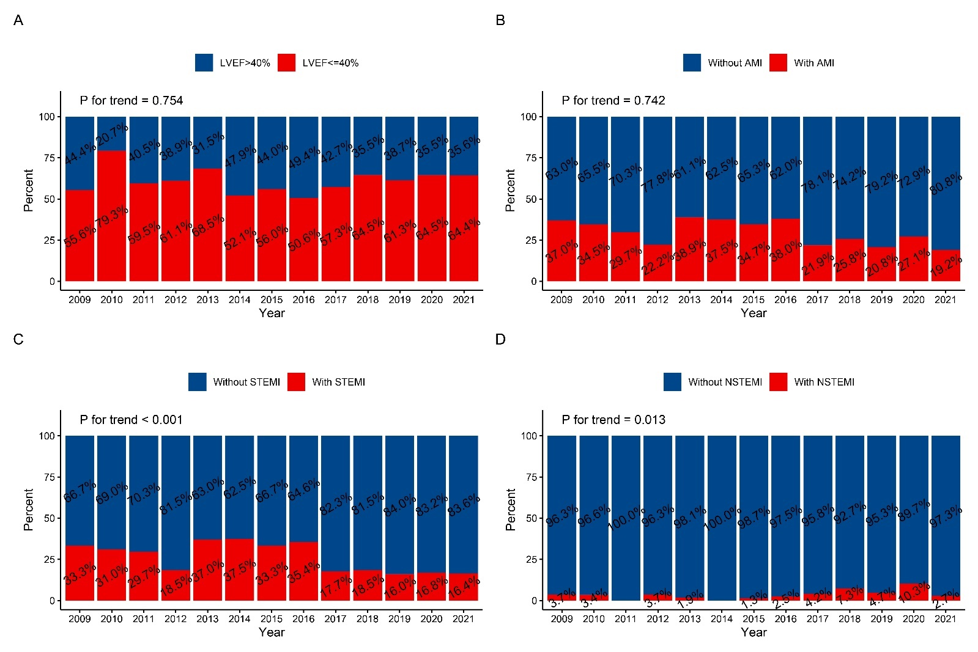Supplemental Figure 1 Time trends of etiologies among patients with LVT from 2009 to 2021. (A) Time trends of LVEF<=40%; (B) Time trends of AMI; (C) Time trends of STEMI; (D) Time trends of NSTEMI.
LVT=left ventricular thrombus. LVEF=left ventricular ejection fraction. AMI=acute myocardial infarction. STEMI=ST-segment elevation myocardial infarction. NSTEMI=non–ST-segment elevation myocardial infarction.

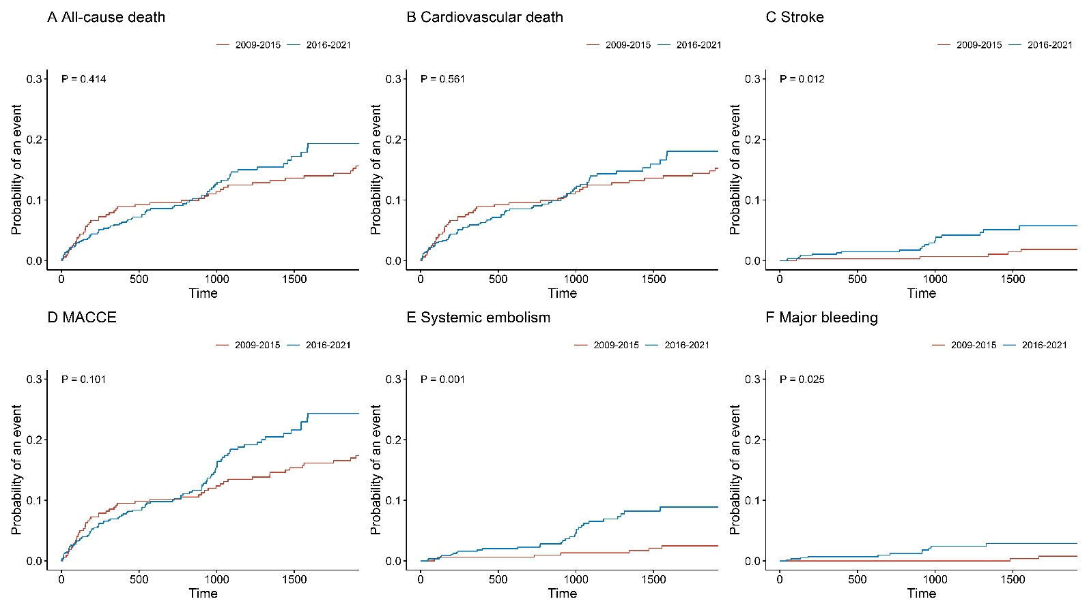
Supplemental Figure 2 Time-to-event curves according to discharge year.
MACCE=major adverse cardiac and cerebrovascular events.

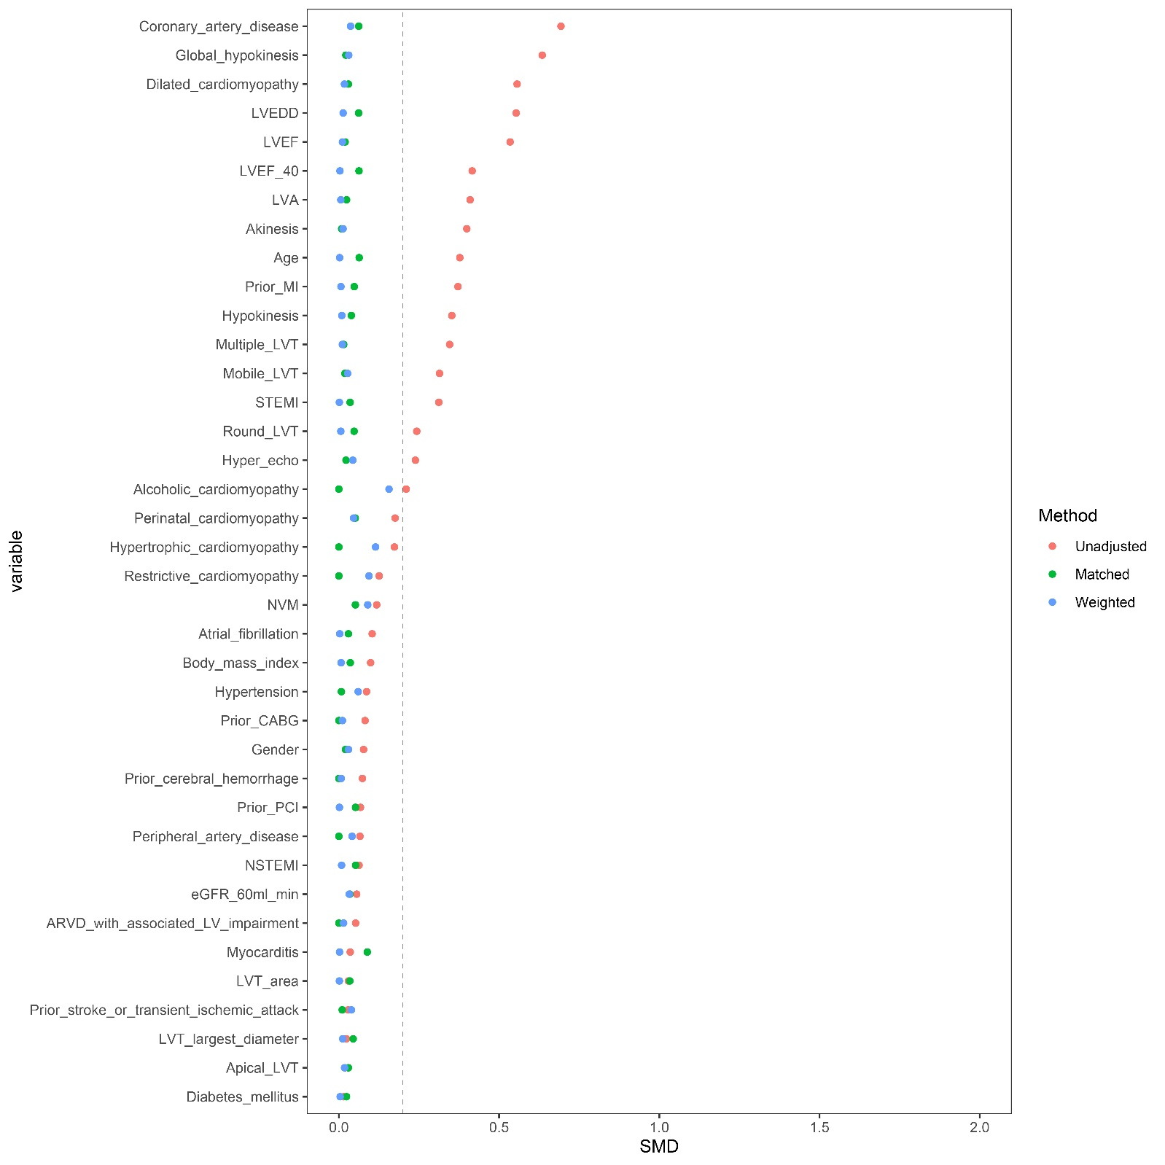Supplemental Figure 3 Standardized mean difference (SMD) between the 2 groups before and after propensity score matching and propensity score weight.
eGFR=estimated glomerular filtration rate. MI=myocardial infarction. CABG=coronary artery bypass grafting. PCI=percutaneous coronary intervention. STEMI=ST-segment elevation myocardial infarction. NSTEMI=non–ST-segment elevation myocardial infarction. ARVD=arrhythmogenic right ventricular dysplasia. LV=left ventricle. NVM=noncompaction of the ventricular myocardium. LVT=left ventricular thrombus. LVEDD=left ventricular end diastolic dimension. LVEF=left ventricular ejection fraction. LVA=left ventricle aneurysms.

