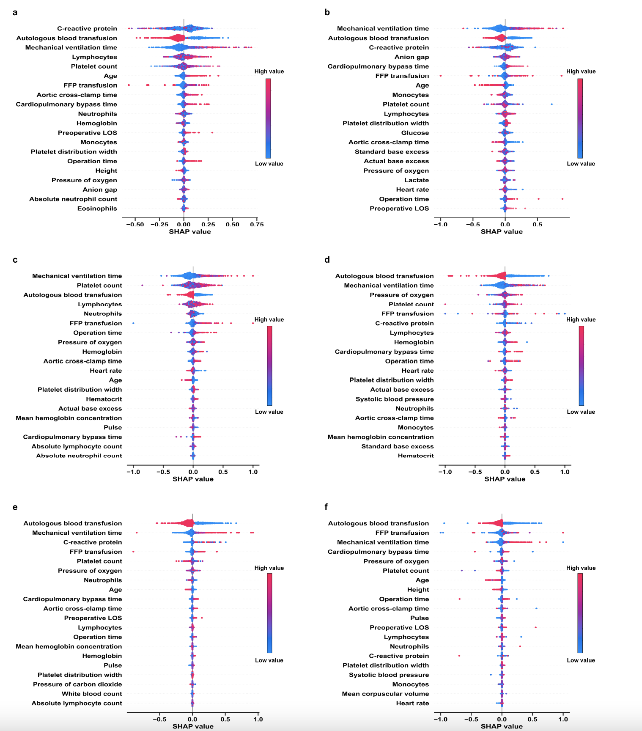
Supplementary Fig. 1. The 15 features with highest mean absolute SHAP values in perspective 1 at different time point, quoted from “A time-aware attention model for prediction of acute kidney injury after pediatric cardiac surgery” [19]. a. onset-6h; b. onset-12h; c. onset-24h; d. onset-48h; e. onset-72h; f. onset-168h. On the y axis, the violin plot shows the full distribution of the SHAP values for each feature. The dot plot in the foreground shows a color coding of the actual value of the feature, resulting in the SHAP value as indicated on the x axis. The color coding is based on the percentile of the feature value with respect to the whole distribution.

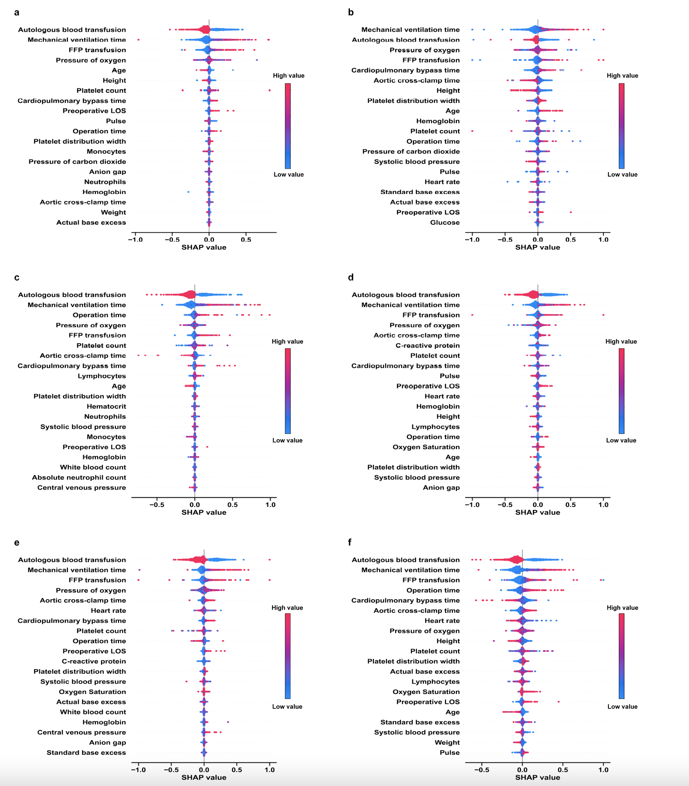
Supplementary Fig. 2. The 15 features with highest mean absolute SHAP values in perspective 2 at different time point, quoted from “A time-aware attention model for prediction of acute kidney injury after pediatric cardiac surgery” [19]. a. surgery+0h; b. surgery+6h; c. surgery+12h; d. surgery+24h; e. surgery+48h; f. surgery+72h. On the y axis, the violin plot shows the full distribution of the SHAP values for each feature. The dot plot in the foreground shows a color coding of the actual value of the feature, resulting in the SHAP value as indicated on the x axis. The color coding is based on the percentile of the feature value with respect to the whole distribution.

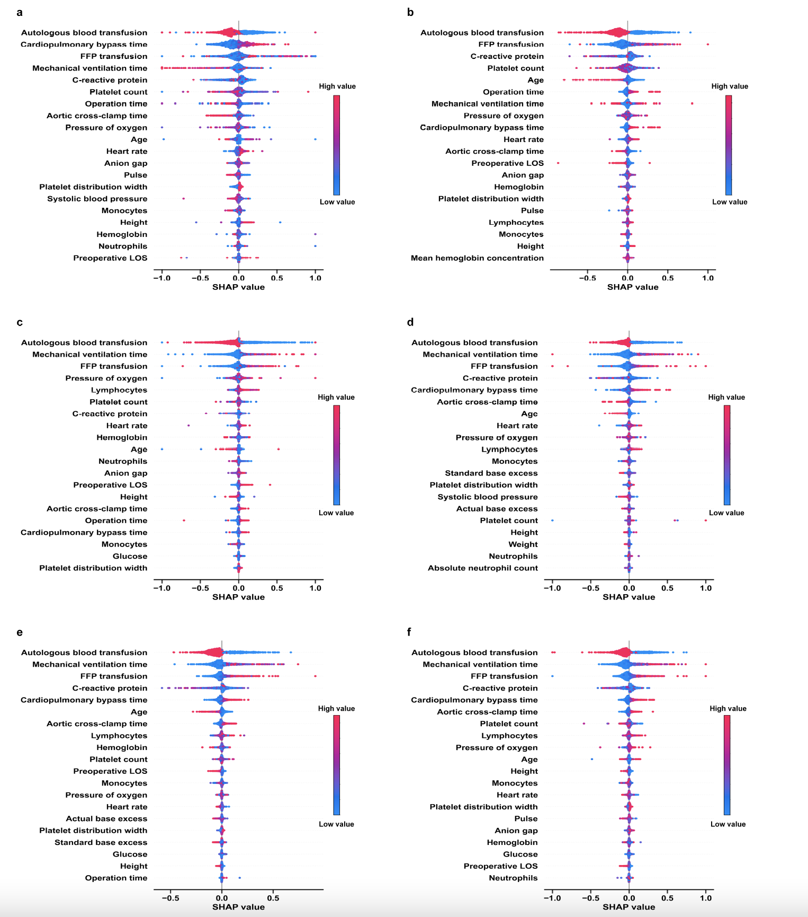

Supplementary Fig. 3. The 15 features with highest mean absolute SHAP values in perspective 3 with different time window, quoted from “A time-aware attention model for prediction of acute kidney injury after pediatric cardiac surgery” [19]. a. random+6h; b. random+12h; c. random+24h; d. random+48h; e. random+72h; e. random+168h. On the y axis, the violin plot shows the full distribution of the SHAP values for each feature. The dot plot in the foreground shows a color coding of the actual value of the feature, resulting in the SHAP value as indicated on the x axis. The color coding is based on the percentile of the feature value with respect to the whole distribution.

Supplementary Table 1
Feature Group (no. features) | Features
Patient characteristics (4) | Age, sex, height, weight
Preoperative conditions (5) | Preoperative length of stay, previous cardiac surgery, noncardiac malformation, other preoperative risk factors, preoperative oxygen saturation of right upper extremity
Intraoperative vital signs (8) | Systolic and diastolic arterial pressure, central venous pressure, heart rate, pulse, body temperature, oxygen saturation, respiratory rate
Arterial blood gas values (19) | Chloride, sodium, potassium, calcium, pH level, pressure of carbon dioxide, bicarbonate, standard base excess, hemoglobin, pressure of oxygen, hematocrit, carboxyhemoglobin, oxygen saturation, methemoglobin, standard bicarbonate, actual base excess, lactate, glucose, anion gap
Laboratory results (23) | Hematocrit, red blood count, platelet count, hemoglobin, white blood count, mean corpuscular volume, mean platelet volume, mean corpuscular hemoglobin, mean corpuscular hemoglobin concentration, red blood distribution width, platelet distribution width, eosinophils, absolute eosinophil count, neutrophils, absolute neutrophil count, lymphocytes, absolute lymphocyte count, monocytes, absolute monocyte count, basophils, absolute basophils count, plateletcrit, C-reactive protein
Surgery characteristics (35) | Elective, operation time, cardiopulmonary bypass time, aortic cross-clamp time, mechanical ventilation time, surgery diagnosis, surgery procedure, surgery risk scores including aristotle basic complexity score, RACHS-1 category, STS mortality score and STS morbidity score, number of operations, number of defects, pRBC transfusion during surgery, FFP transfusion during surgery, autologous blood transfusion during surgery, postoperative oxygen saturation of right upper limb
The table lists all the variables used in our experiments, including patient characteristics, intraoperative vital signs, laboratory results and so on. RACHS-1: risk adjustment for congenital heart surgery, STS: society of thoracic surgeons, pRBC: packed red blood cells, FFP: fresh frozen plasma.

Supplementary Table 2. Features compared between non- ABT and ABT groups
features | all | Non-autotransfusion | autotransfusion | P-value
Patient population | 3386 | 587 | 2799
Intraoperative vital signs  systolic pressure (mmHg)  diastolic pressure (mmHg)  central venous pressure (cmH2O)  body temperature (℃)  heart rate (bpm)  pulse (bpm)  respiratory rate (bpm)  oxygen saturation (%) | 78.4 [76.0,88.6]  47.3 (7.1)  9.1 (5.2)  35.4 [35.1,35.7]  131.5 [125.0,145.7]  135.2 [127.0,151.1]  24.0 [23.6,26.4]  99.0 [97.4,99.1] | 81.5 [76.0,90.3]  47.4 (5.7)  9.6 (6.2)  35.4 [34.8,35.7]  135.6 [125.0,147.4]  140.1 [127.0,153.3]  24.4 [23.1,27.0]  98.7 [96.4,99.2] | 77.7 [76.0,88.2]  47.3 (7.4)  9.0 (5.0)  35.4 [35.2,35.7]  130.1 [125.0,145.1]  133.9 [127.0,150.5]  24.0 [23.7,26.3]  99.0 [97.6,99.1] | 0.022  0.856  0.047  0.002  <0.001  <0.001  0.203  0.004
Arterial blood gas values  chloridion Cl⁻ (mM)  sodion Na⁺ (mM)  potassium K⁺ (mM)  pH level  pressure of carbon dioxide (mmHg)  bicarbonate (mM)  standard base excess (mM)  hemoglobin (g/L)  pressure of oxygen (mmHg)  hematokrit (%)  carboxyhemoglobin (%)  oxygen saturation (%)  methemoglobin (%)  standard bicarbonate radical (mM)  calcium Ca²⁺ (mM)  actual base excess (mM)  lactate (mM)  glucose (mM)  anion gap (mM) | 108.7 (4.0)  136.8 (3.2)  3.8 (0.4)  7.4 (0.1)  36.3 [33.5,39.8]  22.6 (2.6)  -1.6 (2.7)  113.1 (19.3)  177.3 [134.5,202.5]  34.9 (5.8)  1.1 (0.4)  99.1 [98.2,99.5]  1.1 [0.9,1.3]  23.3 (2.2)  1.2 (0.1)  -1.4 (2.6)  1.3 [0.9,1.9]  5.8 [5.2,6.7]  7.9 (3.8) | 108.7 (3.9)  136.7 (3.2)  3.7 (0.4)  7.4 (0.1)  36.4 [33.5,39.7]  22.7 (2.5)  -1.5 (2.6)  114.2 (19.9)  174.9 [129.2,202.2]  35.2 (6.0)  1.1 (0.4)  99.1 [98.1,99.6]  1.0 [0.8,1.2]  23.3 (2.2)  1.2 (0.1)  -1.3 (2.6)  1.3 [0.9,1.9]  5.8 [5.2,6.7]  8.0 (4.0) | 108.7 (4.0)  136.9 (3.2)  3.8 (0.4)  7.4 (0.1)  36.3 [33.5,39.8]  22.5 (2.6)  -1.6 (2.7)  112.9 (19.2)  177.8 [135.9,202.8]  34.8 (5.8)  1.1 (0.4)  99.1 [98.2,99.5]  1.1 [0.9,1.3]  23.2 (2.2)  1.2 (0.1)  -1.4 (2.6)  1.3 [0.9,1.9]  5.8 [5.2,6.7]  7.9 (3.7) | 0.947  0.181  0.424  0.514  0.782  0.334  0.277  0.148  0.241  0.153  0.428  0.145  <0.001  0.319  0.199  0.320  0.941  0.861  0.382
Laboratory results  Hematokrit (%)  red blood cell count (10^12/L)  platelet count (10^9/L)  hemoglobin (g/L)  white blood cell count (10^9/L)  mean corpuscular volume (fL)  mean hemoglobin concentration (g/L)  mean corpuscular hemoglobin (pg)  red blood cell distribution width (%)  eosinophil (10^9/L)  neutrophil (10^9/L)  lymphocyte (10^9/L)  monocyte (10^9/L)  basophilic granulocyte (10^9/L)  platelet distribution width (%)  mean platelet volume (fL)  thrombocytocrit (%)  absolute eosinophil count (10^9/L)  absolute basophil count (10^9/L)  absolute monocyte count (10^9/L)  absolute lymphocyte count (10^9/L)  absolute neutrophil count (10^9/L)  high-sensitivity C-reactive protein (mg/L) | 35.9 [33.7,38.4]  4.4 [4.1,4.7]  320.7 (97.4)  118.5 [109.6,126.9]  9.1 [7.5,11.2]  83.5 (8.1)  328.7 (13.4)  27.5 (3.1)  13.4 [12.7,14.6]  2.2 [1.3,3.5]  33.4 [25.7,44.4]  56.2 [45.2,64.3]  6.2 [5.0,7.8]  0.4 [0.3,0.6]  11.5 [9.7,15.4]  9.6 (1.1)  0.3 (0.1)  0.3 (0.2)  0.0 [0.0,0.1]  0.6 [0.4,0.8]  4.8 [3.5,6.2]  3.1 [2.3,4.3]  2.0 [1.0,4.0] | 36.2 [34.1,38.9]  4.4 [4.1,4.7]  317.3 (93.9  120.2 [111.5,128.4]  9.2 [7.6,11.3]  83.7 (8.4)  328.6 (14.1)  27.5 (3.2)  13.4 [12.7,14.7]  2.2 [1.2,3.6]  34.9 [26.8,46.2]  55.1 [44.0,63.8]  6.2 [4.9,7.6]  0.5 [0.3,0.7]  13.0 [10.4,15.7]  9.5 (1.1)  0.3 (0.1)  0.3 (0.2)  0.0 [0.0,0.1]  0.6 [0.4,0.7]  4.6 [3.5,6.1]  3.2 [2.4,4.4]  2.4 [1.0,4.9] | 35.8 [33.5,38.3]  4.4 [4.0,4.7]  321.4 (98.1)  118.2 [109.2,126.6]  9.1 [7.5,11.1]  83.5 (8.0)  328.7 (13.3)  27.5 (3.1)  13.4 [12.7,14.6]  2.2 [1.3,3.5]  33.1 [25.6,44.1]  56.4 [45.5,64.4]  6.3 [5.1,7.9]  0.4 [0.3,0.6]  11.3 [9.6,15.4]  9.6 (1.1)  0.3 (0.1)  0.3 (0.2)  0.0 [0.0,0.1]  0.6 [0.4,0.8]  4.8 [3.5,6.3]  3.1 [2.3,4.2]  1.9 [1.0,3.8] | 0.003  0.018  0.350  0.002  0.777  0.551  0.9  0.675  0.53  0.871  0.017  0.053  0.04  <0.001  <0.001  0.011  0.098  0.483  <0.001  0.057  0.317  0.052  <0.001
Demographics  Age(months)  Gender  female  male  Height(cm)  Weight(kg) | 11.9 [4.5,28.9]  1714 (50.6%)  1672 (49.4%)  73.0 [62.0,91.0]  8.6 [5.8,12.5] | 10.0 [4.6,25.7]  293 (49.9%)  294 (50.1%)  71.0 [61.0,89.0]  8.3 [5.6,12.0] | 12.2 [4.5,29.7]  1421 (50.8%)  1378 (49.2%)  73.5 [62.0,92.0]  8.8 [5.9,12.5] | 0.167  0.741  0.100  0.191
Intraop/postop variables  Operation time(mins)  Operation condition  selective operation  emergency operation  Cardiopulmonary bypass time(mins)  Cross clamp time (mins)  Mechanical ventilation time (hours)  pRBC transfusion during surgery (units)  FFP transfusion during surgery (ml/kg)  ABT during surgery (ml/kg) | 125.0 [108.0,156.0]  3341 (98.7%)  45 (1.3%)  60.0 [48.0,82.0]  40.0 [28.0,55.0]  7.0 [4.0,22.0]  1.0 [1.0,2.0]  17.6 [12.5,30.4]  12.5 [7.4,19.8] | 122.0 [106.0,156.0]  577 (98.3%)  10 (1.7%)  60.0 [48.0,83.0]  40.0 [28.5,55.0]  17.0 [4.0,25.0]  1.0 [1.0,2.0]  21.4 [13.8,43.1]  0.0 [0.0,0.0] | 126.0 [109.0,155.5]  2764 (98.7%)  35 (1.3%)  60.0 [48.0,82.0]  40.0 [28.0,55.0]  7.0 [4.0,22.0]  1.0 [1.0,2.0]  17.1 [12.2,28.3]  14.5 [10.2,21.6] | 0.212  0.501  0.811  0.911  <0.001  0.01  <0.001  <0.001
PreSpO2 of right upper limb (%) | 98.0 [96.0,99.0] | 98.0 [96.0,99.0] | 98.0 [96.0,99.0] | 0.006
PostSpO2 of right upper limb (%) | 98.0 [97.0,99.0] | 98.0 [97.0,99.0] | 98.0 [97.0,99.0] | 0.852
Number of previous congenital heart surgery  0  1  2 | 3332 (98.4%)  51 (1.5%)  3 (0.1%) | 572 (97.4%)  15 (2.6%)  0 (0.0%) | 2760 (98.6%)  36 (1.3%)  3 (0.1%) | 0.053
Other preoperative risk factors  none  have | 2817 (83.2)  569 (16.8) | 511 (87.1)  76 (12.9) | 2306 (82.4)  493 (17.6) | 0.007
Other malformation  none  have | 3179 (93.9%)  207 (6.1%) | 561 (95.6%)  26 (4.4%) | 2618 (93.5%)  181 (6.5%) | 0.075
RACHS-1 category  1  2  3  4 | 850 (25.1%)  2038 (60.2%)  423 (12.5%)  75 (2.2%) | 131 (22.3%)  352 (60.0%)  89 (15.2%)  15 (2.6%) | 719 (25.7%)  1686 (60.2%)  334 (11.9%)  60 (2.1%) | 0.085
Aristotle basic complexity score | 6.0 [5.6,6.0] | 6.0 [6.0,6.8] | 6.0 [5.0,6.0] | 0.003
STS mortality score | 0.2 [0.2,0.4] | 0.3 [0.2,0.4] | 0.2 [0.2,0.4] | 0.022
STS morbidity score | 0.7 [0.5,1.1] | 0.7 [0.5,1.1] | 0.7 [0.5,1.1] | 0.005
Number of major operations  1  2  3  4  5  6 | 1228 (36.3%)  1173 (34.6%)  754 (22.3%)  194 (5.7%)  33 (1.0%)  4 (0.1%) | 193 (32.9%)  218 (37.1%)  145 (24.7%)  24 (4.1%)  5 (0.9%)  2 (0.3%) | 1035 (37.0%)  955 (34.1%)  609 (21.8%)  170 (6.1%)  28 (1.0%)  2 (0.1%) | 0.037
Number of defects  1  2  3  4  5  6  7 | 1189 (35.1%)  1091 (32.2%)  782 (23.1%)  253 (7.5%)  51 (1.5%)  19 (0.6%)  1 (0.0%) | 181 (30.8%)  186 (31.7%)  148 (25.2%)  54 (9.2%)  13 (2.2%)  4 (0.7%)  1 (0.2%) | 1008 (36.0%)  905 (32.3%)  634 (22.7%)  199 (7.1%)  38 (1.4%)  15 (0.5%)  0 (0.0%) | 0.018
Preoperative length of stay (days) | 4.0 [2.0,7.0] | 5.0 [3.0,8.0] | 4.0 [2.0,7.0] | <0.001
Surgery procedure  Tricuspid valve plasty  none  have  TOF repair, ventriculotomy, transannular patch  none  have  Arterial switch operation  none  have  Mitral valve plasty  none  have  TAPVC repair  none  have  PDA closure  none  have  PFO, primary closure  none  have  VSD repair, primary closure  none  have  VSD repair, patch  none  have  ASD repair, patch  none  have  ASD repair, primary closure  none  have  Partial atrioventricular passageway repair  none  have | 3243 (95.8%)  143 (4.2%)  3276 (96.8%)  110 (3.2%)  3336 (98.5%)  50 (1.5%)  3249 (96.0%)  137 (4.0%)  3297 (97.4%)  89 (2.6%)  2533 (74.8%)  853 (25.2%)  2587 (76.4%)  799 (23.6%)  3011 (88.9%)  375 (11.1%)  1856 (54.8%)  1530 (45.2%)  2451 (72.4%)  935 (27.6%)  2650 (78.3%)  736 (21.7%)  3326 (98.2%)  60 (1.8%) | 553 (94.2%)  34 (5.8%)  565 (96.3%)  22 (3.7%)  577 (98.3)  10 (1.7%)  554 (94.4%)  33 (5.6%)  571 (97.3%)  16 (2.7%)  440 (75.0%)  147 (25.0%)  423 (72.1%)  164 (27.9%)  524 (89.3%)  63 (10.7%)  310 (52.8%)  277 (47.2%)  462 (78.7%)  125 (21.3%)  455 (77.5%)  132 (22.5%)  576 (98.1%)  11 (1.9%) | 2690 (96.1%)  109 (3.9%)  2711 (96.9%)  88 (3.1%)  2759 (98.6)  40 (1.4%)  2695 (96.3%)  104 (3.7%)  2726 (97.4%)  73 (2.6%)  2093 (74.8%)  706 (25.2%)  2164 (77.3%)  635 (22.7%)  2487 (88.9%)  312 (11.1%)  1546 (55.2%)  1253 (44.8%)  1989 (71.1%)  810 (28.9%)  2195 (78.4%)  604 (21.6%)  2750 (98.2%)  49 (1.8%) | 0.049  0.534  0.754  0.044  0.984  0.969  0.008  0.827  0.304  <0.001  0.667  0.973
Surgery diagnosis  TOF  none  have  CoA  none  have  PDA  none  have  PFO  none  have  VSD, type 1  none  have  VSD, type 2  none  have  ASD, primum  none  have  ASD, secundum  none  have | 3234 (95.5%)  152 (4.5%)  3294 (97.3%)  92 (2.7%)  2530 (74.7%)  856 (25.3%)  2577 (76.1%)  809 (23.9%)  2893 (85.4%)  493 (14.6%)  2021 (59.7%)  1365 (40.3%)  3328 (98.3%)  58 (1.7%)  1711 (50.5%)  1675 (49.5%) | 559 (95.2%)  28 (4.8%)  568 (96.8%)  19 (3.2%)  435 (74.1%)  152 (25.9%)  419 (71.4%)  168 (28.6%)  506 (86.2%)  81 (13.8%)  330 (56.2%)  257 (43.8%)  576 (98.1%)  11 (1.9%)  323 (55.0%)  264 (45.0%) | 2675 (95.6%)  124 (4.4%)  2726 (97.4%)  73 (2.6%)  2095 (74.8%)  704 (25.2%)  2158 (77.1%)  641 (22.9%)  2387 (85.3%)  412 (14.7%)  1691 (60.4%)  1108 (39.6%)  2752 (98.3%)  47 (1.7%)  1388 (49.6%)  1411 (50.4%) | 0.801  0.476  0.746  0.004  0.61  0.066  0.876  0.019
AKI  none  have | 3055 (90.2)  331 (9.8) | 439 (74.8)  148 (25.2) | 2616 (93.5)  183 (6.5) | <0.001
Data are presented as median (interquartile range) or mean (standard deviation) or number (%). PreSpO2: preoperative oxygen saturation, PostSpO2: postoperative oxygen saturation, pRBC: packed red blood cell, FFP: fresh frozen plasma, ABT: autologous blood transfusion, RACHS-1: risk adjustment for congenital heart surgery, STS: society of thoracic surgeons, TOF: tetralogy of fallot, TAPVC: total anomalous pulmonary venous connection, PDA: patent ductus arteriosus, PFO: patent foramen ovale, VSD: ventricular septal defect, ASD: atrial septal defect, CoA: coarctation of the aorta. Chi-squared tests for the following variables may be invalid due to the low number of observations: Number of previous congenital heart surgery, RACHS-1 category, Number of major operations, Number of defects.

Supplementary Table 3. Features compared between non- AKI and AKI groups
features | all | Non-AKI | AKI | P-value
Patient population | 3386 | 3055 | 331
Intraoperative vital signs  systolic pressure (mmHg)  diastolic pressure (mmHg)  central venous pressure (cmH2O)  body temperature (℃)  heart rate (bpm)  pulse (bpm)  respiratory rate (bpm)  oxygen saturation (%) | 78.4 [76.0,88.6]  47.3 (7.1)  9.1 (5.2)  35.4 [35.1,35.7]  131.5 [125.0,145.7]  135.2 [127.0,151.1]  24.0 [23.6,26.4]  99.0 [97.4,99.1] | 78.4 [76.0,88.7]  47.3 (7.2)  9.1 (5.2)  35.4 [35.1,35.7]  131.2 [125.0,145.6]  134.8 [127.0,150.7]  24.0 [23.6,26.2]  99.0 [97.6,99.2] | 78.3 [73.6,87.8]  47.3 (6.2)  9.5 (5.2)  35.3 [34.8,35.6]  134.6 [125.0,147.8]  138.3 [127.0,154.3]  24.8 [23.1,27.8]  98.3 [95.6,99.1] | 0.058  0.918  0.227  <0.001  0.147  0.137  0.008  <0.001
Arterial blood gas values  chloridion Cl⁻ (mM)  sodion Na⁺ (mM)  potassium K⁺ (mM)  pH level  pressure of carbon dioxide (mmHg)  bicarbonate (mM)  standard base excess (mM)  hemoglobin (g/L)  pressure of oxygen (mmHg)  hematokrit (%)  carboxyhemoglobin (%)  oxygen saturation (%)  methemoglobin (%)  standard bicarbonate radical (mM)  calcium Ca²⁺ (mM)  actual base surplus (mM)  lactate (mM)  glucose (mM)  anion gap (mM) | 108.7 (4.0)  136.8 (3.2)  3.8 (0.4)  7.4 (0.1)  36.3 [33.5,39.8]  22.6 (2.6)  -1.6 (2.7)  113.1 (19.3)  177.3 [134.5,202.5]  34.9 (5.8)  1.1 (0.4)  99.1 [98.2,99.5]  1.1 [0.9,1.3]  23.3 (2.2)  1.2 (0.1)  -1.4 (2.6)  1.3 [0.9,1.9]  5.8 [5.2,6.7]  7.9 (3.8) | 108.7 (4.0)  136.8 (3.2)  3.8 (0.4)  7.4 (0.0)  36.3 [33.5,39.7]  22.5 (2.6)  -1.6 (2.6)  112.7 (18.6)  178.1 [137.8,202.9]  34.8 (5.6)  1.1 (0.4)  99.1 [98.3,99.5]  1.1 [0.9,1.3]  23.2 (2.2)  1.2 (0.1)  -1.4 (2.6)  1.3 [0.9,1.8]  5.8 [5.2,6.7]  7.9 (3.8) | 108.4 (4.1)  136.7 (3.3)  3.8 (0.4)  7.4 (0.1)  36.7 [33.9,41.0]  22.9 (2.8)  -1.3 (2.9)  116.7 (24.1)  166.8 [94.0,200.6]  36.0 (7.3)  1.1 (0.4)  98.9 [94.8,99.5]  1.0 [0.8,1.2]  23.4 (2.4)  1.2 (0.1)  -1.2 (2.9)  1.4 [1.0,2.2]  5.9 [5.2,6.8]  8.0 (3.9) | 0.191  0.474  0.168  0.355  0.069  0.048  0.13  0.004  0.001  0.004  0.58  0.002  <0.001  0.249  0.002  0.263  <0.001  0.136  0.591
Laboratory results  hematokrit (%)  red blood cell count (10^12/L)  platelet count (10^9/L)  hemoglobin (g/L)  white blood cell count (10^9/L)  mean corpuscular volume (fL)  mean hemoglobin concentration (g/L)  mean corpuscular hemoglobin (pg)  red blood cell distribution width (%)  eosinophil (10^9/L)  neutrophil (10^9/L)  lymphocyte (10^9/L)  monocyte (10^9/L)  basophilic granulocyte (10^9/L)  platelet distribution width (%)  mean platelet volume (fL)  thrombocytocrit (%)  absolute eosinophil count (10^9/L)  absolute value of basophils (10^9/L)  absolute value of monocytes (10^9/L)  absolute lymphocyte count (10^9/L)  absolute neutrophil count (10^9/L)  high-sensitivity C-reactive protein (mg/L) | 35.9 [33.7,38.4]  4.4 [4.1,4.7]  320.7 (97.4)  118.5 [109.6,126.9]  9.1 [7.5,11.2]  83.5 (8.1)  328.7 (13.4)  27.5 (3.1)  13.4 [12.7,14.6]  2.2 [1.3,3.5]  33.4 [25.7,44.4]  56.2 [45.2,64.3]  6.2 [5.0,7.8]  0.4 [0.3,0.6]  11.5 [9.7,15.4]  9.6 (1.1)  0.3 (0.1)  0.3 (0.2)  0.0 [0.0,0.1]  0.6 [0.4,0.8]  4.8 [3.5,6.2]  3.1 [2.3,4.3]  2.0 [1.0,4.0] | 35.9 [33.6,38.3]  4.4 [4.1,4.7]  322.2 (97.4)  118.3 [109.5,126.7]  9.1 [7.5,11.1]  83.3 (7.9)  328.7 (13.2)  27.4 (3.0)  13.4 [12.7,14.5]  2.2 [1.3,3.5]  33.2 [25.7,43.7]  56.4 [45.9,64.4]  6.2 [5.0,7.8]  0.4 [0.3,0.6]  11.4 [9.7,15.4]  9.6 (1.1)  0.3 (0.1)  0.3 (0.2)  0.0 [0.0,0.1]  0.6 [0.4,0.8]  4.8 [3.6,6.3]  3.1 [2.3,4.2]  1.9 [1.0,3.9] | 36.2 [34.1,39.4]  4.4 [4.0,4.6]  306.5 (96.5)  120.0 [110.7,129.6]  9.3 [7.7,11.6]  85.4 (9.8)  328.3 (14.9)  28.1 (3.7)  13.7 [12.7,15.2]  1.9 [1.1,3.2]  37.2 [27.4,51.2]  52.0 [39.2,62.4]  6.4 [5.1,8.3]  0.4 [0.3,0.7]  13.5 [10.4,15.7]  9.7 (1.2)  0.3 (0.1)  0.2 (0.2)  0.0 [0.0,0.1]  0.6 [0.4,0.8]  4.6 [3.3,5.9]  3.4 [2.5,5.0]  2.7 [1.3,5.4] | 0.018  0.410  0.005  0.014  0.213  <0.001  0.597  0.001  0.004  0.008  <0.001  <0.001  0.092  0.034  <0.001  0.297  0.006  0.086  0.022  0.146  0.005  <0.001  <0.001
Demographics  Age(months)  Gender  female  male  Height(cm)  Weight(kg) | 11.9 [4.5,28.9]  1714 (50.6%)  1672 (49.4%)  73.0 [62.0,91.0]  8.6 [5.8,12.5] | 12.6 [5.1,30.6]  1556 (50.9%)  1499 (49.1%)  74.0 [63.0,92.0]  9.0 [6.0,12.9] | 5.6 [1.9,15.3]  158 (47.7%)  173 (52.3%)  64.0 [55.0,78.0]  6.3 [4.3,9.6] | <0.001  0.295  <0.001  <0.001
Intraop/postop variables  Operation time(mins)  Operation condition  selective operation  emergency operation  Cardiopulmonary bypass time(mins)  Cross clamp time (mins)  Mechanical ventilation time (hours)  pRBC transfusion during surgery (units)  FFP transfusion during surgery (ml/kg)  ABT during surgery (ml/kg) | 125.0 [108.0,156.0]  3341 (98.7%)  45 (1.3%)  60.0 [48.0,82.0]  40.0 [28.0,55.0]  7.0 [4.0,22.0]  1.0 [1.0,2.0]  17.6 [12.5,30.4]  12.5 [7.4,19.8] | 123.0 [107.0,150.5]  3027 (99.1%)  28 (0.9%)  59.0 [47.0,78.0]  39.0 [28.0,53.0]  6.0 [4.0,21.0]  1.0 [1.0,1.5]  16.9 [12.2,27.3]  12.6 [8.0,19.3] | 148.0 [119.0,207.0]  314 (94.9%)  17 (5.1%)  85.0 [59.0,133.5]  53.0 [38.5,91.0]  24.0 [16.0,90.0]  2.0 [1.0,3.0]  39.7 [17.6,81.1]  10.0 [0.0,24.0] | <0.001  <0.001  <0.001  <0.001  <0.001  <0.001  <0.001  0.001
PreSpO2 of right upper limb (%) | 98.0 [96.0,99.0] | 98.0 [97.0,99.0] | 97.0 [91.5,98.0] | <0.001
PostSpO2 of right upper limb (%) | 98.0 [97.0,99.0] | 98.0 [97.0,99.0] | 98.0 [97.0,99.0] | 0.048
Number of previous congenital heart surgery  0  1  2 | 3332 (98.4%)  51 (1.5%)  3 (0.1%) | 3013 (98.6%)  39 (1.3%)  3 (0.1%) | 319 (96.4%)  12 (3.6%)  0(0.0%) | 0.003
Other preoperative risk factors  none  have | 2817 (83.2%)  569 (16.8%) | 2572 (84.2%)  483 (15.8%) | 245 (74.0%)  86 (26.0%) | <0.001
Other malformation  none  have | 3179 (93.9%)  207 (6.1%) | 2879 (94.2%)  176 (5.8%) | 300 (90.6%)  31 (9.4%) | 0.013
RACHS-1 category  1  2  3  4 | 850 (25.1%)  2038 (60.2%)  423 (12.5%)  75 (2.2%) | 808 (26.4%)  1843 (60.3%)  353 (11.6%)  51 (1.7%) | 42 (12.7%)  195 (58.9%)  70 (21.1%)  24 (7.3%) | <0.001
Aristotle basic complexity score | 6.0 [5.6,6.0] | 6.0 [4.0,6.0] | 6.0 [6.0,8.7] | <0.001
STS mortality score | 0.2 [0.2,0.4] | 0.2 [0.2,0.4] | 0.4 [0.2,0.7] | <0.001
STS morbidity score | 0.7 [0.5,1.1] | 0.7 [0.5,1.1] | 1.1 [0.6,1.3] | <0.001
Number of major operations  1  2  3  4  5  6 | 1228 (36.3%)  1173 (34.6%)  754 (22.3%)  194 (5.7%)  33 (1.0%)  4 (0.1%) | 1162 (38.0%)  1069 (35.0%)  632 (20.7%)  167 (5.5%)  24 (0.8%)  1 (0.0%) | 66 (19.9%)  104 (31.4%)  122 (36.9%)  27 (8.2%)  9 (2.7%)  3 (0.9%) | <0.001
Number of defects  1  2  3  4  5  6  7 | 1189 (35.1%)  1091 (32.2%)  782 (23.1%)  253 (7.5%)  51 (1.5%)  19 (0.6%)  1 (0.0%) | 1130 (37.0%)  1001 (32.8%)  656 (21.5%)  215 (7.0%)  39 (1.3%)  14 (0.5%)  0 (0.0%) | 59 (17.8%)  90 (27.2%)  126 (38.1%)  38 (11.5%)  12 (3.6%)  5 (1.5%)  1 (0.3%) | <0.001
Preoperative length of stay (days) | 4.0 [2.0,7.0] | 4.0 [2.0,7.0] | 7.0 [4.0,11.0] | <0.001
Surgery procedure  Tricuspid valve plasty  none  have  TOF repair, ventriculotomy, transannular patch  none  have  Arterial switch operation  none  have  Mitral valve plasty  none  have  TAPVC repair  none  have  PDA closure  none  have  PFO, primary closure  none  have  VSD repair, primary closure  none  have  VSD repair, patch  none  have  ASD repair, patch  none  have  ASD repair, primary closure  none  have  Partial atrioventricular passageway repair  none  have | 3243 (95.8%)  143 (4.2%)  3276 (96.8%)  110 (3.2%)  3336 (98.5%)  50 (1.5%)  3249 (96.0%)  137 (4.0%)  3297 (97.4%)  89 (2.6%)  2533 (74.8%)  853 (25.2%)  2587 (76.4%)  799 (23.6%)  3011 (88.9%)  375 (11.1%)  1856 (54.8%)  1530 (45.2%)  2451 (72.4%)  935 (27.6%)  2650 (78.3%)  736 (21.7%)  3326 (98.2%)  60 (1.8%) | 2930 (95.9%)  125 (4.1%)  2968 (97.2%)  87 (2.8%)  3023 (99.0%)  32 (1.0%)  2936 (96.1%)  119 (3.9%)  2985 (97.7%)  70 (2.3%)  2342 (76.7%)  713 (23.3%)  2336 (76.5%)  719 (23.5%)  2708 (88.6%)  347 (11.4%)  1660 (54.3%)  1395 (45.7%)  2188 (71.6%)  867 (28.4%)  2410 (78.9%)  645 (21.1%)  3001 (98.2%)  54 (1.8%) | 313 (94.6%)  18 (5.4%)  308 (93.1%)  23 (6.9%)  313 (94.6%)  18 (5.4%)  313 (94.6%)  18 (5.4%)  312 (94.3%)  19 (5.7%)  191 (57.7%)  140 (42.3%)  251 (75.8%)  80 (24.2%)  303 (91.5%)  28 (8.5%)  196 (59.2%)  135 (40.8%)  263 (79.5%)  68 (20.5%)  240 (72.5%)  91 (27.5%)  325 (98.2%)  6 (1.8%) | 0.311  <0.001  <0.001  0.228  <0.001  <0.001  0.849  0.132  0.102  0.003  0.009  0.873
Surgery diagnosis  TOF  none  have  CoA  none  have  PDA  none  have  PFO  none  have  VSD, type 1  none  have  VSD, type 2  none  have  ASD, primum  none  have  ASD, secundum  none  have | 3234 (95.5%)  152 (4.5%)  3294 (97.3%)  92 (2.7%)  2530 (74.7%)  856 (25.3%)  2577 (76.1%)  809 (23.9%)  2893 (85.4%)  493 (14.6%)  2021 (59.7%)  1365 (40.3%)  3328 (98.3%)  58 (1.7%)  1711 (50.5%)  1675 (49.5%) | 2928 (95.8%)  127 (4.2%)  2991 (97.9%)  64 (2.1%)  2339 (76.6%)  716 (23.4%)  2329 (76.2%)  726 (23.8%)  2605 (85.3%)  450 (14.7%)  1810 (59.2%)  1245 (40.8%)  3002 (98.3%)  53 (1.7%)  1544 (50.5%)  1511 (49.5%) | 306 (92.4%)  25 (7.6%)  303 (91.5%)  28 (8.5%)  191 (57.7%)  140 (42.3%)  248 (74.9%)  83 (25.1%)  288 (87.0%)  43 (13.0%)  211 (63.7%)  120 (36.3%)  326 (98.5%)  5 (1.5%)  167 (50.5%)  164 (49.5%) | 0.007  <0.001  <0.001  0.643  0.441  0.127  0.94  0.978
Data are presented as median (interquartile range) or mean (standard deviation) or number (%). PreSpO2: preoperative oxygen saturation, PostSpO2: postoperative oxygen saturation, pRBC: packed red blood cell, FFP: fresh frozen plasma, ABT, autologous blood transfusion, RACHS-1: risk adjustment for congenital heart surgery, STS: society of thoracic surgeons, TOF: tetralogy of fallot, TAPVC: total anomalous pulmonary venous connection, PDA: patent ductus arteriosus, PFO: patent foramen ovale, VSD: ventricular septal defect, ASD: atrial septal defect, CoA: coarctation of the aorta. Chi-squared tests for the following variables may be invalid due to the low number of observations: Number of previous congenital heart surgery, RACHS-1 category, Number of major operations, Number of defects.

Supplementary Table 4. Classification of features
Feature Group (no. features) | Features
Confounders (20) | body temperature, oxygen saturation, methemoglobin, hematocrit, hemoglobin, neutrophil, basophilic granulocyte, platelet distribution width, absolute value of basophils, high-sensitivity C-reactive protein, PreSpO2 of right upper limb, Mechanical ventilation time, pRBC transfusion during surgery, FFP transfusion during surgery, Other preoperative risk factors, Aristotle basic complexity score, STS mortality score, STS morbidity score, ASD Repair and Patch, Preoperative length of stay
instrumental variables (12) | Systolic pressure, central venous pressure, heart rate, pulse, red blood cell count, monocyte, mean platelet volume, Tricuspid Valve Plasty, Mitral Valve Plasty, PFO and Primary Closure, PFO, ASD Secundum
effect modifiers (35) | Respiratory rate, bicarbonate, hemoglobin, pressure of oxygen, hematocrit, oxygen saturation, calcium Ca²⁺, lactate, platelet count, mean corpuscular volume, mean corpuscular hemoglobin, red blood cell distribution width, eosinophil, lymphocyte, thrombocytocrit, absolute lymphocyte count, absolute neutrophil count, Age, Height, Weight, PostSpO2 of right upper limb, Operation time, Operation condition, Cardiopulmonary bypass time, Cross clamp time, RACHS-1 category, Non-cardiac Malformation, TOF Repair Ventriculotomy and Transannular Patch, Arterial Switch Operation, TAPVC Repair, PDA Closure, ASD Repair and PrimaryClosure, TOF, CoA, PDA
This table lists the input features of the DoWhy model, divided into three categories: confounders, instrumental variables, and effect modifiers. Confounders mean characteristics associated with both autologous blood transfusion and AKI. Instrumental variables mean features associated with autologous blood transfusion only. effect modifiers mean features that are closely associated with AKI only. PreSpO2: preoperative oxygen saturation, PostSpO2: postoperative oxygen saturation, pRBC: packed red blood cell, FFP: fresh frozen plasma, RACHS-1: risk adjustment for congenital heart surgery, STS: society of thoracic surgeons, TOF: tetralogy of fallot, TAPVC: total anomalous pulmonary venous connection, PDA: patent ductus arteriosus, PFO: patent foramen ovale, VSD: ventricular septal defect, ASD: atrial septal defect, CoA: coarctation of the aorta. Chi-squared tests for the following variables may be invalid due to the low number of observations: Number of previous congenital heart surgery, RACHS-1 category, Number of major operations, Number of defects.

Supplementary Table 5. Univariate and multifactorial logistic regression analysis of ABT and confounders.
features | OR | 95%CI | P-value | Adjusted OR | 95%CI | P-value
Intraoperative vital signs  body temperature (℃)  oxygen saturation (%) | 0.938  0.977 | [0.935,0.942]  [0.976,0.978] | <0.001  <0.001 | 0.989  0.989 | [0.928,1.053]  [0.967,1.012] | 0.724  0.342
Arterial blood gas values  Methemoglobin (%) | 0.123 | [0.110,0.138] | <0.001 | 0.774 | [0.489,1.223] | 0.272
Laboratory results  Hematocrit (%)  hemoglobin (g/L)  neutrophil (10^9/L)  basophilic granulocyte (10^9/L)  platelet distribution width (%)  absolute value of basophils (10^9/L)  high-sensitivity C-reactive protein (mg/L) | 0.942  0.982  0.945  0.014  0.841  0.000  0.674 | [0.939,0.944]  [0.981,0.983]  [0.942,0.948]  [0.010,0.018]  [0.833,0.849]  [0.000,0.000]  [0.652,0.696] | <0.001  <0.001  <0.001  <0.001  <0.001  <0.001  <0.001 | 1.007  0.990  1.001  1.345  1.051  2.228  1.003 | [0.936,1.082]  [0.968,1.013]  [0.992,1.010]  [0.716,2.525]  [1.003,1.101]  [0.006,776.416]  [0.987,1.020] | 0.858  0.404  0.829  0.356  0.037  0.789  0.693
PreSpO2 of right upper limb | 0.977 | [0.976,0.978] | <0.001 | 0.985 | [0.968,1.002] | 0.076
Intraop/postop variables  Mechanical ventilation time (mins)  pRBC transfusion during surgery (units)  FFP transfusion during surgery (mL/kg)  ABT during surgery (mL/kg) | 0.992  0.491  0.9720.884 | [0.990,0.994]  [0.461,0.522]  [0.969,0.975]  [0.877,0.892] | <0.001  <0.001  <0.001  <0.001 | 1.003  1.219  1.007  0.964 | [0.999,1.006]  [1.115,1.333]  [1.003,1.010]  [0.954,0.975] | 0.108  <0.001  <0.001  <0.001
Aristotle basic complexity score | 0.715 | [0.702,0.728] | <0.001 | 1.053 | [0.938,1.182] | 0.384
STS mortality score | 0.022 | [0.016,0.029] | <0.001 | 0.479 | [0.235,0.977] | 0.043
STS morbidity score | 0.160 | [0.141,0.181] | <0.001 | 2.354 | [1.256,4.414] | 0.008
Preoperative length of stay (days) | 0.791 | [0.777,0.805] | <0.001 | 1.010 | [1.000,1.020] | 0.049
Other preoperative risk factors | 0.178 | [0.142,0.224] | <0.001 | 0.825 | [0.577,1.178] | 0.290
Surgery procedure  ASD repair, patch | 0.078 | [0.061,0.100] | <0.001 | 0.776 | [0.576,1.045] | 0.095
pRBC: packed red blood cell, FFP: fresh frozen plasma, ABT: autologous blood transfusion, PreSpO2: preoperative oxygen saturation, STS: society of thoracic surgeons, ASD: atrial septal defect.

