SUPPLEMENTAL MATERIALS
1.Supplemental Methods
The variables included in the model estimating propensity score are: age, gender, body mass index, hypertension, diabetes mellitus, eGFR<60ml/min/1.73m², peripheral artery disease, prior stroke, prior MI, prior CABG, prior PCI, prior cerebral hemorrhage, atrial fibrillation, coronary artery disease, STEMI, NSTEMI, dilated cardiomyopathy, hypertrophic cardiomyopathy, ARVD with associated LV impairment, perinatal cardiomyopathy, restrictive cardiomyopathy, alcoholic cardiomyopathy, myocarditis, aspirin, clopidogrel, ticagrelor, DAPT, VKA, rivaroxaban, dabigatran, DOAC, antiplatelet therapy only, anticoagulation only, aspirin with anticoagulant, clopidogrel with anticoagulant, ticagrelor with anticoagulant, dual antiplatelet therapy with anticoagulant, NVM, LVEDD, LVEF, LVEF<=40%, global hypokinesis, hypokinesis, akinesis, apical LVT, round LVT, mobile LVT, multiple LVT, calcified LVT, LVT largest diameter, LVT area, left ventricular aneurysm.

2.Supplemental Figures
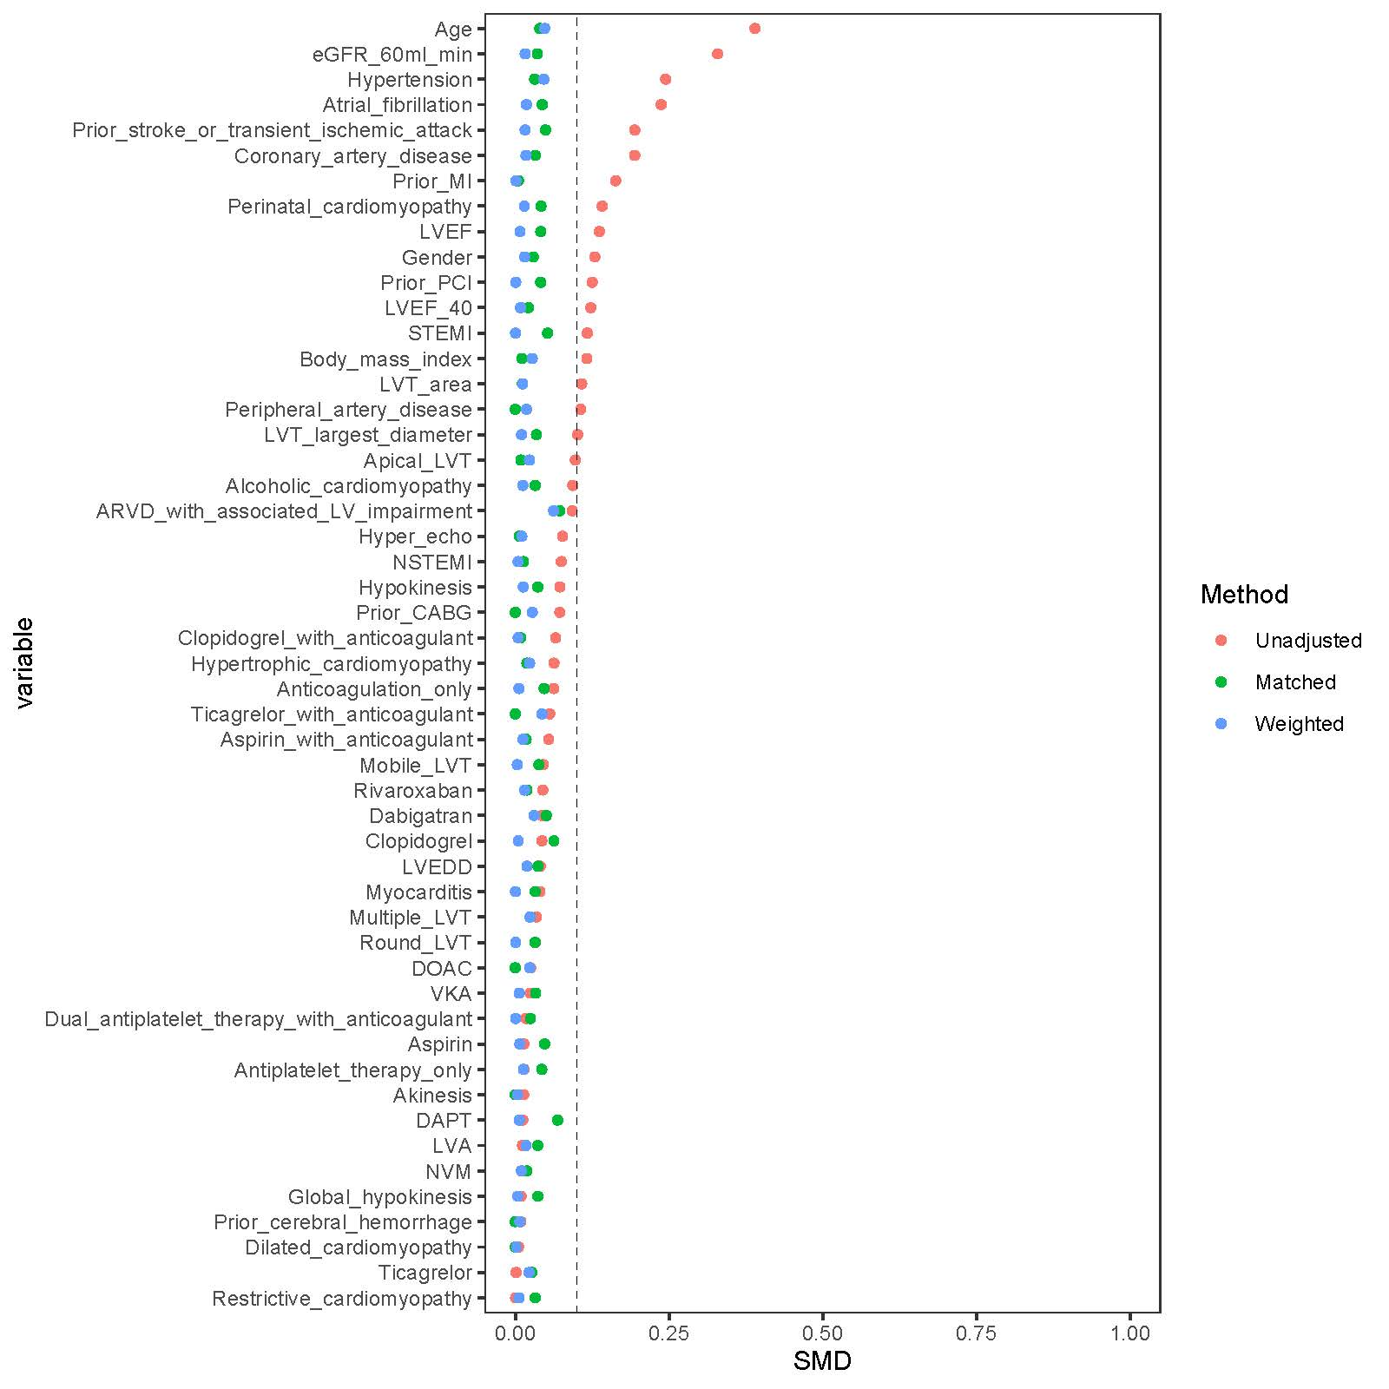
Supplemental Figure 1 Standardized mean difference (SMD) between the 2 groups before and after propensity score matching and propensity score weighting.
SMD=standard mean difference. eGFR=estimated glomerular filtration rate. MI=myocardial infarction. CABG=coronary artery bypass grafting. PCI=percutaneous coronary intervention. STEMI=ST-segment elevation myocardial infarction. NSTEMI=non-ST-segment elevation myocardial infarction. ARVD=arrhythmogenic right ventricular dysplasia. NVM=noncompaction of the ventricular myocardium. DAPT=dual antiplatelet therapy. VKA=vitamin-K antagonists. DOAC=direct oral anticoagulants. LVEDD=left ventricular end diastolic dimension. LVEF=left ventricular ejection fraction. LVT=left ventricular thrombus.

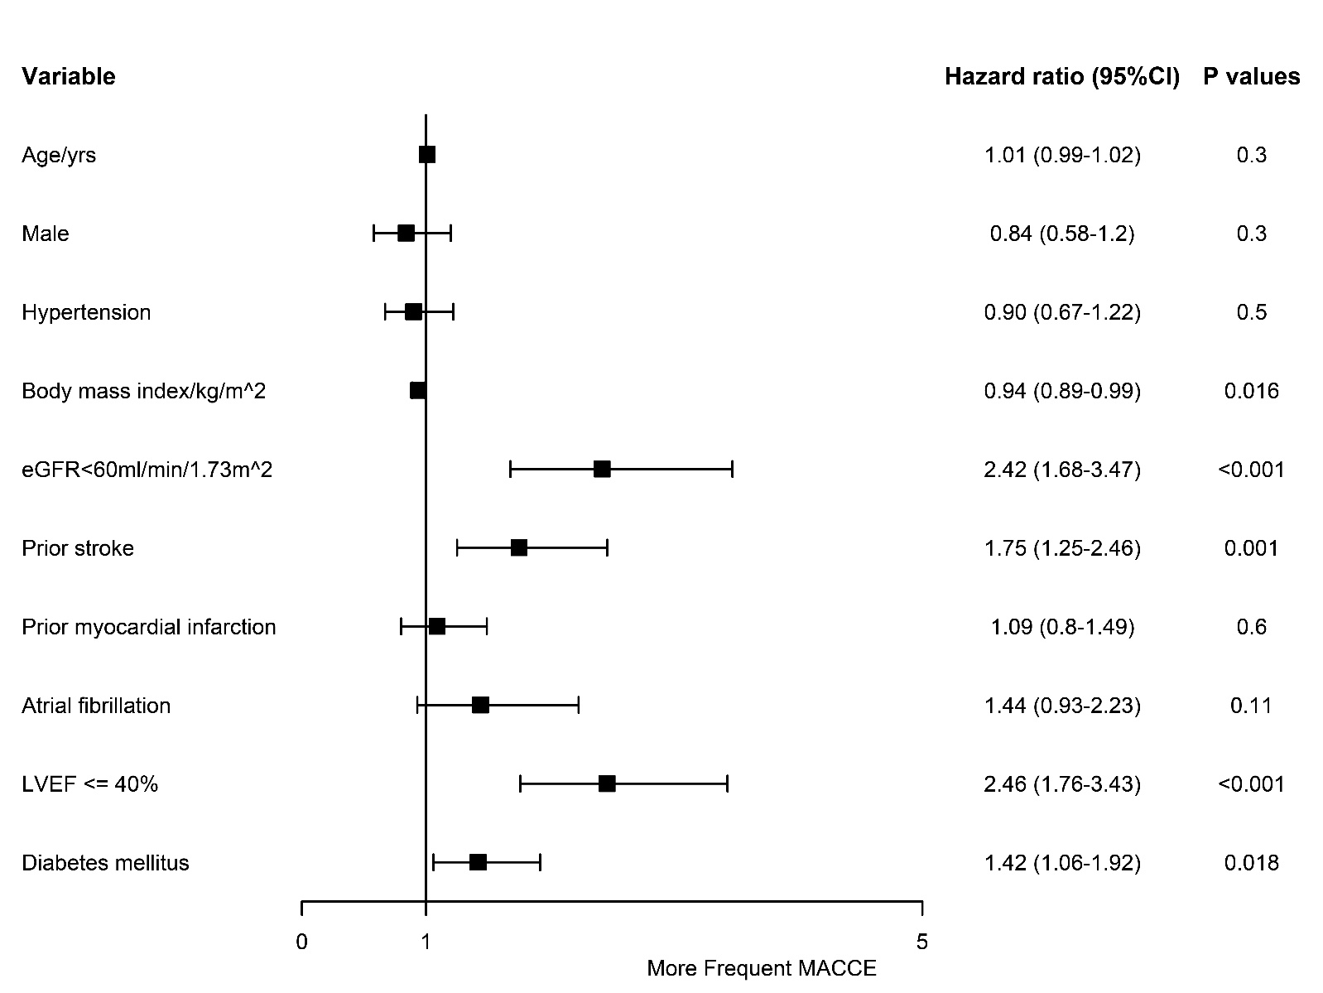
Supplemental Figure 2 Association between baseline characters and the risk of major adverse cardiac and cerebrovascular events by multivariable analysis.
CI=confidence interval. eGFR=estimated glomerular filtration rate. LVEF=left ventricular ejection fraction.

Supplemental Figure 3 Survival curves for adverse outcomes in LVT patients receiving anticoagulation.
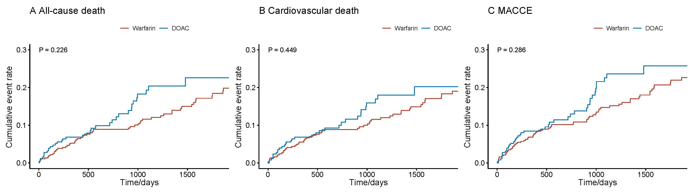LVT=left ventricular thrombus. DOAC=direct oral anticoagulants. MACCE=major adverse cardiac and cerebrovascular events.

Supplemental Figure 4 Survival curves for adverse outcomes in non-diabetic LVT patients receiving anticoagulation.
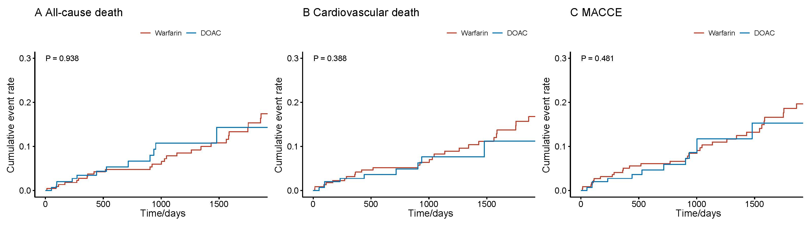LVT=left ventricular thrombus. DOAC=direct oral anticoagulants. MACCE=major adverse cardiac and cerebrovascular events.

Supplemental Figure 5 Survival curves for adverse outcomes in diabetic LVT patients receiving anticoagulation.
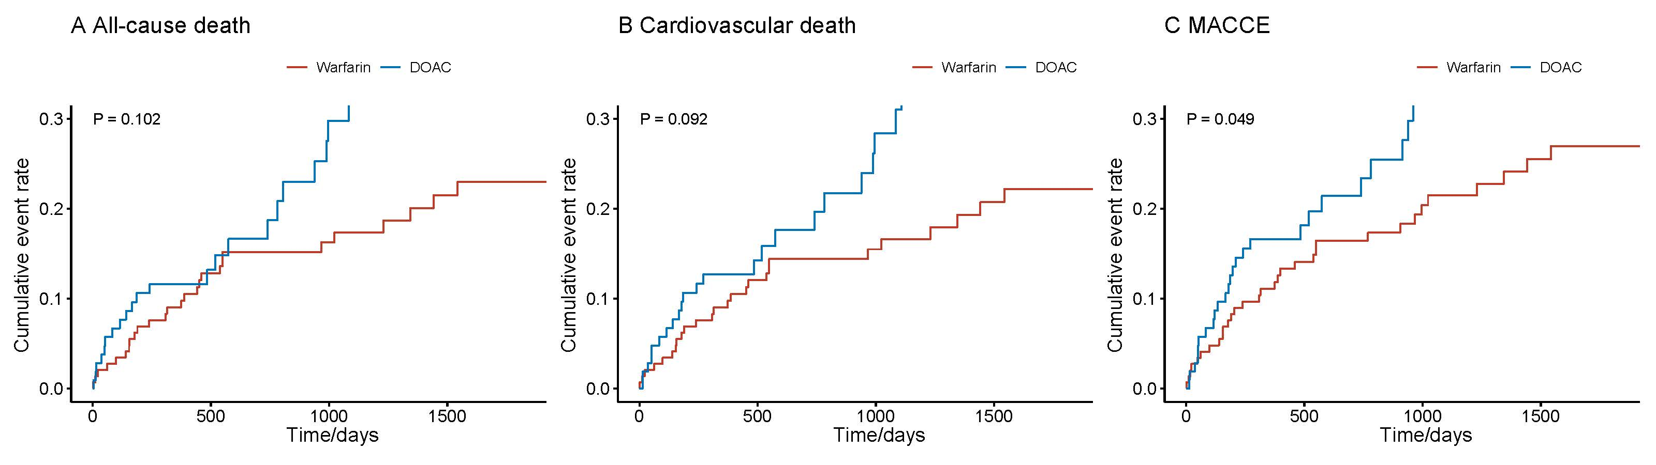LVT=left ventricular thrombus. DOAC=direct oral anticoagulants. MACCE=major adverse cardiac and cerebrovascular events.

3.Supplemental Tables
Supplemental Table 1 Baseline features of follow-up and lost to follow-up cases.
 | Overall | Lost to follow-up cases | Follow-up cases | P value | SMD
n | 1,193 | 125 | 1,068
Demographic
Age/years | 53.21 (14.72) | 55.26 (13.19) | 52.97 (14.88) | 0.099 | 0.163
Male | 999 (83.7) | 109 (87.2) | 890 (83.3) | 0.327 | 0.109
Body mass index/kg/m² | 25.00 [22.60, 27.47] | 24.61 [22.49, 27.46] | 25.03 [22.65, 27.47] | 0.669 | 0.054
Past medical history
Hypertension | 561 (47.0) | 56 (44.8) | 505 (47.3) | 0.666 | 0.05
Diabetes mellitus | 490 (41.1) | 61 (48.8) | 429 (40.2) | 0.078 | 0.174
eGFR<60 ml/min/1.73m² | 178 (14.9) | 20 (16.0) | 158 (14.8) | 0.822 | 0.033
Peripheral artery disease | 87 (7.3) | 8 (6.4) | 79 (7.4) | 0.823 | 0.039
Prior stroke | 187 (15.7) | 21 (16.8) | 166 (15.5) | 0.814 | 0.034
Prior MI | 650 (54.5) | 82 (65.6) | 568 (53.2) | 0.011 | 0.255
Prior CABG | 25 (2.1) | 2 (1.6) | 23 (2.2) | 0.937 | 0.041
Prior PCI | 177 (14.8) | 12 (9.6) | 165 (15.4) | 0.108 | 0.177
Prior cerebral hemorrhage | 8 (0.7) | 1 (0.8) | 7 (0.7) | 1 | 0.017
Atrial fibrillation | 102 (8.5) | 9 (7.2) | 93 (8.7) | 0.688 | 0.056
Underlying disease
Coronary artery disease | 912 (76.4) | 103 (82.4) | 809 (75.7) | 0.122 | 0.164
STEMI | 243 (20.4) | 16 (12.8) | 227 (21.3) | 0.035 | 0.226
NSTEMI | 49 (4.1) | 4 (3.2) | 45 (4.2) | 0.763 | 0.054
Dilated cardiomyopathy | 195 (16.3) | 17 (13.6) | 178 (16.7) | 0.454 | 0.086
Hypertrophic cardiomyopathy | 28 (2.3) | 2 (1.6) | 26 (2.4) | 0.786 | 0.059
ARVD with associated LV impairment | 7 (0.6) | 0 (0.0) | 7 (0.7) | 0.773 | 0.115
Perinatal cardiomyopathy | 15 (1.3) | 0 (0.0) | 15 (1.4) | 0.363 | 0.169
Restrictive cardiomyopathy | 6 (0.5) | 1 (0.8) | 5 (0.5) | 1 | 0.042
Alcoholic cardiomyopathy | 15 (1.3) | 1 (0.8) | 14 (1.3) | 0.952 | 0.05
Myocarditis | 8 (0.7) | 1 (0.8) | 7 (0.7) | 1 | 0.017
NVM | 27 (2.3) | 1 (0.8) | 26 (2.4) | 0.398 | 0.13
Medications
Aspirin | 685 (57.4) | 82 (65.6) | 603 (56.5) | 0.063 | 0.188
Clopidogrel | 561 (47.0) | 57 (45.6) | 504 (47.2) | 0.808 | 0.032
Ticagrelor | 44 (3.7) | 4 (3.2) | 40 (3.7) | 0.956 | 0.03
DAPT | 489 (41.0) | 52 (41.6) | 437 (40.9) | 0.96 | 0.014
VKA | 419 (35.1) | 43 (34.4) | 376 (35.2) | 0.937 | 0.017
Rivaroxaban | 259 (21.7) | 22 (17.6) | 237 (22.2) | 0.288 | 0.115
Dabigatran | 25 (2.1) | 1 (0.8) | 24 (2.2) | 0.46 | 0.118
DOAC | 285 (23.9) | 23 (18.4) | 262 (24.5) | 0.158 | 0.15
Antiplatelet therapy only | 446 (37.4) | 52 (41.6) | 394 (36.9) | 0.351 | 0.097
Anticoagulation only | 349 (29.3) | 27 (21.6) | 322 (30.1) | 0.06 | 0.196
Anticoagulation status |  |  |  | 0.227 | 0.351
Dabigatran 110 mg BID | 24 (2.0) | 1 (0.8) | 23 (2.2)
Dabigatran 150 mg BID | 1 (0.1) | 0 (0.0) | 1 (0.1)
Rivaroxaban 2.5 mg QD | 15 (1.3) | 5 (4.0) | 10 (0.9)
Rivaroxaban 5 mg QD | 7 (0.6) | 0 (0.0) | 7 (0.7)
Rivaroxaban 5 mg BID | 2 (0.2) | 0 (0.0) | 2 (0.2)
Rivaroxaban 10 mg QD | 20 (1.7) | 1 (0.8) | 19 (1.8)
Rivaroxaban 10 mg BID | 3 (0.3) | 0 (0.0) | 3 (0.3)
Rivaroxaban 15 mg QD | 76 (6.4) | 7 (5.6) | 69 (6.5)
Rivaroxaban 15 mg BID | 29 (2.4) | 2 (1.6) | 27 (2.5)
Rivaroxaban 20 mg QD | 107 (9.0) | 7 (5.6) | 100 (9.4)
Aspirin with anticoagulant | 109 (9.1) | 12 (9.6) | 97 (9.1) | 0.979 | 0.018
Clopidogrel with anticoagulant | 102 (8.5) | 7 (5.6) | 95 (8.9) | 0.281 | 0.127
Ticagrelor with anticoagulant | 1 (0.1) | 0 (0.0) | 1 (0.1) | 1 | 0.043
Anticoagulant with dual antiplatelet therapy | 143 (12.0) | 20 (16.0) | 123 (11.5) | 0.189 | 0.13
Imaging morphology of LVT
LVEDD | 58.00 [53.00, 66.00] | 58.00 [52.00, 67.00] | 58.00 [53.00, 66.00] | 0.822 | 0.047
LVEF | 38.00 [29.00, 46.00] | 40.00 [29.00, 47.00] | 38.00 [29.00, 46.00] | 0.433 | 0.065
LVEF<=40% | 724 (60.7) | 70 (56.0) | 654 (61.2) |  | 0.106
Global hypokinesis | 301 (25.2) | 22 (17.6) | 279 (26.1) | 0.049 | 0.207
Hypokinesis | 516 (43.3) | 56 (44.8) | 460 (43.1) | 0.784 | 0.035
Akinesis | 714 (59.8) | 76 (60.8) | 638 (59.7) | 0.894 | 0.022
Apical LVT | 1080 (90.5) | 113 (90.4) | 967 (90.5) | 1 | 0.005
Round LVT | 720 (60.4) | 68 (54.4) | 652 (61.0) | 0.18 | 0.135
Mobile LVT | 97 (8.1) | 8 (6.4) | 89 (8.3) | 0.565 | 0.074
Multiple LVT | 132 (11.1) | 12 (9.6) | 120 (11.2) | 0.688 | 0.054
Calcified LVT | 214 (17.9) | 19 (15.2) | 195 (18.3) | 0.471 | 0.082
LVT largest diameter/mm | 23.00 [17.00, 32.00] | 24.00 [19.00, 34.00] | 23.00 [17.00, 32.00] | 0.073 | 0.161
LVT area/mm² | 3.00 [1.65, 4.80] | 3.24 [1.84, 5.46] | 3.00 [1.64, 4.75] | 0.147 | 0.067
Left ventricular aneurysm | 598 (50.1) | 64 (51.2) | 534 (50.0) | 0.873 | 0.024
Data are n/N (%), median (IQR) or mean (SD). SMD=standard mean difference. eGFR=estimated glomerular filtration rate. MI=myocardial infarction. CABG=coronary artery bypass grafting. PCI=percutaneous coronary intervention. STEMI=ST-segment elevation myocardial infarction. NSTEMI=non-ST-segment elevation myocardial infarction. ARVD=arrhythmogenic right ventricular dysplasia. NVM=noncompaction of the ventricular myocardium. DAPT=dual antiplatelet therapy. VKA=vitamin-K antagonists. DOAC=direct oral anticoagulants. LVEDD=left ventricular end diastolic dimension. LVEF=left ventricular ejection fraction. LVT=left ventricular thrombus.

Supplemental Table 2. Baseline features according diabetes mellitus after propensity score matching.
 | Without diabetes | With diabetes | P value | SMD
n | 382 | 382
Demographic
Age/years | 55.79 (13.22) | 55.26 (13.40) | 0.581 | 0.04
Male | 327 (85.6) | 323 (84.6) | 0.761 | 0.029
Body mass index/kg/m² | 25.32 [22.86, 27.76] | 25.09 [23.19, 27.65] | 0.877 | 0.011
Past medical history
Hypertension | 203 (53.1) | 197 (51.6) | 0.717 | 0.031
eGFR<60 ml/min/1.73m² | 58 (15.2) | 63 (16.5) | 0.692 | 0.036
Peripheral artery disease | 35 (9.2) | 35 (9.2) | 1 | <0.001
Prior stroke | 60 (15.7) | 67 (17.5) | 0.56 | 0.049
Prior MI | 220 (57.6) | 219 (57.3) | 1 | 0.005
Prior CABG | 11 (2.9) | 11 (2.9) | 1 | <0.001
Prior PCI | 64 (16.8) | 70 (18.3) | 0.634 | 0.041
Prior cerebral hemorrhage | 3 (0.8) | 3 (0.8) | 1 | <0.001
Atrial fibrillation | 35 (9.2) | 40 (10.5) | 0.627 | 0.044
Underlying disease
Coronary artery disease | 307 (80.4) | 302 (79.1) | 0.719 | 0.033
STEMI | 80 (20.9) | 72 (18.8) | 0.526 | 0.052
NSTEMI | 15 (3.9) | 16 (4.2) | 1 | 0.013
Dilated cardiomyopathy | 63 (16.5) | 63 (16.5) | 1 | <0.001
Hypertrophic cardiomyopathy | 7 (1.8) | 8 (2.1) | 1 | 0.019
ARVD with associated LV impairment | 0 (0.0) | 1 (0.3) | 1 | 0.072
Perinatal cardiomyopathy | 1 (0.3) | 2 (0.5) | 1 | 0.042
Restrictive cardiomyopathy | 3 (0.8) | 2 (0.5) | 1 | 0.032
Alcoholic cardiomyopathy | 3 (0.8) | 2 (0.5) | 1 | 0.032
Myocarditis | 3 (0.8) | 2 (0.5) | 1 | 0.032
NVM | 8 (2.1) | 7 (1.8) | 1 | 0.019
Medications
Aspirin | 226 (59.2) | 217 (56.8) | 0.558 | 0.048
Clopidogrel | 196 (51.3) | 184 (48.2) | 0.426 | 0.063
Ticagrelor | 16 (4.2) | 14 (3.7) | 0.852 | 0.027
DAPT | 168 (44.0) | 155 (40.6) | 0.379 | 0.069
VKA | 129 (33.8) | 135 (35.3) | 0.704 | 0.033
Rivaroxaban | 82 (21.5) | 85 (22.3) | 0.861 | 0.019
Dabigatran | 11 (2.9) | 8 (2.1) | 0.642 | 0.05
DOAC | 93 (24.3) | 93 (24.3) | 1 | <0.001
Antiplatelet therapy only | 149 (39.0) | 141 (36.9) | 0.602 | 0.043
Anticoagulation only | 101 (26.4) | 109 (28.5) | 0.571 | 0.047
Aspirin with anticoagulant | 36 (9.4) | 38 (9.9) | 0.903 | 0.018
Clopidogrel with anticoagulant | 40 (10.5) | 39 (10.2) | 1 | 0.009
Ticagrelor with anticoagulant | 382 (100.0) | 382 (100.0) | NA | <0.001
Anticoagulant with dual antiplatelet therapy | 45 (11.8) | 42 (11.0) | 0.82 | 0.025
Imaging morphology of LVT
LVEDD | 58.00 [52.00, 66.00] | 58.00 [54.00, 66.00] | 0.301 | 0.037
LVEF | 39.00 [30.00, 45.00] | 37.00 [29.00, 45.83] | 0.495 | 0.041
LVEF<=40% | 233 (61.0) | 237 (62.0) | 0.823 | 0.022
Global hypokinesis | 89 (23.3) | 95 (24.9) | 0.672 | 0.037
Hypokinesis | 182 (47.6) | 175 (45.8) | 0.664 | 0.037
Akinesis | 231 (60.5) | 231 (60.5) | 1 | <0.001
Apical LVT | 348 (91.1) | 347 (90.8) | 1 | 0.009
Round LVT | 235 (61.5) | 229 (59.9) | 0.711 | 0.032
Mobile LVT | 29 (7.6) | 33 (8.6) | 0.691 | 0.038
Multiple LVT | 42 (11.0) | 45 (11.8) | 0.82 | 0.025
Calcified LVT | 74 (19.4) | 73 (19.1) | 1 | 0.007
LVT largest diameter/mm | 22.00 [17.00, 31.00] | 23.00 [16.00, 32.75] | 0.425 | 0.034
LVT area/mm² | 2.86 [1.61, 4.32] | 3.00 [1.62, 4.96] | 0.544 | 0.011
Left ventricular aneurysm | 200 (52.4) | 193 (50.5) | 0.664 | 0.037
Data are n/N (%), median (IQR) or mean (SD). eGFR=estimated glomerular filtration rate. MI=myocardial infarction. CABG=coronary artery bypass grafting. PCI=percutaneous coronary intervention. STEMI=ST-segment elevation myocardial infarction. NSTEMI=non-ST-segment elevation myocardial infarction. ARVD=arrhythmogenic right ventricular dysplasia. NVM=noncompaction of the ventricular myocardium. DAPT=dual antiplatelet therapy. VKA=vitamin-K antagonists. DOAC=direct oral anticoagulants. LVT=left ventricular thrombus. LVEDD=left ventricular end diastolic dimension. LVEF=left ventricular ejection fraction. LVA=left ventricle aneurysms.
Supplemental Table 3. Baseline features according diabetes mellitus after inverse probability of treatment weighting.
 | Without diabetes | With diabetes | P value | SMD
n | 636.52 | 422.17
Demographic
Age/years | 53.02 (15.20) | 53.71 (13.86) | 0.479 | 0.048
Male | 532.1 (83.6) | 350.5 (83.0) | 0.823 | 0.015
Body mass index/kg/m² | 25.05 [22.49, 27.45] | 25.00 [23.03, 27.47] | 0.758 | 0.028
Past medical history
Hypertension | 304.6 (47.8) | 211.8 (50.2) | 0.489 | 0.046
eGFR<60 ml/min/1.73m² | 92.0 (14.5) | 63.4 (15.0) | 0.806 | 0.016
Peripheral artery disease | 48.2 (7.6) | 34.0 (8.1) | 0.785 | 0.018
Prior stroke | 96.0 (15.1) | 66.1 (15.7) | 0.805 | 0.016
Prior MI | 336.8 (52.9) | 223.7 (53.0) | 0.984 | 0.001
Prior CABG | 13.9 (2.2) | 11.0 (2.6) | 0.692 | 0.028
Prior PCI | 97.8 (15.4) | 65.0 (15.4) | 0.99 | 0.001
Prior cerebral hemorrhage | 4.0 (0.6) | 2.4 (0.6) | 0.902 | 0.007
Atrial fibrillation | 53.5 (8.4) | 37.6 (8.9) | 0.782 | 0.018
Underlying disease
Coronary artery disease | 480.8 (75.5) | 322.0 (76.3) | 0.803 | 0.017
STEMI | 135.8 (21.3) | 90.0 (21.3) | 0.995 | <0.001
NSTEMI | 26.0 (4.1) | 17.6 (4.2) | 0.945 | 0.004
Dilated cardiomyopathy | 104.9 (16.5) | 69.3 (16.4) | 0.976 | 0.002
Hypertrophic cardiomyopathy | 15.8 (2.5) | 12.1 (2.9) | 0.756 | 0.023
ARVD with associated LV impairment | 4.0 (0.6) | 0.9 (0.2) | 0.311 | 0.062
Perinatal cardiomyopathy | 8.9 (1.4) | 5.2 (1.2) | 0.871 | 0.015
Restrictive cardiomyopathy | 3.0 (0.5) | 2.2 (0.5) | 0.927 | 0.006
Alcoholic cardiomyopathy | 8.1 (1.3) | 4.8 (1.1) | 0.873 | 0.012
Myocarditis | 4.8 (0.8) | 3.2 (0.8) | 0.996 | <0.001
NVM | 15.6 (2.5) | 9.7 (2.3) | 0.879 | 0.01
Medications
Aspirin | 361.0 (56.7) | 237.9 (56.3) | 0.913 | 0.007
Clopidogrel | 302.1 (47.5) | 201.4 (47.7) | 0.942 | 0.005
Ticagrelor | 23.5 (3.7) | 13.8 (3.3) | 0.722 | 0.023
DAPT | 262.3 (41.2) | 172.6 (40.9) | 0.922 | 0.007
VKA | 224.9 (35.3) | 147.8 (35.0) | 0.923 | 0.007
Rivaroxaban | 139.4 (21.9) | 95.1 (22.5) | 0.821 | 0.015
Dabigatran | 14.8 (2.3) | 11.9 (2.8) | 0.693 | 0.031
DOAC | 154.8 (24.3) | 107.0 (25.3) | 0.728 | 0.024
Antiplatelet therapy only | 234.2 (36.8) | 152.6 (36.2) | 0.841 | 0.013
Anticoagulation only | 189.6 (29.8) | 126.9 (30.1) | 0.929 | 0.006
Aspirin with anticoagulant | 59.3 (9.3) | 40.9 (9.7) | 0.851 | 0.013
Clopidogrel with anticoagulant | 56.9 (8.9) | 38.3 (9.1) | 0.944 | 0.005
Ticagrelor with anticoagulant | 0.6 (0.1) | 0.0 (0.0) | 0.416 | 0.043
Anticoagulant with dual antiplatelet therapy | 73.3 (11.5) | 48.7 (11.5) | 0.993 | 0.001
Imaging morphology of LVT
LVEDD | 58.00 [52.00, 66.00] | 58.00 [54.00, 66.00] | 0.583 | 0.019
LVEF | 38.00 [29.00, 45.94] | 37.00 [29.00, 46.00] | 0.807 | 0.008
LVEF<=40% | 388.0 (61.0) | 259.1 (61.4) | 0.898 | 0.009
Global hypokinesis | 162.9 (25.6) | 108.8 (25.8) | 0.953 | 0.004
Hypokinesis | 279.6 (43.9) | 188.1 (44.6) | 0.847 | 0.013
Akinesis | 384.5 (60.4) | 255.8 (60.6) | 0.956 | 0.004
Apical LVT | 580.4 (91.2) | 382.2 (90.5) | 0.721 | 0.023
Round LVT | 383.8 (60.3) | 254.7 (60.3) | 0.993 | 0.001
Mobile LVT | 50.2 (7.9) | 32.9 (7.8) | 0.958 | 0.003
Multiple LVT | 72.6 (11.4) | 51.4 (12.2) | 0.726 | 0.024
Calcified LVT | 115.5 (18.1) | 78.3 (18.6) | 0.874 | 0.011
LVT largest diameter/mm | 23.00 [17.00, 31.00] | 23.00 [16.00, 33.00] | 0.719 | 0.01
LVT area/mm² | 3.00 [1.70, 4.60] | 3.12 [1.62, 4.96] | 0.809 | 0.012
Left ventricular aneurysm | 322.7 (50.7) | 217.8 (51.6) | 0.793 | 0.018
Data are n/N (%), median (IQR) or mean (SD). eGFR=estimated glomerular filtration rate. MI=myocardial infarction. CABG=coronary artery bypass grafting. PCI=percutaneous coronary intervention. STEMI=ST-segment elevation myocardial infarction. NSTEMI=non-ST-segment elevation myocardial infarction. ARVD=arrhythmogenic right ventricular dysplasia. NVM=noncompaction of the ventricular myocardium. DAPT=dual antiplatelet therapy. VKA=vitamin-K antagonists. DOAC=direct oral anticoagulants. LVT=left ventricular thrombus. LVEDD=left ventricular end diastolic dimension. LVEF=left ventricular ejection fraction. LVA=left ventricle aneurysms.

Supplemental Table 4 Variance inflation factor for variables in the multivariable analysis.
 | Age | Male | Diabetes mellitus | Body mass index/kg/m² | eGFR<60 ml/min/1.73m² | Hypertension | Prior stroke | Prior MI | Atrial fibrillation | LVEF<=40%
VIF | 1.391009 | 1.064294 | 1.0883 | 1.101583 | 1.131783 | 1.150756 | 1.056553 | 1.215559 | 1.044131 | 1.096323
VIF=Variance inflation factor. eGFR=estimated glomerular filtration rate. MI=myocardial infarction. LVEF=left ventricular ejection fraction.

Supplemental Table 5 Correlation matrix for variables in the multivariable analysis.
 | Age | Male | Diabetes mellitus | Body mass index/kg/m² | eGFR<60 ml/min/1.73m² | Hypertension | Prior stroke | Prior MI | Atrial fibrillation | LVEF<=40%
Age | 1 | 0.01 | 0.19 | -0.13 | 0.25 | 0.21 | 0.17 | 0.38 | 0.14 | -0.16
Male | 0.01 | 1 | -0.06 | 0.14 | -0.13 | 0.06 | 0 | 0.12 | -0.01 | -0.09
Diabetes mellitus | 0.19 | -0.06 | 1 | 0.06 | 0.16 | 0.12 | 0.1 | 0.08 | 0.12 | 0.06
Body mass index/kg/m² | -0.13 | 0.14 | 0.06 | 1 | -0.03 | 0.18 | -0.05 | -0.05 | 0.01 | -0.04
eGFR<60 ml/min/1.73m² | 0.25 | -0.13 | 0.16 | -0.03 | 1 | 0.12 | 0.06 | 0.07 | 0.08 | 0.12
Hypertension | 0.21 | 0.06 | 0.12 | 0.18 | 0.12 | 1 | 0.16 | 0.14 | -0.03 | -0.13
Prior stroke | 0.17 | 0 | 0.1 | -0.05 | 0.06 | 0.16 | 1 | 0.09 | 0.06 | 0.01
Prior MI | 0.38 | 0.12 | 0.08 | -0.05 | 0.07 | 0.14 | 0.09 | 1 | -0.01 | -0.17
Atrial fibrillation | 0.14 | -0.01 | 0.12 | 0.01 | 0.08 | -0.03 | 0.06 | -0.01 | 1 | 0.01
LVEF<=40% | -0.16 | -0.09 | 0.06 | -0.04 | 0.12 | -0.13 | 0.01 | -0.17 | 0.01 | 1
eGFR=estimated glomerular filtration rate. MI=myocardial infarction. LVEF=left ventricular ejection fraction.

Supplemental Table 6 Multivariable analysis for the relationship between DOAC and adverse outcomes in LVT patients receiving anticoagulation.
 | In LVT patients with anticoagulation  (n=638) |  | In non-diabetic LVT patients with anticoagulation |  | In diabetic LVT patients with anticoagulation
Endpoints | Hazard ratio (95%CI) | P values | Hazard ratio (95%CI) | P values | Hazard ratio (95%CI) | P values | P for interaction
All-cause death | 1.40 (0.90-2.18) | 0.14 | 1.16 (0.58-2.29) | 0.7 | 1.64 (0.91-2.95) | 0.10 | 0.13
Cardiovascular death | 1.25 (0.79-1.96) | 0.3 | 0.83 (0.39-1.74) | 0.6 | 1.63 (0.91-2.92) | 0.1 | 0.054
MACCE | 1.30 (0.86-1.96) | 0.2 | 0.85 (0.43-1.68) | 0.6 | 1.73 (1.03-2.92) | 0.038 | 0.022
LVT=left ventricular thrombus. DOAC=direct oral anticoagulants. MACCE=major adverse cardiac and cerebrovascular events. CI=confidence interval.
The presented hazard ratio is multivariable adjusted for age, gender, eGFR<60ml/min/1.73m², body mass index, ejection fraction<=40%, hypertension, prior myocardial infarction, prior stroke, and atrial fibrillation.

