SUPPLEMENTARY MATERIAL
Supplementary Figure 1.

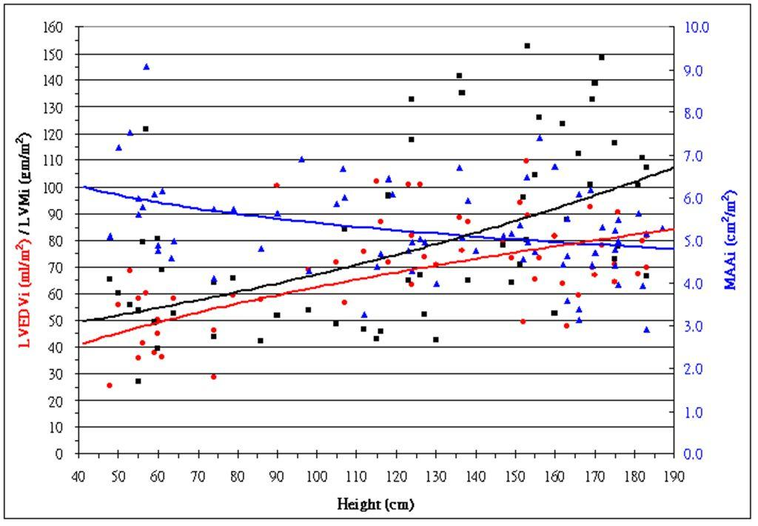
Figure 1.
Scatter plot distribution between body surface area (BSA)-adjusted indices of LV quality to height. We checked the relationship between BSA indices of LV quality and height by using a scatter plot distribution. This scatter plot indicated that the height of the children expressed a slightly positive correlation with the LVEDV index and LVMM index but a negative correlation with the MAA index. Therefore, setting a threshold on only one value among these indices of LV quality to differentiate between normal or abnormal LV quality is not reasonable. LVEDVi = left ventricular end-diastolic volume index (red circle and red regression line; LVEDV/BSA; mL/m²); LVMi = left ventricular myocardial mass index (black square and black regression line; LVM/BSA; g/m²); MAAi = mitral annulus area index (blue triangle and blue regression line; MAA/BSA; cm²/m²).

Supplementary Table 1.
Pearson correlation coefficients (r) and p values (p) between LV characteristics relative to factors of body size
Factors |  | LVEDV |  |  | LVMM |  |  | MAA
Factors |  | r | p |  | r | p |  | r | p
Age |  | .87 | 3.2E-20 |  | .85 | 2.7E-18 |  | .86 | 1.3E-23
Height |  | .93 | 1.2E-25 |  | .87 | 1.6E-18 |  | .90 | 1.8E-25
Weight |  | .90 | 1.4E-22 |  | .86 | 2.1E-18 |  | .89 | 3.7E-26
BSA |  | .64 | 2.7E-8 |  | .63 | 5.4E-8 |  | .70 | 1.4E-12

The most significantly correlated factor of the body size to the LV character is represented by bold letters. BSA = body surface area; LV = left ventricle; LVEDV = left ventricular end-diastolic volume (ml); LVMM = left ventricular myocardial mass (g); MAA = mitral annulus area (cm²).
We recently applied our study result to one patient with a favorable outcome (Supplementary Table 2). This HLHS patient was initially planned to receive an SVP 3 years ago. After preparatory surgeries, she had reached a hemi-Fontan circulation. However, the quality of her left ventricular characters were acceptable during the last follow-up cardiac CT after the preliminary result of this study was obtained. We retrospectively calculated the quality of her left ventricular characters in a previously performed cardiac CT. The result provided us with the confidence to proceed with biventricular circulation. Biventricular conversion was performed on this patient; a smooth postoperative course was observed, and she was discharged from hospital with satisfactory activity.
Supplementary Table 2.
Age | LVEDV | LVMM | MAA
15 ds | 45.1 % | 63.0 % | 46.0 %
18 ds | Norwood I+ RV-PA shunt+ divided PDA+ TV valvuloplasty
2.3 ms | 40.7 % | 83.2 % | 60.2 %
4.0 ms | 67.2 % | 89.9 % | 67.1 %
4.2 ms | Bilateral Glenn shunts+ atrial septectomy+ RV-PA shunt division  + TV annuloplasty
6.1 ms | 64.6 % | 65.7 % | 63.9 %
3.1 ys | 67.2 % | 51.6 % | 69.8 %
3.3 ys | Take down Glenn shunts+ patches repaired ASD and VSD  + aortoplasty+ PA augmentation

Biventricular conversion on a 3.3 years old patient who had been planned to a Fontan circulation in her infancy. ASD= atrial septal defect; CT= computed tomography; ds= days; LVEDV = left ventricle end-diastole volume; LVMM = left ventricle myocardial mass; MAA = mitral annulus area; ms = months; PA = pulmonary artery; PDA = patent ductus arteriosus; RV = right ventricle; TV = tricuspid valve; VSD = ventricular septal defect; ys = years.

