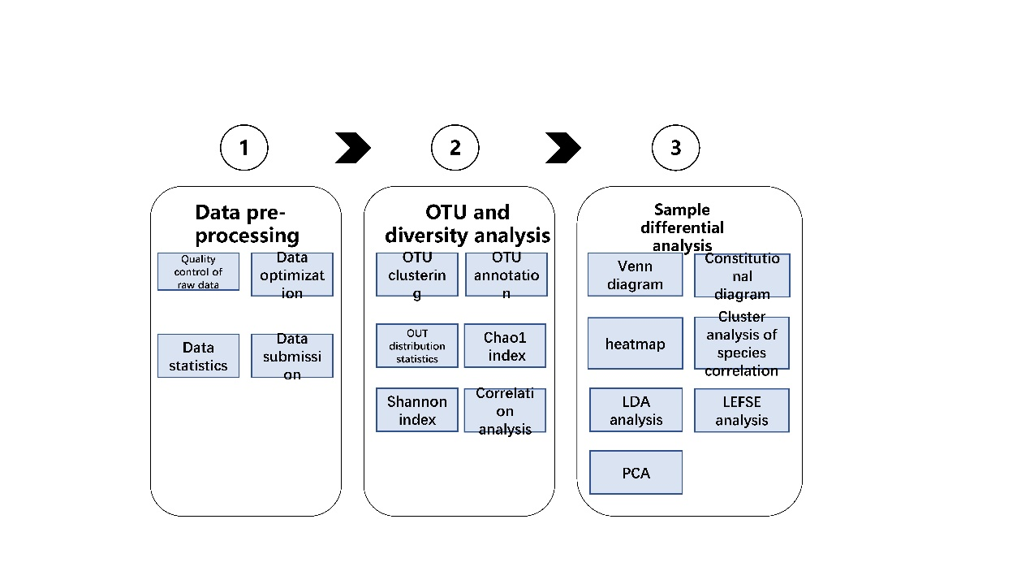
Supplementary Fig. 1. Flow chart of data analysis methods.

