Supplement Table 1. Odds ratio for presence of CAC 11-100 and CAC≥101 versus CAC 0-10 according to number of risk factors in middle-aged and elderly patients ≥55 years of age
Risk factor burden | CAC 11-100  Odds Ratio 95% CI  (crude) | CAC 11-100  Odds Ratio 95% CI (age- and sex-adjusted) | CAC≥101  Odds Ratio 95% CI  (crude) | CAC ≥101  Odds Ratio 95% CI (age- and sex-adjusted)
1 (525) | ref | ref | ref | ref
2 (1275) | 1.332 (0.990-1.793) | 1.242 (0.916-1.682) | 1.378 (1.044-1.818) | 1.147 (0.858-1.534)
3 (1762) | 1.465 (1.100-1.953) | 1.360 (1.007-1.835) | 1.626 (1.245-2.153) | 1.337 (1.002-1.783)
≥4 (3870) | 1.768 (1.352-2.312) | 1.615 (1.196-2.180) | 2.204 (1.717-2.830) | 1.873 (1.403-2.499)
CAC = coronary artery calcium; CAD = coronary artery disease; CI = confidence interval

Supplement Table 2. Odds ratio for presence of mixed plaque versus non-calcified plaque and calcified plaque versus mixed plaque according to coronary artery disease risk factors in middle-aged and elderly patients ≥55 years of age.
CAD risk factors | mixed plaque versus  non-calcified plaque  Odds Ratio 95％CI | calcified plaque versus  mixed plaque  Odds Ratio 95％CI
Age | 1.041 (0.986-1.100) | 0.952 (0.928-0.978)
Female | 0.410 (0.157-1.073) | 1.816 (1.150-2.867)
Smoking | 1.309 (0.430-3.980) | 0.924 (0.564-1.513)
Total cholesterol | 0.494 (0.136-1.785) | 0.813 (0.376-1.754)
Triglyceride | 1.356 (0.591-3.109) | 0.979 (0.664-1.443)
LDL cholesterol | 0.910 (0.225-3.678) | 0.790 (0.328-1.898)
HDL cholesterol | 1.139 (0.370-3.505) | 1.243 (0.743-2.080)
Systolic blood pressure | 1.036 (1.008-1.065) | 0.987 (0.975-0.999)
Diastolic blood pressure | 0.499 (0.128-1.946) | 1.291 (0.668-2.496)
Body mass index | 1.044 (0.937-1.165) | 0.937 (0.889-0.988)
Diabetes mellitus | 1.020 (0.445-2.334) | 0.632 (0.414-0.964)
Family history of CAD | 0.947 (0.347-2.584) | 0.821 (0.487-1.384)
CAD = coronary artery disease; CI = confidence interval, HDL = High-density lipoprotein; LDL = Low-density lipoprotein

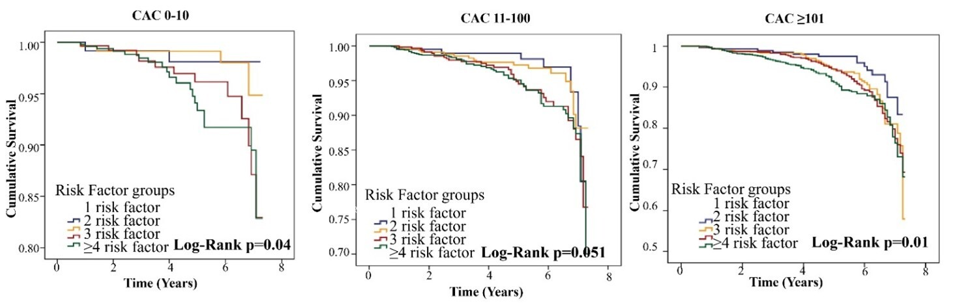
Supplement Figure 1. Cumulative survival rates for different burden of risk factors in each CAC group.

Supplement Table 3. Relationship Between Coronary Artery Calcium and Coronary artery disease in Middle-Aged and Elderly (≥55 Years Old)
 |  | MACCEs
CAC burden |  |  | Event Rate per 1000 Person-Years | Unadjusted  Hazard Ratio | Adjusted  Hazard Ratio*
CAC 0-10 | 970 (38) |  | 10.98 (4.44-17.56) | Ref. | Ref.
CAC 11-100 | 2331 (122) |  | 14.99 (10.06-19.92) | 1.355 (0.934-1.965) | 1.271 (0.875-1.847)
CAC ≥101 | 4131 (318) |  | 22.93 (18.50-27.50) | 2.045 (1.450-2.885) | 1.724 (1.217-2.442)
Values are n (%), unless otherwise indicated. *Adjusted for age and sex. MACCE = major adverse cardiovascular and cerebrovascular event; CAC = coronary artery calcium

Supplement Table 4. Incidence rate ratio with increasing coronary artery calcium scoring groups according to burden of risk factors in middle-aged and elderly patients ≥55 years of age
Risk factor burden | MACCEs dependent on CAC burden
Risk factor burden | CAC 0-10  Event rate per  1000 person-years | p value | CAC 11-100  Event rate per  1000 person-years | p value | CAC≥101  Event rate per  1000 person-years | p value
1 | ref |  | ref |  | ref
2 | 1.20 (0.22-6.58) | 0.835 | 1.12 (0.47-2.71) | 0.796 | 1.63 (0.92-2.88) | 0.091
3 | 3.23 (0.72-14.46) | 0.124 | 1.83 (0.81-4.11) | 0.149 | 1.70 (0.98-2.96) | 0.058
≥4 | 3.59 (0.84-15.31) | 0.085 | 1.78 (0.81-3.89) | 0.148 | 1.71 (1.01-2.92) | 0.044
CAC = coronary artery calcium; MACCE = major adverse cardiovascular and cerebrovascular event

Supplement Table 5. Incidence rate ratio with increasing coronary artery calcium scoring groups according to age groups in middle-aged and elderly patients ≥55 years of age.
Age groups | MACCEs dependent on CAC burden
Age groups | CAC 0-10  Event rate per  1000 person-years | p value | CAC 11-100  Event rate per  1000 person-years | p value | CAC≥101  Event rate per  1000 person-years | p value
55-65 (3927) | ref |  | ref |  | ref
65-75 (3616) | 1.87 (0.89-3.93) | 0.099 | 1.42 (0.95-2.13) | 0.088 | 1.02 (0.78-1.33) | 0.899
≥75 (2070) | 12.65 (6.74-23.75) | <0.0001 | 1.81 (1.13-2.91) | 0.014 | 1.46 (1.11-1.93) | 0.007
CAC = coronary artery calcium; MACCE = major adverse cardiovascular and cerebrovascular event

Supplement Table 6. Incidence rate ratio with the type of coronary artery disease according to age groups in middle-aged and elderly patients ≥55 years of age
Age groups | MACCEs dependent on the type of coronary artery disease
Age groups | No CAD  Event rate per  1000 person-years | p value | Non-obstruct CAD Event rate per 1000 person-years | p value | Obstruct CAD  Event rate per 1000 person-years | p value
55-65 (3927) | ref |  | ref |  | ref
65-75 (3616) | 1.61 (0.70-3.72) | 0.267 | 1.69 (1.20-2.37) | 0.003 | 0.92 (0.68-1.24) | 0.579
≥75 (2070) | 1.95 (0.74-5.12) | 0.176 | 2.62 (1.83-3.74) | <0.0001 | 1.28 (0.93-1.76) | 0.128
CAD = coronary artery disease; MACCE = major adverse cardiovascular and cerebrovascular event

Supplement Table 7. Evaluating the predictive value of CAD risk prediction model for MACCE.
Variables | ROC curve parameters
 | Cut-off | AUC | 95% CI | Sensitivity | Specificity | PPV (%) | NPV (%) | LR+ | LR-
Age | 71 | 0.579 | 0.552-0.605 | 48 | 65 | 42 | 40 | 1.37 | 1.25
CAC | 186 | 0.588 | 0.562-0.612 | 42 | 58 | 42 | 42 | 1.00 | 1.00
Risk Factor | 3 | 0.508 | 0.482-0.534 | 79 | 24 | 77 | 78 | 1.04 | 1.14
Age and CAC and Risk Factor | 18 | 0.614 | 0.588-0.639 | 59 | 59 | 50 | 50 | 1.44 | 1.44
ROC = receiver operating characteristic curve; AUC = area under the receiver operating characteristic.
PV = positive predictive value; NPV = negative predictive value; LR+ = positive likelihood ratio. LR- = negative likelihood ratio; MACCE = major adverse cardiovascular and cerebrovascular event.

