Supplemental file
Supplement to:
Total Arterial Revascularization in Diabetic Patients Undergoing Coronary Artery Bypass Graft Surgery: A Systematic Review and Meta-analysis

Search strategy
Pubmed (14072)
#1 diabetes mellitus[MeSH Terms] 492737
#2 ((diabetes[Title/Abstract]) AND (hyperglycemia[Title/Abstract])) AND (diabetes mellitus[Title/Abstract]) 13698
#3 "arterial coronary bypass"[Title/Abstract] OR "arterial revascularization"[Title/Abstract] OR "arterial conduit"[Title/Abstract] OR "mammary artery"[Title/Abstract] OR "internal thoracic artery"[Title/Abstract] OR "RIMA"[Title/Abstract] OR "BIMA"[Title/Abstract] OR "radial artery"[Title/Abstract] OR "gastroepiploic artery"[Title/Abstract] OR "RGA"[Title/Abstract] 19689
#4 ((coronary artery bypass graft[Title/Abstract]) OR (surgery[Title/Abstract])) OR (CABG[Title/Abstract]) 1,444284
#5 #1 OR #2 496828
#6 #3 OR #4 1457401
#7 #5 AND #6 14072

Cochrane library (609)
#1 MeSH descriptor: [Diabetes Mellitus] explode all trees 35999
#2 (diabetes):ti,ab,kw OR (diabetes mellitus):ti,ab,kw OR (hyperglycemia):ti,ab,k 99455
#3 #1 OR #2 102138
#4 (arterial coronary bypass):ti,ab,kw OR (arterial revascularization):ti,ab,kw OR (arterial conduit):ti,ab,kw OR (mammary artery):ti,ab,kw OR (internal thoracic artery):ti,ab,kw 3815
#5 (RIMA):ti,ab,kw OR (BIMA):ti,ab,kw OR (radial artery):ti,ab,kw OR (gastroepiploic artery):ti,ab,kw OR (RGA):ti,ab,kw 2768
#6 #4 OR #5 6334
#7 #3 AND #6 609

Embase (998)
#1 'diabetes mellitus':ta,ab OR diabetes:ab,ta OR 'hyperglycemia':ab,ta 943158
#2 'arterial coronary bypass':ta,ab OR 'arterial revascularization':ta,ab OR 'arterial conduit':ta,ab OR 'mammary artery':ta,ab OR 'internal thoracic artery':ta,ab OR 'rima':ta,ab OR 'bima':ta,ab OR 'radial artery':ta,ab OR 'ra':ta,ab OR 'gastroepiploic artery':ta,ab OR 'rga':ta,ab 169,447
#3 #1 AND #2 6951
#4 'coronary artery bypass graft':ta,ab OR 'surgery':ab,ta OR 'cabg':ta,ab 1,714,538
#5 #3 AND #4 998

Meta-analyses Of Observational Studies in Epidemiology Checklist
Checklist Items |  | Status
Reporting of background should include
 | Problem definition | COMPLETED
 | Hypothesis statement | DEFERRED
 | Description of study outcomes | COMPLETED
 | Type of exposure or intervention used | COMPLETED
 | Type of study designs used | COMPLETED
 | Study population | COMPLETED
Reporting of search strategy should include
 | Qualifications of searchers (eg, librarians and investigators) | COMPLETED
 | Search strategy, including time period included in the synthesis and keywords | COMPLETED
 | Effort to include all available studies, including contact with authors | COMPLETED
 | Databases and registries searched | COMPLETED
 | Search software used, name and version, including special features used (eg, explosion) | COMPLETED
 | Use of hand searching (eg, reference lists of obtained articles) | COMPLETED
 | List of citations located and those excluded, including justification | COMPLETED
 | Method of addressing articles published in languages other than English | DEFERRED
 | Method of handling abstracts and unpublished studies | DEFERRED
 | Description of any contact with authors | DEFERRED
Reporting of methods should include
 | Description of relevance or appropriateness of studies assembled for assessing the hypothesis to be tested | COMPLETED
 | Rationale for the selection and coding of data (eg, sound clinical principles or convenience) | COMPLETED
 | Documentation of how data were classified and coded (eg, multiple raters, blinding, and interrater reliability) | COMPLETED
 | Assessment of confounding (eg, comparability of cases and controls in studies where appropriate) | COMPLETED
 | Assessment of study quality, including blinding of quality assessors; stratification or regression on possible predictors of study results | COMPLETED
 | Assessment of heterogeneity | COMPLETED
 | Description of statistical methods (eg, complete description of fixed or random effects models, justification of whether the chosen models account for predictors of study results, dose-response models, or cumulative meta-analysis) in sufficient detail to be replicated | COMPLETED
 | Provision of appropriate tables and graphics | COMPLETED
Reporting of results should include
 | Graphic summarizing individual study estimates and overall estimate | COMPLETED
 | Table giving cescriptive information for each study included | COMPLETED
 | Results of sensitivity testing (eg, subgroup analysis) | COMPLETED
 | Indication of statistical uncertainty of findings | COMPLETED
Reporting of discussion should include
 | Quantitative assessment of bias (eg, publication bias) | COMPLETED
 | Justification for exclusion (eg, exclusion of non—English-language citations) | COMPLETED
 | Assessment of quality of included studies | COMPLETED
Reporting of conclusions should include
 | Consideration of alternative explanations for observed results | COMPLETED
 | Generalization of the conclusions (ie, appropriate for the cata presented and within the domain of the literature review) | COMPLETED
 | Guidelines for future research | COMPLETED
 | Disclosure of funding source | COMPLETED

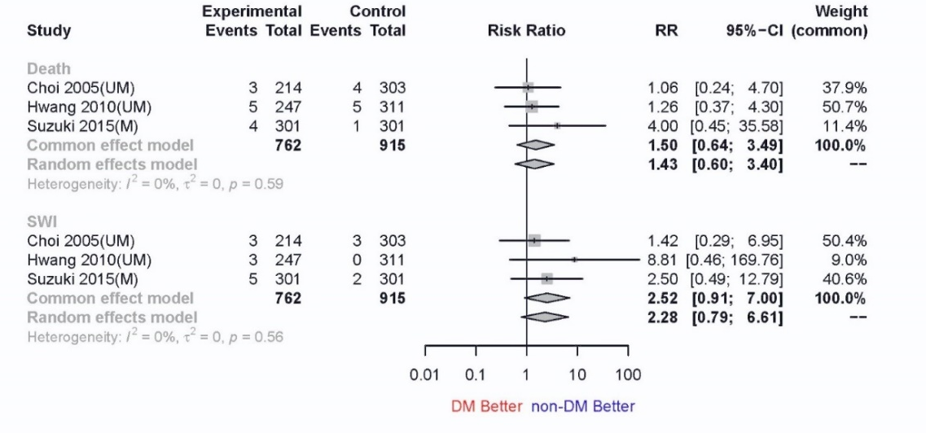
A
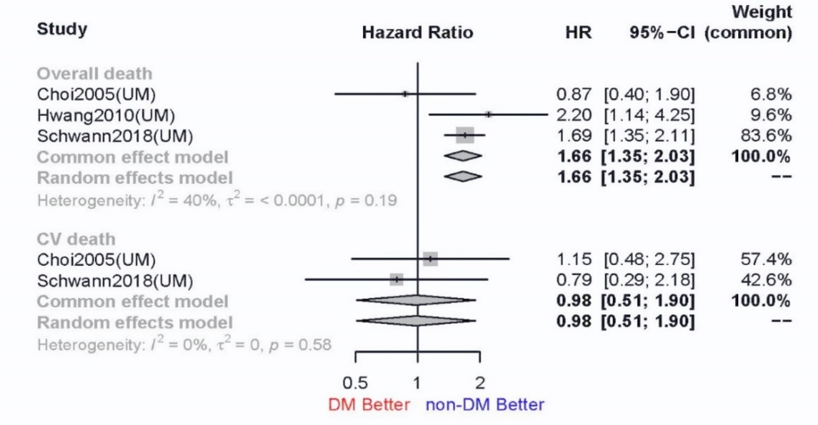
B
Figure S1. Plots for the clinical outcomes of TAR in diabetic and non-diabetic patients.
A). Forest plot of early death and any SWI. B) Forest plot of long-term death and cardiovascular death.
Note: M: the studies with data of matched cohorts; UM: the studies with data of unmatched cohorts; TAR: total arterial revascularization; CVR: conventional revascularization with veins; HR: hazard ratio; CI: confidence interval; DM: diabetes mellitus patients; non-DM: non-diabetes Mellitus patients.

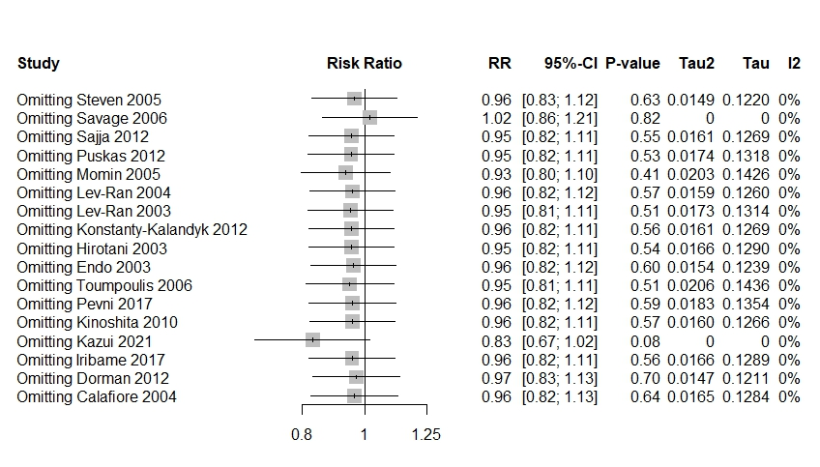
A
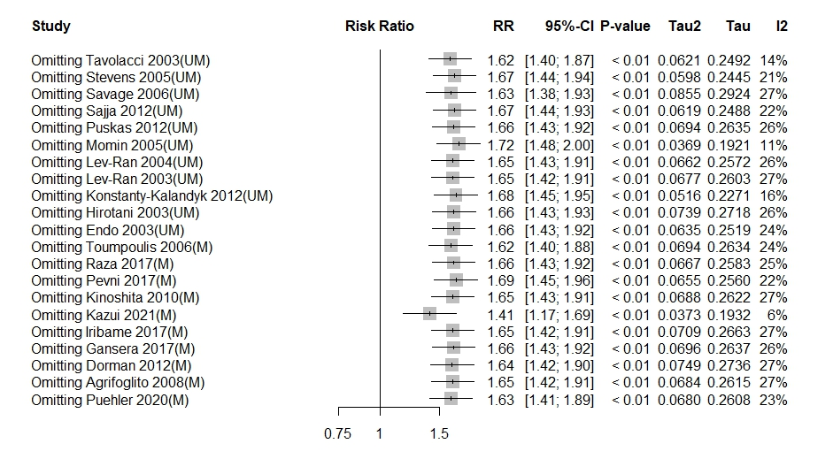
B
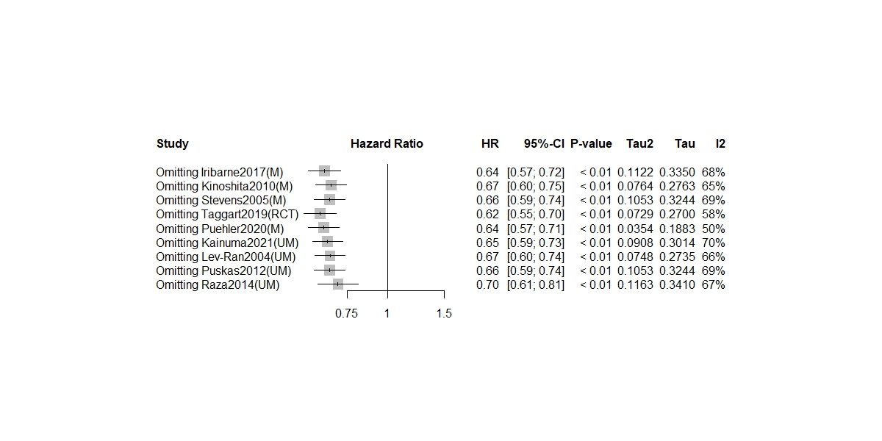
C
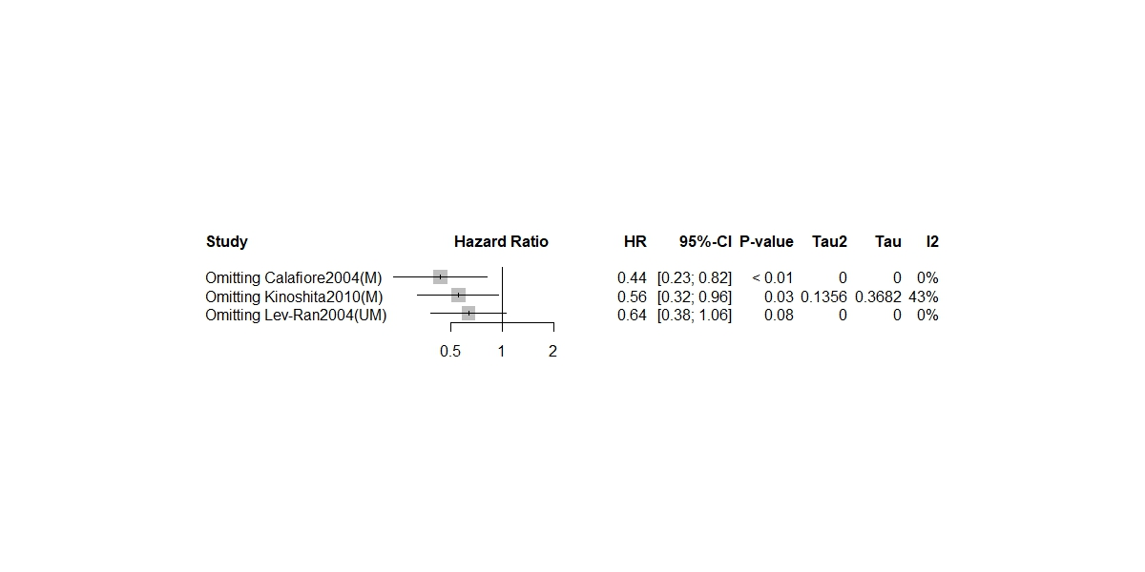
D
Figure S2. Sensitivity analyses of early death (A), SWI (B), long-term overall death (C) and cardiovascular death (D) in the comparison between BIMA and CVR in DM patients.
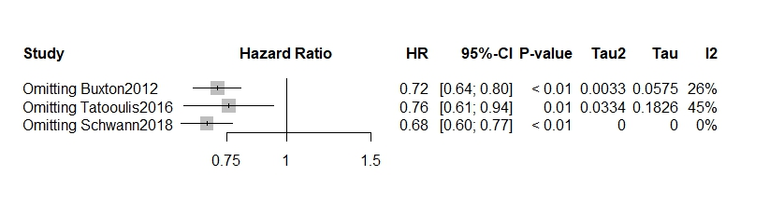
Figure S3. Sensitivity analyses of long-term overall death in the comparison between RA and CVR in DM patients.

Study | Selection |  |  |  | Comparability | Outcome | Follow-up |  | Total score.
Study | Representative of the exposed cohort. | Selection of the nonexposed cohort. | Ascertainment of exposure. | Demonstration that outcome of interest was not present at the start of the study. | Comparability of cohorts on the basis of the design or analysis. | Assessment of outcome. | Was follow-up long enough for outcomes to occur? | Adequacy of follow-up of cohorts. | Total score.
Buxton2012 | ★ | ★ | ★ | ★ | ★★ | ★ | ★ | ☆ | 8
DiBacco2019 | ★ | ★ | ★ | ★ | ★★ | ★ | ★ | ★ | 9
Hwang2010 | ★ | ★ | ★ | ★ | ★☆ | ★ | ★ | ★ | 8
Suzuki2005 | ★ | ★ | ★ | ★ | ★★ | ★ | ★ | ★ | 9
Tatoulis2016 | ★ | ★ | ★ | ★ | ★☆ | ★ | ★ | ★ | 8
Choi2005 | ★ | ★ | ★ | ★ | ★☆ | ★ | ★ | ☆ | 7
Abelaira2021 | ★ | ★ | ★ | ★ | ★☆ | ★ | ★ | ☆ | 7
Agrifoglio2008 | ★ | ★ | ★ | ★ | ★☆ | ★ | ★ | ☆ | 7
Dorman2012 | ★ | ★ | ★ | ★ | ★★ | ★ | ★ | ☆ | 8
Calafiore2004 | ★ | ★ | ★ | ★ | ★★ | ★ | ★ | ★ | 9
Endo2003 | ★ | ★ | ★ | ★ | ★☆ | ★ | ★ | ★ | 8
Gansera2017 | ★ | ★ | ★ | ★ | ★★ | ☆ | ★ | ★ | 7
Hirotani2003 | ★ | ★ | ★ | ★ | ★☆ | ★ | ★ | ★ | 7
Iribarne2017 | ★ | ★ | ★ | ★ | ★☆ | ★ | ★ | ★ | 8
Kainuma2021 | ★ | ★ | ★ | ★ | ★★ | ☆ | ★ | ★ | 8
Kazui2021 | ★ | ★ | ★ | ★ | ★★ | ☆ | ★ | ★ | 8
Konstanty-Kalandyk2012 | ★ | ★ | ★ | ★ | ★☆ | ☆ | ☆ | ★ | 6
Kinoshita2010 | ★ | ★ | ★ | ★ | ★☆ | ★ | ★ | ★ | 8
Lev-Ran2004 | ★ | ★ | ★ | ★ | ★☆ | ★ | ★ | ★ | 8
Lev-Ran2003 | ★ | ★ | ★ | ★ | ★☆ | ★ | ★ | ★ | 8
Momin2005 | ★ | ★ | ★ | ★ | ★☆ | ★ | ☆ | ★ | 7
Muneretto2006 | ★ | ★ | ★ | ★ | ★★ | ☆ | ★ | ☆ | 7
Pevni2017 | ★ | ★ | ★ | ★ | ★★ | ★ | ★ | ☆ | 8
Puskas2012 | ★ | ★ | ★ | ★ | ★☆ | ★ | ★ | ★ | 8
Raza2017 | ★ | ★ | ★ | ★ | ★★ | ★ | ★ | ☆ | 8
Raza2014 | ★ | ★ | ★ | ★ | ★☆ | ★ | ★ | ★ | 8
Sajja2012 | ★ | ★ | ★ | ★ | ★☆ | ☆ | ☆ | ★ | 6
Savage2006 | ★ | ★ | ★ | ★ | ★☆ | ☆ | ★ | ☆ | 6
Stevens2005 | ★ | ★ | ★ | ★ | ★★ | ★ | ★ | ★ | 9
Tavolacci2003 | ★ | ★ | ★ | ★ | ★☆ | ★ | ☆ | ★ | 7
Toumpoulis2006 | ★ | ★ | ★ | ★ | ★☆ | ★ | ★ | ★ | 8
Hoffman 2014 | ★ | ★ | ★ | ★ | ★★ | ★ | ★ | ☆ | 8
Puehler2020 | ★ | ★ | ★ | ★ | ★★ | ★ | ★ | ☆ | 8
Study | D1 | D2 | D3 | D4 | D5 | Overall
Taggart2019 | Low | Some concern | Low | Low | Low | Some concerns
Footnotes: D1: Risk of bias arising from the randomization process; D2: Risk of bias due to deviations from the intended interventions; D3: Risk of bias due to missing outcome data; D4: Risk of bias in the measurement of the outcome; D5: Risk of bias in the selection of the reported result; Overall: Overall risk of bias
Table 1. Results of quality assessment using the Newcastle-Ottawa Scale and Version 2 of the Cochrane tool for assessing risk of bias in randomized trial ( RoB2) for cohort study and randomized trial, respectively.

