Online-Only Supplements
Supplementary Fig. 1. Geographic distribution of participating hospitals in the China PEACE-Retrospective AMI study
Supplementary Fig. 2. Study flow chart
Supplementary Method 1. Eligible candidates for treatments
Supplementary Table 1. Proportion of patients eligible for treatment according to SMuRF status among patients who survived the first 24 hours of admission
Supplementary Table 2. In-hospital outcomes according to SMuRF status in the overall population
Supplementary Table 3. Subgroup analysis for crude in-hospital mortality in the overall population
Supplementary Fig. 3. Associations between SMuRF-less status and in-hospital mortality analyzed with mixed models in order to examine the potential effect of each treatment during hospitalization
Supplementary Fig. 4. Associations between SMuRF-less status and in-hospital mortality stratified by sex
Supplementary Fig. 5. Associations between SMuRF-less status and in-hospital mortality stratified by sex and analyzed with mixed models in order to examine the potential effect of each treatment during hospitalization
Supplementary Fig. 6. Associations between SMuRF-less status and 7-day mortality
Supplementary Fig. 7. Associations between SMuRF-less status and 7-day mortality analyzed with mixed models in order to examine the potential effect of each treatment during hospitalization
Supplementary Fig. 8. Associations between SMuRF-less status and in-hospital mortality for patients who survived the first 24 hours of admission
Supplementary Table 4. Mediation analysis of the associations between SMuRF-less status and mortality within 24 hours of admission

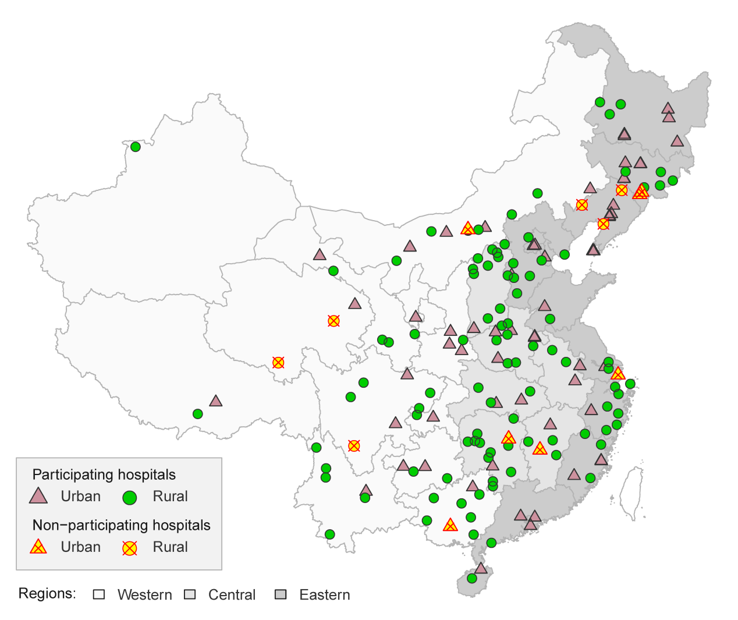
Supplementary Fig. 1. Geographic distribution of participating hospitals in the China PEACE-Retrospective AMI study.

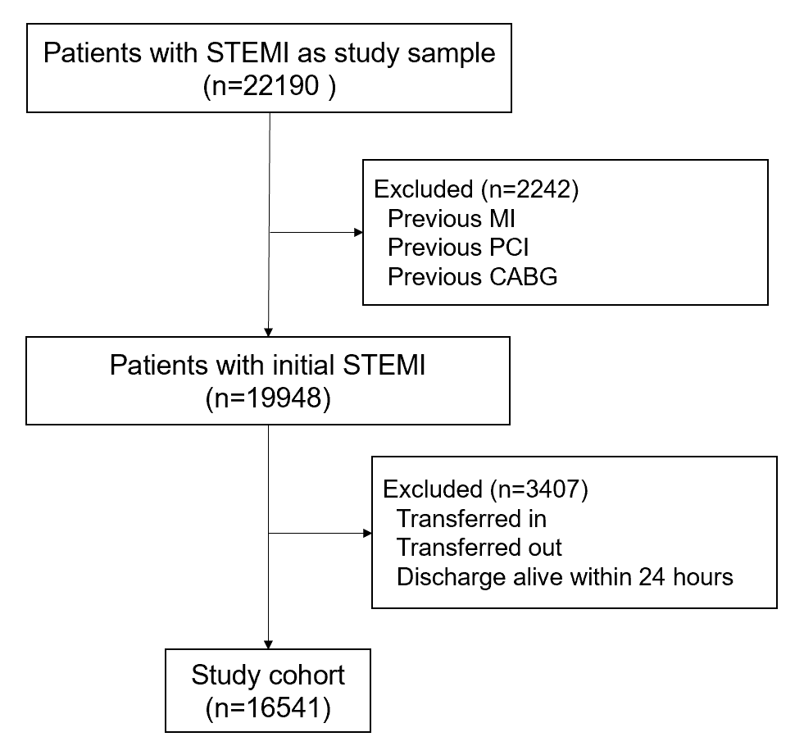
Supplementary Fig. 2. Study flow chart. STEMI indicates ST-segment elevation myocardial infarction; MI, myocardial infarction; PCI, percutaneous coronary intervention; CABG, coronary artery bypass grafting.

Supplementary Method 1. Eligible candidates for treatments.
Patients whose lengths of hospital stay did not exceed 24 hours were excluded for all the following treatments.
For the reperfusion therapy, we included patients who were admitted within 12 hours of symptom onset and did not receive reperfusion therapy before hospital presentation. Then we excluded patients with any contraindications (history of hemorrhagic stroke, active bleeding at presentation, or any other physician documented contraindications for fibrinolytic therapy if the patient was treated in a non-percutaneous coronary intervention [PCI] capable hospital; allergy to contrast agents or any other documented contraindication to PCI if the patient was treated in a PCI-capable hospital).
For aspirin, we excluded patients with any contraindications for aspirin (allergy to aspirin, active bleeding on admission, history of hemorrhagic stroke, or other documented contraindications).
For P2Y₁₂ inhibitor, we excluded patients who participated in the ClOpidogrel and Metoprolol in Myocardial Infarction Trial (COMMIT) or patients with any contraindications for P2Y₁₂ inhibitor (allergy to P2Y₁₂ inhibitor, active bleeding on admission, history of hemorrhagic stroke, or other documented contraindications).
For β-blockers, we excluded patients who participated in the ClOpidogrel and Metoprolol in Myocardial Infarction Trial (COMMIT) or patients with any contraindications for β-blockers (allergy to β-blocker, cardiogenic shock on admission, heart failure on admission, second or third-degree atrioventricular block with no pacemaker implanted, systolic blood pressure <100 mmHg on admission, bradycardia [heart rate <60 beats/min] on admission without taking a β-blocker, or other documented contraindications).
For angiotensin-converting enzyme (ACE) inhibitors or angiotensin receptor blockers (ARB), we excluded patients with any contraindications for ACE inhibitors (allergy to ACE inhibitors, hyperkalemia [serum potassium>5.5 mmol/L during hospitalization], creatinine >265 umol/L during hospitalization, pregnancy or breast feeding, hypotension or other documented contraindications).
For statins, we excluded patients who were allergic to statins.

Supplementary Table 1. Proportion of patients eligible for treatment according to SMuRF status among patients who survived the first 24 hours of admission.
Variables, N (%) | SMuRF-less | ≥1 SMuRF | P value
In-hospital aspirin | 2929 (99.4) | 12637 (99.4) | 0.935
In-hospital P2Y₁₂ inhibitor | 2922 (99.2) | 12611 (99.2) | 0.802
In-hospital DAPT | 2917 (99.0) | 12578 (98.9) | 0.833
In-hospital β-blocker | 2197 (74.6) | 10210 (80.3) | <0.001
In-hospital ACE inhibitor/ARB | 2756 (93.5) | 12228 (96.2) | <0.001
In-hospital statin | 2947 (100) | 12712 (100) | 1.000
In-hospital cardiac catheterization | 1627 (55.2) | 9244 (72.7) | <0.001
Reperfusion therapy | 1518 (51.5) | 6925 (54.5) | 0.004
Abbreviations: DAPT, dual antiplatelet therapy; ACE, angiotensin-converting enzyme; ARB, angiotensin receptor blocker.

Supplementary Table 2. In-hospital outcomes according to SMuRF status in the overall population.
In-hospital outcomes, N (%) | SMuRF-less | ≥1 SMuRF | P value
Mortality | 608/3288 (18.5) | 1389/13253 (10.5) | <0.001
Mortality within 24h | 341/3288 (10.4) | 540/13253 (4.1) | <0.001
Mortality after 24hª | 267/2947 (9.1) | 849/12713 (6.7) | <0.001
7-day mortality | 550/3288 (16.7) | 1173/13253 (8.9) | <0.001
Composite complications^{b} | 854/3288 (26.0) | 2512/13253 (19.0) | <0.001
Ventricular tachycardia/fibrillation | 156/3288 (4.7) | 563/13253 (4.2) | 0.211
Major bleeding | 24/3288 (0.7) | 109/13253 (0.8) | 0.595
Length of stay (days), Median (IQR) | 9 (5, 14) | 11 (7, 15) | <0.001
ª Among patients who survived after 24 hours of admission.
^{b} Composite complications include mortality, re-infarction, cardiogenic shock, ischemic stroke, or congestive heart failure.

Supplementary Table 3. Subgroup analysis for crude in-hospital mortality in the overall population.
Subgroup, N (%) | SMuRF-less | ≥1 SMuRF | P value
Age (years)
<40 | 9/79 (11.4) | 14/372 (3.8) | 0.012
40-59 | 87/789 (11.0) | 171/4345 (3.9) | <0.001
60-79 | 344/1873 (18.4) | 881/7158 (12.3) | <0.001
≥80 | 168/547 (30.7) | 323/1378 (23.4) | 0.001
Sex
Female | 276/1104 (25.0) | 628/3866 (16.2) | <0.001
Male | 332/2184 (15.2) | 761/9387 (8.1) | <0.001
Systolic blood pressure (mmHg)
<90 | 156/317 (49.2) | 224/581 (38.6) | 0.002
90-139 | 378/2365 (16.0) | 786/7652 (10.3) | <0.001
≥140 | 66/598 (11.0) | 365/4997 (7.3) | 0.001
Cardiogenic shock at admission
No | 439/2978 (14.7) | 1073/12450 (8.6) | <0.001
Yes | 169/310 (54.5) | 316/803 (39.4) | <0.001
Chest discomfort at admission
No | 109/348 (31.3) | 229/988 (23.2) | 0.003
Yes | 499/2940 (17.0) | 1160/12265 (9.5) | <0.001

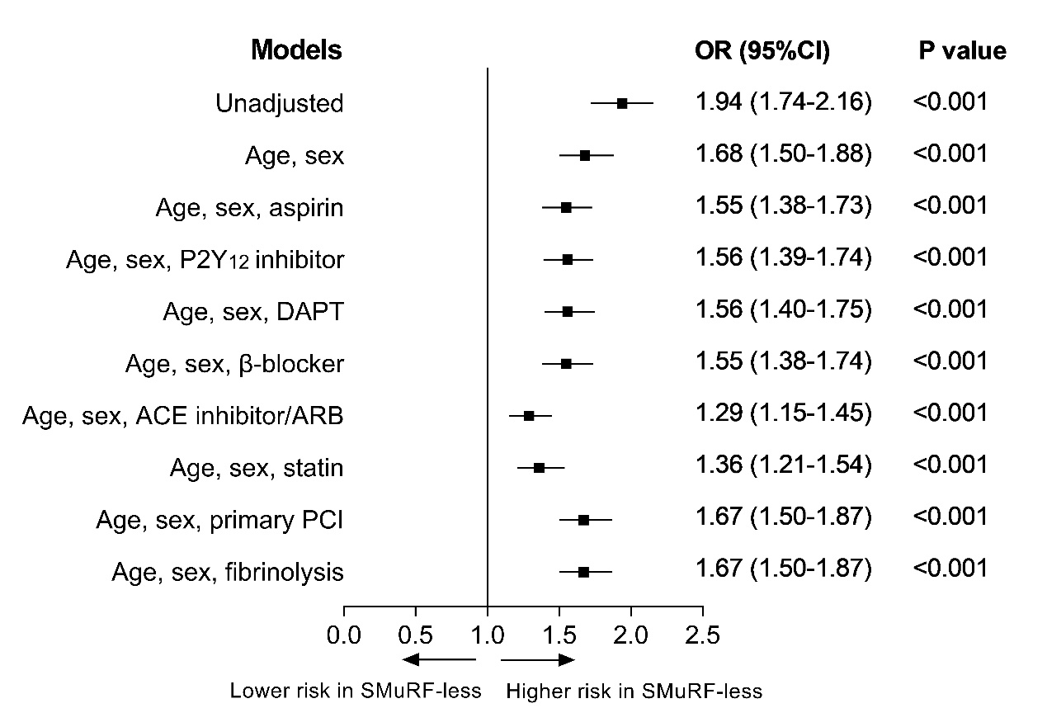
Supplementary Fig. 3. Associations between SMuRF-less status and in-hospital mortality analyzed with mixed models in order to examine the potential effect of each treatment during hospitalization. DAPT indicates dual antiplatelet therapy; ACE, angiotensin-converting enzyme; ARB, angiotensin receptor blocker; PCI, percutaneous coronary intervention.

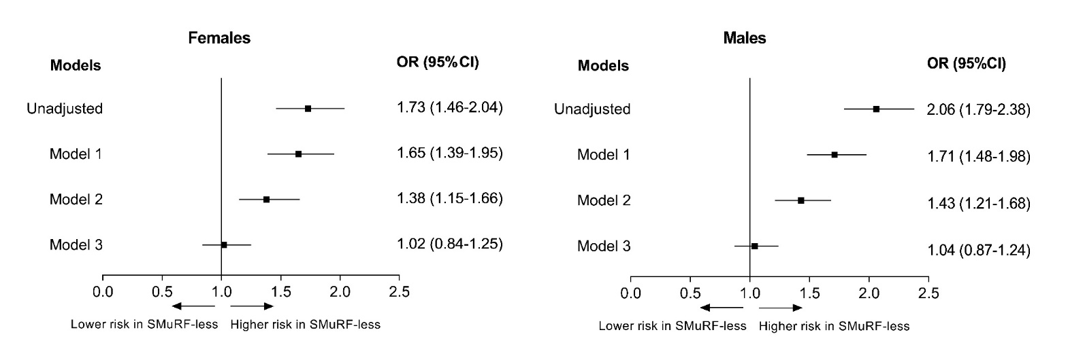
Supplementary Fig. 4. Associations between SMuRF-less status and in-hospital mortality stratified by sex. Model 1: adjusted for age; Model 2: adjusted for variables in model 1 plus clinical profiles (including previous stroke, previous atrial fibrillation, previous chronic renal disease, previous heart failure, previous peripheral arterial disease, chest discomfort, cardiac arrest at admission, cardiogenic shock at admission, stroke at admission, heart rate, and systolic blood pressure); Model 3: adjusted for variables in model 2 plus in-hospital pharmacotherapies (including aspirin, P2Y12 inhibitor, dual antiplatelet therapy, β-blocker, angiotensin-converting enzyme inhibitor/angiotensin receptor blocker, statin), and reperfusion therapy (fibrinolytic therapy, primary percutaneous coronary intervention).

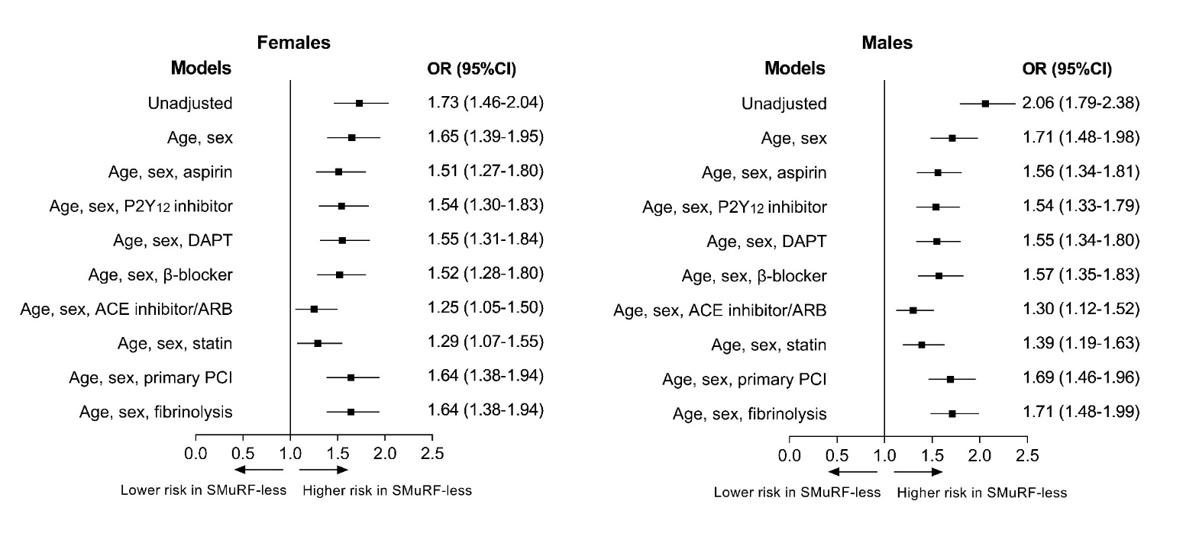
Supplementary Fig. 5. Associations between SMuRF-less status and in-hospital mortality stratified by sex analyzed with mixed models in order to examine the potential effect of each treatment during hospitalization. DAPT indicates dual antiplatelet therapy; ACE, angiotensin-converting enzyme; ARB, angiotensin receptor blocker; PCI, percutaneous coronary intervention.

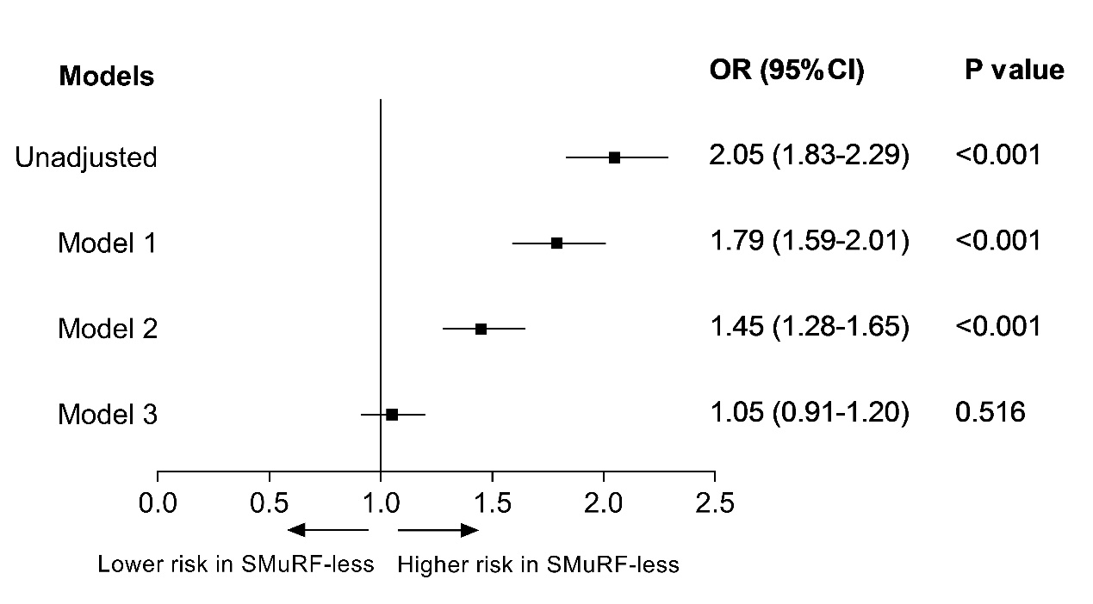
Supplementary Fig. 6. Associations between SMuRF-less status and 7-day mortality. Model 1: adjusted for age and sex; Model 2: adjusted for variables in model 1 plus clinical profiles (including previous stroke, previous atrial fibrillation, previous chronic renal disease, previous heart failure, previous peripheral arterial disease, chest discomfort, cardiac arrest at admission, cardiogenic shock at admission, stroke at admission, heart rate, and systolic blood pressure); Model 3: adjusted for variables in model 2 plus in-hospital pharmacotherapies (including aspirin, P2Y12 inhibitor, dual antiplatelet therapy, β-blocker, angiotensin-converting enzyme inhibitor/angiotensin receptor blocker, statin), and reperfusion therapy (fibrinolytic therapy, primary percutaneous coronary intervention).

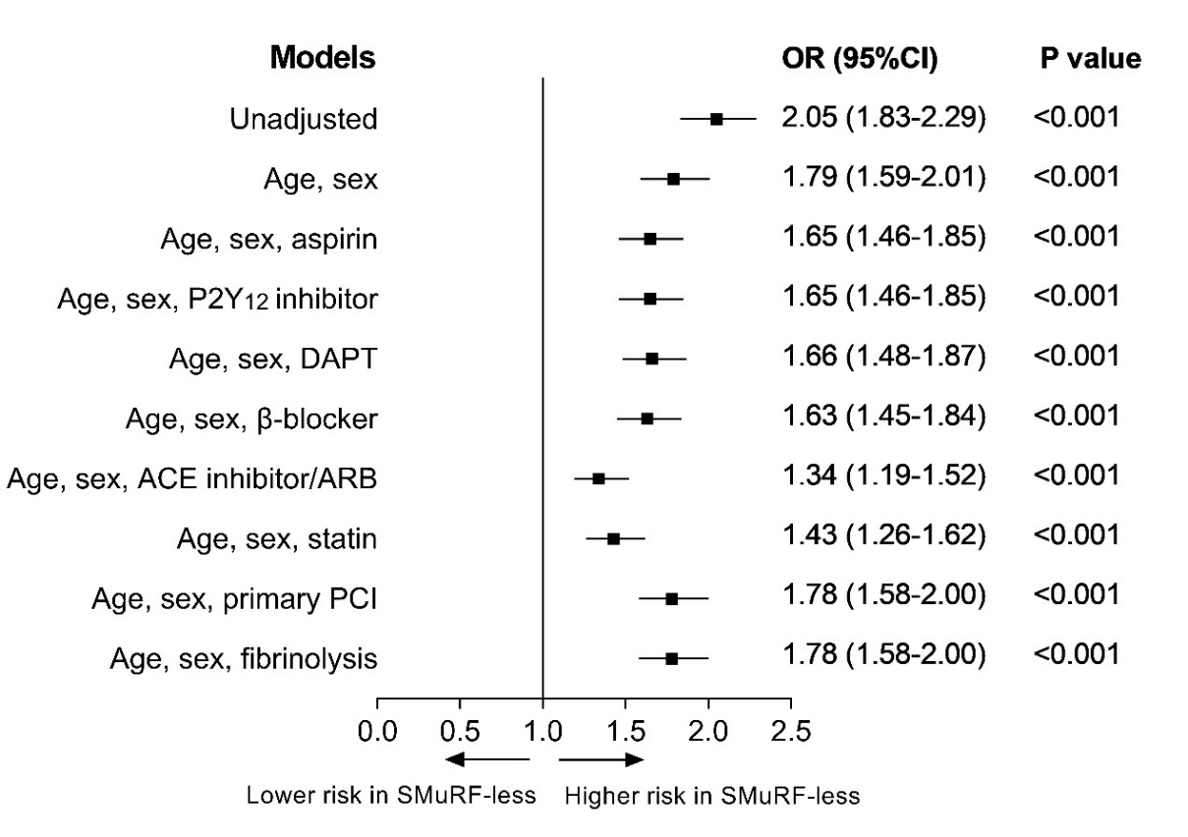
Supplementary Fig. 7. Associations between SMuRF-less status and 7-day mortality analyzed with mixed models in order to examine the potential effect of each treatment during hospitalization. DAPT indicates dual antiplatelet therapy; ACE, angiotensin-converting enzyme; ARB, angiotensin receptor blocker; PCI, percutaneous coronary intervention.

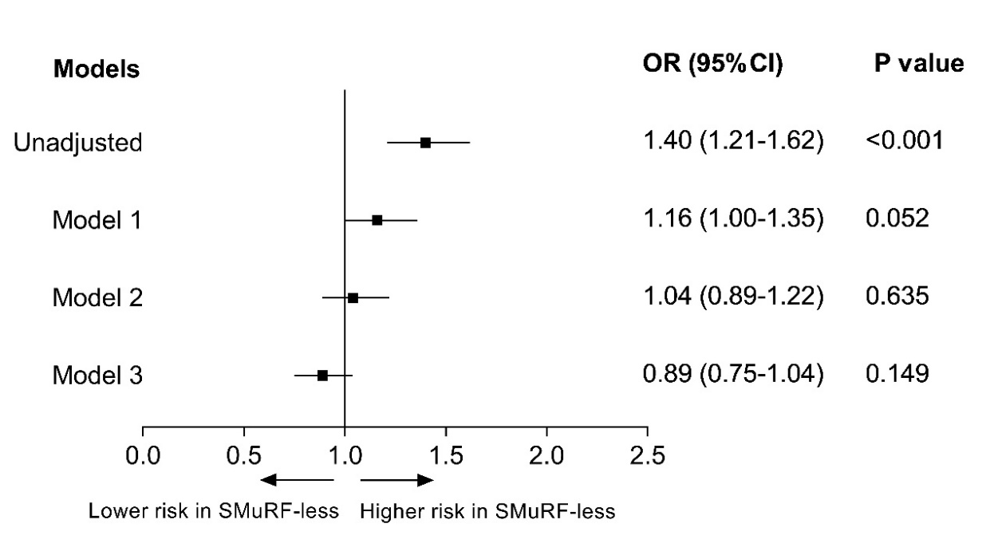
Supplementary Fig. 8. Associations between SMuRF-less status and in-hospital mortality for patients who survived the first 24 hours of admission. Model 1: adjusted for age and sex; Model 2: adjusted for variables in model 1 plus clinical profiles (including previous stroke, previous atrial fibrillation, previous chronic renal disease, previous heart failure, previous peripheral arterial disease, chest discomfort, cardiac arrest at admission, cardiogenic shock at admission, stroke at admission, heart rate, and systolic blood pressure); Model 3: adjusted for variables in model 2 plus in-hospital pharmacotherapies (including aspirin, P2Y12 inhibitor, dual antiplatelet therapy, β-blocker, angiotensin-converting enzyme inhibitor/angiotensin receptor blocker, statin), and reperfusion therapy (fibrinolytic therapy, primary percutaneous coronary intervention).

Supplementary Table 4. Mediation analysis of the associations between SMuRF-less status and mortality within 24 hours of admission.
 | Proportion mediated effect, %ª
Total indirect effect^{b} | 57.9%
Indirect effect through:
Clinical profiles | 18.2%
Systolic blood pressure | 7.6%
Cardiogenic shock at admission | 1.3%
Treatments within 24 hours | 39.6%
P2Y₁₂ inhibitor within 24 hours | 13.0%
DAPT within 24 hours | 11.9%
Aspirin within 24 hours | 8.5%
ACE inhibitor/ARB within 24 hours | 8.1%
Statin within 24 hours | 4.3%
β-blocker within 24 hours | 4.1%
Primary PCI | 2.5%
ª The percent explained is listed for the total indirect effects of SMuRF-less status on the mortality within 24 hours of admission as compared with SMuRF status and for each mediator included in the analysis.
^{b} The sum of the percent explained effects of the individual mediators may not equal the total indirect effect because of correlation and overlapping mediation effects among mediators that is reflected in the total indirect effect but not the individual mediators.
Abbreviations: DAPT, dual antiplatelet therapy; ACE, angiotensin-converting enzyme; ARB, angiotensin receptor blocker; PCI, percutaneous coronary intervention.

