Supplementary material

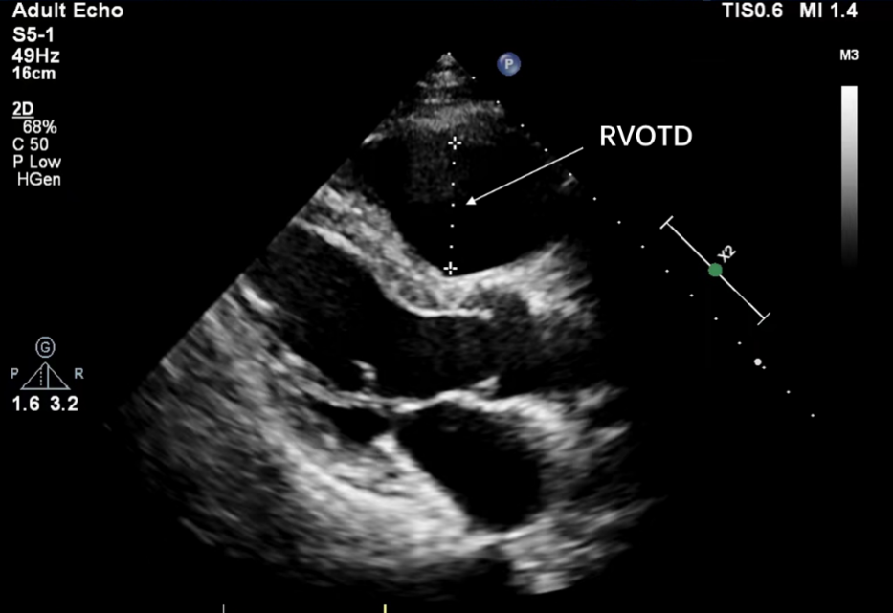
Supplementary Fig. 1. Two-dimensional RVOTD measurements obtained from the parasternal long-axis (PSLAX) view in end-diastole [1].

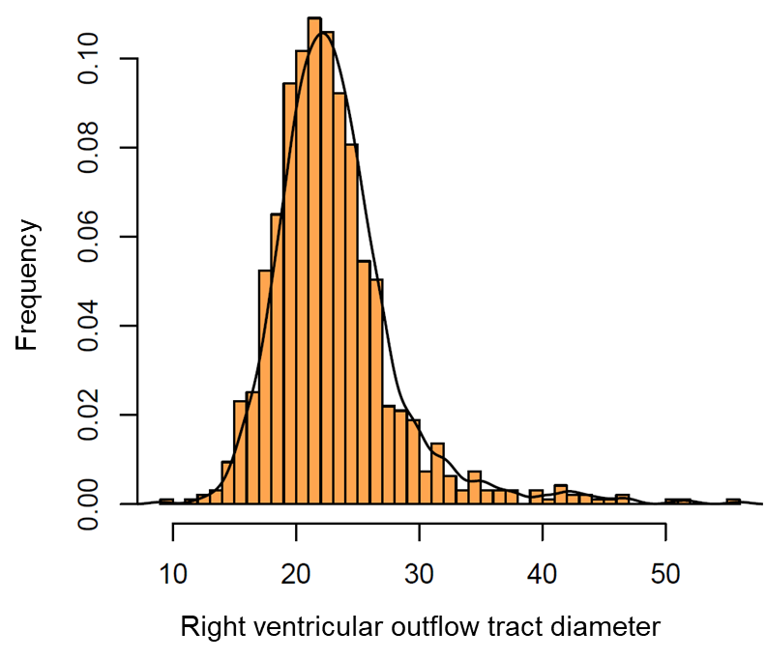
Supplementary Fig. 2. Distribution of right ventricular diameter in the whole population.

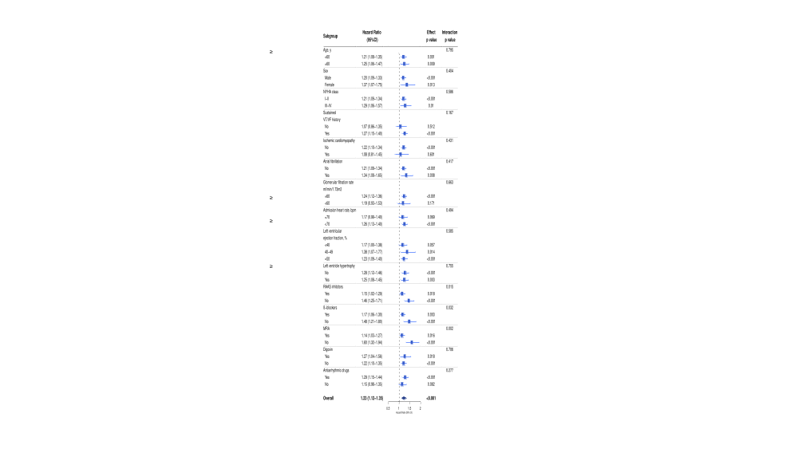
Supplementary Fig. 3. Association between RVOTD and the risk of VT/VF in subgroups.

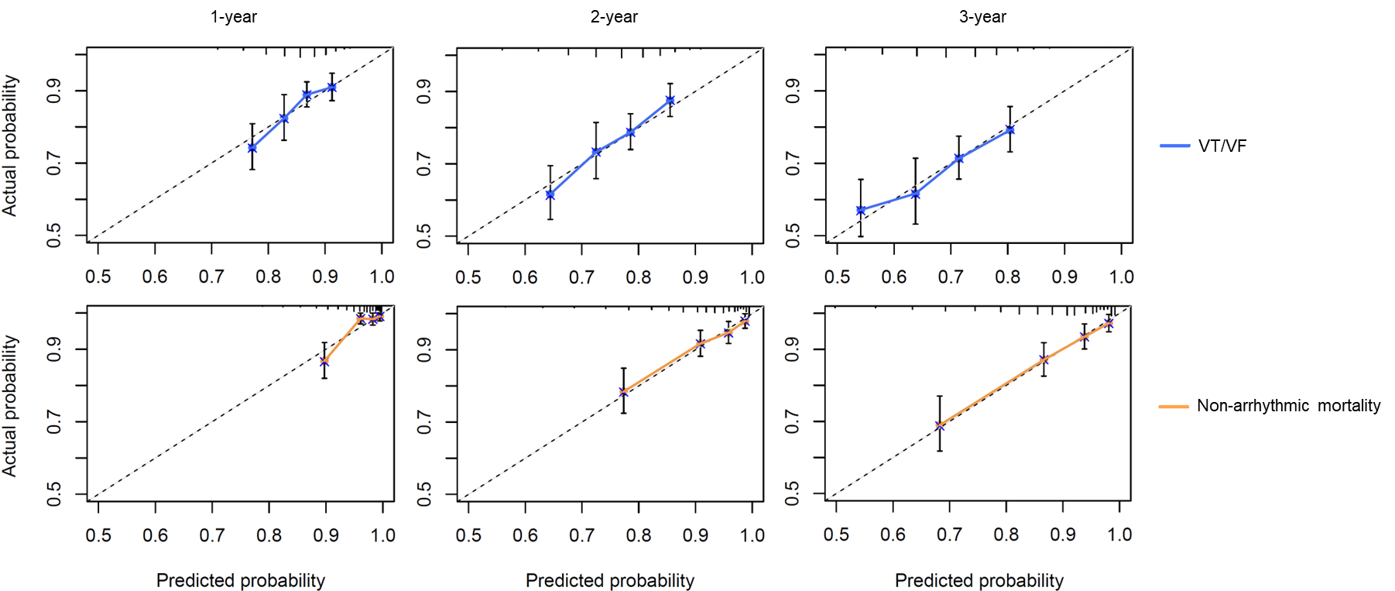
Supplementary Fig. 4. Calibration curves for the predicted and actual probability of free from VT/VF and non-arrhythmic mortality by RVOTD-ICD risk score in 1, 2, and 3 years’ time.

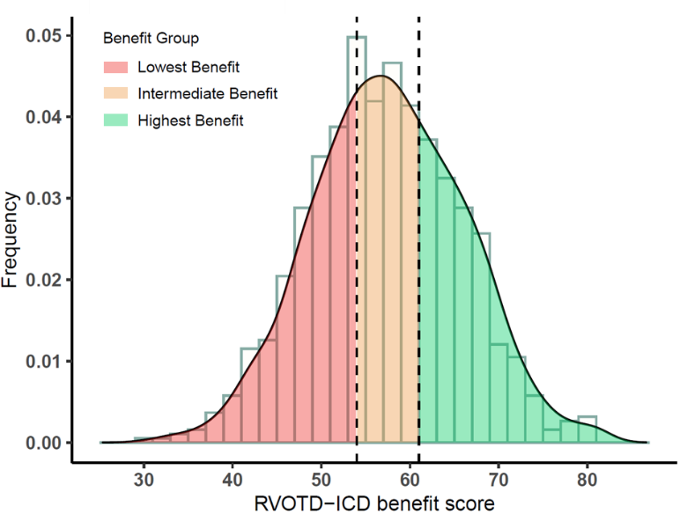
Supplementary Fig. 5. Distribution of RVOTD-ICD benefit score in the whole population.

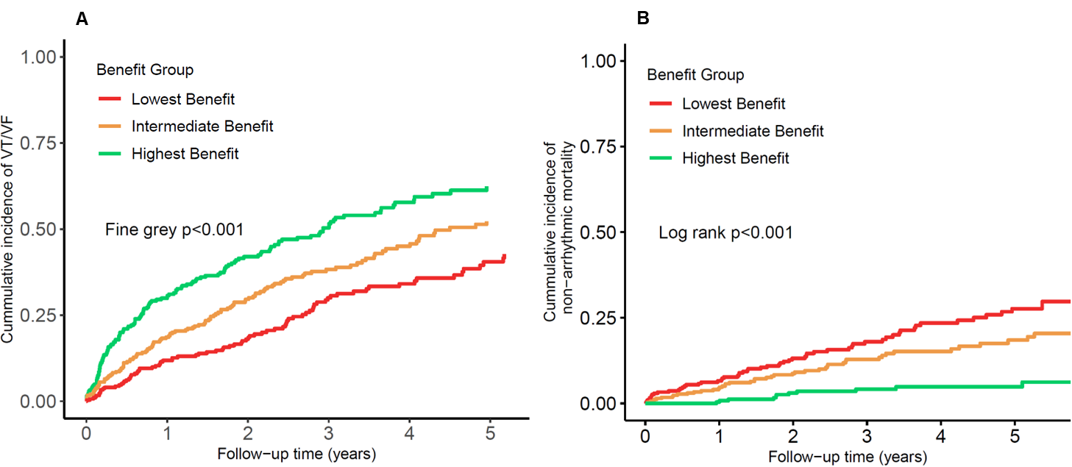
Supplementary Fig. 6. Cumulative incidence of ventricular tachyarrhythmia (including anti-tachycardia pacing) (A) and Non-arrhythmic Mortality (B) among the three RVOTD-ICD benefit score groups.

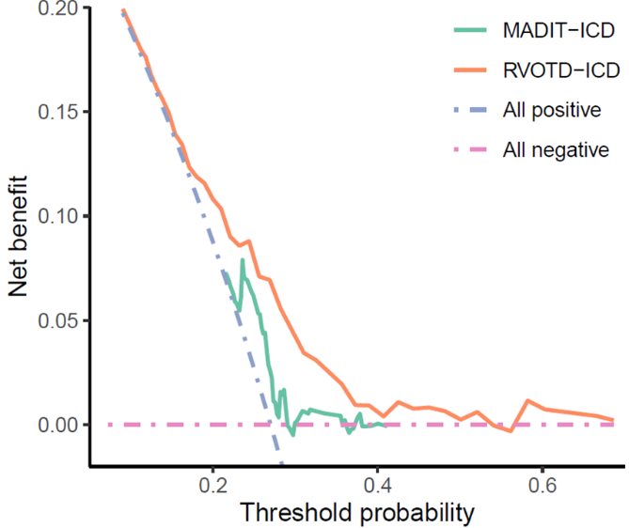
Supplementary Fig. 7. Decision curve analysis for the MADIT-ICD and RVOTD-ICD benefit scores in 5 years’ all-cause mortality.

Supplementary Table 1. Association of RVOTD and other possible risk factors with the risk of VT/VF and non-arrhythmic mortality.
Parameters | VT/VF risk |  |  |  | Non-arrhythmic Mortality
 | Univariable  analysis  HR (95% CI) | P value | Multivariable analysis  HR (95% CI) | P value | Univariable analysis  HR (95% CI) | P value | Multivariable  analysis  HR (95% CI) | P value
Seattle proportional risk model
Age (per decade older) | 0.87 (0.80-0.94) | <0.001 |  |  | 1.29 (1.12-1.48) | <0.001
Male sex | 1.47 (1.08-2.01) | 0.016 |  |  | 0.88 (0.59-1.31) | 0.521
Diabetes | 0.73 (0.53-1.02) | 0.068 |  |  | 1.73 (1.17-2.54) | 0.005 | 1.60 (1.09-2.37) | 0.017
LV Ejection fraction (per 10% increase) | 0.95 (0.87-1.03) | 0.172 |  |  | 0.67 (0.58-0.77) | <0.001
SBP (per 10 mmHg below 140) | 1.08 (1.00-1.08) | 0.049 |  |  | 1.15 (1.02-1.30) | 0.022
Serum sodium level (each mEq/L below 145) | 1.02 (0.98-1.06) | 0.289 |  |  | 1.05 (0.99-1.11) | 0.102
Creatinine (mg/dL) | 1.00 (0.99-1.01) | 0.952 |  |  | 1.00 (1.00-1.01) | 0.547
NYHA I/II | 1.12 (0.88-1.43) | 0.358 |  |  | 0.29 (0.20-0.41) | <0.001 | 0.51 (0.34-0.77) | 0.001
Body mass index (per 5 kg/m² increase) | 1.00 (0.85-1.18) | 0.993 |  |  | 0.88 (0.69-1.12) | 0.308
Digoxin use | 1.08 (0.83-1.40) | 0.579 |  |  | 1.80 (1.27-2.54) | <0.001
MADIT-ICD VT/VF score & MADIT-ICD non-arrhythmic mortality score
Age<75 years | 2.27 (1.35-3.81) | 0.002 | 2.29 (1.36-3.86) | 0.002 | 0.51 (0.33-0.79) | 0.003 | 0.60 (0.38-0.95) | 0.030
Male sex | As above |  |  |  | As above
SBP<140 mmHg | 1.29 (0.88-1.89) | 0.186 |  |  | 1.11 (0.66-1.88) | 0.685
Heart rate>75 bpm | 1.23 (0.94-1.61) | 0.127 |  |  | 1.16 (0.78-1.72) | 0.457
Arial arrhythmia | 1.09 (0.85-1.40) | 0.483 |  |  | 1.50 (1.06-2.12) | 0.023
Myocardial infarction | 0.73 (0.57-0.94) | 0.013 |  |  | 1.14 (0.82-1.61) | 0.444
prior NSVT | 1.62 (1.02-2.58) | 0.043 | 1.63 (1.02-2.61) | 0.039
prior VT/VF | 1.77 (1.20-2.61) | 0.004 | 1.85 (1.25-2.72) | 0.002 | 0.58 (0.39-0.86) | 0.006
LVEF≤25% | 1.09 (0.75-1.59) | 0.649 |  |  | 2.06 (1.32-3.20) | 0.001
NYHA class≥II | 0.93 (0.67-1.29) | 0.660 |  |  | 2.43 (1.24-4.78) | 0.010
Diabetes | As above |  |  |  | As above
Body mass index  <23 kg/m² | 0.99 (0.77-1.27) | 0.901 |  |  | 1.28 (0.90-1.81) | 0.174
Other medications
RAAS inhibitors | 1.18 (0.91-1.53) | 0.215 |  |  | 0.65 (0.46-0.91) | 0.014 | 0.62 (0.44-0.88) | 0.008
β-blocker | 0.84 (0.58-1.21) | 0.352 |  |  | 0.86 (0.51-1.45) | 0.577
Diuretic | 1.34 (1.02-1.77) | 0.037 |  |  | 2.07 (1.30-3.29) | 0.002
Mineralocorticoid  receptor antagonist | 1.33 (1.03-1.72) | 0.026 |  |  | 1.13 (0.78-1.62) | 0.517
Digoxin | 1.08 (0.83-1.40) | 0.579 |  |  | 1.80 (1.28-2.53) | 0.001
Antiarrhythmic drugs | 1.16 (0.91-1.48) | 0.222 |  |  | 0.98 (0.69-1.38) | 0.891
Echocardiographic parameters
LVEDD | 1.14 (1.01-1.29) | 0.028 |  |  | 1.63 (1.38-1.93) | <0.001 | 1.39 (1.16-1.66) | <0.001
LVPWT | 0.99 (0.93-1.06) | 0.858 |  |  | 0.98 (0.89-1.07) | 0.611
IVST | 0.98 (0.95-1.01) | 0.267 |  |  | 0.91 (0.75-1.11) | 0.358
LAD | 1.11 (0.99-1.24) | 0.080 |  |  | 1.47 (1.27-1.70) | <0.001
RVOTD | 1.23 (1.12-1.35) | <0.001 | 1.22 (1.11-1.33) | 0.002 | 0.97 (0.82-1.13) | 0.680
Laboratory parameters
ln (NT-proBNP) | 1.00 (0.80-1.23) | 0.952 |  |  | 5.16 (3.55-7.53) | <0.001 | 3.03 (2.00-4.58) | <0.001
hs-cTnI (per 1 SD) | 0.92 (0.79-1.07) | 0.287 |  |  | 1.08 (1.00-1.17) | 0.053
hs-CRP (per 1 SD) | 1.02 (0.91-1.14) | 0.763 |  |  | 1.29 (1.12-1.48) | <0.001
All continuous variables are included per SD unless specified otherwise. Single variable validated in more than one different risk models (e.g. age) only entered once into multivariable analysis. IVST, interventricular septal thickness; LVPWT, left ventricular posterior wall thickness; other abbreviations as in Table 1.

Supplementary Table 2. Association Between Right Ventricular Outflow Tract Diameter Levels and Outcomes (ATP included).
Group | Event rate  (per 100 person-year) | Unadjusted  HR (95% CI) | p  value | SPRM adjusted*  HR (95% CI) | p  value | MADIT-ICD adjusted†  HR (95% CI) | p  value
VT/VF events | 16.89 (15.21-18.72)
Lower median | 13.83 (11.79-16.12) | Reference |  | Reference |  | Reference
Higher median | 20.60 (17.85-23.64) | 1.37 (1.11-1.68) | 0.003 | 1.33 (1.07-1.63) | 0.008 | 1.24 (1.00-1.53) | 0.046
per 1 SD increase |  | 1.19 (1.09-1.29) | <0.001 | 1.14 (1.04-1.24) | 0.004 | 1.14 (1.04-1.24) | 0.005
*SPRM adjusted model initially included RVOTD and all the variables in Seattle Proportional Risk Model (male sex, younger age, no diabetes, lower left ventricular ejection fraction, systolic blood pressure, lower creatinine level, serum sodium level, better NYHA functional class, body mass index and digoxin use).
†For VT/VF events, MADIT-ICD adjusted model initially included RVOTD and all the variables in MADIT-ICD VT/VF score (LVEF<25%, atrial arrhythmia, heart rate >75 bpm, SBP <140 mmHg, myocardial infarction, age<75 years, male, and prior sustained VT/VF), which were then backward selected based on AIC rule; For non-arrhythmic mortality, MADIT-ICD adjusted model initially included RVOTD and all the variables in MADIT-ICD non-arrhythmic mortality score (NYHA≥II, diabetes, BMI<23kg/m², atrial arrhythmia, LVEF≤25%, age≥75), which were then backward selected based on AIC rule.

Supplementary Table 3. Comparison of Area under Receiver Operating Characteristic Curve and Net Reclassification Improvement (NRI) for VT/VF and Non-arrhythmic Mortality between MADIT-ICD and RVOTD-ICD risk scores.
Full cohort | VT/VF score |  |  |  | Non-arrhythmic mortality score
 | AUC (95% CI) | P value | NRI (%, 95%CI) | P value | AUC (95% CI) | P value | NRI (%, 95%CI) | P value
1-year
MADIT-ICD | 0.57 (0.52-0.62) | 0.029 | Ref. | 0.020 | 0.69 (0.60-0.77) | 0.006 | Ref. | <0.001
RVOTD-ICD | 0.64 (0.59-0.70) |  | 16.1 (1.3-28.0) |  | 0.81 (0.73-0.88) |  | 42.4 (17.2-55.7)
2-year
MADIT-ICD | 0.56 (0.51-0.60) | 0.008 | Ref. | 0.020 | 0.66 (0.60-0.72) | 0.007 | Ref. | <0.001
RVOTD-ICD | 0.64 (0.59-0.68) |  | 16.3 (2.6-28.1) |  | 0.75 (0.69-0.81) |  | 31.7 (10.5-42.6)
3-year
MADIT-ICD | 0.56 (0.51-0.61) | 0.103 | Ref. | 0.020 | 0.65 (0.59-0.71) | <0.001 | Ref. | <0.001
RVOTD-ICD | 0.62 (0.57-0.66) |  | 12.1 (1.7-23.4) |  | 0.78 (0.73-0.83) |  | 39.5 (22.2-50.3)

Supplementary Table 4. Observed VT/VF and non-arrhythmic mortality risk in primary and secondary prevention groups.
RVOTD-benefit group | At 1 year |  | At 2 years |  | At 3 years
RVOTD-benefit group | VT/VF | Non-arrhythmic  Mortality | VT/VF | Non-arrhythmic  mortality | VT/VF | Non-arrhythmic  mortality
Primary prevention
observed rate (%) | 10.9 | 5.3 | 18.3 | 11.2 | 25.9 | 16.9
95% CI | 7.7-14.8 | 2.7-7.8 | 13.8-23.3 | 7.4-14.9 | 20.1-30.0 | 12.0-21.6
Secondary prevention
observed rate (%) | 16.3 | 3.0 | 25.3 | 7.4 | 31.8 | 10.1
95% CI | 13.4-19.4 | 1.6-4.4 | 21.7-29.0 | 5.2-9.6 | 27.7-36.0 | 7.4-12.8

Supplementary Table 5. Net benefit of using MADIT-ICD and RVOTD-ICD benefit score for identifying all-cause mortality conditional on different decision thresholds.
Decision threshold (%) | Net benefit vs all negative
Decision threshold (%) | All positive | MADIT-ICD | RVOTD-ICD
20 | 0.073 | 0.072 | 0.103
25 | 0.025 | 0.059 | 0.071
30 | -0.042 | 0.001 | 0.045
35 | -0.132 | 0.004 | 0.019
40 | -0.217 | 0.001 | 0.004

Reference
1. Addetia K, Miyoshi T, Citro R, et al. Two-Dimensional Echocardiographic Right Ventricular Size and Systolic Function Measurements Stratified by Sex, Age, and Ethnicity: Results of the World Alliance of Societies of Echocardiography Study. Journal of the American Society of Echocardiography : official publication of the American Society of Echocardiography. 2021; 34: 1148-1157.e1141.

