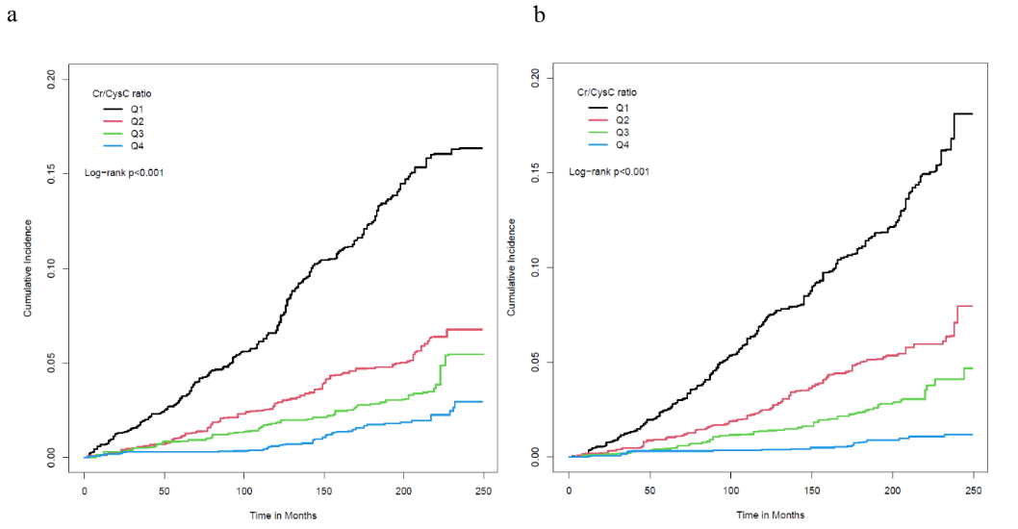
Supplementary Figure 1. Cumulative incidence of CVD mortality presented by gender. (a) Cumulative incidence of CVD mortality in male participates. (b) Cumulative incidence of CVD mortality in female participates.

Supplementary table 1. Univariate and multivariate logistic regression model of Cr/CysC ratio (per SD increase) for CVD morbidity presented by gender
Outcomes | Unadjusted model |  |  | Adjusted modelª
Outcomes | OR^{b} (95% CI) | p-value |  | OR^{b} (95% CI) | p-value
Male
CVDs | 0.41 (0.35, 0.48) | <0.001 |  | 0.73 (0.55, 0.97) | 0.033
Heart Failure | 0.36 (0.28, 0.46) | <0.001 |  | 0.42 (0.27, 0.65) | <0.001
Coronary Heart Disease | 0.48 (0.41, 0.57) | <0.001 |  | 0.97 (0.79, 1.19) | 0.763
Angina Pectoris | 0.42 (0.33, 0.54) | <0.001 |  | 0.75 (0.51, 1.09) | 0.122
Myocardial Infarction | 0.44 (0.35, 0.56) | <0.001 |  | 0.73 (0.50, 1.07) | 0.100
Stroke | 0.37 (0.29, 0.48) | <0.001 |  | 0.52 (0.35, 0.77) | 0.002
Female
CVDs | 0.45 (0.39, 0.52) | <0.001 |  | 0.62 (0.49, 0.78) | <0.001
Heart Failure | 0.31 (0.25, 0.38) | <0.001 |  | 0.39 (0.25, 0.61) | <0.001
Coronary Heart Disease | 0.44 (0.33, 0.58) | <0.001 |  | 0.70 (0.44, 1.10) | 0.120
Angina Pectoris | 0.52 (0.42, 0.65) | <0.001 |  | 0.83 (0.61, 1.11) | 0.198
Myocardial Infarction | 0.44 (0.35, 0.56) | <0.001 |  | 0.69 (0.48, 1.00) | 0.053
Stroke | 0.49 (0.36, 0.65) | <0.001 |  | 0.51 (0.35, 0.75) | 0.001
ª Adjusted for age, gender, and ethnicity, SBP, LDL-C, BMI, HbA1c, smoking, eGFR.
^{b} Odds ratio of Cr/CysC ratio (per SD increase)
Due to missing data, 768 participants are excluded from the adjusted model

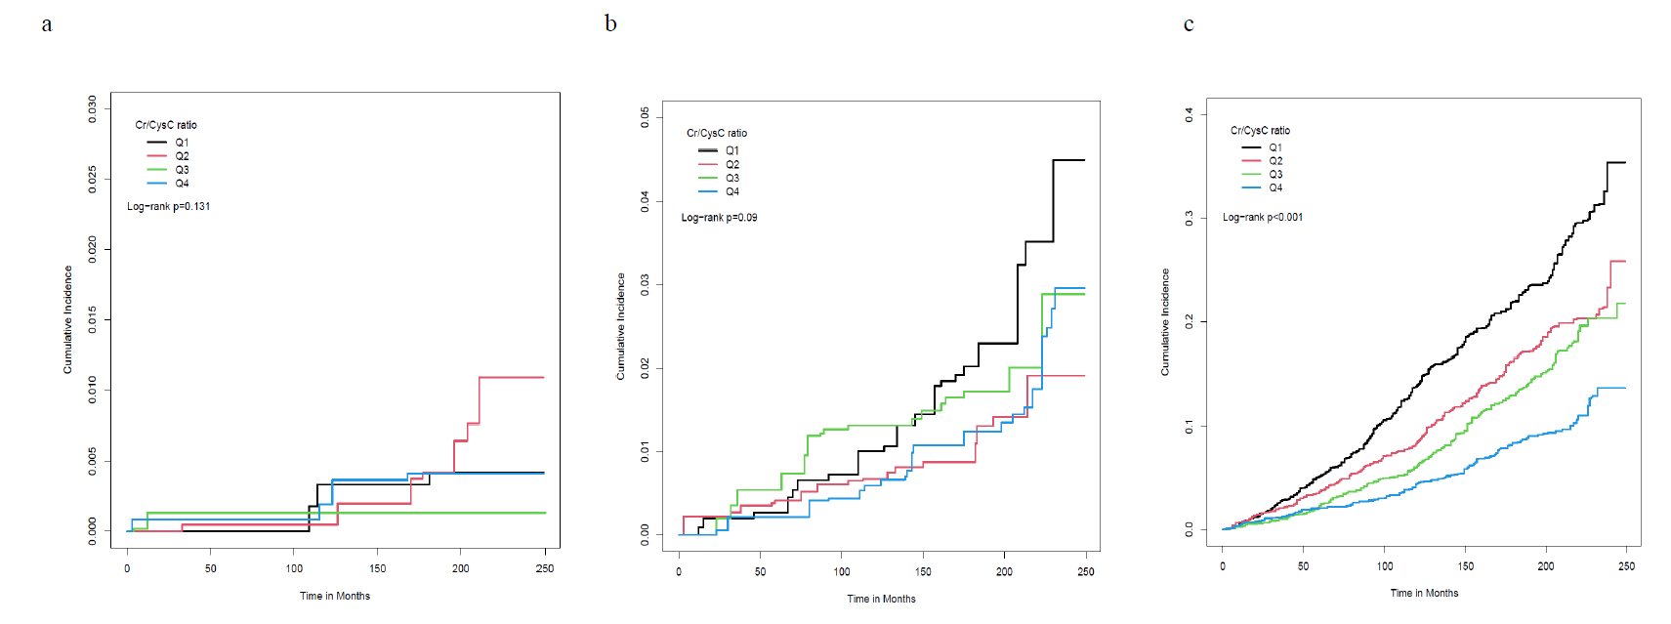
Supplementary Figure 2. Cumulative incidence of CVD mortality presented by age. (a) Cumulative incidence of CVD mortality in participates younger than 37 years older. (b) Cumulative incidence of CVD mortality in participates between 37 and 52 years older. (c) Cumulative incidence of CVD mortality in participates elder than 52 years older.

Supplementary Table 2. Univariate and multivariate logistic regression model of Cr/CysC ratio (per SD increase) for CVD morbidity presented by age
Outcomes | Unadjusted model |  |  | Adjusted modelª
Outcomes | OR^{b} (95% CI) | p-value |  | OR^{b} (95% CI) | p-value
Age tertile 1
CVDs | 0.60 (0.44, 0.84) | 0.003 |  | 0.50 (0.28, 0.90) | 0.022
Heart Failure | 0.60 (0.32, 1.12) | 0.108 |  | 1.01 (0.27, 3.72) | 0.993
Coronary Heart Disease | 0.38 (0.26, 0.54) | <0.001 |  | 1.17 (0.90, 1.54) | 0.234
Angina Pectoris | 0.91 (0.48, 1.73) | 0.763 |  | 0.64 (0.27, 1.53) | 0.308
Myocardial Infarction | 0.66 (0.42, 1.04) | 0.071 |  | 0.80 (0.32, 2.01) | 0.631
Stroke | 0.57 (0.37, 0.89) | 0.014 |  | 0.43 (0.18, 1.03) | 0.058
Age tertile 2
CVDs | 0.57 (0.45, 0.73) | <0.001 |  | 0.61 (0.43, 0.86) | 0.007
Heart Failure | 0.47 (0.28, 0.77) | 0.004 |  | 0.36 (0.16, 0.83) | 0.018
Coronary Heart Disease | 0.86 (0.56, 1.31) | 0.472 |  | 0.96 (0.62, 1.48) | 0.839
Angina Pectoris | 0.53 (0.37, 0.74) | <0.001 |  | 0.58 (0.32, 1.06) | 0.073
Myocardial Infarction | 0.66 (0.45, 0.97) | 0.034 |  | 0.70 (0.39, 1.26) | 0.221
Stroke | 0.50 (0.26, 0.93) | 0.030 |  | 0.50 (0.23, 1.09) | 0.079
Age tertile 3
CVDs | 0.80 (0.70, 0.91) | <0.001 |  | 0.67 (0.53, 0.84) | 0.001
Heart Failure | 0.56 (0.45, 0.68) | <0.001 |  | 0.39 (0.29, 0.54) | <0.001
Coronary Heart Disease | 1.00 (0.89, 1.12) | 0.952 |  | 0.83 (0.63, 1.08) | 0.153
Angina Pectoris | 0.87 (0.74, 1.02) | 0.089 |  | 0.77 (0.60, 0.98) | 0.034
Myocardial Infarction | 0.95 (0.82, 1.12) | 0.550 |  | 0.69 (0.50, 0.97) | 0.032
Stroke | 0.62 (0.50, 0.77) | <0.001 |  | 0.52 (0.38, 0.71) | <0.001
ª Adjusted for age, gender, and ethnicity, SBP, LDL-C, BMI, HbA1c, smoking, eGFR.
^{b} Odds ratio of Cr/CysC ratio (per SD increase)
Due to missing data, 768 participants are excluded from the adjusted model
Age tertile 1: participates younger than 37 years older; Age tertile 2: participates between 37 and 52 years older; Age tertile 3: participates elder than 52 years older
Supplementary Table 3. Univariate and multivariate logistics regression model of Cr/CysC ratio (per SD increase) for CVD morbidity
Outcomes | Unadjusted model |  |  | Adjusted modelª
Outcomes | OR^{b} (95% CI) | p-value |  | OR^{b} (95% CI) | p-value
CRP>=1.0 mg/dL
CVDs | 0.48 (0.35, 0.65) | <0.001 |  | 0.45 (0.26, 0.79) | 0.007
Heart Failure | 0.35 (0.23, 0.52) | <0.001 |  | 0.31 (0.16, 0.59) | <0.001
Coronary Heart Disease | 0.42 (0.28, 0.63) | <0.001 |  | 0.39 (0.18, 0.86) | 0.021
Angina Pectoris | 0.49 (0.30, 0.78) | 0.004 |  | 0.63 (0.32, 1.23) | 0.166
Myocardial Infarction | 0.75 (0.49, 1.17) | 0.201 |  | 0.41 (0.19, 0.90) | 0.028
Stroke | 0.30 (0.19, 0.47) | <0.001 |  | 0.19 (0.09, 0.37) | <0.001
CRP<1.0 mg/dL
CVDs | 0.52 (0.46, 0.59) | <0.001 |  | 0.70 (0.55, 0.88) | 0.003
Heart Failure | 0.43 (0.35, 0.53) | <0.001 |  | 0.42 (0.29, 0.61) | <0.001
Coronary Heart Disease | 0.67 (0.57, 0.77) | <0.001 |  | 0.96 (0.80, 1.16) | 0.687
Angina Pectoris | 0.56 (0.48, 0.67) | <0.001 |  | 0.79 (0.6, 1.05) | 0.097
Myocardial Infarction | 0.59 (0.49, 0.71) | <0.001 |  | 0.76 (0.55, 1.05) | 0.094
Stroke | 0.48 (0.38, 0.60) | <0.001 |  | 0.57 (0.40, 0.81) | 0.003
a Adjusted for age, gender, and ethnicity, SBP, LDL-C, BMI, HbA1c, smoking, eGFR.
b Odds ratio of Cr/CysC ratio (per SD increase)

Supplementary Table 4. Univariate and multivariate logistics regression model of Cr/CysC ratio (per SD increase) for CVD morbidity
Outcomes | Unadjusted model |  |  | Adjusted modelª
Outcomes | OR^{b} (95% CI) | p-value |  | OR^{b} (95% CI) | p-value
Malignancy
CVDs | 0.52 (0.39, 0.69) | <0.001 |  | 0.44 (0.27, 0.74) | 0.003
Heart Failure | 0.43 (0.24, 0.77) | 0.006 |  | 0.23 (0.09, 0.61) | 0.004
Coronary Heart Disease | 0.72 (0.49, 1.07) | 0.098 |  | 0.71 (0.41, 1.26) | 0.233
Angina Pectoris | 0.53 (0.35, 0.82) | 0.005 |  | 0.42 (0.22, 0.80) | 0.009
Myocardial Infarction | 0.74 (0.52, 1.04) | 0.084 |  | 0.67 (0.39, 1.17) | 0.154
Stroke | 0.45 (0.27, 0.75) | 0.003 |  | 0.43 (0.19, 0.97) | 0.042
Without malignancy
CVDs | 0.53 (0.47, 0.59) | <0.001 |  | 0.68 (0.55, 0.85) | 0.001
Heart Failure | 0.42 (0.35, 0.50) | <0.001 |  | 0.42 (0.32, 0.55) | <0.001
Coronary Heart Disease | 0.65 (0.56, 0.74) | <0.001 |  | 0.91 (0.72, 1.14) | 0.398
Angina Pectoris | 0.58 (0.49, 0.68) | <0.001 |  | 0.84 (0.65, 1.08) | 0.161
Myocardial Infarction | 0.61 (0.51, 0.73) | <0.001 |  | 0.71 (0.51, 0.97) | 0.032
Stroke | 0.46 (0.36, 0.57) | <0.001 |  | 0.50 (0.36, 0.69) | <0.001
ª Adjusted for age, gender, and ethnicity, SBP, LDL-C, BMI, HbA1c, smoking, eGFR.
^{b} Odds ratio of Cr/CysC ratio (per SD increase)

Supplementary Table 5. Univariate and multivariate Cox regression analysis of Cr/CysC ratio (per SD increase) grouped by variables associated with CVD mortality.
Variables | Events/N at risk |  | Univariate analysis |  |  | Multivariate analysis*
Variables | Events/N at risk |  | HR (95% CI) | p-value |  | HR (95% CI) | p-value
CRP>=1.0 mg/dL | 370/1028 |  | 0.35 (0.22, 0.56) | <0.001 |  | 0.57 (0.32, 1.01) | 0.056
CRP<1.0 mg/dL | 2449/9354 |  | 0.43 (0.38, 0.48) | <0.001 |  | 0.55 (0.46, 0.65) | <0.001
Malignancy | 511/894 |  | 0.65 (0.45, 0.94) | 0.022 |  | 0.84 (0.50, 1.40) | 0.496
Without malignancy | 2306/9481 |  | 0.40 (0.36, 0.45) | <0.001 |  | 0.50 (0.41, 0.60) | <0.001
*Adjusted for sex, age, ethnicity, SBP, LDL-C, BMI, HbA1c, smoking, eGFR, having heart failure, angina pectoris, myocardial infarction, coronary heart disease, stroke.

