Online supplementary material
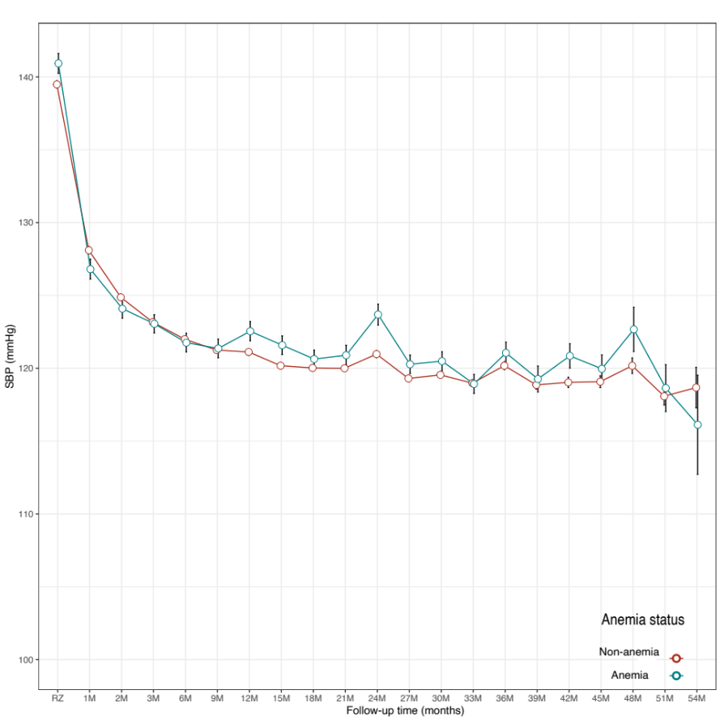
Supplementary Fig. 1. Dynamic change of blood pressure of participants with anemia and non-anemia after randomization.

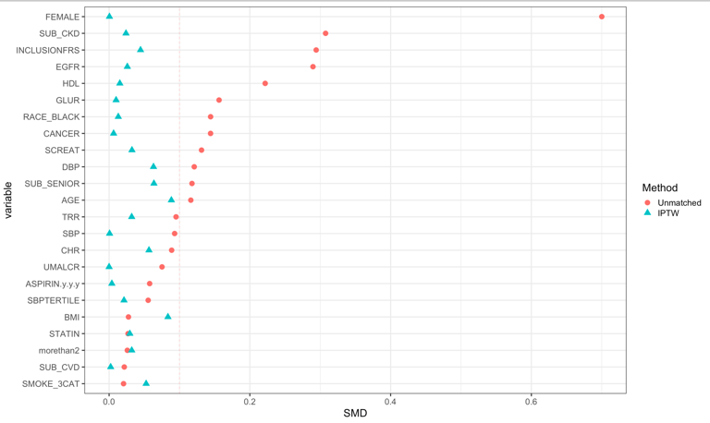
Supplementary Fig. 2. Absolute standardized differences of baseline characteristics in pre- and post-matched population.
Supplementary Table 1. Impact of anemia on outcomes among participants received standard blood pressure control.
 |  |  | HR (95% CI)
Outcomes | Non-Anemia | Anemia | Model 1 | Model 2 | Model 3 | Model 4
Primary outcome | Reference
Composite cardiovascular events | 267 (7.0%) | 43 (7.9%) | 1.16(0.84,1.59) | 1.23(0.88,1.72) | 1.15(0.83,1.62) | 1.03(0.69,1.54)
Secondary outcome
All-cause death | 172 (4.5%) | 27 (5.0%) | 1.11(0.74,1.67) | 1.19(0.78,1.82) | 1.05(0.68,1.60) | 1.08(0.66,1.78)
HR: hazard ratio; CI: confidence interval;
In model 1, no confounder was adjusted.
In model 2, confounders with P value <0.05 between the two groups were adjusted (age, gender, eGFR, SBP, DBP, FRS, baseline CKD, race, serum creatinine, cancer history, cholesterol, blood glucose, and high-density lipoprotein).
In model 3, we adjusted for the predicted probability score calculated by logistic regression model.
In model 4, the HR was calculated within the population after inverse probability of treatment weighting.

Supplementary Table 2. Interaction effect of anemia on cardiovascular benefits of intensive BP control among participants enrolled in SPRINT.
Outcomes |  | Standard  BP treatment | Intensive  BP treatment | HR (95% CI) | P value | Interaction P
Primary outcome |  | Reference
Composite cardiovascular events | Anemia | 43 (7.4%) | 46 (8.0%) | 1.06(0.70,1.61) | 0.77 | 0.08
 | Non-anemia | 276 (6.7%) | 197 (4.8%) | 0.71(0.59,0.85) | <0.001
Secondary outcome
All-cause death | Anemia | 27 (4.7%) | 32 (5.6%) | 1.17(0.70,1.95) | 0.56
 | Non-anemia | 183 (4.5%) | 123 (3.0%) | 0.67(0.53,0.84) | <0.001 | 0.053
HR: hazard ratio; CI: confidence interval;

