Unadjusted Kaplan-Meier Curve (Before IPTW)
(1) Kaplan-Meier curve in terms of all-cause death
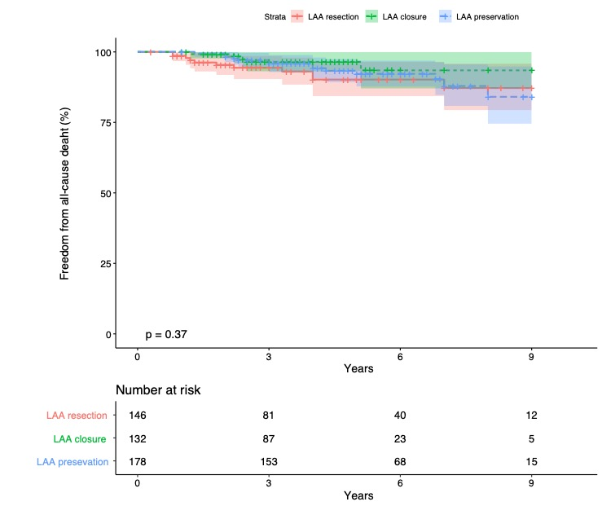
LAA, left atrial appendage.

(2) Kaplan-Meier curve in terms of stroke

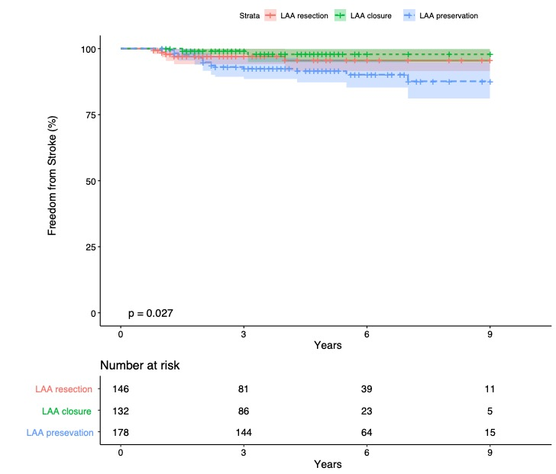
LAA, left atrial appendage.

(3) Kaplan-Meier curve in terms of aggravation of MR

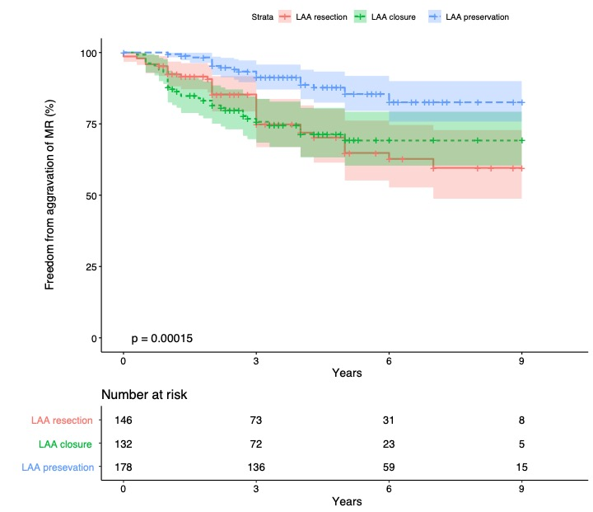
LAA, left atrial appendage; MR, mitral regurgitation

(4) Kaplan-Meier curve in terms of aggravation of recurrent AF
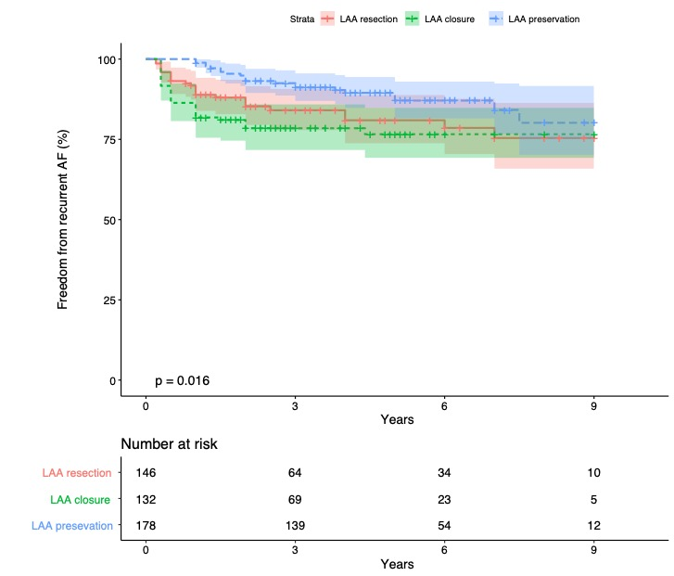
LAA, left atrial appendage; AF, atrial fibrillation

Ablation Strategy.
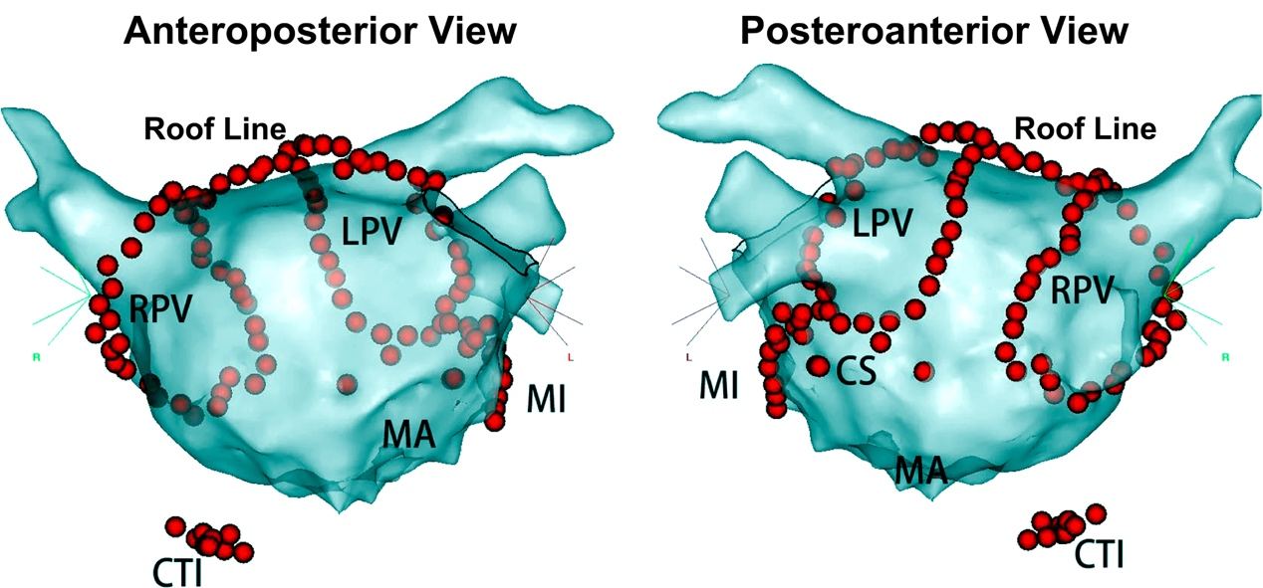
The red dots represented endocardial ablation. CS, coronary sinus; CTI, cavotricuspid isthmus; LPV, left pulmonary vein; MA, mitral annulus; MI, mitral isthmus; RPV, right pulmonary vein

Left atrial appendage treatments.

(A) Left atrial appendage endocardial closure under direct vision; (B) Left atrial appendage excision by stapler.

