Contents of Supplementary Materials
P1 Title Page
P2 - P4 Supplementary material 1. Search Strategy
P5 - P6 Supplementary material 2. Customized NOS Tools
P7 - P23 Supplementary material 3. Supplementary Figures and Tables
P7 Supplementary Figure Legends
P8 Supplementary Fig. 1 Pooled prevalence of COPD in CAD patients
P9 Supplementary Fig. 2 Publication bias of pooled prevalence of COPD in CAD patients
P10 Supplementary Fig. 3 Leave-one-out analysis of pooled prevalence of COPD in CAD patients
P11 Supplementary Fig. 4 Forest plot of cardiac deaths risk according to COPD status
P12 Supplementary Fig. 5 Forest plot of myocardial infarction risk according to COPD status
P13 Supplementary Fig. 6 Forest plot of revascularization risk according to COPD status
P14 Supplementary Fig. 7 Forest plot of stroke risk according to COPD status
P15 Supplementary Fig. 8 Publication bias of pooled risk ratio of outcomes according to COPD status
P16 Supplementary Fig. 9 Leave-one-out analysis of pooled risk ratio of outcomes
P17 Supplementary Fig. 10 Publication bias of pooled risk ratio of outcomes
P18 Supplementary Fig. 11 Leave-one-out analysis of pooled risk ratio of outcomes
P19 Supplementary Fig. 12 Forest plot of revascularization methods according to COPD status
P20 Supplementary Fig. 13 Forest plot for all-cause mortality risk with revascularization subtype
P21 Supplementary Fig. 14 Forest plot of all-cause mortality risk with COPD diagnostic method
P22 Supplementary Fig. 15 Forest plot of outcomes according to revascularization method
P23 Supplementary Fig. 16 Prevalence of COPD in CAD in Strictly Correct Group
P24 Supplementary Table 1 Research characteristics of Enrolled Studies
P28 Supplementary Table 2 Sensitivity analysis of pooled prevalence according to analytical methods
P28 Supplementary Table 3 Sensitivity analysis for pooled prevalence according to exclusion of studies with sample size
P29 Supplementary Table 4 Univariate meta-regression according to prevalence of COPD in CAD
P29 Supplementary Table 5 Multivariate meta-regression according to prevalence of COPD in CAD
P30 Supplementary Table 6 Outcomes of CAD patients according to COPD status
P33 Supplementary Table 7 Quality assessment of COPD prevalence
P34 Supplementary Table 8 Quality assessment of COPD-CAD patient outcome
P35 Supplementary material 4. PRISMA Checklist
1
Global Insights into Chronic Obstructive Pulmonary Disease and Coronary Artery Disease: A Systematic Review and Meta-analysis of 6,400,000 Patients

Supplemental material 1. Search Strategy
Pubmed：
#1 Search: chronic obstructive pulmonary disease
#2 Search: Chronic Obstructive Lung Disease
#3 Search: COAD
#4 Search: COPD
#5 Search: Chronic Obstructive Airway Disease
#6 Search: Chronic Obstructive Pulmonary Disease
#7 Search: Chronic Airflow Obstructions
#8 Search: Chronic Airflow Obstruction
#9 Search: ((((((((chronic obstructive pulmonary disease) OR Chronic Obstructive Lung Disease) OR
COAD) OR COPD) OR Chronic Obstructive Airway Disease) OR Chronic Obstructive Pulmonary
Disease) OR Chronic Airflow Obstructions) OR Chronic Airflow Obstruction)
#10 Search: Coronary Artery Disease
#11 Search: Coronary Artery Diseases
#12 Search: Left Main Coronary Artery Disease
#13 Search: Left Main Disease
#14 Search: Left Main Diseases
#15 Search: Left Main Coronary Disease
#16 Search: Coronary Arteriosclerosis
#17 Search: Coronary Arterioscleroses
#18 Search: Coronary Atheroscleroses
2

#19 Search: Coronary Atherosclerosis
#20 Search: ((((((((((Coronary Artery Disease) OR Coronary Artery Diseases) OR Left Main Coronary
Artery Disease) OR Left Main Disease OR Left Main Diseases) OR Left Main Coronary Disease) OR
Coronary Arteriosclerosis) OR Coronary Arteriosclerosis) OR Coronary Arterioscleroses) OR
Coronary Atheroscleroses) OR Coronary Atherosclerosis)
#21 Search: ((((((((chronic obstructive pulmonary disease) OR Chronic Obstructive Lung Disease) OR
COAD) OR COPD) OR Chronic Obstructive Airway Disease) OR Chronic Obstructive Pulmonary
Disease) OR Chronic Airflow Obstructions) OR Chronic Airflow Obstruction) AND (((((((((( Coronary
Artery Disease ) OR Coronary Artery Diseases ) OR Left Main Coronary Artery Disease) OR Left
Main Disease OR Left Main Diseases) OR Left Main Coronary Disease) OR Coronary Arteriosclerosis)
OR Coronary Arteriosclerosis) OR Coronary Arterioscleroses) OR Coronary Atheroscleroses) OR
Coronary Atherosclerosis)
Embase：
#1 'chronic obstructive pulmonary disease'/ exp
#2 'chronic obstructive lung disease'/ exp
#3 'COPD'
#4 'chronic obstructive pulmonary disease'/ exp OR 'chronic obstructive lung disease'/ exp OR 'COPD'
#5 'coronary artery disease'/exp
#6 'coronary atherosclerosis'
#7 'coronary arteriosclerosis'
#8 'coronary artery disease'/exp OR 'coronary atherosclerosis' OR 'coronary arteriosclerosis'
3

#9 ('chronic obstructive pulmonary disease'/exp OR 'chronic obstructive lung disease'/exp OR 'COPD')
AND ('coronary artery disease'/exp OR 'coronary atherosclerosis' OR 'coronary arteriosclerosis')
Web of Science：
#1
TS
= (Chronic
obstructive
pulmonary
disease) OR TS = (Chronic obstructive
lung
disease) OR TS = (COPD)
#2 TS = (Coronary artery disease) OR TS = (Coronary artery diseases)
OR TS = (Coronary Atherosclerosis)
#3 #2 AND #1
OpenGrey：
(Chronic obstructive pulmonary disease OR Chronic obstructive lung disease OR COPD)
AND
(Coronary artery disease OR Coronary artery diseases OR Coronary Atherosclerosis）
Chest：
COPD and CAD
European Heart Journal：
COPD and CAD
4

Supplemental material 2. Customized NOS Tools
Table 1 – Customized NOS for prevalence of COPD in CAD
5
Selection
SAMPLE REPRESENTATIVENESS

- 1 point: Truly or somewhat representative of the average CAD in the community.
- 0 point: Not representative of the average CAD in the community (e.g. selected group of CAD patients)

Selection
SAMPLE SIZE

- 1 point: Sample size was greater than or equal to 1000 participants.
- 0 point: Sample size was less than 1000 participants.

Comparability
NON-RESPONDENTS

- 1 point: Comparability between respondent and non-respondent characteristics was established with a satisfactory response rate.
- 0 points: The comparability between respondents and non-respondents was unsatisfactory, the response rate was unsatisfactory, or there was no description of the response rate or the characteristics of the responders or non-responders.

Outcome
ASCERTAINMENT OF COPD

- 1 point: COPD was diagnosed through Pulmonary Function Test confirmation
- 0 point: COPD was diagnosed through medical history, self-reported methods, and ICD codes.

Outcome
QUALITY OF DESCRIPTIVE STATISTICS REPORTING

- 1 point: The study reported descriptive statistics to describe the population (e.g., age, sex, other comorbidities)
- 0 point: The study did not report descriptive statistics, or incompletely reported descriptive statistics

Table 2 – Customized NOS for outcomes according to COPD status in CAD
6
SELECTION
Sample representativeness:
- 1 point: Truly or somewhat representative of the average CAD in the community.
- 0 points: Not representative of the average CAD in the community (e.g. selected group of CAD patients)

COPD definition
- 1 point: COPD was diagnosed through Pulmonary Function Test confirmation.
- 0 point: COPD was diagnosed through medical history, self-reported methods, and ICD codes.

Selection of non-COPD patients
- 1 point: propensity-score matched, community controls, patients enrolled in the same setting
- 0 point: other type of controls/no description

Definition of non-COPD patients
- 1 point: non-COPD was confirmed through Pulmonary Function Test confirmation.
- 0 point: no description

COMPARABILITY (Max 2 points)
Comparability of COPD and non-COPD patients
- 1 point: COPD and non-COPD are sufficiently balanced for major risk scores (e.g. SYNTAX scores etc.)/imbalance not a major concern
- 1 point: COPD and non-COPD patients are sufficiently balanced also for other comorbidities/imbalance not a major concern

ENDPOINT
Ascertainment of endpoint
- 1 point: secure record (e.g. administrative databases, death certificates, etc.), or sufficiently reliable medical records
- 0 point: other/no description

Same method of ascertainment for COPD and non-COPD patients
- 1 point: yes
- 0 point: no

Non-response rate
- 1 point: same rate for both groups/differential rate was not a major concern
- 0 point: differential rate was a major concern

Supplemental material 3. Supplementary Figures and Tables
Supplemental Figure Legends
Figure S1. Pooled prevalence of COPD in CAD patients
COPD, chronic obstructive pulmonary disease; CAD, coronary artery disease; CI, confidence interval.
Figure S2. Publication bias of pooled prevalence of COPD in CAD patients Figure S3. Leave-one-out analysis of pooled prevalence of COPD in CAD patients Figure S4. Forest plot of cardiac deaths risk according to COPD status
Figure S5. Forest plot of myocardial infarction risk according to COPD status Figure S6. Forest plot of revascularization risk according to COPD status Figure S7. Forest plot of stroke risk according to COPD status
Figure S8. Forest plot of heart failure risk according to COPD status Figure S9. Forest plot of respiratory failure risk according to COPD status
Figure S10. Publication bias of pooled risk ratio of outcomes according to COPD status Figure S11. Leave-one-out analysis of pooled risk ratio of outcomes according to COPD status
Figure S12. Forest plot of revascularization methods according to COPD status
A. PCI prescription; B. CABG prescription. CABG, coronary artery bypass graft; PCI, percutaneous coronary intervention; CI, confidence interval; COPD, chronic obstructive pulmonary disease.
Figure S13. Forest plot for all-cause mortality risk with revascularization subtype according to COPD status
CAD, coronary artery disease; CABG, coronary artery bypass graft; PCI, percutaneous coronary intervention; CI, confidence interval.
Figure S14. Forest plot of all-cause mortality risk with COPD diagnostic method subtype according to COPD status
CAD, coronary artery disease; PFT, pulmonary function test; ICD/SRM, ICD-codes/Self-reported Methods; CI, confidence interval.
Figure S15. Forest plot of outcomes according to revascularization method in COPD-CAD patients
A. Outcome of all-cause death; B. Outcome of myocardial infarction; C. Outcome of revascularization;
D. Outcome of stroke. CABG, coronary artery bypass graft; PCI, percutaneous coronary intervention; CI, confidence interval; COPD, chronic obstructive pulmonary disease.
7

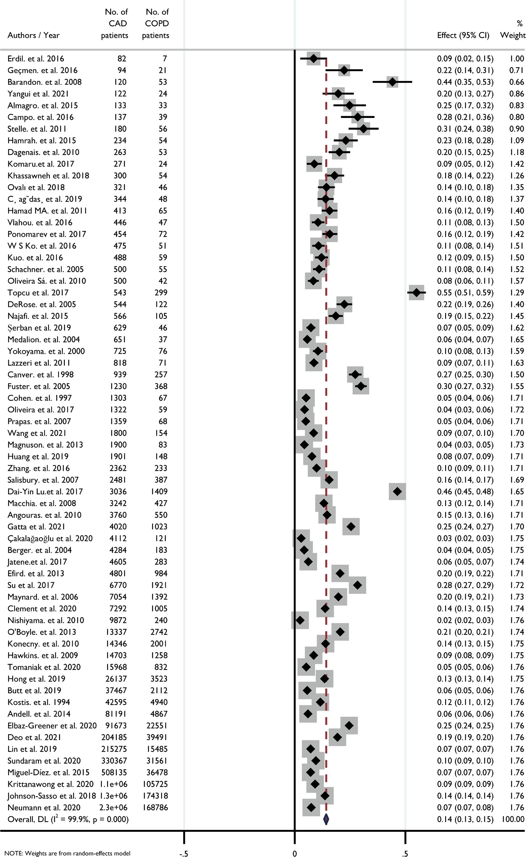
Figure S1. Pooled prevalence of COPD in CAD patients
COPD, chronic obstructive pulmonary disease; CAD, coronary artery disease; CI, confidence interval.
8

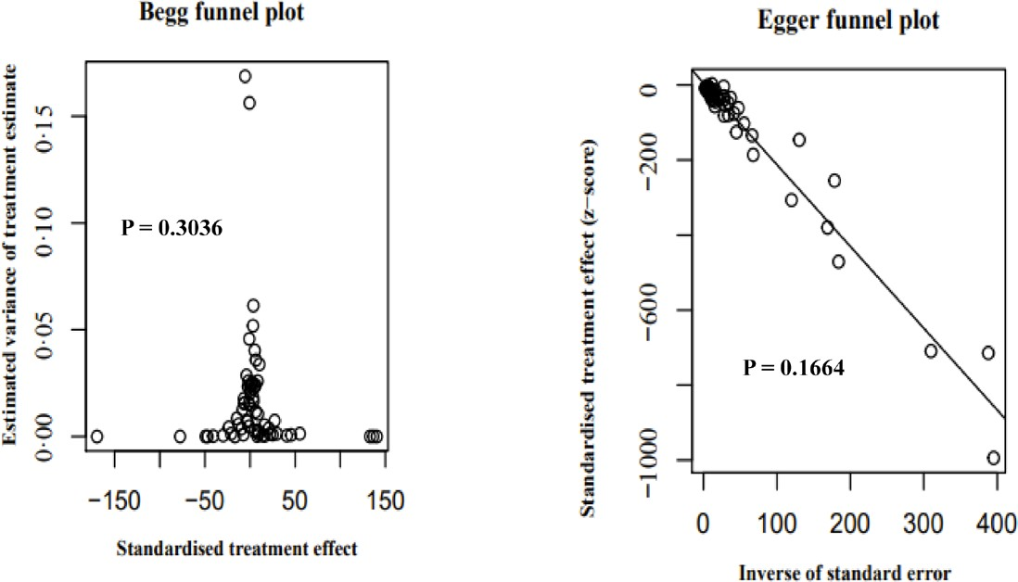
Figure S2. Publication bias of pooled prevalence of COPD in CAD patients
9

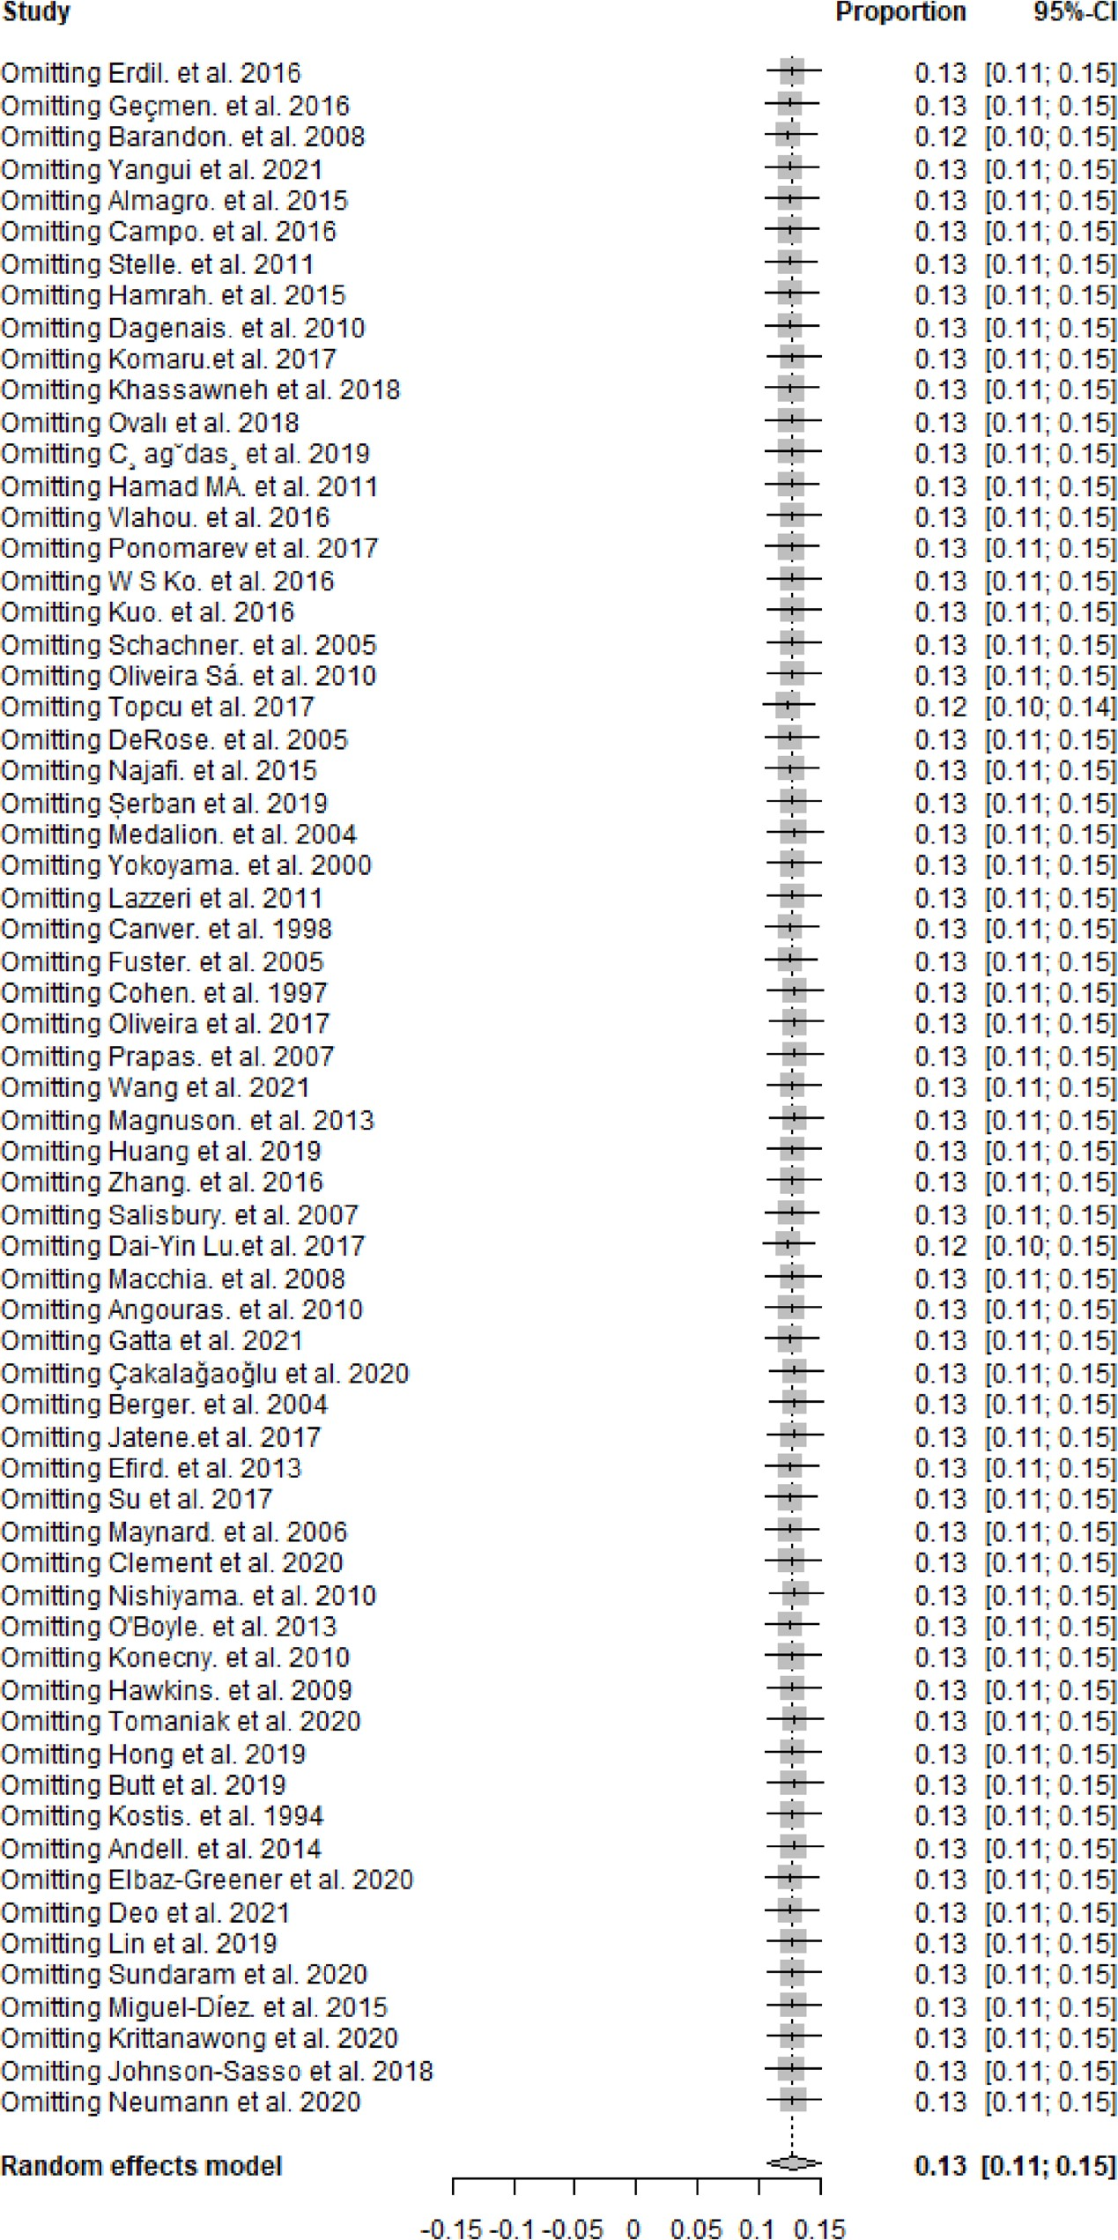
Figure S3. Leave-one-out analysis of pooled prevalence of COPD in CAD patients
10

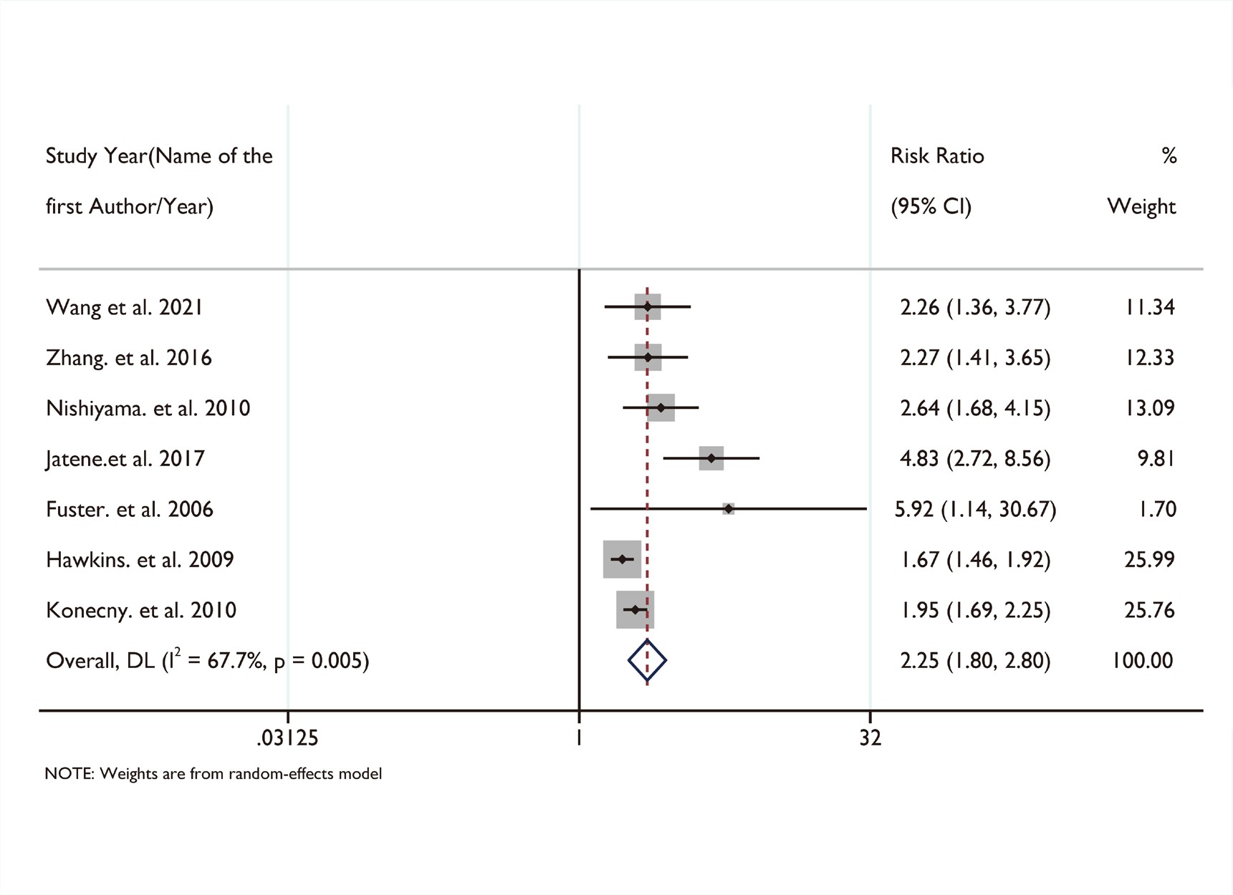
Figure S4. Forest plot of cardiac deaths risk according to COPD status
11

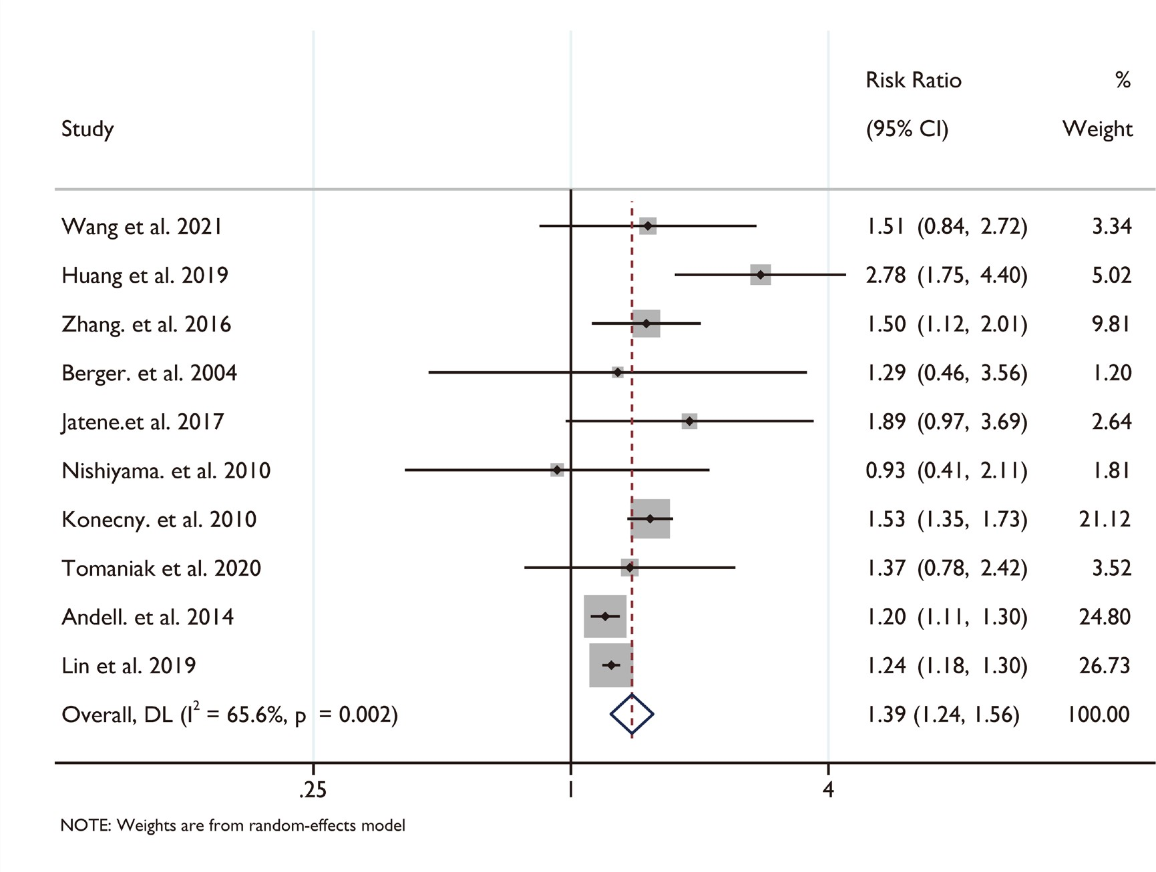
Figure S5. Forest plot of myocardial infarction risk according to COPD status
12

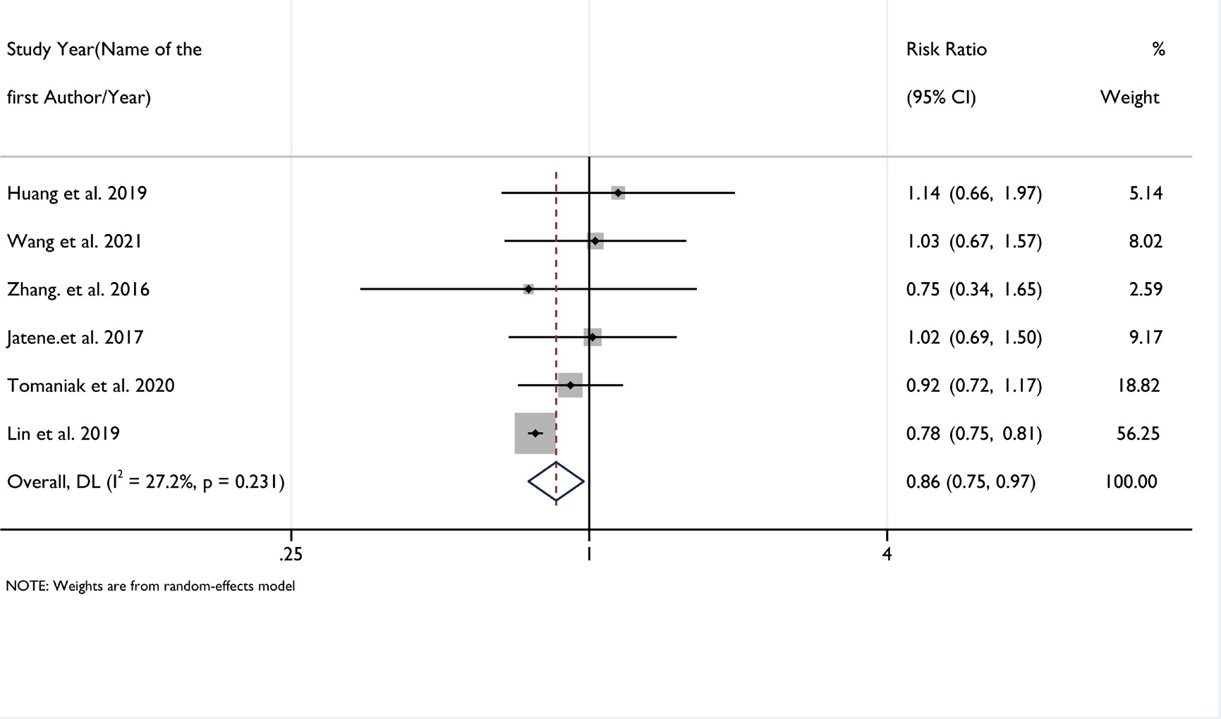
Figure S6. Forest plot of revascularization risk according to COPD status
13

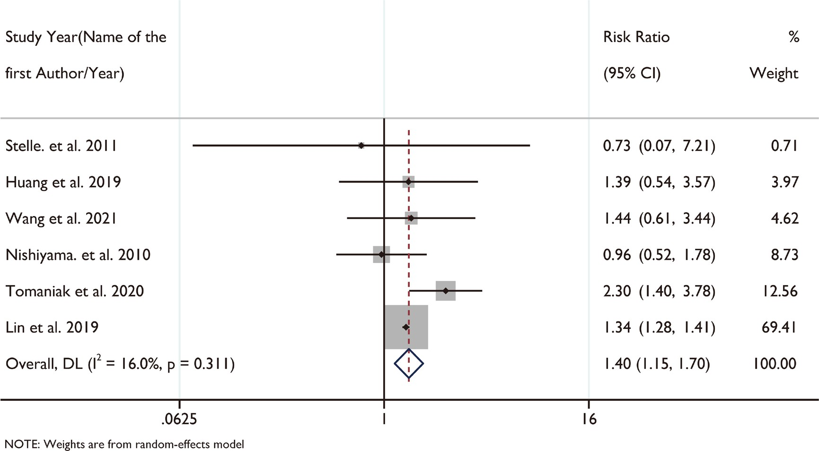
Figure S7. Forest plot of stroke risk according to COPD status
14

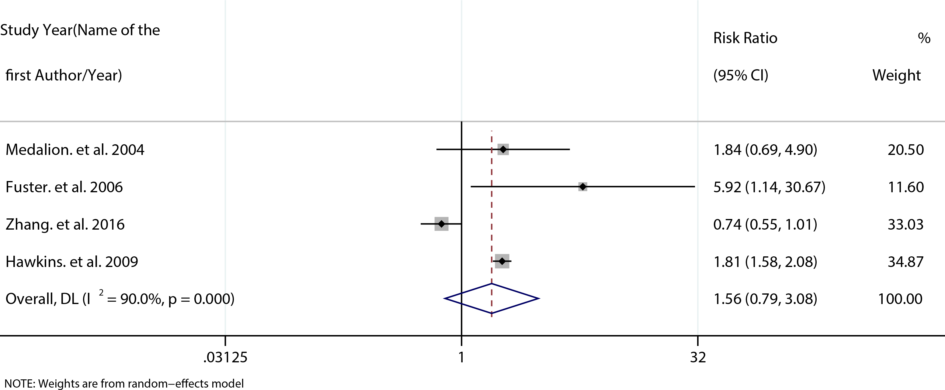
Figure S8. Forest plot of heart failure risk according to COPD status
15

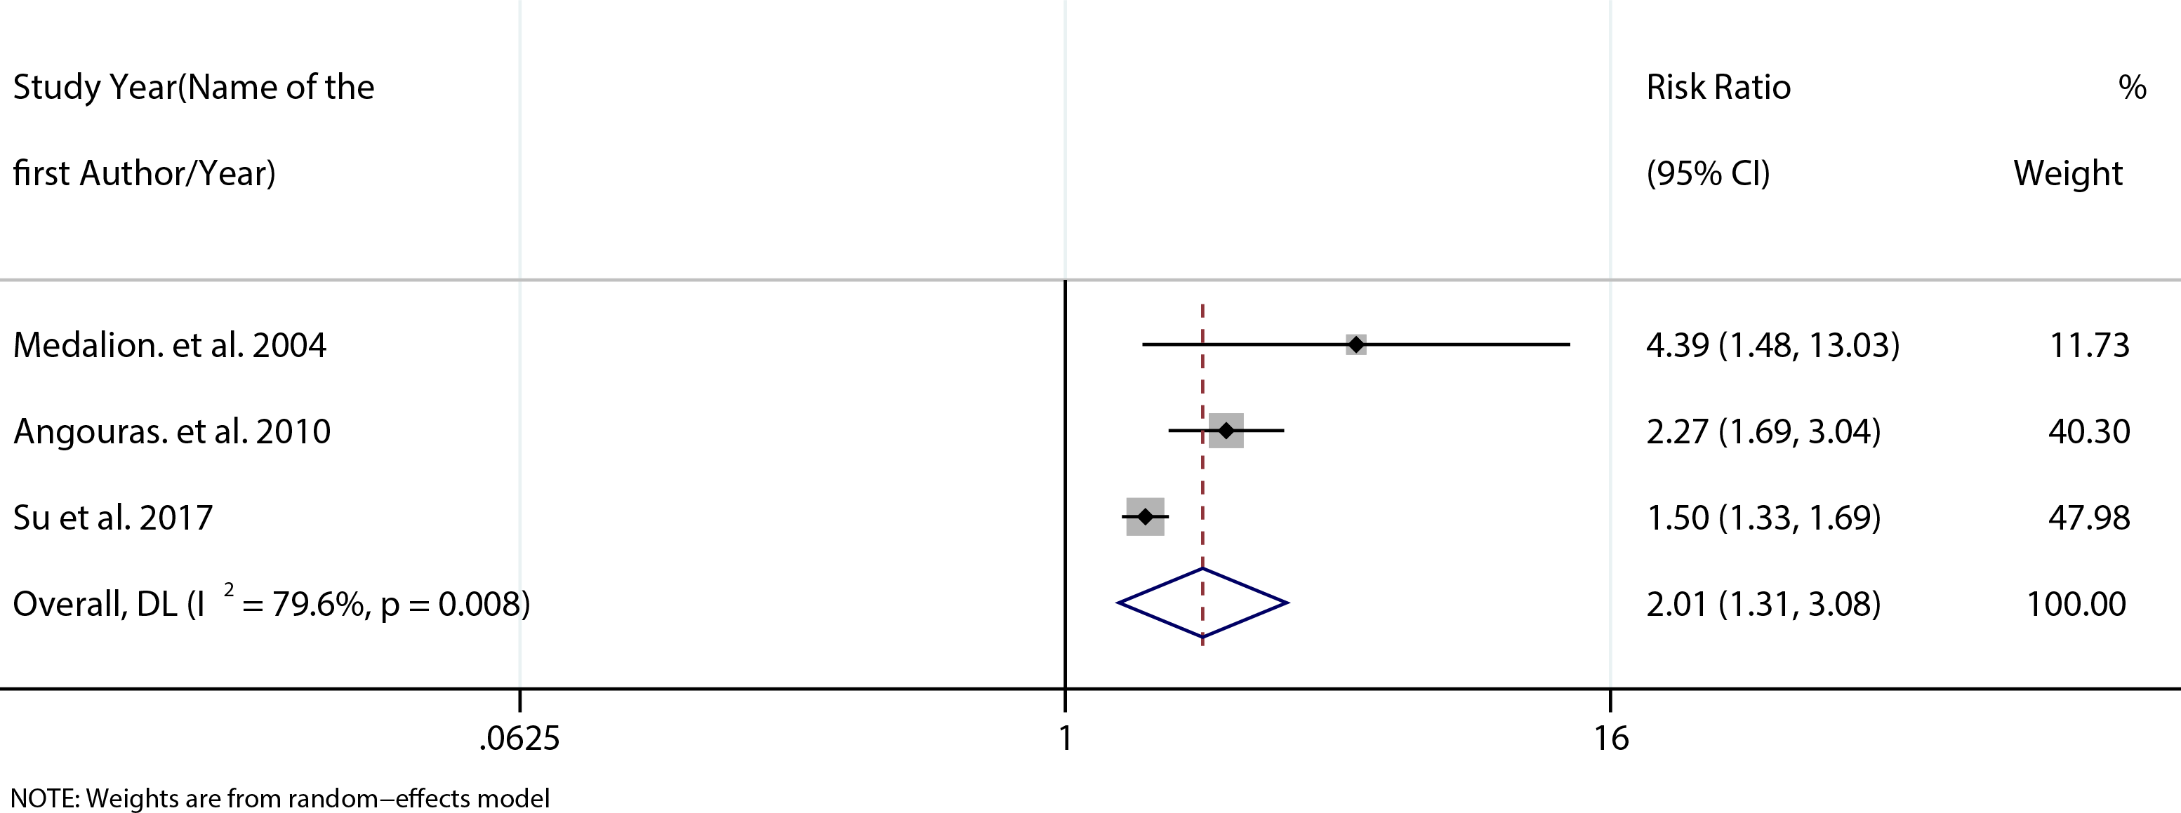
Figure S9. Forest plot of respiratory failure risk according to COPD status
16

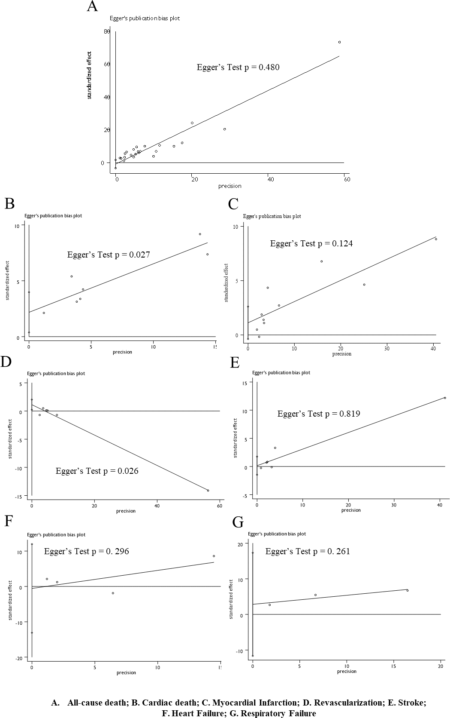
Figure S10. Publication bias of pooled risk ratio of outcomes according to COPD status
17

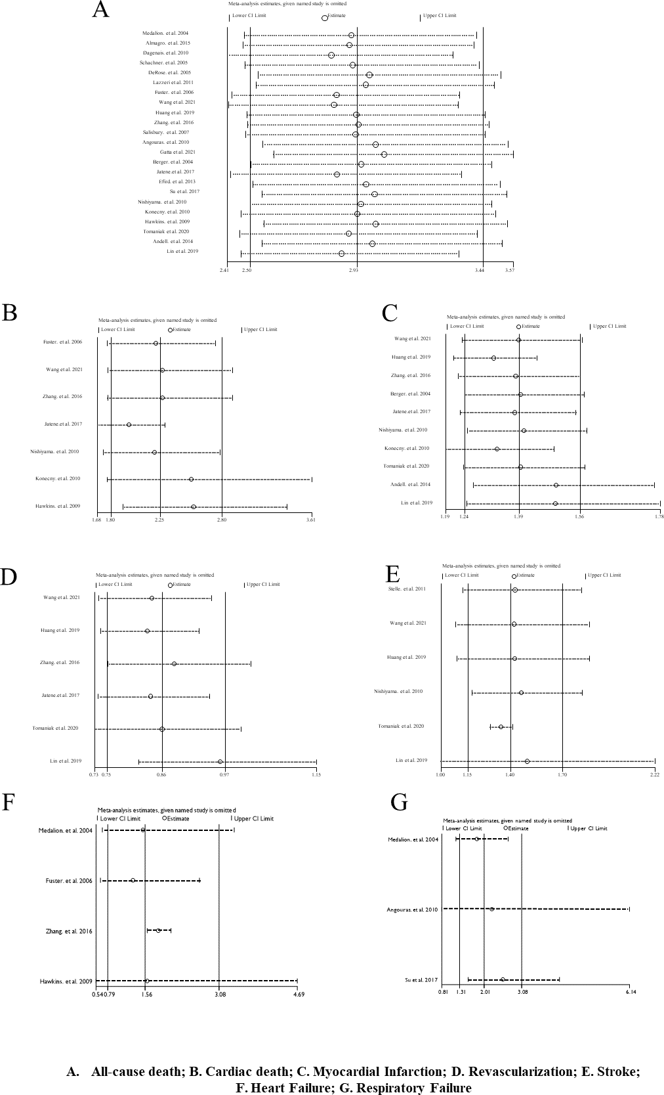
Figure S11. Leave-one-out analysis of pooled risk ratio of outcomes according to COPD
status
18

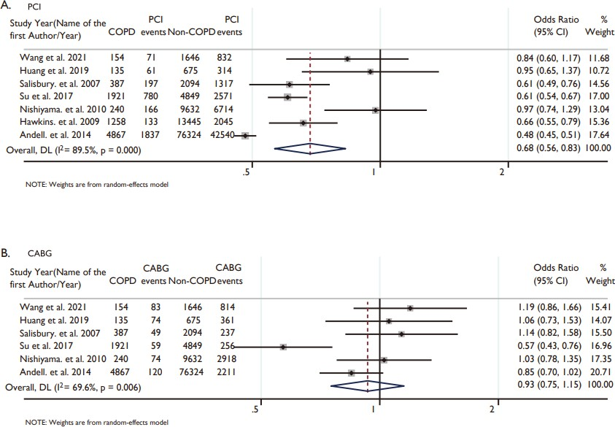
Figure S12. Forest plot of revascularization methods according to COPD status
A. PCI prescription; B. CABG prescription. CABG, coronary artery bypass graft; PCI, percutaneous coronary intervention; CI, confidence interval; COPD, chronic obstructive pulmonary disease.
19

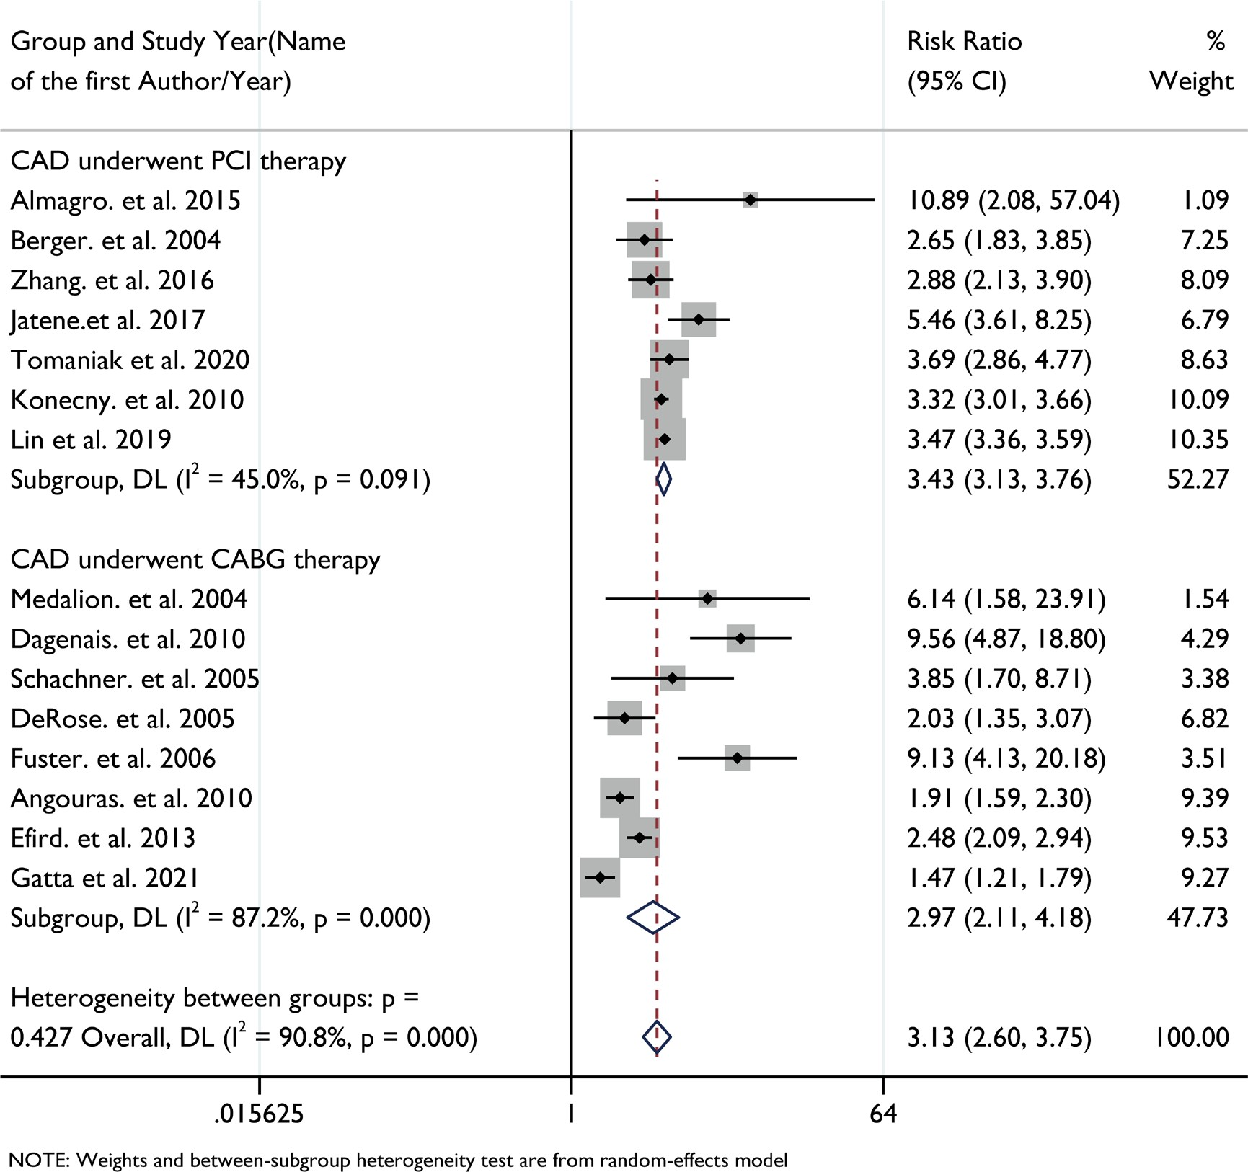
Figure S13. Forest plot for all-cause mortality risk with revascularization subtype according to COPD status
CAD, coronary artery disease; CABG, coronary artery bypass graft; PCI, percutaneous coronary
intervention; CI, confidence interval.
20

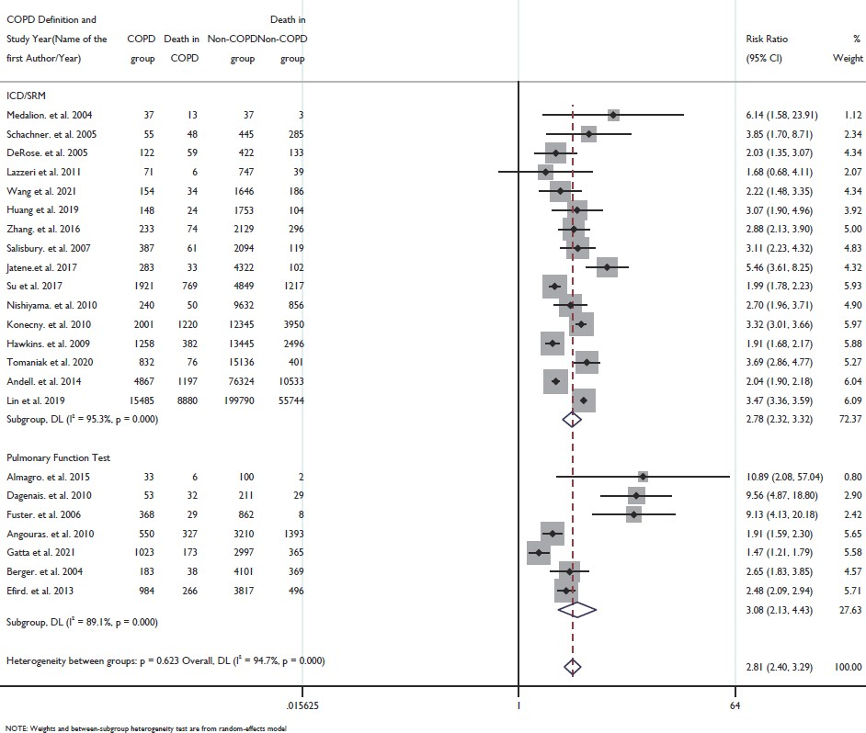
Figure S14. Forest plot of all-cause mortality risk with COPD diagnostic method subtype according to COPD status
CAD, coronary artery disease; PFT, pulmonary function test; ICD/SRM, ICD codes/Self-reported
Methods; CI, confidence interval.
21

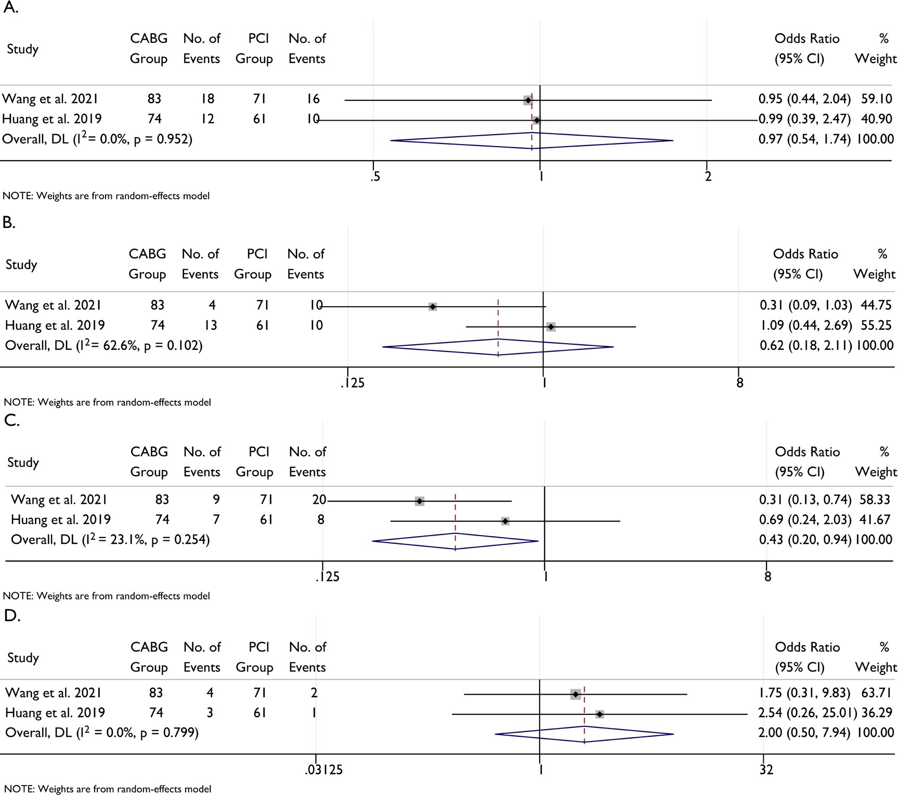
Figure S15. Forest plot of outcomes according to revascularization method in COPD-CAD patients
A. Outcome of all-cause death; B. Outcome of myocardial infarction; C. Outcome of revascularization;
D. Outcome of stroke. CABG, coronary artery bypass graft; PCI, percutaneous coronary intervention; CI, confidence interval; COPD, chronic obstructive pulmonary disease.
22

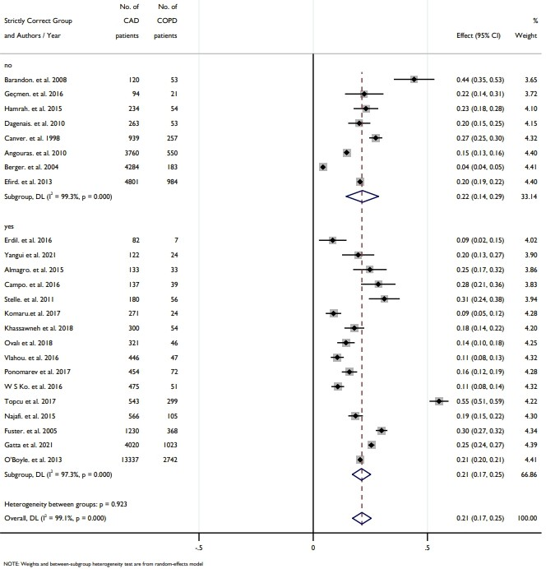
Figure S16. Prevalence of COPD in CAD in Strictly Correct Group and
Non-strictly Correct Group according to GOLD Criteria

Table S1. Research characteristics of Enrolled Studies
Study Year (Name of
the first Author/Year)
Research held
Country or Region
Economic
Status
Diagnosed
Method
Area
Study Type
Patients Characteristics
Upper middle income Upper middle
income
Observational Single Center Observational Single Center Observational Single Center Observational Single Center Observational Single Center Observational Single Center Observational Single Center Observational Single Center Observational Single Center Observational Single Center Observational Single Center Observational Single Center Observational
Single Center
Pulmonary Function Test
Pulmonary Function Test
Pulmonary Function Test
Pulmonary Function Test
Pulmonary Function Test
Pulmonary Function Test
Pulmonary Function Test
Pulmonary Function Test
Pulmonary Function Test
Pulmonary Function Test
Pulmonary Function Test
Pulmonary Function Test
Self-reported
Method
Erdil. et al. 201628
Turkey
Europe
CAD patients underwent CABG
Geçmen. et al. 201629
Turkey
Europe
CAD patients underwent CABG
Barandon. et al. 200830
France
Europe
High income
CAD patients underwent CABG
Upper middle
income
Yangui et al. 202131
Tunisia
Africa
CAD patients
Almagro. et al. 201532
Spain
Europe
High income
CAD patients underwent PCI
Campo. et al. 201633
Italy
Europe
High income
MI patients with smoking
United States Of
American
North
America
Stelle. et al. 201134
High income
CAD patients underwent CABG
Hamrah. et al. 201535
Japan
Asia
High income
CAD patients
North
America
CAD patients underwent CABG
over 70 years old
Dagenais. et al. 201036
Canada
High income
Komaru.et al. 201737
Japan
Asia
High income
CAD patients
Upper middle income Upper middle income Upper middle
income
Khassawneh et al. 201838
Jordan
Asia
CAD patients
Ovalı et al. 201839
Turkey
Europe
CAD patients underwent CABG
C¸ ag˘das¸ et al. 201940
Turkey
Europe
CAD patients underwent PCI
Observational
Single Center
CAD patients underwent CABG
with EF lower than 30%
Self-reported
Method
Hamad MA. et al. 201141
Netherlands
Europe
High income
Observational Single Center Observational Single Center Observational Single Center Adminstrative database Observational Single Center Observational
Single Center
Pulmonary Function Test
Pulmonary Function Test
Pulmonary Function
Test
Vlahou. et al. 201642
Greece
Europe
High income
CAD patients underwent CABG
Ponomarev et al. 201743
Russia
Europe
High income
CAD patients underwent CABG
Upper middle
income
W S Ko. et al. 201644
China
Asia
CAD patients underwent PCI
Taiwan region
(Province of China)
Kuo. et al. 201645
Asia
High income
MI patients
ICD codes
Self-reported Method
Self-reported
Method
Schachner. et al. 200546
Austria
Europe
High income
CAD patients underwent CABG
South
America
Upper middle
income
Oliveira Sá. et al. 201047
Brazil
CAD patients underwent CABG
24

Upper middle
income
Observational Single Center Observational Single Center Observational Single Center Observational Single Center Observational Single Center Observational Single Center Observational Single Center Observational Single Center Adminstrative database Observational Single Center Observational Single Center Observational Single Center Randomized Clinical Trial Randomized Clinical Trial Randomized Clinical Trial Observational Single Center Observational Multi Center Adminstrative database Adminstrative database Observational Single Center Observational Single Center Observational
Single Center
Pulmonary Function Test
Self-reported Method
Pulmonary Function Test
Self-reported Method
Self-reported Method
Self-reported Method
Self-reported Method
Pulmonary Function Test
Pulmonary Function Test
Self-reported Method
Self-reported Method
Self-reported Method
Self-reported
Method
Topcu et al. 201748
Turkey
Europe
CAD patients
United States Of
American
North
America
CAD patients underwent CABG
with EF<25%
DeRose. et al. 200549
High income
Upper middle income Upper middle
income
Najafi. et al. 201550
Iran
Asia
CAD patients underwent CABG
Șerban et al. 201951
Romania
Europe
MI patients
Medalion. et al. 200452
Israel
Asia
High income
CAD patients underwent CABG
United States Of
American
North
America
Yokoyama. et al. 200053
High income
CAD patients underwent CABG
Lazzeri et al. 201154
Italy
Europe
High income
MI patients underwent PCI
United States Of
American
North
America
Canver. et al. 199855
High income
CAD patients underwent CABG
Fuster. et al. 200556
Spain
Europe
High income
CAD patients underwent CABG
Cohen. et al. 199757
Israel
Asia
High income
CAD patients underwent CABG
South
America
Upper middle
income
Oliveira et al. 201758
Brazil
CAD patients underwent CABG
Prapas. et al. 200759
Greece
Europe
High income
CAD patients underwent CABG
CAD patients underwent
revascularization
Wang et al. 202111
Multiple Countries
N/A
N/A
Magnuson. et al. 201360
Multiple Countries
N/A
N/A
CAD patients with diabetes
ICD codes
CAD patients underwent
revascularization
Self-reported Method
Self-reported Method
Self-reported
Method
Huang et al. 201910
Multiple Countries
N/A
N/A
Upper middle
income
Zhang. et al. 201661
China
Asia
CAD patients underwent PCI
United States Of American Taiwan region
(Province of China)
North
America
Salisbury. et al. 200762
High income
MI patients
Dai-Yin Lu.et al. 201763
Asia
High income
CAD patients underwent CABG
ICD codes
Macchia. et al. 200864
Italy
Europe
High income
MI patients
ICD codes
Pulmonary Function Test
Pulmonary Function Test
Self-reported
Method
Angouras. et al. 201065
Greece
Europe
High income
CAD patients underwent CABG
Gatta et al. 202166
United Kingdom
Europe
High income
CAD patients underwent CABG
Upper middle
income
Çakalağaoğlu et al. 202067
Turkey
Europe
CAD patients underwent CABG
25

United States Of
American
North
America
Observational Multi Center Randomized Clinical Trial Observational Single Center Adminstrative database Adminstrative database Adminstrative database Observational Multi Center Adminstrative database Observational Single Center Randomized Clinical Trial Randomized Clinical Trial Observational Single Center Adminstrative database Adminstrative database Observational Multi Center Adminstrative database Adminstrative database Adminstrative database Adminstrative database Adminstrative database Adminstrative database Adminstrative
database
Pulmonary Function Test
Self-reported Method
Pulmonary Function
Test
Berger. et al. 200468
High income
CAD patients underwent PCI
Jatene.et al. 201769
Multiple Countries
N/A
N/A
CAD patients underwent PCI
United States Of American Taiwan region
(Province of China) United States Of American
United States Of
American
North
America
Efird. et al. 201370
High income
CAD patients underwent CABG
Su et al. 201771
Asia
High income
MI patients
ICD codes
North America North
America
Maynard. et al. 200672
High income
MI patients
ICD codes
Clement et al. 202073
High income
CAD patients underwent CABG
ICD codes
CAD patients underwent
revascularization
Self-reported Method
Pulmonary Function
Test
Nishiyama. et al. 201074
Japan
Asia
High income
O'Boyle. et al. 201375
United Kingdom
Europe
High income
CAD patients underwent CABG
United States Of
American
North
America
Konecny. et al. 201076
High income
CAD patients underwent PCI
ICD codes
Self-reported Method
Self-reported Method
Self-reported
Method
Hawkins. et al. 200977
Multiple Countries
N/A
N/A
MI patients
Tomaniak et al. 202078
Multiple Countries
N/A
N/A
CAD patients underwent PCI
North
America
Hong et al. 201979
Canada
High income
CAD patients
Butt et al. 201980
Denmark
Europe
High income
CAD patients underwent CABG
ICD codes
United States Of
American
North
America
Kostis. et al. 199481
High income
MI patients
ICD codes
Andell. et al. 201482
Sweden
Europe
High income
MI patients
ICD codes
Elbaz-Greener et al.
202083
Israel
Asia
High income
MI patients underwent CABG
ICD codes
United States Of American Taiwan region
(Province of China)
North
America
Deo et al. 202184
High income
CAD patients underwent CABG
ICD codes
Lin et al. 201927
Asia
High income
CAD patients underwent PCI
ICD codes
Self-reported
Method
Sundaram et al. 202085
United Kingdom
Europe
High income
MI patients
CAD patients underwent
revascularization
Miguel-Díez. et al. 201586
Spain
Europe
High income
ICD codes
Krittanawong et al. 202087
Johnson-Sasso et al.
201888
United States Of American United States Of
American
North America North
America
High income
MI patients less than 55 years
ICD codes
High income
MI patients
ICD codes
26

Adminstrative
database
Neumann et al. 202089
Germany
Europe
High income
MI patients
ICD codes
COPD, Chronic Obstructive Pulmonary Disease; CAD, Coronary Artery Disease; MI, Mocardial Infarction; UA, Unable Angina; CABG, Coronary Artery Bypass Graft; PCI,
Percutaneous Coronary Intervention; ICD, International Classification of the Diseases; N/A, Not Applicable.
27

Table S2. Sensitivity analysis of pooled prevalence according to analytical methods
Method
Prevalence
95%CI
Tau
Tau2
I2
Untransformed
proportions
14.20%
13.3-15.1%
0.035
0.0012
99.90%
IV, Logit
Transformation
12.70%
10.7-15.0%
0.787
0.619
99.90%
IV, FT
13.90%
11.6-16.3%
0.14
0.0136
99.90%
IV = Inverse Variance; FT = Freeman-Tukey; CI, Confidence Interval.
Table S3. Sensitivity analysis for pooled prevalence according to exclusion of studies with
sample size
No. of Studies Diagnosed
with PFT
No. of
Studies
Sample Size
Prevalence
95%CI
Tau
Tau2
I2
Overall Excluding sample sizes
<1000
Excluding sample sizes
<2500
Excluding sample sizes
<5000
Excluding sample sizes
<10000
Excluding sample sizes
<20000
65
24
14.2%
13.3-15.1%
0.035
0.0012
99.9%
37
6
12.6%
11.5-13.8%
0.035
0.0012
100.0%
28
5
13.5%
12.2-14.8%
0.035
0.0012
100.0%
20
1
10.8-13.9%
0.035
0.0012
12.3%
100.0%
16
0
9.8-13.1%
0.033
0.0011
11.4%
100.0%
12
0
9.4-13.1%
0.033
0.0011
11.2%
100.0%
28

Table S4. Univariate Meta-regression according to prevalence of COPD in CAD
Standard
error
Upper 95%
CI
P
value
Tau
square
R
square, %
Variables
Coefficient
Lower 95% CI
Univariate Meta-regression COPD Diagnosed Method ICD codes
Self-reported Method Pulmonary Function Test Economic Status
High Income
Upper Middle Income N/A
Study Type
Adminstrative Database Observational Multi-center Observational Single-center Randomized Clinical Trial Risk of Bias
High Low Area Africa Asia Europe
North America South America N/A
Age
> 65 years
<= 65 years Male Hypertension
Diabetes Mellitus Dyslipidemia Atrial Fibrillation History of Stroke
Smoker
<0.0001
0.449
28.39
-
-0.4932
0.536
- 0.212
0.212
-
-0.9092
0.121
-
-0.0772
0.951
0.020
0.011
0.045
0.587
6.320
-
-0.1237
-0.8326
- 0.240
0.335
-
-0.5933
-1.4884
- 0.346
-0.1767
0.606
0.013
0.003
0.532
15.010
-
-1.0436
-0.0176
-0.8870
- 0.404
0.211
0.345
-
-1.8363
-0.4318
-1.5639
-
-0.2509
0.397
-0.2100
0.010
0.934
0.010
0.118
0.613
2.180
-
0.427
-
0.273
-
-0.1080
-
0.962
0.118
0.089
0.584
6.800
-
-0.5178
-0.4427
-0.2953
-1.3218
-1.2463
- 0.824
0.812
0.820
0.969
0.857
-
-2.1320
-2.0335
-1.9025
-3.2205
-2.9253
- 1.097
1.148
1.312
0.577
0.433
0.530
0.586
0.719
0.172
0.146
0.652
0.631
0.000
-
-0.1003
0.015
0.013
0.017
0.011
-0.008
0.038
0.006
- 0.222
0.011
0.007
0.008
0.007
0.026
0.041
0.006
-
-0.5358
-0.0061
-0.0007
0.001
-0.0032
-0.0589
-0.0425
-0.0061
- 0.335
0.037
0.027
0.034
0.025
0.043
0.118
0.018
0.652
0.160
0.063
0.038
0.132
0.765
0.358
0.336
0.624
0.594
0.528
0.556
0.858
0.669
0.657
1.780
4.660
5.760
4.040
0.000
0.000
0.000
COPD: Chronic Obstructive Pulmonary Intervention; CAD, Coronary Artery Disease; ICD, International Classfication
of the Diseases; CI, Confidence Interval; N/A, Not Applicable.
29

Table S5. Multivariate Meta-regression according to prevalence of COPD in CAD
Standard
error
Upper 95%
CI
P
value
Tau
square
R
square, %
Variables
Coefficient
Lower 95% CI
Overall
COPD Diagnosed Method Self-reported Method Pulmonary Function Test ICD codes
Economic Status
High Income
Upper Middle Income N/A
Study Type
Adminstrative Database Observational Multi-center Observational Single-center Randomized Clinical Trial Diabetes Mellitus
0.002
0.429
23.64
-0.1535
0.490
-
0.359
0.344
-
-0.8580
-0.1841
-
0.551
1.164
-
0.669
0.154
-
-0.2389
-0.5820
- 0.257
0.458
-
-0.7428
-1.4795
- 0.265
0.315
0.353
0.204
-
-0.9057
-0.0747
- 0.007
- 0.444
0.334
- 0.009
-
-1.7757
-0.7299
-
-0.0098
-
-0.0357
0.581
- 0.023
0.041
0.823
-
0.420
COPD: Chronic Obstructive Pulmonary Intervention; CAD, Coronary Artery Disease; ICD, International
Classfication of the Diseases; CI, Confidence Interval; N/A, Not Applicable.
30

Table S6. Outcomes of CAD patients according to COPD status
COPD Group
Non-COPD Group
Study Year(Name of the first
Author/Year)
Total COP D
Partic
ipants
No. of Myocar dial Infarcti
on
Total Non- COPD
Particip
ants
No. of Myocar dial Infarctio
n
No. of MA
CE
No. of All- cause
death
No. of Cardi ac
death
No. of Revas culari
zation
No. of Stro
ke
No. of Respirat ory
Failure
No. of MA
CE
No. of All- cause
death
No. of Revascu larizatio
n
No. of Heart
Failure
Age, year
s
No. of Cardiac
death
No. of Strok
e
No. of Heart
Failure
No. of
Respirato ry Failure
Age,
years
Medalion. et al. 2004
Almagro. et al. 2015
Dagenais. et al. 2010
Schachner. et al. 2005
DeRose. et al. 2005
Lazzeri et al. 2011 Fuster. et al. 2006 Wang et al. 2021 Huang et al. 2019 Zhang. et al. 2016 Salisbury. et al.
2007
37
63.5
N/A
13
N/A
N/A
N/A
N/A
27
17
37
64.5
N/A
3
N/A
N/A
N/A
N/A
22
6
33
67.5
N/A
6
N/A
N/A
N/A
N/A
N/A
N/A
100
61.6
N/A
2
N/A
N/A
N/A
N/A
N/A
N/A
53
N/A
N/A
32
N/A
N/A
N/A
N/A
N/A
N/A
211
N/A
N/A
29
N/A
N/A
N/A
N/A
N/A
N/A
55
N/A
N/A
48
N/A
N/A
N/A
N/A
N/A
N/A
445
N/A
N/A
285
N/A
N/A
N/A
N/A
N/A
N/A
122
N/A
N/A
59
N/A
N/A
N/A
N/A
N/A
N/A
422
N/A
N/A
133
N/A
N/A
N/A
N/A
N/A
N/A
71
368
154
148
233
74
64.9
66.9
67.2
66.4
N/A N/A 61
44
N/A
6
29
34
24
74
N/A 5
20
N/A 23
N/A N/A 14
26
74
N/A N/A 29
16
7
N/A N/A 6
5
N/A
N/A 5
N/A N/A
62
N/A N/A N/A N/A
N/A
747
862
1646
1753
2129
67
62.4
64.9
65.9
63.9
N/A N/A 500
234
N/A
39
8
186
104
296
N/A 2
102
N/A 98
N/A N/A 102
125
504
N/A N/A 303
168
84
N/A N/A 45
43
N/A
N/A 2
N/A
N/A 697
N/A N/A N/A N/A
N/A
387
64.5
N/A
61
N/A
N/A
N/A
N/A
N/A
N/A
2094
60.1
N/A
119
N/A
N/A
N/A
N/A
N/A
N/A
31

Angouras. et al. 2010
Gatta et al. 2021 Berger. et al. 2004 Jatene.et al. 2017 Efird. et al. 2013 Su et al. 2017 Nishiyama. et al. 2010
Konecny. et al. 2010
Hawkins. et al. 2009
Tomaniak et al. 2020
Andell. et al. 2014
550
65.2
N/A
327
N/A
N/A
N/A
N/A
N/A
68
3210
64
N/A
1393
N/A
N/A
N/A
N/A
N/A
188
1023
183
283
984
1921
68.4
66.1
67.8
63.8
77
N/A 5
43
N/A N/A
173
38
33
266
769
N/A N/A 16
N/A
N/A
N/A 4
10
N/A N/A
N/A N/A 30
N/A
N/A
N/A N/A N/A N/A
N/A
N/A N/A N/A N/A
N/A
N/A N/A N/A N/A
573
2997
4101
4322
3817
4849
66.4
63.3
63
64
67
N/A 123
351
N/A N/A
365
369
102
496
1217
N/A N/A 53
N/A
N/A
N/A 70
82
N/A N/A
N/A N/A 452
N/A
N/A
N/A N/A N/A N/A
N/A
N/A N/A N/A N/A
N/A
N/A N/A N/A N/A
1069
240
N/A
7
50
22
6
N/A
11
N/A
N/A
9632
N/A
235
856
354
259
N/A
457
N/A
N/A
2001
69.9
N/A
1220
280
378
N/A
N/A
N/A
N/A
12345
66
N/A
3950
951
1629
N/A
N/A
N/A
N/A
1258
68.1
N/A
382
307
N/A
N/A
N/A
317
N/A
13445
64.5
N/A
2496
2177
N/A
N/A
N/A
2107
N/A
832
67.9
87
76
N/A
13
74
18
N/A
N/A
15136
64.4
566
401
N/A
173
1458
144
N/A
N/A
4867
75
N/A 1187
7
1197
N/A
808
N/A
N/A
N/A
N/A
76324
70
N/A 1205
31
10533
N/A
10838
N/A
N/A
N/A
N/A
Lin et al. 2019
15485
74
8880
N/A
2072
5019
2155
N/A
N/A
199790
64.7
55744
N/A
22086
76189
21445
N/A
N/A
32

Table S7. Quality assessment of COPD prevalence
Study Year (Name of the first Author/Year)
Selection
Comparability
Outcome
Total
Kostis. et al. 1994 Cohen. et al. 1997 Canver. et al. 1998 Yokoyama. et al. 2000 Berger. et al. 2004 Medalion. et al. 2004 DeRose. et al. 2005 Schachner. et al. 2005 Fuster. et al. 2006 Maynard. et al. 2006 Prapas. et al. 2007 Salisbury. et al. 2007 Barandon. et al. 2008 Macchia. et al. 2008 Hawkins. et al. 2009 Angouras. et al. 2010 Oliveira Sá. et al. 2010 Dagenais. et al. 2010 Konecny. et al. 2010 Nishiyama. et al. 2010 Hamad MA. et al. 2011 Stelle. et al. 2011 Lazzeri et al. 2011 Efird. et al. 2013 Magnuson. et al. 2013 O'Boyle. et al. 2013 Andell. et al. 2014 Almagro. et al. 2015 Miguel-Díez. et al. 2015 Hamrah. et al. 2015 Najafi. et al. 2015 Campo. et al. 2016 Erdil. et al. 2016 Geçmen. et al. 2016
W S Ko. et al. 2016 Kuo. et al. 2016 Vlahou. et al. 2016 Zhang. et al. 2016 Jatene.et al. 2017
Komaru.et al. 2017 Dai-Yin Lu.et al. 2017 Oliveira et al. 2017 Ponomarev et al. 2017 Su et al. 2017
Topcu et al. 2017 Johnson-Sasso et al. 2018 Khassawneh et al. 2018 Ovalı et al. 2018
Butt et al. 2019
C¸ ag˘das¸ et al. 2019 Hong et al. 2019 Huang et al. 2019
Lin et al. 2019
Șerban et al. 2019 Çakalağaoğlu et al. 2020 Clement et al. 2020
Elbaz-Greener et al. 2020 Krittanawong et al. 2020 Neumann et al. 2020 Sundaram et al. 2020 Tomaniak et al. 2020 Deo et al. 2021
Gatta et al. 2021
Wang et al. 2021 Yangui et al. 2021
2
2
1
1
2
1
1
1
2
2
2
2
1
2
2
2
1
1
2
2
1
1
1
2
2
2
2
1
2
1
1
1
1
1
1
1
1
2
2
1
2
2
1
2
1
2
1
1
2
1
2
2
2
1
2
2
2
1
2
2
2
2
2
2
1
1
1
1
1
1
1
1
1
1
1
1
1
1
1
1
1
1
1
1
1
1
1
1
1
1
1
1
1
1
1
1
1
1
1
1
1
1
1
1
1
1
1
1
1
1
1
1
1
1
1
1
1
1
1
1
1
1
1
1
1
1
1
1
1
1
1
0
2
1
2
1
1
1
2
1
1
1
2
1
1
2
1
2
1
1
1
2
1
2
2
1
1
2
1
2
2
2
2
2
2
1
2
1
1
2
1
1
2
1
2
1
2
1
1
1
1
1
1
1
1
1
1
1
1
1
1
1
2
1
2
4
3*
4
3*
5
3*
3*
3*
5
4
4
4
4
4
4
5
3*
4
4
4
3*
4
3*
5
5
4
4
4
4
4
4
4
4
4
4
3*
4
4
4
4
4
4
4
4
4
4
4
3*
4
3*
4
4
4
3*
4
4
4
3*
4
4
4
4
5
4
4
*: Study at high risk of bias, with total score <= 3.
COPD, Chronic Obstructive Pulmonary Disease; NOS, Newcastle–Ottawa Scale.
33

Table S8. Quality assessment of COPD-CAD patient outcome
Study Year (Name of the first Author/Year)
Selection
Comparability
Outcome
Total
Berger. et al. 2004 Medalion. et al. 2004 DeRose. et al. 2005 Schachner. et al. 2005 Fuster. et al. 2006 Salisbury. et al. 2007 Hawkins. et al. 2009 Angouras. et al. 2010 Dagenais. et al. 2010 Konecny. et al. 2010 Nishiyama. et al. 2010 Stelle. et al. 2011 Lazzeri et al. 2011 Efird. et al. 2013 Andell. et al. 2014 Almagro. et al. 2015 Zhang. et al. 2016 Jatene.et al. 2017
Su et al. 2017 Huang et al. 2019 Lin et al. 2019
Tomaniak et al. 2020
Gatta et al. 2021 Wang et al. 2021
4
2
2
2
3
1
1
3
0
2
1
3
2
3
1
4
1
2
1
2
2
2
4
2
2
2
2
2
2
2
2
2
2
2
2
2
2
2
2
2
2
2
2
2
2
2
2
2
3
3
3
3
3
3
3
3
3
3
3
3
3
3
3
3
3
3
3
3
3
3
3
3
9
7
7
7
8
6*
6*
8
5*
7
6*
8
7
8
6*
9
6*
7
6*
7
7
7
9
7
*: Study at high risk of bias, with total score <= 6.
COPD, Chronic Obstructive Pulmonary Disease; NOS, Newcastle–Ottawa Scale.
34


PRISMA 2020 Checklist
35
Section and Topic
Item #

Checklist item

Location where item is reported
TITLE

Title
1
Identify the report as a systematic review.
P1
ABSTRACT

Abstract
2
See the PRISMA 2020 for Abstracts checklist.
See abstracts
INTRODUCTION

Rationale
3
Describe the rationale for the review in the context of existing knowledge.
P3
Objectives
4
Provide an explicit statement of the objective(s) or question(s) the review addresses.
P3
METHODS

Eligibility criteria
5
Specify the inclusion and exclusion criteria for the review and how studies were grouped for the syntheses.
P4
Information sources
6

Specify all databases, registers, websites, organisations, reference lists and other sources searched or consulted to identify studies. Specify the date when each source was last searched or consulted.
P4-5 and Figure 1
Search strategy
7
Present the full search strategies for all databases, registers and websites, including any filters and limits used.
Appendix 1
Selection process

8

Specify the methods used to decide whether a study met the inclusion criteria of the review, including how many reviewers screened each record and each report retrieved, whether they worked independently, and if applicable, details of automation tools used in the process.
P3, P4 and Figure 1
Data collection process

9

Specify the methods used to collect data from reports, including how many reviewers collected data from each report, whether they worked independently, any processes for obtaining or confirming data from study investigators, and if applicable, details of automation tools used in the process.
P5-P6

Data items

10a

List and define all outcomes for which data were sought. Specify whether all results that were compatible with each outcome domain in each study were sought (e.g. for all measures, time points, analyses), and if not, the methods used to decide which results to collect.
P5-6

10b

List and define all other variables for which data were sought (e.g. participant and intervention characteristics, funding sources). Describe any assumptions made about any missing or unclear information.
P5-P6

Study risk of bias assessment
11

Specify the methods used to assess risk of bias in the included studies, including details of the tool(s) used, how many reviewers assessed each study and whether they worked independently, and if applicable, details of automation tools used in the process.
P4-P5

Effect measures
12
Specify for each outcome the effect measure(s) (e.g. risk ratio, mean difference) used in the synthesis or presentation of results.
P5-P6
Synthesis methods

13a

Describe the processes used to decide which studies were eligible for each synthesis (e.g. tabulating the study intervention characteristics and comparing against the planned groups for each synthesis (item #5)).
P5-P6

13b

Describe any methods required to prepare the data for presentation or synthesis, such as handling of missing summary statistics, or data conversions.
P5-P6

13c
Describe any methods used to tabulate or visually display results of individual studies and syntheses.
P5-P6
13d

Describe any methods used to synthesize results and provide a rationale for the choice(s). If meta-analysis was performed, describe the model(s), method(s) to identify the presence and extent of statistical heterogeneity, and software package(s) used.
P5-P6

13e
Describe any methods used to explore possible causes of heterogeneity among study results (e.g. subgroup analysis, meta-regression).
P5-P6
13f
Describe any sensitivity analyses conducted to assess robustness of the synthesized results.
P5-P6
Reporting bias assessment
14

Describe any methods used to assess risk of bias due to missing results in a synthesis (arising from reporting biases).

P5

Certainty assessment
15

Describe any methods used to assess certainty (or confidence) in the body of evidence for an outcome.

P5-P6

PRISMA 2020 Checklist
From: Page MJ, McKenzie JE, Bossuyt PM, Boutron I, Hoffmann TC, Mulrow CD, et al. The PRISMA 2020 statement: an updated guideline for reporting systematic reviews. BMJ 2021;372:n71. doi: 10.1136/bmj.n71
For more information, visit: http://www.prisma-statement.org/
36
Section and Topic
Item #

Checklist item

Location where item is reported
RESULTS

Study selection

16a

Describe the results of the search and selection process, from the number of records identified in the search to the number of studies included in the review, ideally using a flow diagram.
P6

16b
Cite studies that might appear to meet the inclusion criteria, but which were excluded, and explain why they were excluded.
-
Study characteristics
17

Cite each included study and present its characteristics.

Table 1 and Table S1.
Risk of bias in studies
18

Present assessments of risk of bias for each included study.

Supplemental Table S7-S8
Results of individual studies
19

For all outcomes, present, for each study: (a) summary statistics for each group (where appropriate) and (b) an effect estimate and its precision (e.g. confidence/credible interval), ideally using structured tables or plots.
Figure S1

Results of syntheses

20a
For each synthesis, briefly summarise the characteristics and risk of bias among contributing studies.
P8
20b

Present results of all statistical syntheses conducted. If meta-analysis was done, present for each the summary estimate and its precision (e.g. confidence/credible interval) and measures of statistical heterogeneity. If comparing groups, describe the direction of the effect.
P6-P9

20c
Present results of all investigations of possible causes of heterogeneity among study results.
P6-P9
20d
Present results of all sensitivity analyses conducted to assess the robustness of the synthesized results.
P6-P9
Reporting biases
21
Present assessments of risk of bias due to missing results (arising from reporting biases) for each synthesis assessed.
P9
Certainty of evidence
22

Present assessments of certainty (or confidence) in the body of evidence for each outcome assessed.

P6-P9

DISCUSSION

Discussion

23a
Provide a general interpretation of the results in the context of other evidence.
P10
23b
Discuss any limitations of the evidence included in the review.
P10-P13
23c
Discuss any limitations of the review processes used.
P13
23d
Discuss implications of the results for practice, policy, and future research.
P13
OTHER INFORMATION

Registration and protocol

24a
Provide registration information for the review, including register name and registration number, or state that the review was not registered.
P1
24b
Indicate where the review protocol can be accessed, or state that a protocol was not prepared.
P1
24c
Describe and explain any amendments to information provided at registration or in the protocol.
-
Support
25
Describe sources of financial or non-financial support for the review, and the role of the funders or sponsors in the review.
P14
Competing interests
26

Declare any competing interests of review authors.

P14

Availability of data, code and other materials
27

Report which of the following are publicly available and where they can be found: template data collection forms; data extracted from included studies; data used for all analyses; analytic code; any other materials used in the review.

P14

