Supplemental Material

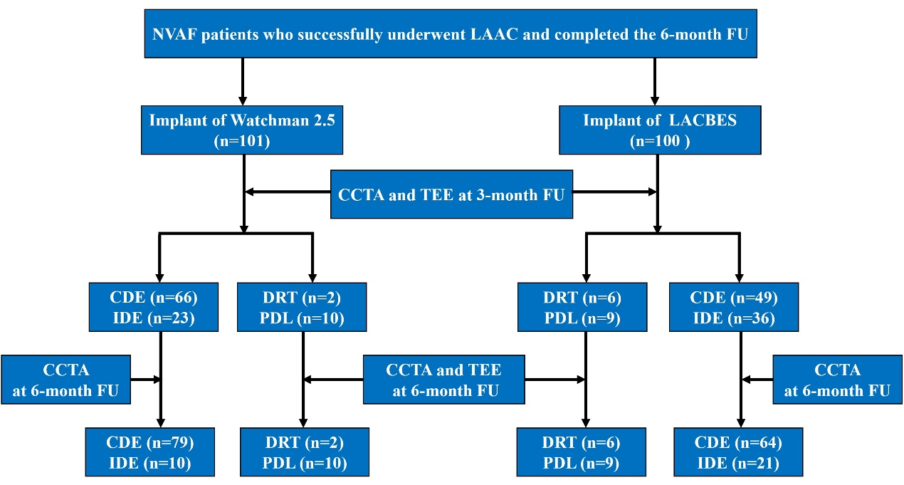

Supplementary Fig. 1. Patient flow chart
Abbreviations: CCTA: cardiac computed tomography angiography; CDE: complete device endothelialization; DRT: device related thrombus; FU: follow-up; IDE: incomplete device endothelialization; PDL: peri-device leak; TEE: transesophageal echocardiography.

Supplementary Table 1. Comparison of Devices

 | Watchman | LACBES
Manufacturer | Boston Scientific, USA | Push Medical, China
structure of the device | 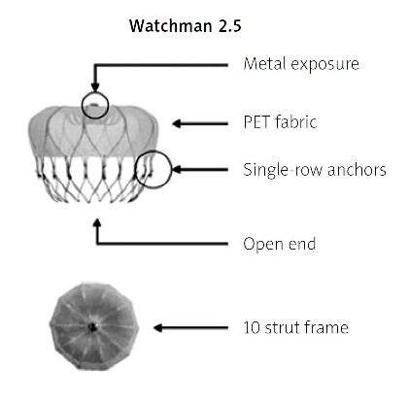 | 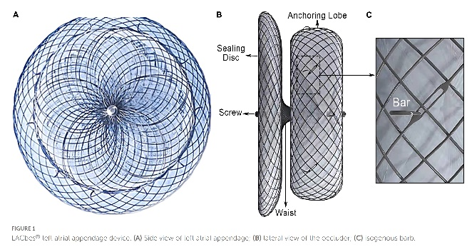
Mechanism of action | Closes off distal body of  left atrial appendage | Lobe of the device placed within the left atrial appendage and the disc sealing the orifice
Sizes (diameter) | 21, 24, 27, 30, and 33 mm | 16, 18, 20, 22, 24, 26, 28, 30, 32, and 34 mm

References:
1.Maksym J, Grabowski M, Mazurek T. Percutaneous left atrial appendage closure with the Watchman device: a systematic review. Postepy Kardiol Interwencyjnej. 2024; 20: 18-29.
2.Bai Y, Tang X, Xu X, Zhao X, Xu Y, Chen W, et al. A newly designed disk-lobe occluder with isogenous barbs for left atrial appendage closure: Initial multicenter experience. Front Cardiovasc Med. 2022; 9: 974994.

Supplementary Table 2. The shape of the LAA

The shape of the LAA | Watchman (n = 101) | LACBES (n = 100) | P value
Cactus, n (%) | 4 (4.0) | 17 (17.0) | 0.003
Cauliflower, n (%) | 64 (63.4) | 59 (59.0) | 0.564
Chicken wing, n (%) | 25 (24.8) | 17 (17.0) | 0.225
Windsock, n (%) | 8 (7.9) | 7 (7.0) | >0.999

Supplementary Table 3. The incidence of IDE was comparable between patients receiving OACs and DAPT at 3 months and 6 months after LAAC
Group | Antithrombotic therapy | IDE w/o PDL | CDE w/o PDL | P value
Watchman group at 3 months | OACs, n (%) | 18 (22.5) | 62 (77.5) | /
Watchman group at 3 months | DAPT, n (%) | 0 (0.0) | 0 (0.0) | /
Watchman group at 3 months | Other, n (%) | 5 (55.6) | 4 (44.4) | /
LACBES group at 3 months | OACs, n (%) | 23 (39.7) | 35 (60.3) | 0.455
LACBES group at 3 months | DAPT, n (%) | 12 (52.2) | 11 (47.8) | /
LACBES group at 3 months | Other, n (%) | 1 (25.0) | 3 (75.0) | /
Watchman group at 6 months | OACs, n (%) | 2 (20.0) | 8 (80.0) | 0.499
Watchman group at 6 months | DAPT, n (%) | 7 (9.46) | 67 (90.5) | /
Watchman group at 6 months | Other, n (%) | 1 (20.0) | 4 (80.0) | /
LACBES group at 6 months | OACs, n (%) | 2 (22.2) | 7 (77.8) | 0.962
LACBES group at 6 months | DAPT, n (%) | 18 (26.5) | 50 (73.5) | /
LACBES group at 6 months | Other, n (%) | 2 (25.0) | 6 (75.0) | /

Abbreviations: CDE: complete device endothelialization; DAPT: dual antiplatelet therapy; IDE: incomplete device endothelialization; OAC: oral anticoagulation; PDL: peri-device leak; w/o: without.

