Supplementary Table 1. Cultural Adaptation Process of the Duke Activity Status Index (DASI) into Chinese
Original Version | Versions T1 and T2 | Version (T-1.2) | Back-Translated Version
1. Can you take care of yourself, that is, eat, dress, bathe or use the toilet? | T1 你能自己照顾自己吗？比如吃饭、穿衣、洗澡或上厕所。 | 你能照顾自己吗？比如进食、穿衣、洗澡或上厕所。 | BT1 Can you take care of yourself, such as eating, dressing, bathing, or using the toilet?
 | T2 你能照顾自己吗？比如，进食、穿衣、洗澡或上厕所。 | 你能照顾自己吗？比如进食、穿衣、洗澡或上厕所。 | BT2 Can you take care of yourself, for example, eating, dressing, bathing, or using the toilet?
2. Can you walk indoors, such as around your house? | T1 你能在室内行走吗？比如在家里走动。 | 你能在家里走动吗？ | BT1 Can you walk indoors, like moving around your house?
2. Can you walk indoors, such as around your house? | T2 你能在家里走动吗？ | 你能在家里走动吗？ | BT2 Can you ambulate indoors, within your residence?
3. Can you walk a block or two on level ground? | T1 你能在平地上走一两个街区吗？ | 你能在平地上行走一到两个街区吗？ | BT1 Can you walk one or two blocks on level ground?
3. Can you walk a block or two on level ground? | T2 你能在平地上行走一到两个街区吗？ | 你能在平地上行走一到两个街区吗？ | BT2 Can you walk one to two blocks on flat terrain?
4. Can you climb a flight of stairs or walk up a hill? | T1 你能爬一层楼梯或一个小斜坡吗？ | 你能爬一层楼梯或在坡地上行走吗？ | BT1 Can you ascend stairs or walk on an incline?
4. Can you climb a flight of stairs or walk up a hill? | T2 你能爬楼梯或者在坡地上行走吗？ | 你能爬一层楼梯或在坡地上行走吗？ | BT2 Can you climb stairs or walk on a slight slope?
5. Can you run a short distance? | T1 你能跑一小段路吗？ | 你能跑一小段距离吗？ | BT1 Can you run a short distance?
5. Can you run a short distance? | T2 你能跑一小段距离吗? | 你能跑一小段距离吗？ | BT2 Can you run a short distance?
6. Can you do light work around the house like dusting or washing dishes? | T1 你能在家里做轻松的家务吗？比如擦灰或洗碗。 | 你能在家里做一些轻松的家务吗？比如擦灰尘或洗碗。 | BT1 Can you perform light household chores, like dusting or washing dishes?
 | T2 你能在家里做一些轻松的家务吗？比如擦灰尘或者洗碗。 | 你能在家里做一些轻松的家务吗？比如擦灰尘或洗碗。 | BT2 Can you do some light household chores, like dusting or washing dishes?
7.Can you do moderate work around the house like vacuuming, sweeping floors or carrying groceries? | T1 你能在家里做中等体力的活吗？比如吸尘、扫地或拎东西。 | 你能做一些适中的家务吗？比如吸尘、扫地或者提杂货。 | BT1 Can you do some moderate housework, like vacuuming, sweeping, or carrying groceries?
 | T2 你能做一些适中的家务吗？比如吸尘、扫地或者提杂货。 | 你能做一些适中的家务吗？比如吸尘、扫地或者提杂货。 | BT2 Can you perform moderate household tasks, such as vacuuming, sweeping, or carrying groceries?
8. Can you do heavy work around the house like scrubbing floors or lifting or moving heavy furniture? | T1 你能在家里做重体力活吗？比如擦地板或搬运重家具。 | 你能做重体力的家务吗？比如擦地板、搬运或者移动重家具。 | BT1 Can you do heavy housework, like scrubbing floors or lifting/moving heavy furniture?
 | T2 你能做重体力的家务吗？比如擦地板、搬运或者移动重家具。 | 你能做重体力的家务吗？比如擦地板、搬运或者移动重家具。 | BT2 Can you engage in heavy household tasks, like scrubbing floors or lifting/moving heavy furniture?
9.Can you do yard work like raking leaves, weeding or pushing a power mower? | T1 你能做园艺劳动吗？比如扫落叶、除草或推电动割草机。 | 你能做庭院里的劳动吗？比如扫落叶或者用除草机除草。 | BT1 Can you do yard work, like raking leaves or using a power lawnmower?
 | T2 你能做院子里的杂活吗？比如扫落叶、或者用除草机除草。 | 你能做庭院里的劳动吗？比如扫落叶或者用除草机除草。 | BT2 Can you engage in gardening activities, like raking leaves or operating a motorized lawnmower?
10. Can you have sexual relations? | T1 你能进行性生活吗？ | 你能进行性生活吗？ | BT1 Can you have sexual intercourse?
10. Can you have sexual relations? | T2 你能有性生活吗？ | 你能进行性生活吗？ | BT2 Can you maintain sexual relations?
11. Can you participate in moderate recreational activities like golf, bowling, dancing, doubles tennis or throwing a baseball or football? | T1 你能参加中等强度的娱乐活动吗？比如高尔夫、保龄球、跳舞、双打网球或扔棒球或橄榄球。 | 你能参加中等强度的娱乐活动吗？比如高尔夫、保龄球、跳舞、双打网球或者投掷棒球或橄榄球。 | BT1 Can you participate in moderate recreational activities, like golf, bowling, dancing, playing doubles tennis, or throwing a baseball or football?
 | T2 你能参与一些温和的娱乐活动吗？比如高尔夫、保龄球、跳舞、双打网球或者投掷棒球或橄榄球。 | 你能参加中等强度的娱乐活动吗？比如高尔夫、保龄球、跳舞、双打网球或者投掷棒球或橄榄球。 | BT2 Can you participate in moderate recreational activities, such as golf, bowling, dancing, playing doubles tennis, or throwing a baseball or football?
12.Can you participate in strenuous sports like swimming, singles tennis, football, basketball or skiing? | T1 你能参加剧烈的运动吗？比如游泳、单打网球、足球、篮球或滑雪。 | 你能参与剧烈的运动吗？比如游泳、单打网球、足球、篮球或者滑雪。 | BT1 Can you participate in vigorous sports, such as swimming, playing singles tennis, football, basketball, or skiing?
 | T2 你能参与一些剧烈运动吗？比如游泳、单打网球、足球、篮球或者滑雪。 | 你能参与剧烈的运动吗？比如游泳、单打网球、足球、篮球或者滑雪。 | BT2 Can you engage in strenuous sports, such as swimming, playing singles tennis, football, basketball, or skiing?

Supplementary Table 2. Complete Chinese Version of the Duke Activity Status Index (DASI)
项目 | 活动能力 | 是 | 否
1 | 你能照顾自己吗？例如进食、穿衣、洗澡或者上厕所。
2 | 你能在家里自由走动吗？
3 | 你能在平路走一到两个街区吗？
4 | 你能爬一层楼梯或爬小山坡吗？
5 | 你能跑一小段路吗？
6 | 你能做一些轻体力的家务活吗？例如做饭、洗碗、擦窗户。
7 | 你能做中等体力强度的家务活吗？例如拎日常杂物、扫地或者用吸尘器。
8 | 你能做重体力强度的家务活吗？例如擦洗地面、搬动或重家具（30-40kg）。
9 | 你能做园艺或者农活吗？例如清扫落叶、锄地、推动割草机。
10 | 你能进行性生活吗？
11 | 你能参加中等强度的娱乐活动吗？例如乒乓球、钓鱼、跳舞、羽毛球双打。
12 | 你能参与剧烈的活动吗？例如游泳、羽毛球单打、爬山、打篮球。

Supplementary Table 3. Translation of the Duke Activity Status Index (DASI) from the Complete Chinese Version
Items | Activity Capacity | Yes | No
1 | Can you take care of yourself, such as eating, dressing, bathing, or using the toilet?
2 | Can you move freely at home?
3 | Can you walk one to two blocks on flat ground?
4 | Can you climb a flight of stairs or a small hill?
5 | Can you run a short distance?
6 | Can you do some light household chores, such as cooking, washing dishes, or cleaning windows?
7 | Can you do moderate-intensity household chores, such as lifting everyday objects, sweeping, or using a vacuum cleaner?
8 | Can you do heavy-intensity household chores, such as scrubbing floors, moving or lifting heavy furniture (30-40kg)?
9 | Can you do gardening or farm work, like raking leaves, hoeing, or pushing a lawnmower?
10 | Can you engage in sexual activity?
11 | Can you participate in moderate-intensity recreational activities, such as table tennis, fishing, dancing, or doubles badminton?
12 | Can you participate in vigorous activities, such as swimming, singles badminton, hiking, or playing basketball?

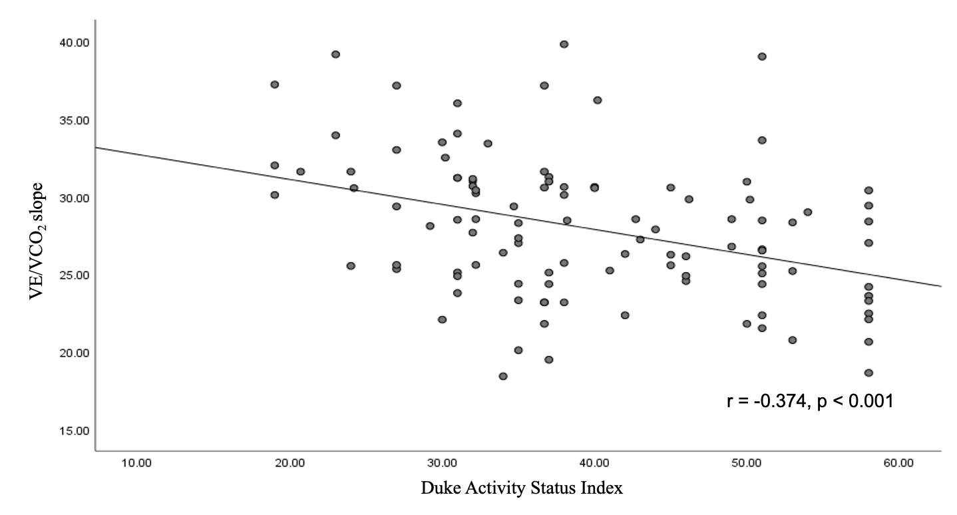
Supplementary Fig. 1. The Association between the DASI score and VE/VCO₂ slope in CVD patients.

