Supplementary Tables：

Supplementary Table 1. Baseline characteristics between POAF group and non-POAF group
 | Unmatched |  |  | 1:1 PSM |  |  | IPTW
 | non-POAF | POAF | p value | non-POAF | POAF | p value | non-POAF | POAF | p value
n | 8244 | 3604 |  | 3506 | 3506 |  | 3478.27 | 3494.7
Age, years | 62[55, 67] | 65[59, 70] | <0.001* | 65[59, 70] | 65.00[59, 70] | 0.698 | 65[59, 70] | 65[59, 70] | 0.971
Male (%) | 6135 (74.4) | 2828 (78.5) | <0.001* | 2768 (79.0) | 2747 (78.4) | 0.56 | 2723.5 (78.3) | 2736.7 (78.3) | 0.991
BMI, kg/m² | 25.8[23.8, 27.5] | 25.8[24, 27.6] | 0.17 | 25.8[23.8, 27.5] | 25.8[24, 27.6] | 0.105 | 25.7[23.8, 27.4] | 25.8[24, 27.6] | 0.007*
Hypertension (%) | 4988 (60.5) | 2288 (63.5) | 0.002* | 2258 (64.4) | 2214 (63.1) | 0.285 | 2208.3 (63.5) | 2216.2 (63.4) | 0.943
Diabetes (%) | 3189 (38.7) | 1420 (39.4) | 0.473 | 1361 (38.8) | 1376 (39.2) | 0.732 | 1363.6 (39.2) | 1373.7 (39.3) | 0.917
COPD (%) | 123 (1.5) | 92 (2.6) | <0.001* | 81 (2.3) | 83 (2.4) | 0.937 | 82.1 (2.4) | 81.5 (2.3) | 0.933
Hyperlipidemia (%) | 4872 (59.1) | 2059 (57.1) | 0.048* | 2041 (58.2) | 2020 (57.6) | 0.629 | 2002.4 (57.6) | 2007.2 (57.4) | 0.899
CKD (%) | 132 (1.6) | 120 (3.3) | <0.001* | 93 (2.7) | 93 (2.7) | 1 | 92.8 (2.7) | 96.9 (2.8) | 0.775
PCI history (%) | 878 (10.7) | 390 (10.8) | 0.807 | 368 (10.5) | 372 (10.6) | 0.907 | 367.9 (10.6) | 376.0 (10.8) | 0.776
Stroke history (%) | 1034 (12.5) | 573 (15.9) | <0.001* | 543 (15.5) | 544 (15.5) | 1 | 544.9 (15.7) | 545.4 (15.6) | 0.939
Cardiac surgery history (%) | 37 (0.4) | 41 (1.1) | <0.001* | 33 (0.9) | 35 (1.0) | 0.903 | 32 (0.9) | 32.6 (0.9) | 0.953
On-pump CABG (%) | 515 (6.2) | 335 (9.3) | <0.001* | 318 (9.1) | 302 (8.6) | 0.528 | 299.0 (8.6) | 299.9 (8.6) | 0.979
Operation time, h | 4[4, 5] | 4[4, 5] | <0.001* | 4[4, 5] | 4[4, 5] | 0.308 | 4[4, 5] | 4[4, 5] | 0.683
Anticoagulation (%) | 83 (1.0) | 86 (2.4) | <0.001* | 39 (1.1) | 83 (2.4) | <0.001* | 39.2 (1.1) | 81.9 (2.3) | <0.001*
Antiplatelet (%) | 8035 (97.5) | 3494 (97.0) | 0.099 | 3407 (97.3) | 3415 (97.4) | 0.707 | 3375.8 (97.1) | 3395.7 (97.2) | 0.832
Preoperative laboratory data
TG, mmol/L | 1.60[1.15, 1.85] | 1.52[1.07, 1.78] | <0.001* | 1.54[1.1, 1.76] | 1.52[1.07, 1.79] | 0.42 | 1.54[1.11, 1.76] | 1.52[1.07, 1.79] | 0.218
TC, mmol/L | 3.96[3.38, 4.35] | 3.96[3.31, 4.3] | <0.001* | 3.96[3.33, 4.27] | 3.96[3.31, 4.3] | 0.808 | 3.96[3.34, 4.28] | 3.96[3.31, 4.3] | 0.35
Cr, μmol/L | 69[59, 81.1] | 73[61.8, 86.8] | <0.001* | 71.5[60.8, 83.97] | 72.6[61.6, 86.2] | 0.01* | 71.3[60.8, 83.9] | 72.5[61.6, 86.1] | 0.001*
UA, μmol/L | 334.2[280.9, 371.3] | 334.2[286, 377.9] | 0.064 | 334.2[284.2, 372.1] | 334.2[284.5, 377.9] | 0.4 | 334.2[283.4, 375.4] | 334.2[284.9, 376.8] | 0.865
K⁺, mmol/L | 4.07[3.84, 4.29] | 4.09[3.84, 4.34] | <0.001* | 4.09[3.85, 4.33] | 4.08[3.84, 4.33] | 0.739 | 4.09[3.85, 4.32] | 4.09[3.84, 4.33] | 0.974
Ca²⁺, mmol/L | 2.22[2.06, 2.33] | 2.21[2.04, 2.32] | 0.004* | 2.21[2.04, 2.32] | 2.21[2.04, 2.32] | 0.796 | 2.21[2.04, 2.32] | 2.21[2.04, 2.32] | 0.856
Mg²⁺, mmol/L | 0.88[0.82, 0.93] | 0.88[0.83, 0.95] | <0.001* | 0.88[0.83, 0.94] | 0.88[0.83, 0.94] | 0.803 | 0.88[0.82, 0.94] | 0.88[0.83, 0.94] | 0.941
CK-MB, ng/ml | 2.9 [1.7, 6.1] | 3.1[1.7, 6.6] | 0.004* | 3.3[1.8, 6.9] | 3[1.7, 6.4] | 0.026* | 3.1[1.8, 6.7] | 3.1[1.7, 6.4] | 0.292
TnI, pg/ml | 0.18[0.07, 0.49] | 0.19[0.07, 0.54] | 0.049* | 0.19[0.07, 0.57] | 0.18[0.07, 0.52] | 0.138 | 0.19[0.07, 0.57] | 0.18[0.07, 0.52] | 0.247
Mb, ng/ml | 176[40.4, 315] | 176.45[40.7, 304.62] | 0.626 | 181.25[39.73, 316.75] | 174.05[39.9, 302] | 0.227 | 177.11[40.1, 315] | 175.52[39.91, 304] | 0.433
BNP, pg/ml | 175[74, 276] | 220[92, 377] | <0.001* | 209[93, 345] | 213[90, 362] | 0.446 | 209[91, 336] | 212.28[89, 358] | 0.317
Preoperative echocardiographic data
LAD, mm | 36.66[35, 38] | 36.66[35, 39] | <0.001* | 36.66[35, 39] | 36.66[35, 39] | 0.923 | 36.66[35, 39] | 36.66[35, 39] | 0.979
LVEF, % | 59.43[58, 65] | 59.43[56, 63] | <0.001* | 59.43[56, 64] | 59.43[56, 64] | 0.904 | 59.43[56, 64] | 59.43[56, 64] | 0.86
E/A ratio | 0.84[0.68, 0.85] | 0.85[0.67, 0.85] | 0.454 | 0.81[0.65, 0.85] | 0.85[0.67, 0.85] | 0.001* | 0.81[0.66, 0.85] | 0.85[0.67, 0.85] | 0.002*
LVEDD, mm | 32.34[29, 33] | 32.34[30, 34] | <0.001* | 32.34[30, 34] | 32.34[30, 34] | 0.617 | 32.34[30, 34] | 32.34[30, 34] | 0.616

Data are presented as median [25th -75th percentiles] or n (%). *, there were significant differences between the non-POAF patients and POAF patients. BMI, body mass index; COPD, chronic obstructive pulmonary disease; CKD, chronic kidney disease; PCI, percutaneous coronary intervention; TG, triglyceride; TC, total cholesterol; Cr, creatinine; UA, uric acid; CK-MB, creatine kinase MB; TnI, troponin I; Mb, myoglobin; BNP, brain natriuretic peptide; LAD, left atrial diameter; LVEF, left ventricular ejection fractions; E/A, ratio early to late diastolic transmitral flow velocity; LVEDD, left ventricular end-diastolic dimension

Supplementary Table 2. Primary and secondary outcomes between non-POAF group and POAF group

 | Unadjusted |  |  | Matched |  |  | Weighted
 | non-POAF | POAF | p value | non-POAF | POAF | p value | non-POAF | POAF | p value
In-hospital mortality (%) | 46 (0.6) | 79 (2.2) | <0.001* | 31 (0.9) | 59 (1.7) | 0.004* | 32.7 (0.9) | 62.1 (1.8) | 0.001*
Stroke (%) | 74 (0.9) | 56 (1.5) | 0.002* | 35 (1.0) | 49 (1.4) | 0.153 | 37.6 (1.1) | 50.6 (1.4) | 0.114
ARF (%) | 26 (0.3) | 40 (1.1) | <0.001* | 9 (0.3) | 39 (1.1) | <0.001* | 13.8 (0.4) | 36.1 (1.0) | <0.001*
AKI (%) | 30 (0.4) | 93 (2.6) | <0.001* | 20 (0.6) | 72 (2.1) | <0.001* | 22.4 (0.6) | 69.7 (2.0) | <0.001*
Significant GIB (%) | 22 (0.3) | 46 (1.3) | <0.001* | 13 (0.4) | 39 (1.1) | 0.001* | 13.9 (0.4) | 37.6 (1.1) | <0.001*
Postoperative LOS, days | 7[6, 8] | 7 [6, 10] | <0.001* | 7 [6, 8] | 7 [6, 10] | <0.001* | 7 [6, 8] | 7 [6, 10] | <0.001*
ICU stay, hours | 20.8 [16, 25.8] | 22 [17, 67.85] | <0.001* | 21 [16.8, 27.8] | 21.8 [17, 66.8] | <0.001* | 21 [16.8, 27] | 21.8 [17, 66] | <0.001*
Data are presented as median [25th -75th percentiles] or n (%). *, there were significant differences between the non-POAF patients and POAF patients. ARF, acute respiratory failure; AKI, acute kidney failure; GIB, gastrointestinal bleeding; LOS, length of stay; ICU, intensive care unit

Supplementary Table 3. The OR of primary outcomes for POAF group

Methods | In-hospital mortality |  | Stroke |  | ARF |  | AKI |  | Significant GIB
Methods | OR  (95%CI) | p value | OR (95%CI) | p value | OR (95%CI) | p value | OR (95%CI) | p value | OR (95%CI) | p value
Unadjusted | 3.99 (2.78-5.80) | <0.001 | 1.74 (1.22-2.47) | 0.002 | 3.55 (2.17-5.89) | <0.001 | 7.25 (4.86-11.14) | <0.001 | 4.83 (2.94-8.19) | <0.001
Matched | 1.74 (1.14-2.70) | 0.012 | 1.54 (0.99-2.43) | 0.059 | 4.37 (2.21-9.64) | <0.001 | 3.65 (2.27-6.17) | <0.001 | 3.02 (1.66-5.89) | 0.001
Weighted | 1.91 (1.38-2.66) | <0.001 | 1.35 (0.97-1.87) | 0.075 | 2.62 (1.65-4.31) | <0.001 | 3.13 (2.19-4.58) | <0.001 | 2.71 (1.72-4.44) | <0.001
Multivariable | 2.53 (1.70-3.81) | <0.001 | 1.28 (0.88-1.85) | 0.195 | 2.93 (1.76-4.95) | <0.001 | 5.41 (3.46-8.70) | <0.001 | 3.45 (2.04-5.98) | <0.001
ARF, acute respiratory failure; AKI, acute kidney failure; GIB, gastrointestinal bleeding

Supplementary Table 4. Logistic regression analysis for the prognosis of POAF duration longer than 48 hours.
Risk factor | Univariate analysis |  |  |  | Multivariate analysis
Risk factor | OR | 95%CI | P value |  | OR | 95%CI | P value
Age | 1.018 | 1.009-1.027 | <0.001 |  | 1.022 | 1.013-1.031 | <0.001
Male | 1.084 | 0.912-1.289 | 0.358 |  | 1.148 | 0.957-1.379 | 0.138
BMI | 1.019 | 0.996-1.043 | 0.111 |  | 1.029 | 1.004-1.005 | 0.025
Hypertension | 0.946 | 0.818-1.094 | 0.455 |  | 0.924 | 0.794-1.077 | 0.313
Diabetes | 1.116 | 0.967-1.288 | 1.288 |  | 1.092 | 0.940-1.268 | 0.250
COPD | 1.114 | 0.719-1.727 | 0.628 |  | 1.025 | 0.655-1.605 | 0.912
Hyperlipidemia | 0.919 | 0.797-1.059 | 0.241 |  | 0.951 | 0.822-1.100 | 0.501
CKD | 1.829 | 1.267-2.639 | 0.001 |  | 1.259 | 0.850-1.864 | 0.250
PCI history | 1.304 | 1.048-1.624 | 0.017 |  | 1.254 | 0.997-1.570 | 0.059
Stroke history | 1.041 | 0.860-1.261 | 0.681 |  | 0.998 | 0.819-1.216 | 0.982
Cardiac surgery history | 0.904 | 0.459-1.778 | 0.769 |  | 0.979 | 0.488-1.961 | 0.952
On-pump CABG | 0.001 | 1.276-2.021 | <0.001 |  | 1.386 | 1.087-1.767 | 0.009
Operation time | 0.010 | 1.015-1.122 | 0.01 |  | 1.053 | 1.000-1.109 | 0.049
TG | 0.942 | 0.869-1.021 | 0.145 |  | 0.954 | 0.876-1.039 | 0.276
TC | 0.948 | 0.878-1.023 | 0.168 |  | 0.969 | 0.895-1.049 | 0.436
Cr | 1.004 | 1.002-1.006 | <0.001 |  | 1.001 | 0.999-1.003 | 0.178
UA | 1.000 | 0.999-1.001 | 0.574 |  | 1.000 | 0.999-1.000 | 0.311
K⁺ | 1.305 | 1.103-1.545 | 0.002 |  | 1.180 | 0.992-1.403 | 0.061
Ca²⁺ | 0.657 | 0.459-0.940 | 0.021 |  | 0.781 | 0.540-1.130 | 0.190
Mg²⁺ | 4.13 | 2.246-7.595 | <0.001 |  | 2.891 | 1.532-5.456 | 0.001
CK-MB | 1.003 | 1.001-1.006 | 0.010 |  | 1.002 | 1.000-1.005 | 0.049
TnI | 1.031 | 1.015-1.048 | <0.001 |  | 1.020 | 1.002-1.039 | 0.028
Mb | 1.000 | 1.000-1.000 | 0.994 |  | 1.000 | 1.000-1.000 | 0.742
BNP | 1.001 | 1.000-1.001 | <0.001 |  | 1.001 | 1.000-1.005 | <0.001
LAD | 1.048 | 1.029-1.066 | <0.001 |  | 1.026 | 1.007-1.046 | 0.008
LVEF | 0.973 | 0.965-0.982 | <0.001 |  | 0.984 | 0.874-0.993 | 0.001
E/A | 1.020 | 0.819-1.269 | 0.862 |  | 1.031 | 0.822-1.292 | 0.793

Multivariate analysis was adjusted for age, male gender, BMI, hypertension, diabetes, LAD, LVEF, CK-MB, K+, BNP.

Supplementary Figure：
Supplementary Fig. 1. Covariate balance plot for assessing balance between non-POAF and POAF groups after PSM and IPTW
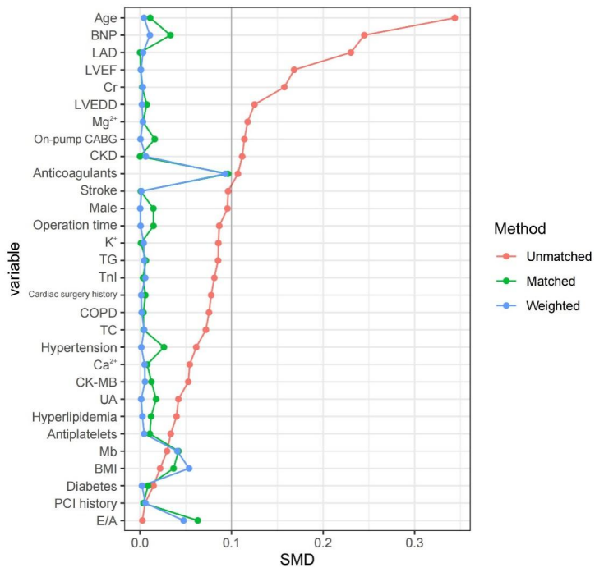
After using PSM with IPTW, the SMD for all variables between the non-POAF and POAF groups were <0.1.
SMD, standardized mean difference; BMI, body mass index; COPD, chronic obstructive pulmonary disease; CKD, chronic kidney disease; PCI, percutaneous coronary intervention; TG, triglyceride; TC, total cholesterol; Cr, creatinine; UA, uric acid; CK-MB, creatine kinase MB; TnI, troponin I; Mb, myoglobin; BNP, brain natriuretic peptide; LAD, left atrial diameter; LVEF, left ventricular ejection fractions; E/A, ratio early to late diastolic transmitral flow velocity; LVEDD, left ventricular end-diastolic dimension

Supplementary Fig. 2. Covariate balance plot for assessing balance between POAF duration shorter than 48 hours and POAF longer than 48 hours groups after PSM and IPTW
After using PSM with IPTW, the SMD for all variables between the POAF duration shorter than 48 hours and POAF longer than 48 hours groups were <0.1.
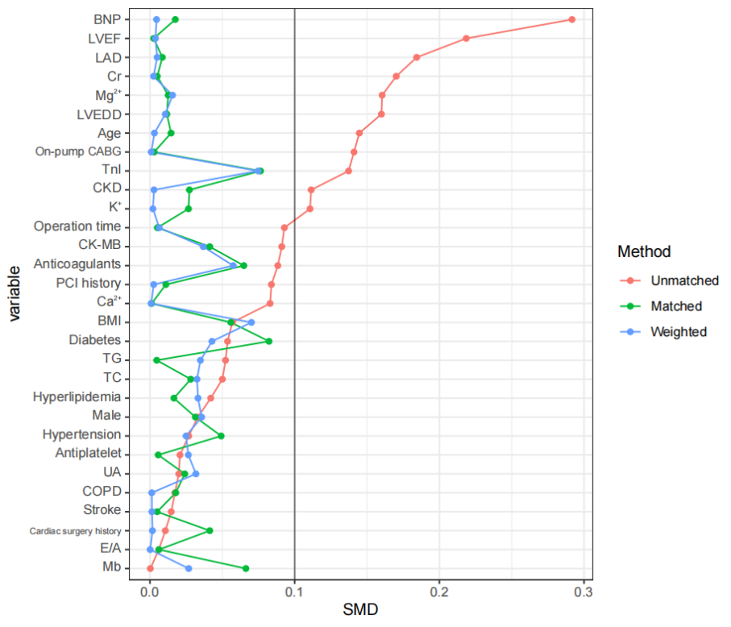
SMD, standardized mean difference; BMI, body mass index; COPD, chronic obstructive pulmonary disease; CKD, chronic kidney disease; PCI, percutaneous coronary intervention; TG, triglyceride; TC, total cholesterol; Cr, creatinine; UA, uric acid; CK-MB, creatine kinase MB; TnI, troponin I; Mb, myoglobin; BNP, brain natriuretic peptide; LAD, left atrial diameter; LVEF, left ventricular ejection fractions; E/A, ratio early to late diastolic transmitral flow velocity; LVEDD, left ventricular end-diastolic dimension

