Supplementary Fig. 1. Representative case for patient with impaired FMD and plaque rupture.

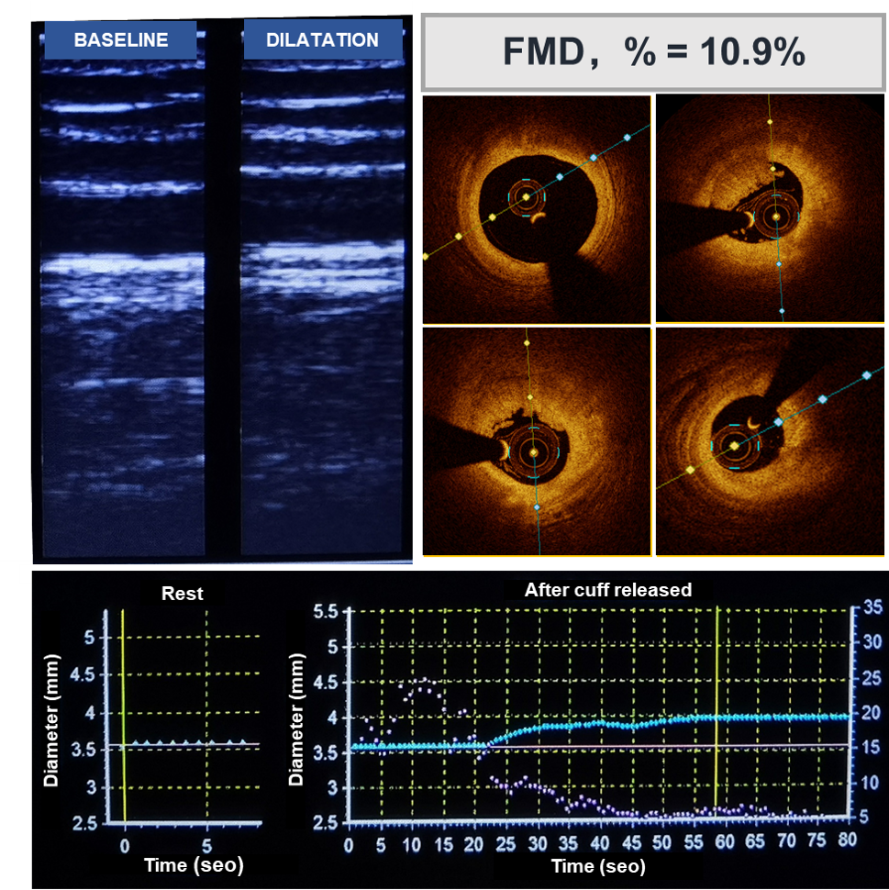

Supplementary Fig. 2. Representative case for patient with normal FMD and plaque erosion.

Supplementary Fig. 3. Receiver operating characteristics curve analysis for thin cap fibroatheroma (TCFA).

 | All patients  (n=426) | Impaired FMD  (n=326) | Normal FMD  (n=100)
Other culprit mechanisms
Spasm | 3 (0.7) | 3 (0.9) | 0 (0)
SACD | 6 (1.4) | 5 (1.5) | 1 (1.0)
Tight stenosis | 6 (1.4) | 5 (1.5) | 1 (1.0)
Values are n (%).
SCAD = spontaneous coronary artery dissection; FMD = flow-mediated vasodilatation
Supplemental Table 1. Distribution of Other Culprit Mechanisms.

