Supplementary Table 1. Information of GWAS summary datasets used in MR analyses
Traits | GWAS.ID
CAD | NA
Cancer | C3_CANCER_EXALLC
Adiponectin | ieu-a-1
Alanine aminotransferase | ukb-d-30620_irnt
Albumin | ukb-d-30600_irnt
Alcohol intake frequency. | ukb-a-25
Alcoholic drinks per week | ieu-b-73
Alkaline phosphatase | ukb-d-30610_irnt
Apoliprotein A | ukb-d-30630_irnt
Apoliprotein B | ukb-d-30640_irnt
Aspartate aminotransferase | ukb-d-30650_irnt
Basal metabolic rate | ukb-a-268
Basophill percentage | ukb-d-30220_irnt
Birth weight | ukb-a-198
Birth weight of first child | ukb-a-318
Body fat | ieu-a-999
Body fat percentage | ukb-a-264
Body mass index | ieu-b-40
Calcium | ukb-d-30680_irnt
Cholesterol | ukb-d-30690_irnt
Cigarettes per Day | ieu-b-25
C-reactive protein | ukb-d-30710_irnt
Creatinine | ukb-d-30700_irnt
Creatinine (enzymatic) in urine | ukb-a-333
Current tobacco smoking | ukb-a-16
Cystatin C | ukb-d-30720_irnt
Daytime dozing / sleeping (narcolepsy) | ukb-a-15
Diastolic blood pressure automated reading | ukb-a-359
Direct bilirubin | ukb-d-30660_irnt
Drive faster than motorway speed limit | ukb-a-8
Eosinophill percentage | ukb-d-30210_irnt
Fasting glucose | ieu-b-114
Fasting insulin | ieu-b-116
Fluid intelligence score | ukb-a-196
Forced expiratory volume in 1-second (FEV1) | ukb-a-337
Forced vital capacity (FVC) | ukb-a-336
Gamma glutamyltransferase | ukb-d-30730_irnt
Getting up in morning | ukb-a-10
Glucose | ukb-d-30740_irnt
Glycated haemoglobin | ukb-d-30750_irnt
Haematocrit percentage | ukb-d-30030_irnt
Haemoglobin concentration | ukb-d-30020_irnt
HDL cholesterol | ukb-d-30760_irnt
Heart rate | ieu-a-1056
Heel bone mineral density (BMD) T-score automated | ukb-a-500
High light scatter reticulocyte count | ukb-d-30300_irnt
High light scatter reticulocyte percentage | ukb-d-30290_irnt
Hip circumference | ukb-a-388
IGF-1 | ukb-d-30770_irnt
Immature reticulocyte fraction | ukb-d-30280_irnt
Impedance of whole body | ukb-a-269
LDL direct | ukb-d-30780_irnt
Lipoprotein A | ukb-d-30790_irnt
Lymphocyte count | ukb-d-30120_irnt
Lymphocyte percentage | ukb-d-30180_irnt
Mean corpuscular haemoglobin | ukb-d-30050_irnt
Mean corpuscular haemoglobin concentration | ukb-d-30060_irnt
Mean corpuscular volume | ukb-d-30040_irnt
Mean platelet (thrombocyte) volume | ukb-d-30100_irnt
Mean reticulocyte volume | ukb-d-30260_irnt
Mean sphered cell volume | ukb-d-30270_irnt
Mean time to correctly identify matches | ukb-a-199
Monocyte count | ukb-d-30130_irnt
Monocyte percentage | ukb-d-30190_irnt
Morning/evening person (chronotype) | ukb-a-11
Nap during day | ukb-a-12
Neuroticism | ieu-a-1007
Neuroticism score | ukb-a-230
Neutrophill count | ukb-d-30140_irnt
Neutrophill percentage | ukb-d-30200_irnt
Overall health rating | ukb-a-251
Past tobacco smoking | ukb-a-17
Peak expiratory flow (PEF) | ukb-a-338
Phosphate | ukb-d-30810_irnt
Platelet count | ukb-d-30080_irnt
Platelet crit | ukb-d-30090_irnt
Platelet distribution width | ukb-d-30110_irnt
Pulse rate automated reading | ukb-a-3
Red blood cell (erythrocyte) count | ukb-d-30010_irnt
Red blood cell (erythrocyte) distribution width | ukb-d-30070_irnt
Reticulocyte count | ukb-d-30250_irnt
Reticulocyte percentage | ukb-d-30240_irnt
SHBG | ukb-d-30830_irnt
Sitting height | ukb-a-195
Sleep duration | ukb-a-9
Sleeplessness / insomnia | ukb-a-13
Sodium in urine | ukb-a-335
Standing height | ukb-a-389
Systolic blood pressure automated reading | ukb-a-360
Telomere length | ieu-b-4879
Testosterone | ukb-d-30850_irnt
Total bilirubin | ukb-d-30840_irnt
Total cholesterol | ieu-a-301
Total protein | ukb-d-30860_irnt
Triglycerides | ukb-d-30870_irnt
Trunk fat mass | ukb-a-291
Trunk fat percentage | ukb-a-290
Trunk fat-free mass | ukb-a-292
Trunk predicted mass | ukb-a-293
Urate | ukb-d-30880_irnt
Urea | ukb-d-30670_irnt
Urinary sodium-potassium ratio | ieu-b-72
Usual walking pace | ukb-a-513
Vitamin D | ukb-d-30890_irnt
Waist circumference | ukb-a-382
Waist-to-hip ratio | ieu-a-72
Weight | ukb-a-249
White blood cell (leukocyte) count | ukb-d-30000_irnt
Whole body fat mass | ukb-a-265
Whole body fat-free mass | ukb-a-266
Whole body water mass | ukb-a-267
Abbreviation: GWAS: genome-wide association study; ID: Identification; MR: Mendelian randomization; ukb: UK Biobank; CAD: Coronary artery disease; HDL: High-density lipoprotein; IGF-1: Insulin-like growth factor 1; LDL: Low-density lipoprotein; SHBG: Sex hormone-binding globulin; NA: Not Applicable.

Supplementary Table 2. The F-statistics of IVs
Exposure | Outcome | F-statistic
Exposure | Outcome | Min | Max
Mean sphered cell volume | CAD | 29.73 | 2824.94
Weight | CAD | 29.73 | 772.58
Glycated haemoglobin | CAD | 29.94 | 8023.61
Sleeplessness / insomnia | CAD | 30.13 | 150.83
Birth weight of first child | CAD | 30.05 | 134.05
Sitting height | CAD | 29.88 | 1146.83
Standing height | CAD | 29.73 | 1335.34
Telomere length | CAD | 29.86 | 1628.82
Trunk fat-free mass | CAD | 29.74 | 630.54
Trunk predicted mass | CAD | 29.75 | 627.97
Mean sphered cell volume | Cancer | 29.73 | 2824.94
Weight | Cancer | 29.73 | 772.58
Glycated haemoglobin | Cancer | 29.94 | 8023.61
Sleeplessness / insomnia | Cancer | 30.13 | 150.83
Birth weight of first child | Cancer | 30.05 | 134.05
Sitting height | Cancer | 29.88 | 1146.83
Standing height | Cancer | 29.73 | 1335.34
Telomere length | Cancer | 29.86 | 1628.82
Trunk fat-free mass | Cancer | 29.74 | 630.54
Trunk predicted mass | Cancer | 29.75 | 627.97
Abbreviation: IVs: instrumental variables; SNP: single nucleotide polymorphism; CAD: Coronary artery disease.

Supplementary Table 3. MR analysis results using instrumental SNPs after Steiger filtering (only results with SNPs identified through Steiger filtering are included)
Exposure | Outcome | Method | p
Mean sphered cell volume | CAD | IVW | 2.44E-03
Mean sphered cell volume | CAD | MR Egger | 4.21E-01
Mean sphered cell volume | CAD | WM | 6.06E-01
Weight | CAD | IVW | 1.22E-06
Weight | CAD | MR Egger | 1.36E-02
Weight | CAD | WM | 1.02E-07
Glycated haemoglobin | CAD | IVW | 6.75E-10
Glycated haemoglobin | CAD | MR Egger | 1.48E-02
Glycated haemoglobin | CAD | WM | 4.52E-03
Sleeplessness / insomnia | CAD | IVW | 7.20E-02
Sleeplessness / insomnia | CAD | MR Egger | 7.85E-01
Sleeplessness / insomnia | CAD | WM | 4.85E-02
Birth weight of first child | CAD | IVW | 9.79E-04
Birth weight of first child | CAD | MR Egger | 6.17E-01
Birth weight of first child | CAD | WM | 9.83E-03
Sitting height | CAD | IVW | 1.00E-09
Sitting height | CAD | MR Egger | 3.87E-03
Sitting height | CAD | WM | 1.45E-06
Telomere length | CAD | IVW | 1.94E-03
Telomere length | CAD | MR Egger | 1.08E-01
Telomere length | CAD | WM | 1.94E-01
Trunk fat-free mass | CAD | IVW | 1.29E-02
Trunk fat-free mass | CAD | MR Egger | 4.27E-01
Trunk fat-free mass | CAD | WM | 1.40E-01
Trunk predicted mass | CAD | IVW | 1.83E-02
Trunk predicted mass | CAD | MR Egger | 2.11E-01
Trunk predicted mass | CAD | WM | 2.81E-01
Glycated haemoglobin | Cancer | IVW | 1.66E-02
Glycated haemoglobin | Cancer | MR Egger | 1.07E-01
Glycated haemoglobin | Cancer | WM | 1.14E-01
Abbreviation: MR: Mendelian randomization; SNP: single nucleotide polymorphism; IVW: inverse-variance weighted; WM: Weighted median; CAD: Coronary artery disease.

Supplementary Table 4. The results of Steiger directionality test
Exposure | Outcome | snp_r².  exposure | snp_r².  outcome | correct_causal_direction | steiger_pval
Telomere length | CAD | 0.03198 | 0.00215 | TRUE | 0
Sleeplessness or insomnia | CAD | 0.00347 | 0.00051 | TRUE | 2.65E-36
Sitting height | CAD | 0.11652 | 0.00589 | TRUE | 0
Weight | CAD | 0.06178 | 0.00552 | TRUE | 0
Trunk fat-free mass | CAD | 0.09274 | 0.0058 | TRUE | 0
Trunk predicted mass | CAD | 0.09235 | 0.00569 | TRUE | 0
Birth weight of first child | CAD | 0.01426 | 0.00146 | TRUE | 2.51E-120
Standing height | CAD | 0.19279 | 0.00773 | TRUE | 0
Mean sphered cell volume | CAD | 0.10586 | 0.00577 | TRUE | 0
Glycated haemoglobin | CAD | 0.0928 | 0.00507 | TRUE | 0
Telomere length | Cancer | 0.03197 | 0.00137 | TRUE | 0
Sleeplessness or insomnia | Cancer | 0.00347 | 0.00012 | TRUE | 2.01E-89
Sitting height | Cancer | 0.11439 | 0.00232 | TRUE | 0
Weight | Cancer | 0.06058 | 0.00185 | TRUE | 0
Trunk fat-free mass | Cancer | 0.09024 | 0.00261 | TRUE | 0
Trunk predicted mass | Cancer | 0.09023 | 0.00261 | TRUE | 0
Birth weight of first child | Cancer | 0.0144 | 0.00017 | TRUE | 6.78E-264
Standing height | Cancer | 0.19115 | 0.00314 | TRUE | 0
Mean sphered cell volume | Cancer | 0.10487 | 0.00199 | TRUE | 0
Glycated haemoglobin | Cancer | 0.08825 | 0.00149 | TRUE | 0

Supplementary Table 5. Heterogeneity test results
Exposure | Outcome | Q_P
Mean sphered cell volume | CAD | 3.86E-40
Weight | CAD | 3.94E-29
Glycated haemoglobin | CAD | 1.22E-23
Sleeplessness / insomnia | CAD | 5.45E-04
Birth weight of first child | CAD | 3.97E-14
Sitting height | CAD | 8.64E-18
Standing height | CAD | 1.22E-19
Telomere length | CAD | 1.74E-09
Trunk fat-free mass | CAD | 1.03E-22
Trunk predicted mass | CAD | 1.05E-21
Mean sphered cell volume | Cancer | 4.09E-32
Weight | Cancer | 2.83E-20
Glycated haemoglobin | Cancer | 6.13E-17
Sleeplessness / insomnia | Cancer | 3.58E-01
Birth weight of first child | Cancer | 1.37E-01
Sitting height | Cancer | 6.97E-21
Standing height | Cancer | 2.02E-27
Telomere length | Cancer | 1.07E-13
Trunk fat-free mass | Cancer | 2.89E-32
Trunk predicted mass | Cancer | 2.88E-33
Abbreviation: CAD: Coronary artery disease.

Supplementary Table 6. The pleiotropy of 10 potential factors
Exposure | Outcome | Egger intercept | SE | P
Mean sphered cell volume | CAD | -0.0026 | 0.0019 | 1.68E-01
Weight | CAD | -0.0016 | 0.0024 | 5.13E-01
Glycated haemoglobin | CAD | 0.0031 | 0.0018 | 8.15E-02
Sleeplessness / insomnia | CAD | -0.0048 | 0.0100 | 6.35E-01
Birth weight of first child | CAD | -0.0027 | 0.0129 | 8.36E-01
Sitting height | CAD | 0.0013 | 0.0018 | 4.63E-01
Standing height | CAD | -0.0013 | 0.0013 | 3.40E-01
Telomere length | CAD | -0.0006 | 0.0027 | 8.26E-01
Trunk fat-free mass | CAD | -0.0004 | 0.0020 | 8.27E-01
Trunk predicted mass | CAD | 0.0006 | 0.0020 | 7.52E-01
Mean sphered cell volume | Cancer | -0.0002 | 0.0012 | 8.50E-01
Weight | Cancer | -0.0008 | 0.0015 | 5.96E-01
Glycated haemoglobin | Cancer | -0.0002 | 0.0011 | 8.90E-01
Sleeplessness / insomnia | Cancer | -0.0054 | 0.0039 | 1.72E-01
Birth weight of first child | Cancer | 0.0042 | 0.0048 | 3.90E-01
Sitting height | Cancer | 0.0009 | 0.0012 | 4.53E-01
Standing height | Cancer | 0.0018 | 0.0009 | 4.94E-02
Telomere length | Cancer | -0.0027 | 0.0018 | 1.44E-01
Trunk fat-free mass | Cancer | 0.0006 | 0.0014 | 6.47E-01
Trunk predicted mass | Cancer | 0.00004 | 0.0014 | 9.74E-01
Abbreviation: SE: standard error; CAD: Coronary artery disease.

Supplementary Table 7. MR-PRESSO analyses between exposures and outcomes with outlier
Exposure | Outcome | MR Analysis | p-value
Mean sphered cell volume | CAD | Outlier-corrected | 1.03E-02
Weight | CAD | Outlier-corrected | 1.90E-06
Glycated haemoglobin | CAD | Outlier-corrected | 2.21E-11
Sleeplessness / insomnia | CAD | Outlier-corrected | 8.36E-02
Birth weight of first child | CAD | Outlier-corrected | 2.19E-03
Sitting height | CAD | Outlier-corrected | 2.33E-09
Standing height | CAD | Outlier-corrected | 2.61E-14
Telomere length | CAD | Outlier-corrected | 2.40E-03
Trunk fat-free mass | CAD | Outlier-corrected | 1.57E-03
Trunk predicted mass | CAD | Outlier-corrected | 2.29E-03
Mean sphered cell volume | Cancer | Outlier-corrected | 3.51E-02
Weight | Cancer | Outlier-corrected | 1.81E-02
Glycated haemoglobin | Cancer | Outlier-corrected | 2.36E-02
Sitting height | Cancer | Outlier-corrected | 4.70E-05
Standing height | Cancer | Outlier-corrected | 4.66E-05
Telomere length | Cancer | Outlier-corrected | 4.03E-20
Trunk fat-free mass | Cancer | Outlier-corrected | 2.57E-05
Trunk predicted mass | Cancer | Outlier-corrected | 9.65E-05

Supplementary Table 8. MR analysis results after excluding SNPs showing associations with CAD or cancer
Exposure | Outcome | Method | p
Mean sphered cell volume | CAD | IVW | 2.36E-02
Mean sphered cell volume | CAD | MR Egger | 4.77E-01
Mean sphered cell volume | CAD | WM | 6.09E-01
Weight | CAD | IVW | 3.86E-05
Weight | CAD | MR Egger | 3.29E-01
Weight | CAD | WM | 7.52E-07
Glycated haemoglobin | CAD | IVW | 1.09E-12
Glycated haemoglobin | CAD | MR Egger | 5.11E-03
Glycated haemoglobin | CAD | WM | 5.33E-03
Sleeplessness / insomnia | CAD | IVW | 7.20E-02
Sleeplessness / insomnia | CAD | MR Egger | 7.85E-01
Sleeplessness / insomnia | CAD | WM | 3.88E-02
Birth weight of first child | CAD | IVW | 7.20E-02
Birth weight of first child | CAD | MR Egger | 5.18E-01
Birth weight of first child | CAD | WM | 2.07E-01
Sitting height | CAD | IVW | 4.83E-08
Sitting height | CAD | MR Egger | 4.58E-03
Sitting height | CAD | WM | 4.78E-06
Standing height | CAD | IVW | 4.01E-13
Standing height | CAD | MR Egger | 1.97E-02
Standing height | CAD | WM | 1.22E-06
telomere length | CAD | IVW | 4.13E-03
telomere length | CAD | MR Egger | 8.35E-02
telomere length | CAD | WM | 1.97E-01
Trunk fat-free mass | CAD | IVW | 2.12E-03
Trunk fat-free mass | CAD | MR Egger | 9.00E-02
Trunk fat-free mass | CAD | WM | 3.21E-02
Trunk predicted mass | CAD | IVW | 2.72E-03
Trunk predicted mass | CAD | MR Egger | 3.86E-02
Trunk predicted mass | CAD | WM | 1.49E-01
Mean sphered cell volume | Cancer | IVW | 3.98E-02
Mean sphered cell volume | Cancer | MR Egger | 3.18E-01
Mean sphered cell volume | Cancer | WM | 9.20E-03
Weight | Cancer | IVW | 1.53E-02
Weight | Cancer | MR Egger | 7.17E-02
Weight | Cancer | WM | 4.76E-02
Glycated haemoglobin | Cancer | IVW | 2.42E-02
Glycated haemoglobin | Cancer | MR Egger | 1.04E-01
Glycated haemoglobin | Cancer | WM | 1.98E-01
Birth weight of first child | Cancer | IVW | 4.84E-03
Birth weight of first child | Cancer | MR Egger | 9.40E-01
Birth weight of first child | Cancer | WM | 1.08E-02
Sitting height | Cancer | IVW | 5.26E-04
Sitting height | Cancer | MR Egger | 4.45E-01
Sitting height | Cancer | WM | 2.57E-01
Standing height | Cancer | IVW | 1.30E-04
Standing height | Cancer | MR Egger | 6.94E-01
Standing height | Cancer | WM | 9.64E-02
telomere length | Cancer | IVW | 8.44E-16
telomere length | Cancer | MR Egger | 2.40E-07
Telomere length | Cancer | WM | 8.06E-13
Trunk fat-free mass | Cancer | IVW | 8.15E-05
Trunk fat-free mass | Cancer | MR Egger | 8.05E-01
Trunk fat-free mass | Cancer | WM | 4.20E-02
Trunk predicted mass | Cancer | IVW | 2.81E-04
Trunk predicted mass | Cancer | MR Egger | 5.73E-01
Trunk predicted mass | Cancer | WM | 5.65E-02
Abbreviation: MR: Mendelian randomization; SNP: single nucleotide polymorphism; IVW: inverse-variance weighted; WM: Weighted median; CAD: Coronary artery disease.

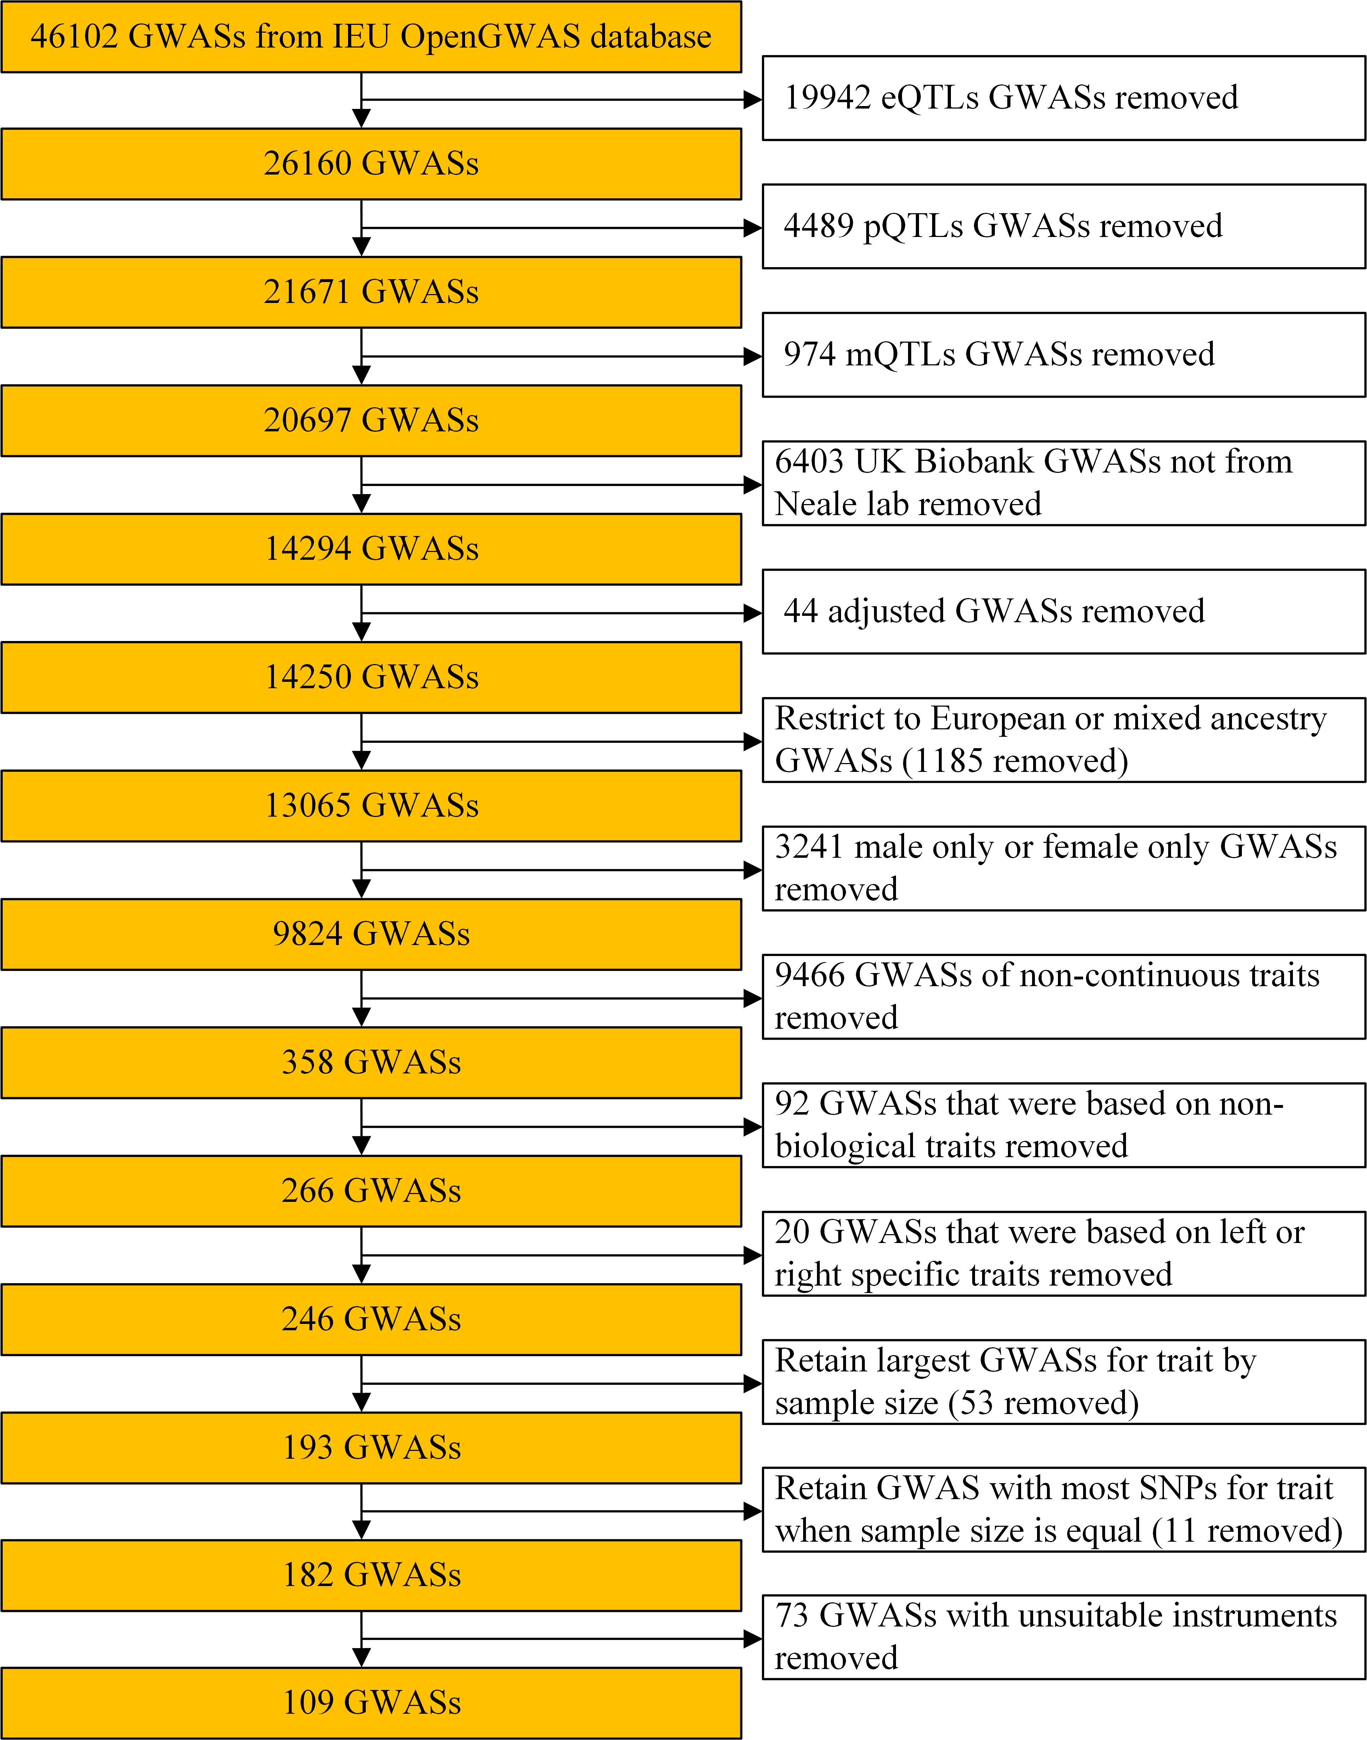
Supplementary Figure 1. Flowchart showing the trait selection procedure for causal analyses. GWAS: genome-wide association study.

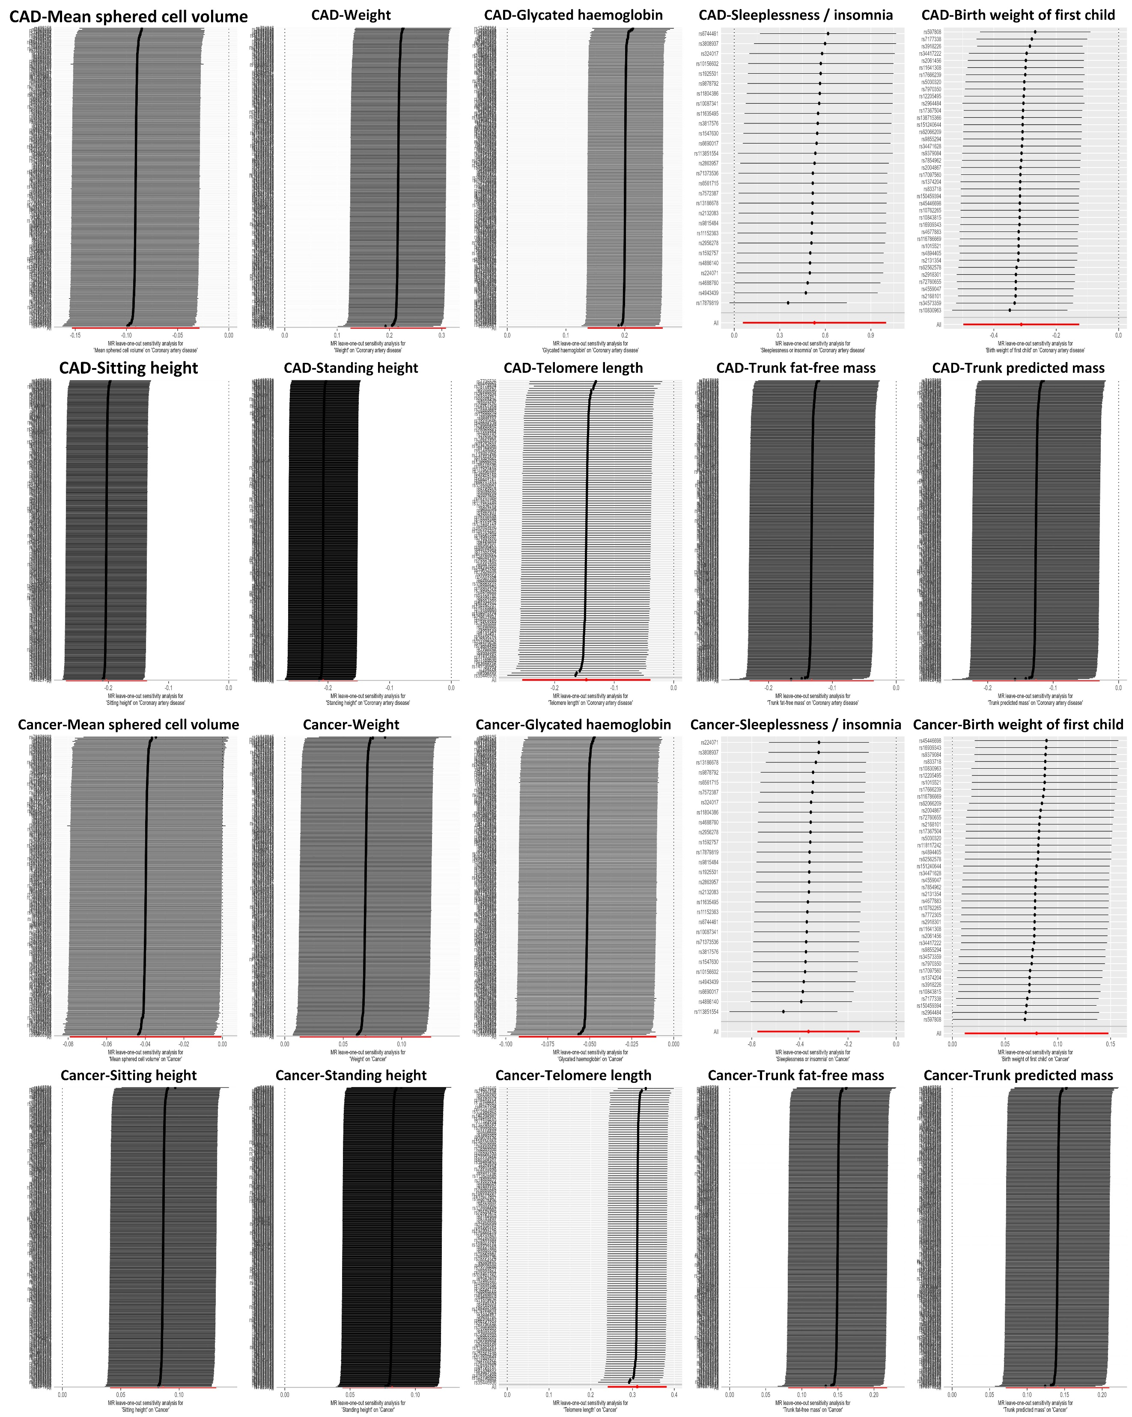
Supplementary Figure 2. Leave-one-out sensitivity analysis examining the causal estimates of 10 factors on both CAD and cancer by the IVW method after exclude a specific SNP from the analysis. The red line represents the IVW estimate of all SNPs on each outcome. MR: Mendelian randomization; SNP: single nucleotide polymorphism; IVW: inverse-variance weighted; CAD: coronary artery disease.

