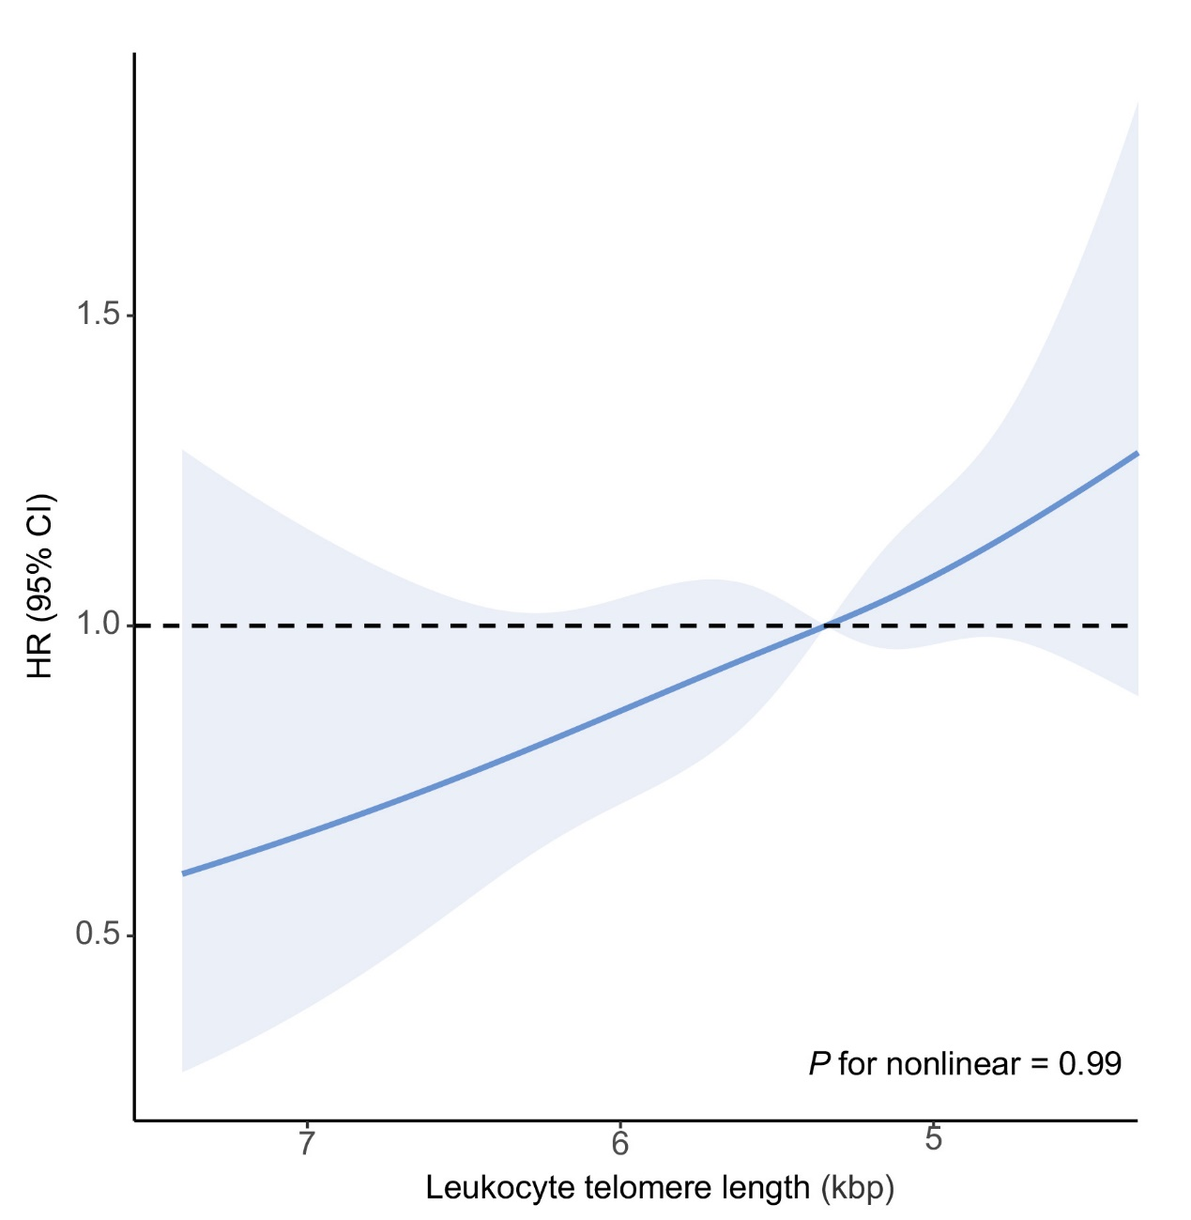
Supplementary Fig. 1. Cox regression-based restricted cubic spline on the association between LTL and all-cause death. Covariates were adjusted for, including age, race, gender, and education. LTL: leucocyte telomere length.

