Supplementary Tables and Figures

Supplementary Table 1. Hypertrophic cardiomyopathy features on echocardiographs (n = 46).
Parameters | Mean ± SD | Maximum | Minimum
Maximal-end-diastolic-thickness of LV (mm) | 18.60 ± 4.98 | 33 | 13
Dd (mm) | 41.90 ± 6.91 | 52 | 31
Ds (mm) | 25.60 ± 4.88 | 39 | 17
EDV (ml) | 81.20 ± 23.96 | 132 | 40
ESV (ml) | 25.40 ± 12.14 | 66 | 8
EF (%) | 68.50 ± 9.05 | 85 | 42
IVSd (mm) | 15.50 ± 5.59 | 33 | 6
IVSs (mm) | 18.40 ± 5.95 | 38 | 10
Left atrial diameter (mm) | 37.02 ± 6.91 | 53 | 26
Ascending aortic diameter (mm) | 30.60 ± 3.56 | 37 | 23
LV, left ventricular; D, dimension; EDV, end-diastolic volume; ESV, end-systolic volume; EF, ejection fraction; IVS, interventricular septum; -d, in diastole; -s, in systole.

Supplementary Table 2. Hypertrophic cardiomyopathy phenotypes on echocardiographs.
HCM phenotypes |  | Patients  (n = 46) | Percentages (%)
Left ventricle | Diffuse HCM | 2 | 4.3
Left ventricle | Septal HCM | 37 | 80.5
Left ventricle | Apical HCM | 1 | 2.2
Left ventricle | Concentric HCM | 4 | 8.8
Both left and right ventricles |  | 2 | 4.3
HCM, hypertrophic cardiomyopathy.

Supplementary Table 3. The risk of having an LVOT/Ao diameter ratio < 0.38 in patients without and with SAM
SAM | LVOT/Ao diameter ratio < 0.38 | OR (95 % CI)
(-) | 9.1 % | 1
(+) | 79.2 % | 5.7 (1.6; 12.7)
LVOT left ventricular outflow tract; Ao, aortic; CMR, cardiac magnetic resonance; SAM, systolic anterior motion; OR, odds ratio; CI, confidence interval.

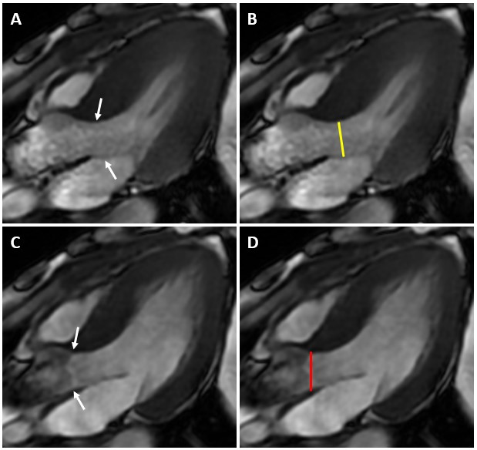
Supplementary Fig. 1. Assessment of LVOT/Ao diameter ratio on 3-chamber steady-state free precession cardiac magnetic resonance image. The LVOT diameter is identified as the minimal distance between the interventricular septum and the anterior leaflet of the mitral valve during systole (A (arrows), B (yellow line)). The aortic diameter is measured at the aortic annulus in the end-diastole (C (arrows), D (red line)). The LVOT diameter was divided by the aortic diameter to calculate the LVOT/Ao diameter ratio. LVOT, left ventricular outflow tract; Ao, aortic.

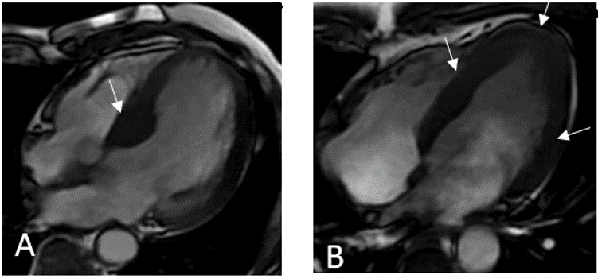
Supplementary Fig. 2. Cine 4-chamber view obtained at end-diastolic phase. (A) Cardiac magnetic resonance image of a 70-year-old male shows midseptal hypertrophic cardiomyopathy (arrow); (B) cardiac magnetic resonance image of a 46-year-old male shows concentric hypertrophic cardiomyopathy (arrows).

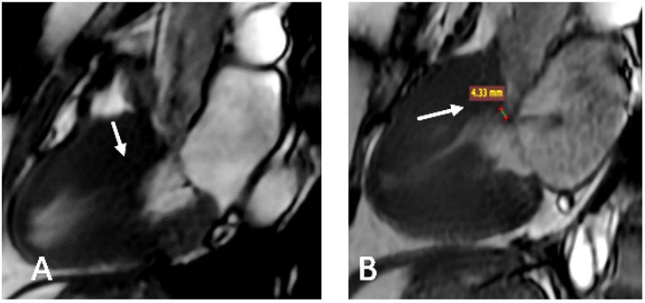
Supplementary Fig. 3. A 72-year-old female had severe LVOT obstruction with positive SAM on cine 3-chamber view (A) and LVOT view (B). SAM, systolic anterior motion; LVOT, left ventricular outflow tract.

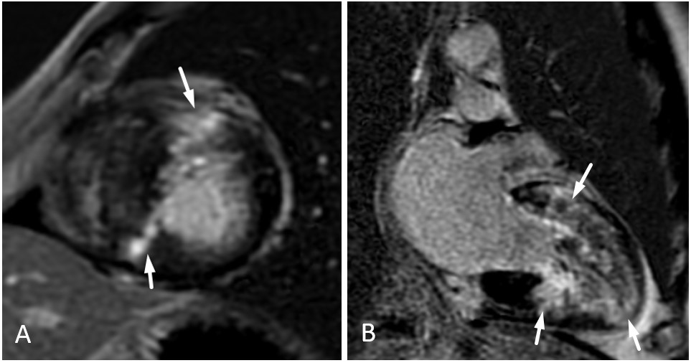
Supplementary Fig. 4. A 55-year-old male had late gadolinium enhancement (arrows) with a transmural pattern on a short-axis view (A) and a midwall pattern on a 2-chamber view (B).

